Baymax: CSBS Techno-Economic Business Systems Analysis
MDRIIA Group 02 (Kamakshi Bahuguna E007, Devanshi Sachin Kambli B029). Dossier Sections 3 and 4. All values are dimensionless: no currency anywhere. Unit of value: U = the yearly cost of one full-time attendant (one attendant-year). Everything is per patient-year.

1. Executive summary
Bottom line, stated plainly: with the clinical value of faster fall response alone, no system we tested pays for itself under our assumptions, and the guide-specification robot is the weakest of the four. The measured guide robot costs about 0.50 U per patient-year and delivers clinical value of about 0.09 U, a net loss of 0.41 U (benefit-to-cost ratio 0.18). Its running-cost fraction kappa is 0.45, above the 0.25 limit of the standards manual.
- Where profit can come from: labour reallocation. If the robot replaces just 9.8% of the continuous vigilance hours one patient needs (168 h per week, 4.2 attendant-years), it breaks even; at 15% it returns about 0.43 per year on its cost.
- The cheapest lever is the false-dispatch rate: two false dispatches in 77 negatives cost 0.25 U per year. To keep kappa within 0.25 the rate must be at most 0.5% per look-alike event, against the measured 2.6%.
- Uncertainty analysis (20,000 draws over the assumption ranges): probability the guide robot has positive net value is 0.22 when 0 to 15% of vigilance is replaced, and about 0.00 on clinical value alone.
- Strategic reading: a fall-only robot is a weak business; a companion that also reminds, checks and reassures (more hours replaced, more value per device) is where a profitable service can come from. That extra scope is outside our authorised title and is NOT measured here, so it is a hypothesis to test, not a result.

2. The problem and who feels it
An older adult who falls with nobody at home can lie on the floor for hours (the long lie). The cost is carried by several parties, which is why the value is split and hard to capture:
Stakeholder | What they lose today | What fast, reliable dispatch changes
Older person living alone | Risk of a long lie; evidence of harm: half of 20 people who lay over 1 h died within 6 months (Wild, Nayak, Isaacs, BMJ 1981, doi 10.1136/bmj.282.6260.266; small cohort) | Help sooner; less time on the floor
Family and informal caregivers | Constant worry, unplanned visits, lost work hours | Fewer emergency visits, peace of mind (Geriatric Depression Scale could measure this; not simulable)
Hospitals and payers | Longer admissions after a long lie; the sheet quotes 18.4 vs 4.2 days (no primary source: assumption A2) | Fewer bed-days per fall
Care homes and home-care agencies | Staff time spent watching and checking; staff shortages | Attendant hours freed for care (labour reallocation)
Emergency services | Late or non-specific calls | A call with location, posture and time already attached

3. The model: definitions and assumption register
Per patient-year, in attendant-years (U). Clinical value B_c = f x s x dH x b, where f is falls per year, s the measured dispatch sensitivity, dH the bed-days saved per early-dispatched fall and b the value of a bed-day in attendant-days divided by 365. Labour value B_l = alpha x 4.2 U, where alpha is the share of continuous vigilance replaced and 4.2 = 168 x 52 / 2080 (FTE = hours / 2080). Cost C = K0 / T_life (capital per year) + opex + false-dispatch burden, where the burden = N_adl x phi x rho x b (look-alike events per year times the measured false-dispatch rate times the cost of one false dispatch in bed-days). The standards-manual kappa = (opex + false-dispatch burden) / 1 U must stay at or below 0.25, NCRI = 1 - kappa, and payback = 12 K0 / (1 - kappa) months. Net value = B - C, and return on cost = (B - C) / C.
Id | Assumption (value) and its source status
A1 | falls per fall-prone older adult per year [research guide, not independently verified] [value 1.2]
A2 | bed-days saved per early-dispatched fall, 18.4 - 4.2 [titles sheet; NO primary source found] [value 14.2]
A3 | one hospital bed-day in attendant-days [assumption, varied 1 to 5] [value 3.0]
A4 | look-alike daily events per year, about 5 a day [research guide] [value 1825.0]
A5 | one unnecessary emergency dispatch in bed-day equivalents [research guide, assumed] [value 0.65]
A6 | capital cost of the robot in attendant-years = 3 attendant-months [titles sheet, upper bound; varied 2 to 4 months] [value 0.25]
A7 | service life in years [assumption, varied 3 to 7] [value 5.0]
A8 | robot running cost per year in attendant-years [assumption, varied 0.10 to 0.30; standards manual limit kappa <= 0.25] [value 0.2]
A9 | continuous vigilance hours per week for one patient [research guide] [value 168.0]
A10 | share of vigilance hours the robot really replaces [assumption; base 0 = clinical value only; varied 0 to 0.15] [value 0.0]
A11 | capital cost of one fixed camera, 10% of the robot [assumption] [value 0.025]
A12 | running cost of one fixed camera per year [assumption] [value 0.03]
A13 | alerts one caregiver can handle per hour, 5 minutes each [assumption] [value 12.0]
A14 | hours per full-time attendant-year [standards manual] [value 2080.0]

Measured inputs come only from our seeded MuJoCo test runs (results/guide_robot_test and results/small_robot_test): dispatch sensitivity and false-dispatch rate of each system. Everything else is an assumption and is varied in sections 7 to 9.

4. Measured performance feeding the model
System | Dispatch sensitivity (silent falls) | False-dispatch rate (non-events)
Baymax, guide robot (measured) | 28/43 = 0.65 | 2/77 = 0.026
Compact robot (earlier run) | 37/43 = 0.86 | 0/77 = 0.000
4 fixed cameras | 20/43 = 0.47 | 0/77 = 0.000
1 fixed camera | 2/43 = 0.05 | 0/77 = 0.000

The compact robot and the guide robot are different machines: the 120-trial result for the compact robot (0.86, 0 false dispatches) is better than the specification robot (0.65, 2 false dispatches) but the compact robot is not the specification robot and its model is no longer in the code.

5. Unit economics: the cost and benefit stack
System | Clinical value | Capital /yr | Running | False dispatch | Total cost | Net value | Benefit / cost | kappa | Payback (months)
Baymax, guide robot (measured) | 0.091 | 0.050 | 0.200 | 0.253 | 0.503 | -0.412 | 0.18 | 0.45 | 5.49
Compact robot (earlier run) | 0.121 | 0.050 | 0.200 | 0.000 | 0.250 | -0.129 | 0.48 | 0.20 | 3.75
4 fixed cameras | 0.065 | 0.020 | 0.120 | 0.000 | 0.140 | -0.075 | 0.47 | 0.12 | 1.36
1 fixed camera | 0.007 | 0.005 | 0.030 | 0.000 | 0.035 | -0.028 | 0.19 | 0.03 | 0.31

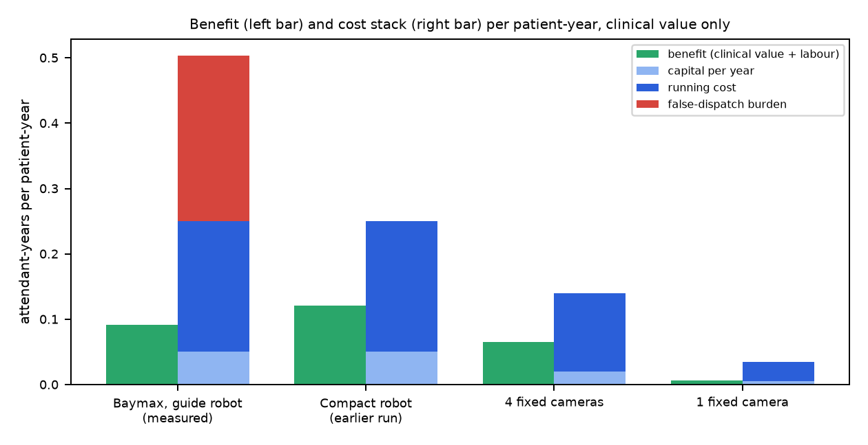
Figure 1. Benefit and cost stack per patient-year (clinical value only, alpha = 0).
Reading the table. (1) No system is net-positive on clinical value alone: the value of avoiding bed-days (about 0.07 to 0.09 U per patient-year for the two robots) is smaller than the cost of owning and running any device. (2) The guide robot's false dispatches (0.253 U) cost more than the benefit it creates (0.091 U). (3) The payback figure (12 K0 / (1 - kappa), from the standards manual) is 5.49 months for the guide robot and 3.75 for the compact one: it is longer than the sheet's 'first quarter' in both cases, and it only describes how fast capital is recovered if there is a surplus to recover it from. (4) The fixed cameras look cheaper because we assumed each costs 10% of the robot (A11, A12): this is an assumption, not a quote, and the comparison is only as good as it.

6. How profit is made: price, margin and the value pool
A supplier can only charge up to the customer's benefit and still stay attractive; profit exists only if benefit B exceeds the supplier's cost C. Expressing price as a multiple of cost-to-serve, the supplier's margin is (p - C) / p. The table shows, for the guide robot as measured, how the profit pool opens as the robot replaces more vigilance hours; the supplier is assumed to price at half way between cost and customer benefit (a 50/50 split of the surplus).
Share of vigilance replaced (alpha) | Hours per day freed | FTE freed | Customer benefit B | Cost C | Surplus B - C | Supplier margin at 50/50 split | Return on cost
0.00 | 0.0 h | 0.00 | 0.091 | 0.503 | -0.412 | no viable price | -0.82
0.05 | 1.2 h | 0.21 | 0.301 | 0.503 | -0.202 | no viable price | -0.40
0.10 | 2.4 h | 0.42 | 0.511 | 0.503 | 0.008 | 1% | 0.02
0.15 | 3.6 h | 0.63 | 0.721 | 0.503 | 0.218 | 18% | 0.43
0.25 | 6.0 h | 1.05 | 1.141 | 0.503 | 0.638 | 39% | 1.27

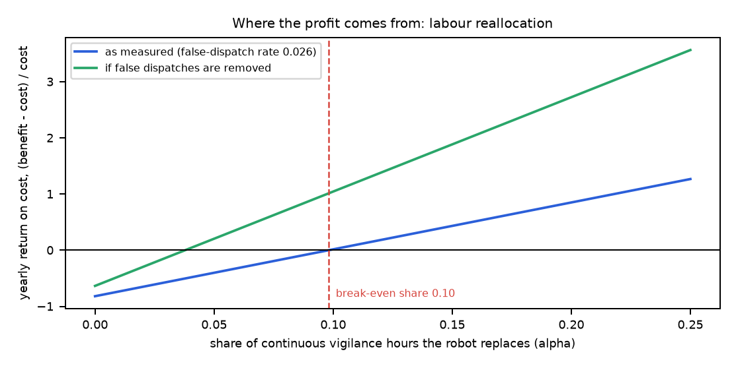
Figure 2. Yearly return on cost against the share of vigilance replaced; the red line is break-even.
- Break-even share of vigilance replaced: 9.8% (about 2.4 attendant-hours per day per patient).
- Removing false dispatches alone lifts the return substantially (green curve), because they are the largest avoidable cost: break-even falls to 3.8% of vigilance.
- On clinical value alone the bed-day value would have to be 8.2 attendant-days per bed-day (assumed 3) for the robot to cover its cost with no false dispatches.
- Revenue models that fit this arithmetic (named, not measured): (a) subscription to families or home-care agencies, priced between cost and benefit; (b) licence per bed to care homes, where labour reallocation is large because one asset serves staff across shifts; (c) outcome-based contract with a hospital or payer that shares the saved bed-days; (d) alert platform fee for the family and dispatch service. Each needs a customer who actually receives the benefit, which differs by model.

7. Labour reallocation H_reclaimed
Continuous vigilance for one patient is 168 attendant-hours per week = 24 h per day = 4.2 FTE (hours / 2080). The robot cannot replace a human watching: it detects falls, not every need. We therefore treat alpha as the key uncertain input rather than claim a figure. H_reclaimed = alpha x 24 h/day: alpha = 0.05 frees 1.2 h per day, 0.10 frees 2.4 h, 0.15 frees 3.6 h. What would raise alpha in practice: the same robot also doing scheduled medicine reminders and welfare checks, fetching the caregiver only when needed, and supervising several rooms (the mobility advantage: one device covers every room, where our single fixed camera dispatched only 5% and four cameras 47% of silent falls). The medicine and chat features are demo extras outside the authorised scope and are not part of any measured result.

8. Capacity: how many patients can one alert desk serve (queuing)
A caregiver or call-centre agent answers each heads-up alert. Using the measured alarm-level false-alarm rate, a robot generates about 0.0209 alerts per patient-hour (about 183 per patient-year, almost all false alarms), and one agent handles 12 alerts per hour (A13). M/M/c (Erlang C) gives the number of patients per desk that keeps the mean wait before an agent starts under 60 s:
Agents on duty (c) | Patients served per desk | Utilisation rho
1 | 95 | 0.17
2 | 468 | 0.41
3 | 923 | 0.54

Implication for the business: the human cost per patient is small once alerts are filtered (about 1 to 2 agents per hundreds of patients), but the false-alarm rate sets the load: halving false alerts roughly doubles the patients per agent.

9. Sensitivity and uncertainty
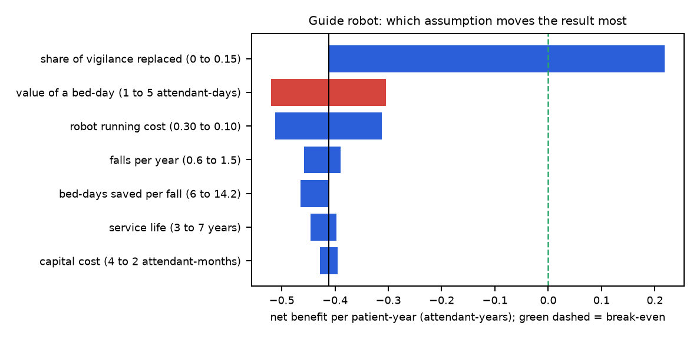
Figure 3. One-at-a-time swings of the guide robot's net value (attendant-years per patient-year).
System | P(net > 0), 0 to 15% vigilance replaced | P(net > 0), clinical value only | P(kappa <= 0.25) | Net value median [5th, 95th]
Baymax, guide robot | 0.22 | 0.00 | 0.05 | -0.23 [-0.82, 0.20]
Compact robot | 0.53 | 0.00 | 0.34 | 0.02 [-0.36, 0.37]
4 fixed cameras | 0.65 | 0.00 | 0.65 | 0.10 [-0.28, 0.44]
1 fixed camera | 0.76 | 0.00 | 0.83 | 0.17 [-0.21, 0.50]

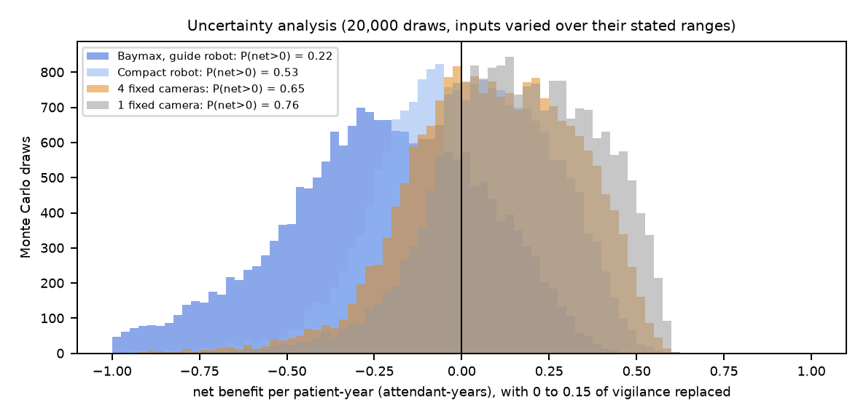
Figure 4. Monte Carlo net value, inputs drawn from their stated ranges; measured sensitivity and false-dispatch rate drawn from their Beta posteriors.
This Monte Carlo explores uncertainty in our assumptions; it is not experimental data and must not be read as a result. Ranges: falls 0.6 to 1.5 per year, bed-days saved 6 to 14.2, bed-day value 1 to 5, capital 2 to 4 attendant-months, life 3 to 7 years, running cost 0.10 to 0.30, alpha 0 to 0.15.

10. What must be true for a profitable, standards-compliant product
Condition | Today (guide robot, measured) | Needed
False-dispatch rate per look-alike event | 2.6% | at most 0.5% (kappa <= 0.25)
Share of vigilance replaced alpha | 0 (not measured) | at least 9.8%
Dispatch sensitivity | 0.65 | higher, but each extra point adds little clinical value (0.09 U at 0.65)
Capital cost | 3 attendant-months (upper bound, assumed) | 2.4 attendant-months or less to reach a one-quarter payback at kappa 0.20
Safety | Not safe: the falling person landed on the robot in 25 of 120 trials | Fixed before any deployment (follow farther back, approach from the side)

11. How this helps the industry today, and what it does not yet do
- Care homes and home-care agencies: a mobile sensor that covers every room with one device reduces blind spots that fixed cameras leave (our four-camera system saw almost nothing in the living area), and the economic lever is staff time, which is the scarce resource in eldercare.
- Hospitals and payers: if early dispatch really shortens stays, even a modest sensitivity matters; the sheet's 18.4 to 4.2 days is unsourced, so the size of this benefit is the biggest unknown to settle with real admissions data.
- Emergency services: an alert that arrives with location, posture, time and a blurred picture shortens the information gap; our simulated dispatch occurred within 100 s of the fall in every detected case, far inside the 6-minute window (which concerns cardiac arrest and is a teaching figure, AHA 2020).
- Robotics suppliers: the cost to serve is dominated by the false-alarm burden and by running cost, not by the hardware alone, so software quality (specificity) is a bigger profit lever than a cheaper chassis.
- Honest limit: these are simulation results with scripted motions, one apartment and an unsafe robot. They show where value could come from and what must be fixed; they do not prove a commercial product.

12. Risks (FMEA link) and next steps
- Top risk by priority: the falling person landing on the robot (S6 x O5 x D3 = 90, unmitigated); then missed falls (post 72) and localisation failures (post 60). The false-alarm and privacy risks are mitigated (post 12 and 6).
- Next steps: (1) cut false dispatches below 0.5% (stricter policy, map-based seat suppression) and re-test on a new seed; (2) measure alpha in a pilot by logging attendant hours; (3) replace assumptions A2, A3, A6, A11, A12 with sourced values; (4) re-run this model from the new telemetry (python analytics/csbs_business_analysis.py).

Reproducibility
Script: analytics/csbs_business_analysis.py. Inputs: results/guide_robot_test/metrics.json and results/small_robot_test/metrics.json (seeded simulation). Outputs: results/business_analysis/model.json and the four figures. Every assumption is listed in section 3 and in the script with its source status.

