* All requests will be POST.

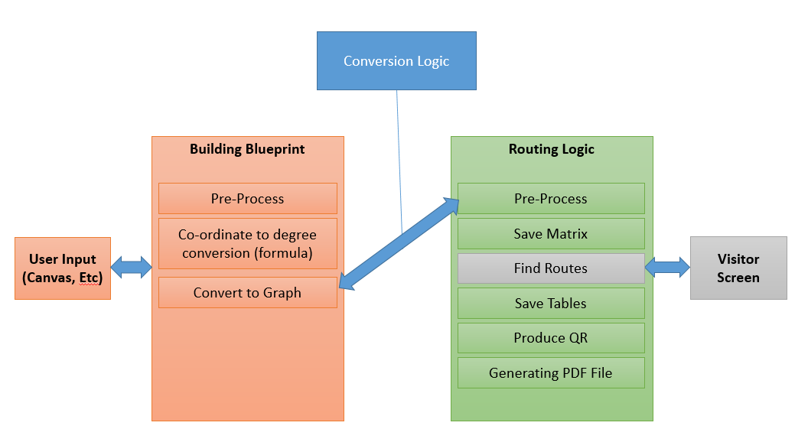

Algo:

[ [,,,,,] ]

[ [,,,,,] ]

[ [,,,,,] ]

1. Inputs: -

* Registration no.
* Name
* No. of floors
* File

1. Process: -

ALGO: -

1. Mark the decision points.
2. Fron: Destination points, via points, path points, QR points (Format: - id, x-coordinate, y-coordinate, type (Destination, via, QR, path))

nodeNumber:

{

adj_node1 :

{

xcoordinate:

ycoord:

type:

}

}

1. npm install graph.