Cheque dishonour in the Bombay High Court, 2021 to 2026
A content analysis of judgments under Section 138 of the Negotiable Instruments Act, 1881

Team
Member 1: Navya Sharma (Section – A)
Member 2: Devanshi Dibya (Section – A)
Member 3: Khushi Maravi (Section – A)
Member 4: Tanishka Maheshwari (Section – A)
Member 5: Aryan Khatkar (Section – A)

1. Topic
Section 138 of the Negotiable Instruments Act, 1881 makes it a crime when a cheque given to repay a debt bounces for want of funds, provided the payee follows a set of steps such as sending a legal notice in time. It is one of the most common criminal cases in the country, and almost everyone has either seen a bounced cheque or heard of one.
We looked at the Bombay High Court because its benches in Mumbai, Nagpur, Aurangabad and Goa hear these matters regularly. What interested us was not whether people win or lose, but the questions that keep coming back: who exactly can be prosecuted, and how early can a court make the accused pay something.

2. How we found the judgments
We searched Indian Kanoon and legal reporting sites (LiveLaw, Verdictum, SupremeToday, RawLaw) using phrases such as "Bombay High Court Section 138 NI Act", "Section 143A interim compensation" and "Section 141 director cheque". We kept only reasoned judgments of the Bombay High Court decided between 1 September 2021 and 31 August 2026.
Many results had to be dropped. Some were from the Supreme Court or other High Courts, some were older Bombay judgments (for example a 2019 case on time-barred debt and a 2015 case on directors), and some were orders without reasons. Ten judgments met every test, and those are the ones we coded. This is a sample found by searching, not a complete count of everything the court decided in these five years.

3. The ten judgments
The table below gives each judgment in one line. Fuller details for each, such as bench strength, provision and the earlier case the court leaned on, are in our data file (data.xlsx) in the repository.
# | Case and number | Decided | Outcome | What the court held (in one line)
1 | Ashwin Ashokrao Karokar v. Laxmikant Govind Joshi  Cr. WP 48/2022 with 71/2022 (Nagpur) | 07-07-2022 | Other; mixed | Section 143A (interim compensation) is a power the court may use, not a duty, and the court must give reasons for the amount it orders.
2 | Indermal Pannalal Jain & Ors. v. State of Maharashtra & Anr.  WP 2018/2017 | 22-11-2022 | Partly allowed; mixed | Complaint averments against company directors were enough and resigning later was no escape, but process against an independent non-executive director was quashed.
3 | Lyka Labs Ltd. & Anr. v. State of Maharashtra & Anr.  Cr. Appl. 886/2022 and connected matters | 08-03-2023 | Other; mixed | A person who only signs a company's cheque is not its "drawer", so cannot be ordered to pay interim compensation under s 143A; a deposit under s 148 is also not compulsory in his appeal.
4 | Prashant Chhaganrao Gadekar v. State of Maharashtra & Anr. (with Bhausaheb Dhavale)  Cr. Rev. Appl. 179/2022 and 247/2022 (Aurangabad) | 08-08-2023 | Partly allowed; mixed | Conviction stood because the accused did not rebut the s 139 presumption; jail term cut to time already served and compensation raised from Rs 7 lakh to Rs 10 lakh.
5 | Guljama Shah Jahir Shah v. Shri Sadguru Kaka Stone Crusher  Cr. WP 83/2023 (Nagpur) | 21-09-2023 | Allowed; accused won | A 20% interim compensation order made without any reasons cannot stand and must be reconsidered.
6 | Ranjana Sharma v. State of Maharashtra & Anr.  Cr. WP 275/2022 | 10-01-2024 | Allowed; accused won | Process against a director was quashed because the complaint did not set out her specific role in running the company (later set aside by the Supreme Court).
7 | Monica w/o Nirav Shah v. Dharampeth Mahila Multi State Co-op. Society Ltd.  Cr. WP 186/2024, 2024:BHC-NAG:5504 (Nagpur) | 06-05-2024 | Allowed; accused won | A joint account holder who did not sign the cheque is not the drawer and cannot be prosecuted under s 138.
8 | M/s Bajaj Constructions v. State of Maharashtra & Ors.  WP (St) 22150/2023 | 10-06-2024 | Allowed; accused won | If the accused shows a believable defence such as part payment, interim compensation can be refused; 20% is a ceiling, not a default.
9 | Navneet Singh Gogia & Anr. v. State of Maharashtra & Anr.  Cr. Rev. Appl. 70/2023 and 71/2023 | 21-01-2025 | Dismissed; accused lost | A magistrate can go on and convict without recording the accused's s 313 statement when the accused and their lawyer stay away without good reason; conviction and sentence confirmed.
10 | Manoj Abhimanyu Patil v. M/s Mansi Labour Suppliers  Cr. WP 1068/2024 (Aurangabad) | 05-02-2025 | Other; mixed | Section 143A is directory, and interim compensation can be ordered only after the accused pleads not guilty.

4. What the data shows

Chart 1: judgments per year
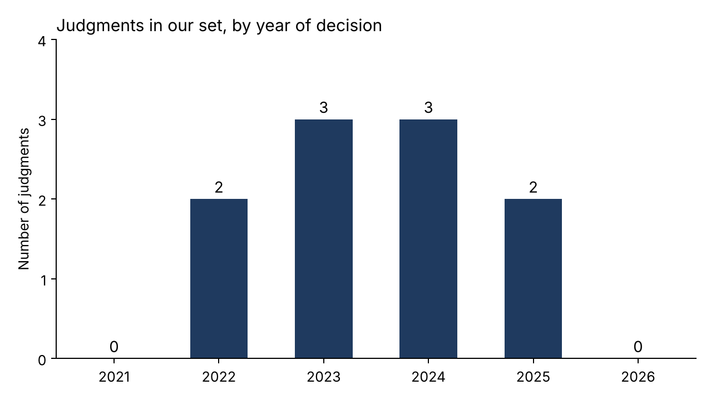
Figure 1. Judgments in our set, by year of decision
Most of our judgments come from 2023 and 2024, with three each, and there are two each in 2022 and 2025. What surprised us is that 2021 and 2026 have none. We do not think this means the court stopped hearing cheque cases. It more likely reflects how we searched, since the window starts only in September 2021 and recent judgments take time to appear on free databases.

Chart 2: how the cases ended
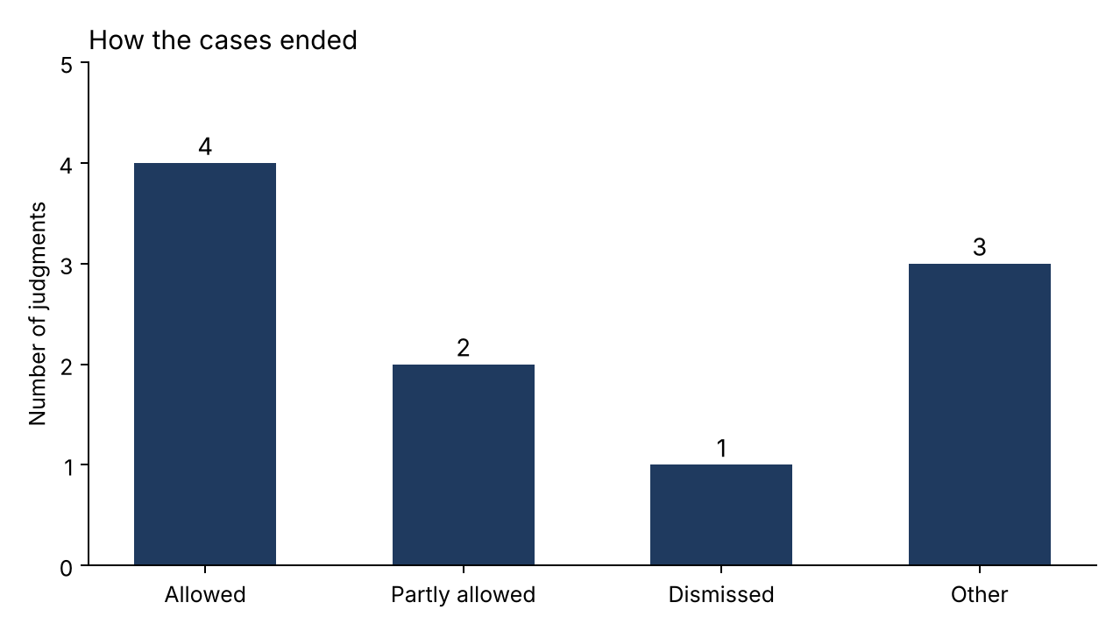
Figure 2. How the cases ended
Four of the ten were allowed, all in favour of the accused person, and two were partly allowed. Three are marked "other" because the court mainly answered a question of law rather than allowing or dismissing a plea. Only one was simply dismissed: in the Gogia case the directors' challenge failed and the conviction stood. That is still fewer than we expected, but it makes sense: the judgments that explain a point of law are mostly the ones where an accused person has gone to the High Court to challenge an order made earlier in the trial.

Chart 3: what the court was asked
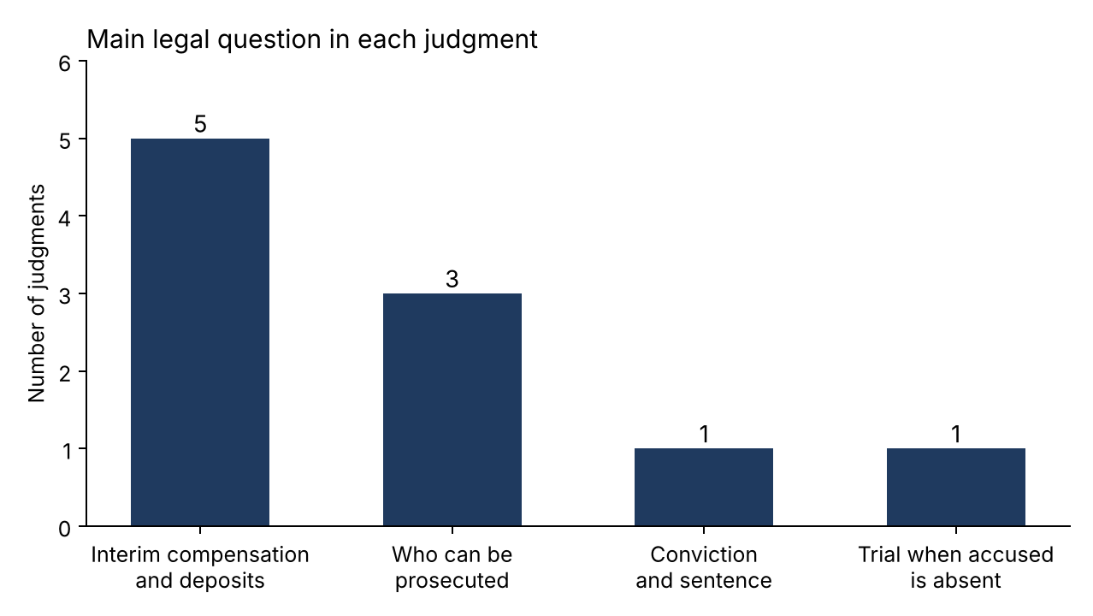
Figure 3. Main legal question in each judgment
Five of the ten are about interim compensation or deposits, the 20% payments that Sections 143A and 148 allow courts to ask for before a final decision. Three ask who can be prosecuted, one deals with conviction and sentence, and one asks whether a trial can go on when the accused stays away. The surprise was how much of the Bombay case law in this window is about the money steps rather than guilt itself.

How the law moved
Reading the judgments in date order gives a small story. In 2022 the court said that interim compensation is a power the court may use, and that it has to explain the amount (Karokar), and later that year it held that a director who resigns after the cheques were drawn is still liable, though an independent non-executive director can be let off (Indermal Pannalal Jain). In 2023 it narrowed who can be made to pay: a mere signatory of a company cheque is not the drawer (Lyka Labs), and a 20% order with no reasons was set aside (Guljama Shah). In 2024 it kept the same careful tone: a joint account holder who did not sign cannot be prosecuted (Monica), and interim compensation can be refused where the accused shows a believable defence (Bajaj Constructions). In January 2025 it let a magistrate convict an absent accused without recording the s 313 statement where the absence was unjustified (Gogia), and in February 2025 it repeated that Section 143A is directory and can be used only after the plea (Manoj Patil).
One judgment shows the limits of a High Court's word. In January 2024 the Bombay High Court quashed process against a director because the complaint did not describe her role in detail. On 22 May 2025 the Supreme Court set that decision aside in HDFC Bank Ltd. v. State of Maharashtra (2025 INSC 759), saying a complainant does not have to plead matters that are within the company's own knowledge.

5. Limits
Ten judgments cannot tell us how the Bombay High Court decides cheque cases in general. Most of ours deal with procedure, so they say little about how often accused persons are convicted at trial. All ten were decided by a single judge, which means a larger bench or the Supreme Court can change the position, as happened with the director case. Where an official copy was not available to us, we relied on the copy on Indian Kanoon or a legal publisher, so a reader should check the court's own copy before quoting any of them.

6. AI-use disclosure
We used Claude, an AI assistant made by Anthropic, to help search for judgments, to draft the one-line coding of each case and to put this report into plain English. We treated its output as a starting point only. Every case name, case number, date and holding was checked against the text of the judgment before it was kept, and nothing in the table was copied from a headnote or an AI summary.

