|  |
| --- |
| **S NO. TITLE PAGE NO.** |
| 1. COMPANY PROFILE 1 2. CERTIFICATE OF TRAINING 2 3. COMPANY SERVICES 3 4. TECHNOLOGY LEARNT 4-5 5. WORKING ONPYTHON 6-10 6. SCREENSHOTS 11-14 7. BENEFIT ABOUT TRAINING OF PYTHON 15 8. CONCLUSION 16 9. PROJECT OF FINAL YEAR 17 10. REFERENCE 18 |

**TABLE OF CONTENTS**

**REPORT SUBMISSION**

I, Shiv Kumar, hereby declare that the work which is being presented in this project/title entitled.

“face recognition using open cv” by me, in the partial fulfillment of requirement for the aaward of

Bachelor of Technology (B.Tech) Degree in “Computer Science and Engineering” .

TCS ion AKATVA has an authentic record of my own work carried out under the guidance.

To the best of my knowledge, the matter embodied in this report has not been submitted to any other university/institute for the award of any degree or diploma.

Date:

SHIV KUMAR

ROLL NO. : 1534110024

Mr. Gaurav kumar Srivastav

(Project Guide)

(Report submission, CSE DEPTT.)

**REPORT SUBMISSION**

I, Shiv Kumar, hereby declare that the work which is being presented in this project/title entitled.

“face recognition using open cv” by me, in the partial fulfillment of requirement for the aaward of

Bachelor of Technology (B.Tech) Degree in “Computer Science and Engineering” .

TCS ion AKATVA has an authentic record of my own work carried out under the guidance.

To the best of my knowledge, the matter embodied in this report has not been submitted to any other university/institute for the award of any degree or diploma.

Date:

SHIV KUMAR

ROLL NO. : 1534110024

Mr. Anuj Mishra

(HOD,CSE DEPTT.)

**COMPANY PROFILE**

**Akatva is a TCS iON Training Partner** focused on providing high-end and high quality trainings on cutting-edge technologies like Java, Python, Bigdata & Hadoop, MySQL, Microsof.NET, PHP, Android and many more to the students who come to us.

Our principals TCS iON with its vast experience and expertise in digital and other technologies areas on a global scale provide the pedagogy and curricula of all the courses that are run in our Training Centre. These trainings are delivered under the strict quality supervision of TCS iON by the “TCS iON Certified” faculty with the necessary technical infrastructure of par excellence for providing best trainings to the students.

The propellers of Akatva are educationists and academicians who nourish genuine desire in their hearts to uplift their students in every possible manner. They focus on employability of the students through quality trainings to make them stand on their feet in life. Aktva TCS iON is the outcome of this desire to provide best training in the IT and digital sphere. It is the best training hub existing today in Noida.

For helping its trained students, Akatva has a full-fledged Placement Division that takes care of all the training needs on the soft side of the candidates before they face interviews by the recruiters.

**COMPANY SERVICES**

Akatva TCS ION Training Partner has the following offerings:

* **Software Development training:** For both freshers as well as for those who seek advanced level training. The focus is to make the trainees employable on a variety of cutting edge technologies.

**Instructor led campus:** We are “Instructor-led campus” meaning hand holding of the students for optimum output.

**Workshops and Placement Service:** Akatva has central placement department that focuses on providing 100 Percent placement assistance to all students. It conducts tailor-made workshops that enhance knowledge, competency, efficiency and employment. TCS iON provides technology by means of a unique IT-as-a-Service model, offering end-to-end business solutions. It caters to the needs of multiple industry segments, through innovative, easy-to-use, secured, integrated, hosted solutions in a build-as-you-grow, pay-as-you-use business model. TCS iON serves its clients with the help of best practices gained through TCS' global experience, domestic market reach, skills, and delivery capabilities. TCS iON's Cloud Based Solution is highly modular, scalable and configurable giving businesses and educational institutions the benefits of increased efficiencies, faster go to market, predictability of technology as well as spend and better business results.

**TECHNOLOGY LEARNT**

The following Working Technologies would be Certified by TCSion Akatva NOIDA.:

|  |  |  |
| --- | --- | --- |
| **Name** | **Sign** | **Description** |

**MySQL**  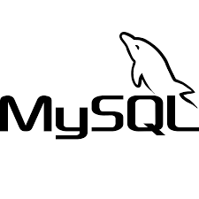 SQL stands for Structure

Query language.

.

**Python**  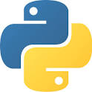 Python is an interpreted

high-level programming

for general-purpose

programming

**INTRODUCTION OF TECHNOLOGY LEARNT**

* **MySQL**

SQL stands for Structured Query Language. SQL lets you access and manipulate databases. SQL became a standard of the American National Standards Institute (ANSI) in 1986, and of the International Organization for Standardization (ISO) in 1987

* SQL can execute queries against a database
* SQL can retrieve data from a database
* SQL can insert records in a database
* SQL can update records in a database
* SQL can delete records from a database
* SQL can create new databases
* SQL can create new tables in a database
* SQL can create stored procedures in a database
* SQL can create views in a database
* SQL can set permissions on tables, procedures, and views
* **PYTHON**

**Python** is a general purpose, dynamic, high level and interpreted programming language. It supports Object Oriented programming approach to develop applications. It is simple and easy to learn and provides lots of high-level data structures.Python is easy to learn yet powerful and versatile scripting language which makes it attractive for Application Development.Python's syntax and dynamic typing with its interpreted nature, makes it an ideal language for scripting and rapid application development. Python supports multiple programming pattern, including object oriented, imperative and functional or procedural programming styles intended to work on special area such as web programming. That is why it is known as *multipurpose* because it can be used with web, enterprise, 3D CAD etc.

**WORKING ON PYTHON**

Python is known for its general purpose nature that makes it applicable in almost each domain of software development. Python as a whole can be used in any sphere of development.

Here, we are specifing applications areas where python can be applied.

#### Web Applications

We can use Python to develop web applications. It provides libraries to handle internet protocols such as HTML and XML, JSON, Email processing, request, beautiful Soup, Feed parser etc. It also provides Frameworks such as Django, Pyramid, Flask e.t.c to design and delelop web based applications. Some important developments are: Python Wiki Engines, Pocoo, Python Blog Software etc.

#### Desktop GUI Applications

Python provides Tk GUI library to develop user interface in python based application. Some other useful toolkits wxWidgets, Kivy, pyqt that are useable on several platforms. The Kivy is popular for writing multitouch applications.

#### Software Development

Python is helpful for software development process. It works as a support language and can be used for build control and management, testing etc.

#### Scientific and Numeric

Python is popular and widely used in scientific and numeric computing. Some useful library and package are SciPy, Pandas, IPython etc. SciPy is group of packages of engineering, science and mathematics.

**Business Applications**

Python is used to build Bussiness applications like ERP and e-commerce systems. Tryton is a high level application platform.

**Audio or Video based Applications**

Python is awesome to perform multiple tasks and can be used to develop multimedia applications. Some of real applications are: TimPlayer, cplay etc.

**How to set up the project in your server.**

**SETUP**

* 4 Steps:
* Install Python
* Install Pip
* Install VirtualEnv
* Install VirtualEnvWrapper-win

**Software requirement for python.**

* IDLE
* ANACONDA
* SPYDER

**NEED OF FRAMEWORK FOR PYHTON**

Python is an open-source object-oriented programming language. Python is one of the most popular programming languages in the world. It has a well-organized source code, and it is used for web applications and numerous other things.

Python is also easy to interface with frameworks. There are several frameworks that allow for easier customization and less coding. They help developers get the job done faster. With these frameworks, games, apps, educational programs, and other software can be built faster and better.

### 1. CherryPy

CherryPy is a minimalist Python web framework. It works on the most recent versions of Python, and it even runs perfectly on Android. It has been in use for almost ten years. CherryPy allows developers to run various HTTP servers at the same time and it allows for profiling. It also has a plugin system that is flexible. [Appoptics](https://blog.appoptics.com/application-performance-monitoring-apm/) **is one of the best way to check the application performance score.**

### 2. Flask

Flask is a framework that is highly suitable for developers that want to make a standalone app. Flask comes with the Jinja template engine by default, but developers can choose any template engine or ORM that is perfect for them. Flask is very useful for writing APIs, endpoints, or RESTful services. Flask is considered open-ended to unique systems. Developers can create backend systems any way they want, but it was designed for more open-ended applications.

### 3. Django

Django is the most popular Python framework. It is an open-source framework that makes things very fast and scalable. The framework is regularly updated to match the latest versions of Python. Django supports a lot of database engines and is used by popular websites like Instagram, Pinterest, The Washington Post and others. Popular comment internet application, Disqus was made using Django. Django is easy to pick up for beginners. The first release of Django was in 2006, and it has been expanding since then. Django can be used to build almost any kind of website from social networks to CMS to wikis to news sites. With Django, you can deliver content in JSON, RSS feeds XML, HTML, and almost any other format.

### 4. Pyramid

Pyramid is a Python framework that supports authentication and routing. It is great for developing large web applications, like CMSs, and it is useful for prototyping a concept and for developers working on API projects. Pyramid is flexible and can be used for both simple and complex projects.

### 5. TurboGears

TurboGears is an innovative Python framework. It is a single file app that can be run on Python and also scaled to a full stack solution. It has a flexible ORM with multi-database support. It can be used for all forms of simple and advanced projects. The documentation is simple and easy to use. With TurboGears, you can create a ready-to-extend application in mere minutes.

### 6. Pylons

Pylons is a framework that makes the tracking of errors easy thanks to its online debugger. It is an open source framework supported by a lot of talented and experienced developers.

### 7. Web2py

Web2py is one of the most portable, flexible, and easy to use Python frameworks available. It doesn’t require any installation or configuration and it uses LDAP for its authentication system. Web2py can be run off a simple USB flash drive. It supports various database engines, and it has a built-in ticketing system to help it manage errors. Web2py doesn't support older versions of Python.

**SCREENSHOT OF PYTHON MODULE**

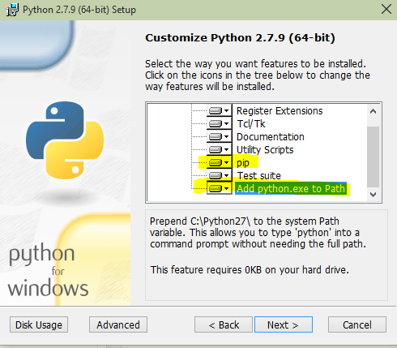

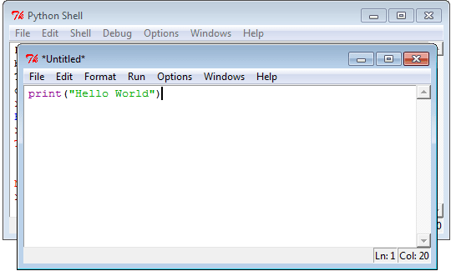

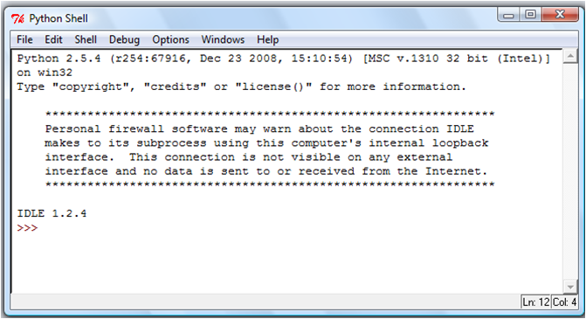

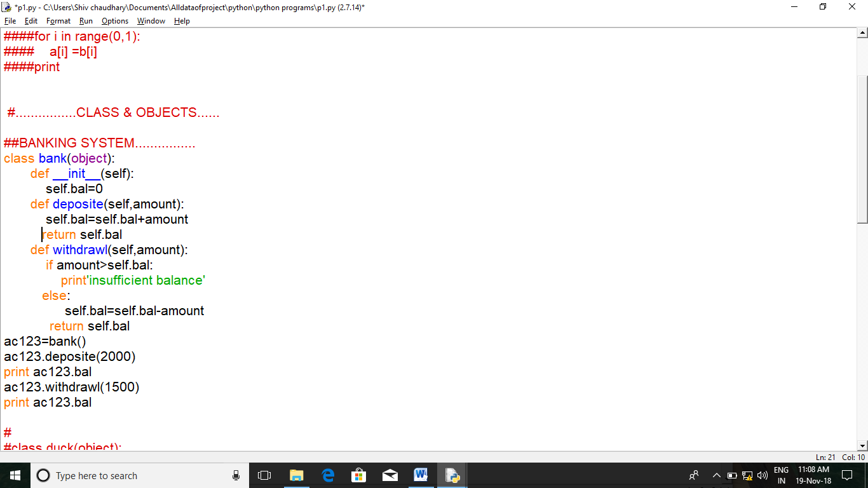

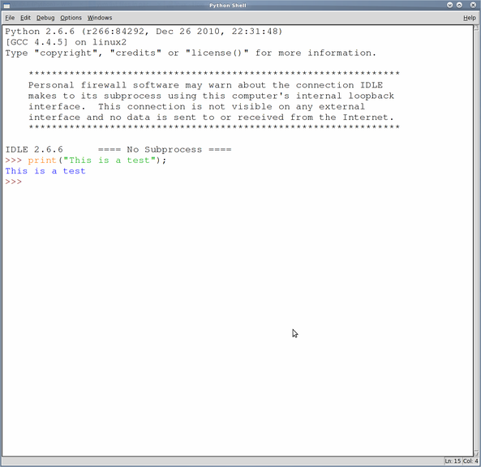



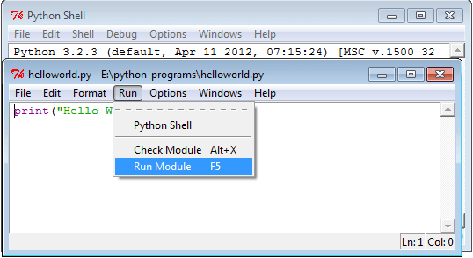

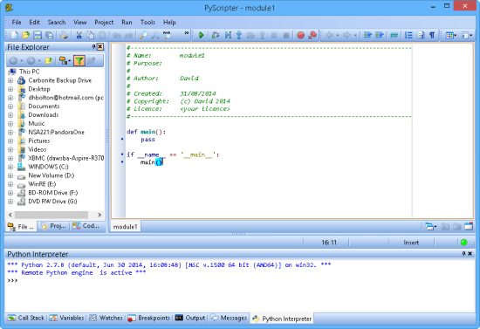

**CONCLUSION**

The industrial training that I want through within the few days brought in new technology and expanded my knowledge in the IT industry.

I got the opportunity to put known concepts into practice in real project and to learn new concepts through applying them.

Meeting with deadlines, keeping the code quality, trying various approaches to determine the best method and finally completing the industrial training with success were experience that gained throughout the training period.

I know best. Also even if you think your good in something there is always something new that you haven’t learnt.

PYHTON developer think about your future in python development. PYTHON is great tool for general purpose programming. It is user friendly one can easily understand the programming techniques.

**MAJOR PROJECT OF FINAL YEAR**

The industrial training completed in “PYTHON”. And after it the final project motivate in “face recognition system”. Because the user have less time to achieve their goals. It is designed to reduce or ignore the physical and mental pressure.

Our project will be provide the better way to deal with the crimes, both handling and controlling them.

A real time face recognition system is capable of identifying or verifying a person from a video frame. To recognize the face in a frame, first you need to detect whether the face is present in the frame. If it is present, mark it as a region of interest (ROI), extract the ROI and process it for facial recognition.

Our project include the storing of every member into the database. This project will provide the easy manner of detection of person. And this project has the facility to give a unique id for every member and storing the details in the database.

We are including the new facility in this project such as a member can have a unique name or identification.

This project help in controlling the crime.

**REFERENCES**

**[1]** [**www.google.com**](http://www.google.com)

**[2]** [**www.python.org**](http://www.python.org)

**[3]** [**www.w3school.com**](http://www.w3school.com)

**[4]** [**www.wikipedia.com**](http://www.wikipedia.com)

**[5] The complete reference python.org**