Database Management System
==============================
DBMS stands for Database Management System. We can break it like this DBMS = Database + Management System. Database is a collection of data and Management System is a set of programs to store and retrieve those data. Based on this we can define DBMS like this: DBMS is a collection of inter-related data and set of programs to store & access those data in an easy and effective manner.
What is the need of DBMS?
Database systems are basically developed for large amount of data. When dealing with huge amount of data, there are two things that require optimization: Storage of data and retrieval of data.
Storage: According to the principles of database systems, the data is stored in such a way that it acquires lot less space as the redundant data (duplicate data) has been removed before storage. Let’s take a layman example to understand this:
In a banking system, suppose a customer is having two accounts, one is saving account and another is salary account. Let’s say bank stores saving account data at one place (these places are called tables we will learn them later) and salary account data at another place, in that case if the customer information such as customer name, address etc. are stored at both places then this is just a wastage of storage (redundancy/ duplication of data), to organize the data in a better way the information should be stored at one place and both the accounts should be linked to that information somehow. The same thing we achieve in DBMS.
Fast Retrieval of data: Along with storing the data in an optimized and systematic manner, it is also important that we retrieve the data quickly when needed. Database systems ensure that the data is retrieved as quickly as possible.

Purpose of Database Systems
The main purpose of database systems is to manage the data. Consider a university that keeps the data of students, teachers, courses, books etc. To manage this data we need to store this data somewhere where we can add new data, delete unused data, update outdated data, retrieve data, to perform these operations on data we need a Database management system that allows us to store the data in such a way so that all these operations can be performed on the data efficiently.

Database Applications – DBMS
Applications where we use Database Management Systems are:
- Telecom: There is a database to keeps track of the information regarding calls made, network usage, customer details etc. Without the database systems it is hard to maintain that huge amount of data that keeps updating every millisecond.
- Industry: Where it is a manufacturing unit, warehouse or distribution centre, each one needs a database to keep the records of ins and outs. For example distribution centre should keep a track of the product units that supplied into the centre as well as the products that got delivered out from the distribution centre on each day; this is where DBMS comes into picture.
- Banking System: For storing customer info, tracking day to day credit and debit transactions, generating bank statements etc. All this work has been done with the help of Database management systems.
- Sales: To store customer information, production information and invoice details.
- Airlines: To travel though airlines, we make early reservations, this reservation information along with flight schedule is stored in database.
- Education sector: Database systems are frequently used in schools and colleges to store and retrieve the data regarding student details, staff details, course details, exam details, payroll data, attendance details, fees details etc. There is a hell lot amount of inter-related data that needs to be stored and retrieved in an efficient manner.
- Online shopping: You must be aware of the online shopping websites such as Amazon, Flipkart etc. These sites store the product information, your addresses and preferences, credit details and provide you the relevant list of products based on your query. All this involves a Database management system.

Advantages of DBMS over file system

Drawbacks of File system
- Data redundancy: Data redundancy refers to the duplication of data, lets say we are managing the data of a college where a student is enrolled for two courses, the same student details in such case will be stored twice, which will take more storage than needed. Data redundancy often leads to higher storage costs and poor access time.
- Data inconsistency: Data redundancy leads to data inconsistency, lets take the same example that we have taken above, a student is enrolled for two courses and we have student address stored twice, now lets say student requests to change his address, if the address is changed at one place and not on all the records then this can lead to data inconsistency.
- Data Isolation: Because data are scattered in various files, and files may be in different formats, writing new application programs to retrieve the appropriate data is difficult.
- Dependency on application programs: Changing files would lead to change in application programs.
- Atomicity issues: Atomicity of a transaction refers to “All or nothing”, which means either all the operations in a transaction executes or none.
For example: Lets say Steve transfers 100$ to Negan’s account. This transaction consists multiple operations such as debit 100$ from Steve’s account, credit 100$ to Negan’s account. Like any other device, a computer system can fail lets say it fails after first operation then in that case Steve’s account would have been debited by 100$ but the amount was not credited to Negan’s account, in such case the rollback of operation should occur to maintain the atomicity of transaction. It is difficult to achieve atomicity in file processing systems.
- Data Security: Data should be secured from unauthorised access, for example a student in a college should not be able to see the payroll details of the teachers, such kind of security constraints are difficult to apply in file processing systems.

Advantage of DBMS over file system
There are several advantages of Database management system over file system. Few of them are as follows:
- No redundant data: Redundancy removed by data normalization. No data duplication saves storage and improves access time.
- Data Consistency and Integrity: As we discussed earlier the root cause of data inconsistency is data redundancy, since data normalization takes care of the data redundancy, data inconsistency also been taken care of as part of it
- Data Security: It is easier to apply access constraints in database systems so that only authorized user is able to access the data. Each user has a different set of access thus data is secured from the issues such as identity theft, data leaks and misuse of data.
- Privacy: Limited access means privacy of data.
- Easy access to data – Database systems manages data in such a way so that the data is easily accessible with fast response times.
- Easy recovery: Since database systems keeps the backup of data, it is easier to do a full recovery of data in case of a failure.
- Flexible: Database systems are more flexible than file processing systems.
Disadvantages of DBMS:
- DBMS implementation cost is high compared to the file system
- Complexity: Database systems are complex to understand
- Performance: Database systems are generic, making them suitable for various applications. However this feature affect their performance for some applications

DBMS Architecture
The architecture of DBMS depends on the computer system on which it runs. For example, in a client-server DBMS architecture, the database systems at server machine can run several requests made by client machine. We will understand this communication with the help of diagrams.

Types of DBMS Architecture
There are three types of DBMS architecture:
1. Single tier architecture
2. Two tier architecture
3. Three tier architecture

1. Single tier architecture
In this type of architecture, the database is readily available on the client machine, any request made by client doesn’t require a network connection to perform the action on the database.
For example, lets say you want to fetch the records of employee from the database and the database is available on your computer system, so the request to fetch employee details will be done by your computer and the records will be fetched from the database by your computer as well. This type of system is generally referred as local database system.

2. Two tier architecture
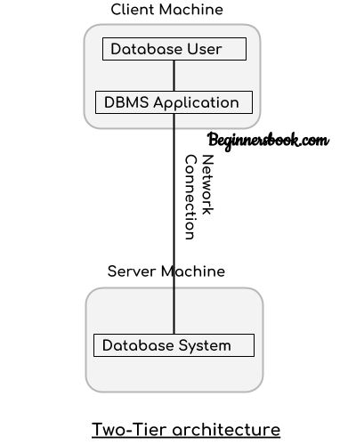
In two-tier architecture, the Database system is present at the server machine and the DBMS application is present at the client machine, these two machines are connected with each other through a reliable network as shown in the above diagram.
Whenever client machine makes a request to access the database present at server using a query language like sql, the server perform the request on the database and returns the result back to the client. The application connection interface such as JDBC, ODBC are used for the interaction between server and client.

3. Three tier architecture
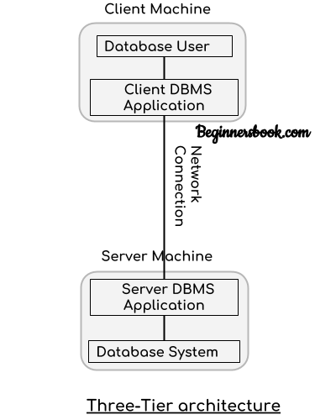
In three-tier architecture, another layer is present between the client machine and server machine. In this architecture, the client application doesn’t communicate directly with the database systems present at the server machine, rather the client application communicates with server application and the server application internally communicates with the database system present at the server.

DBMS – Three Level Architecture
we will discuss the three level DBMS architecture in detail.

DBMS Three Level Architecture Diagram
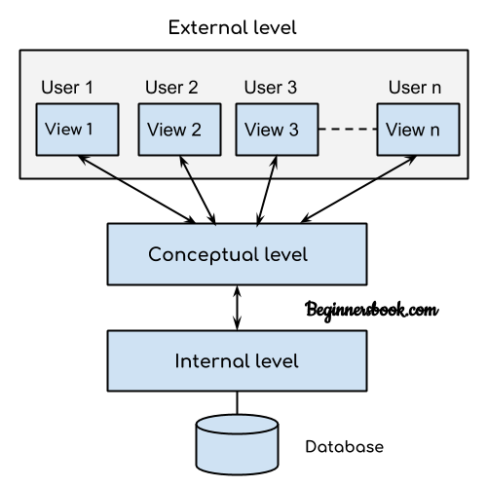
This architecture has three levels:
1. External level
2. Conceptual level
3. Internal level

1. External level
It is also called view level. The reason this level is called “view” is because several users can view their desired data from this level which is internally fetched from database with the help of conceptual and internal level mapping.
The user doesn’t need to know the database schema details such as data structure, table definition etc. user is only concerned about data which is what returned back to the view level after it has been fetched from database (present at the internal level).
External level is the “top level” of the Three Level DBMS Architecture.

2. Conceptual level
It is also called logical level. The whole design of the database such as relationship among data, schema of data etc. are described in this level.
Database constraints and security are also implemented in this level of architecture. This level is maintained by DBA (database administrator).

3. Internal level
This level is also known as physical level. This level describes how the data is actually stored in the storage devices. This level is also responsible for allocating space to the data. This is the lowest level of the architecture.

