Rapido Home Screen – Pickup and Drop Location Entry
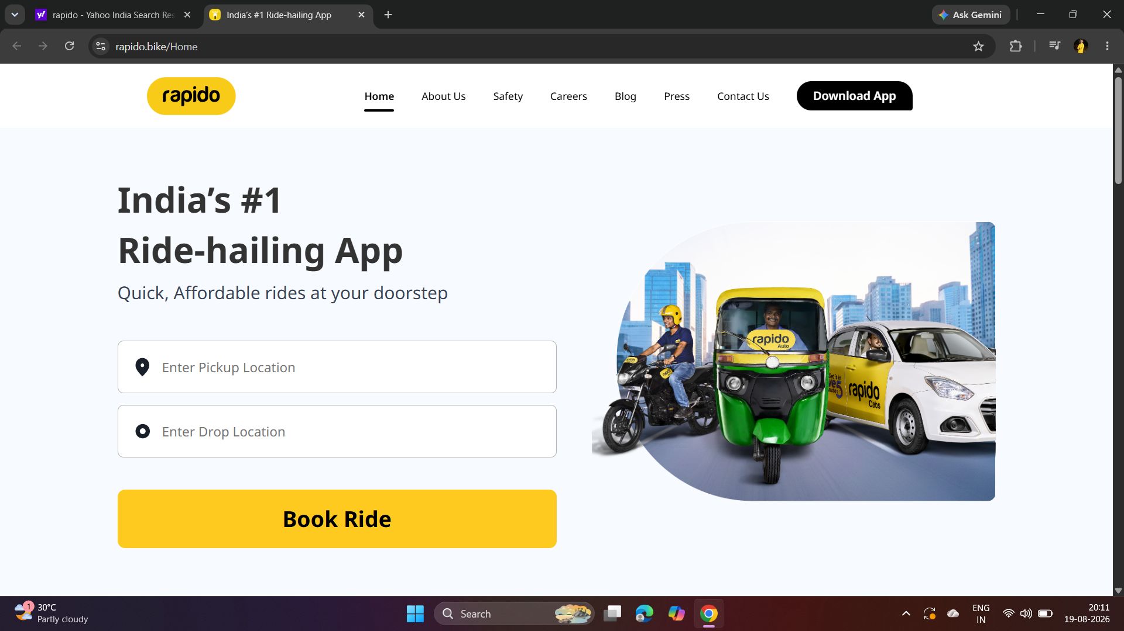

Selected Pickup and Drop Locations with Booking Option
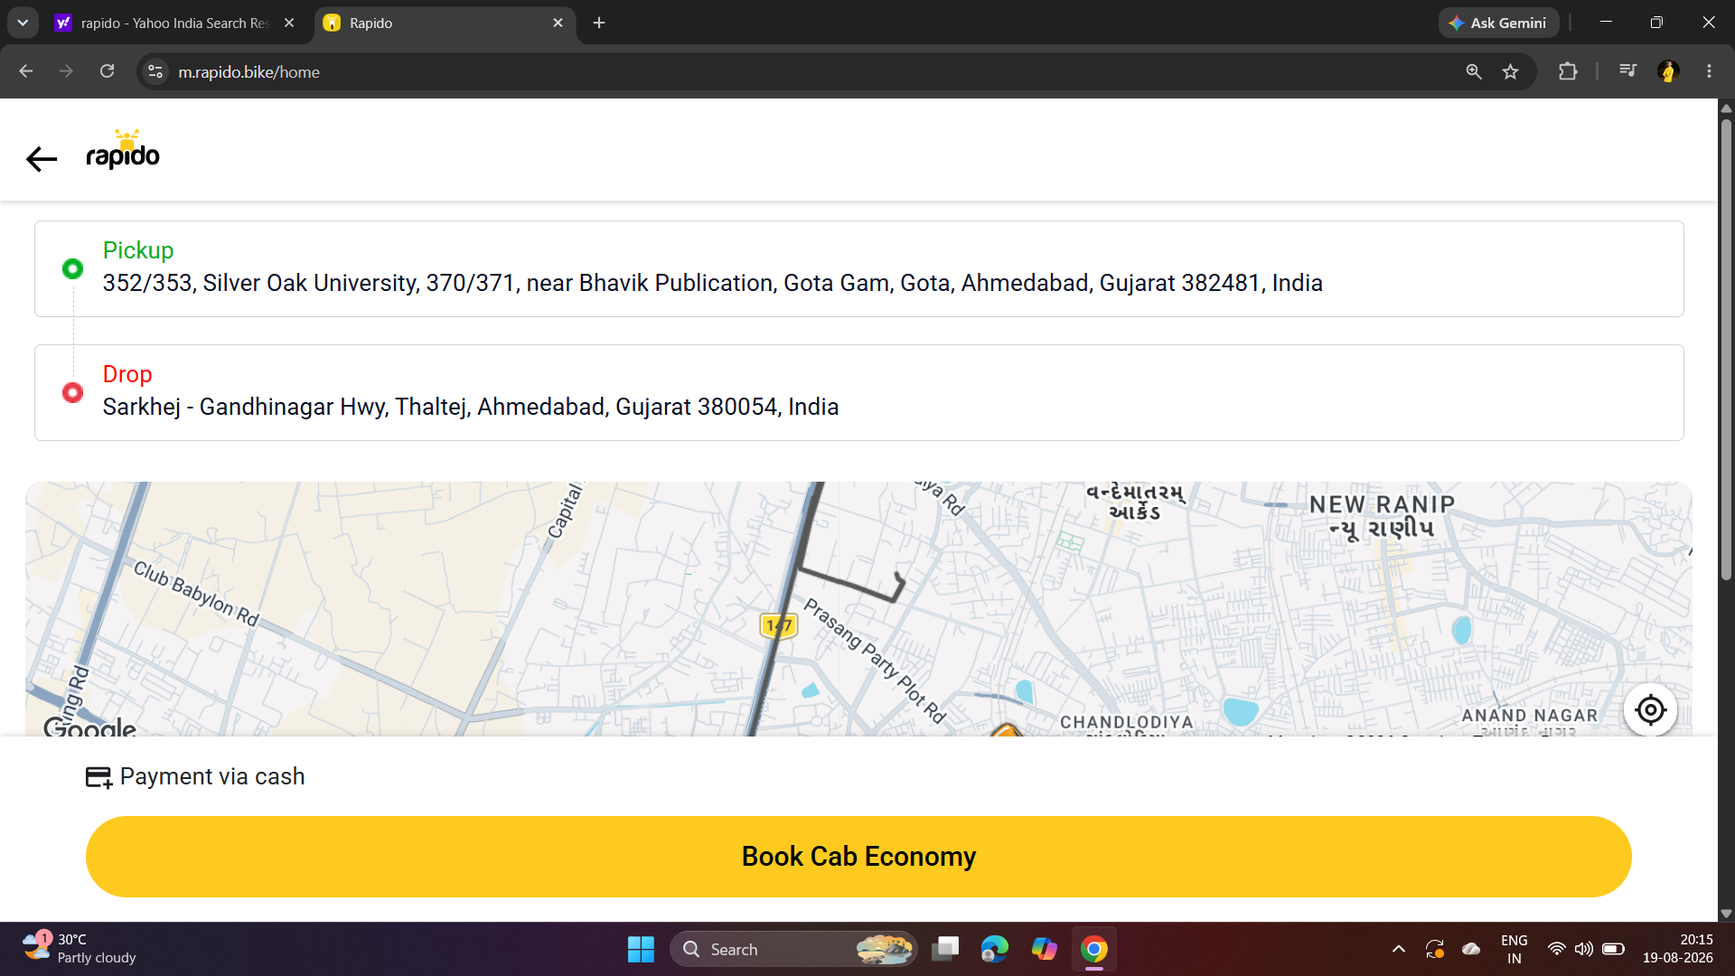

Available Ride Options and Fare Estimates
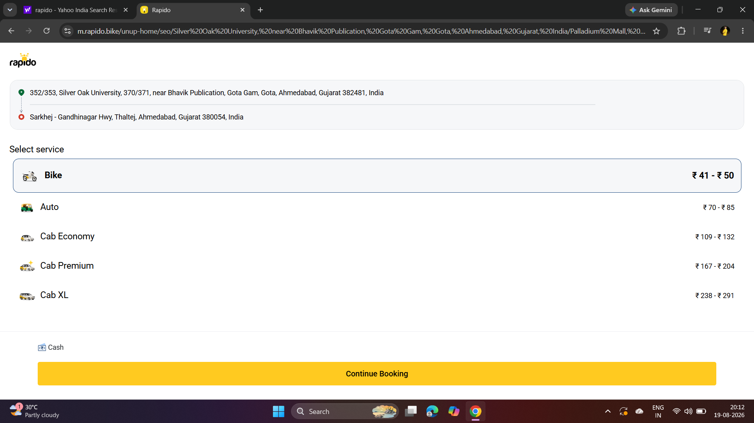

Estimated Fare Display for Available Rides
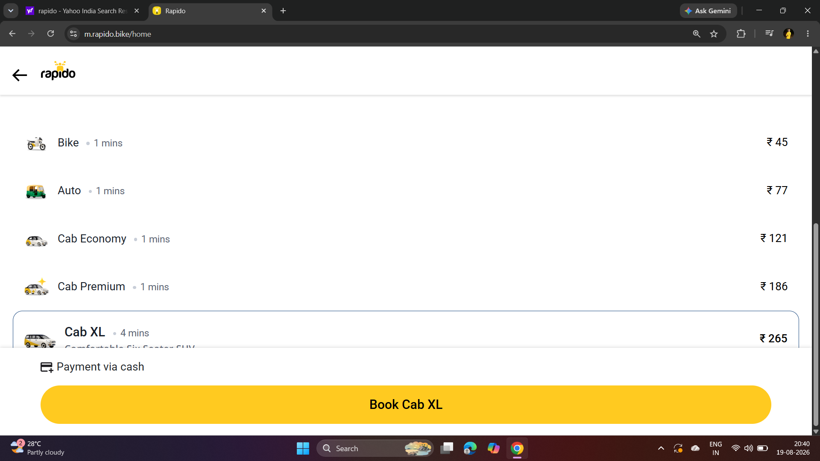

Cab Economy Ride Booking in Progress
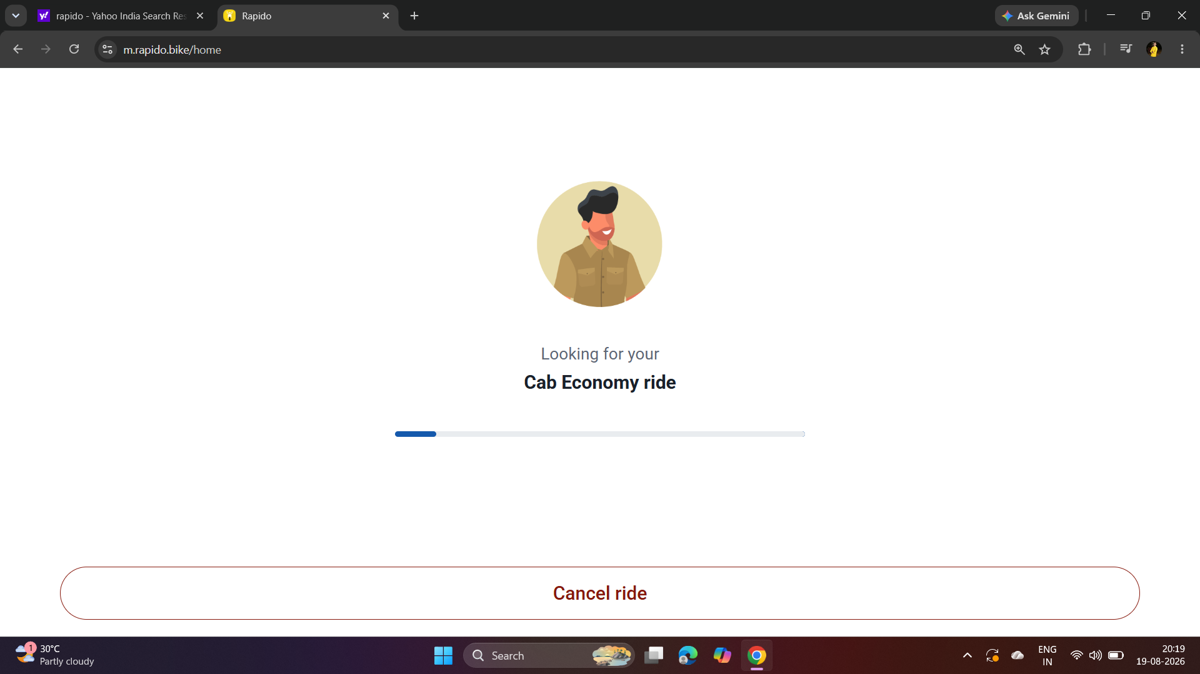

Captain Assigned with Vehicle Details 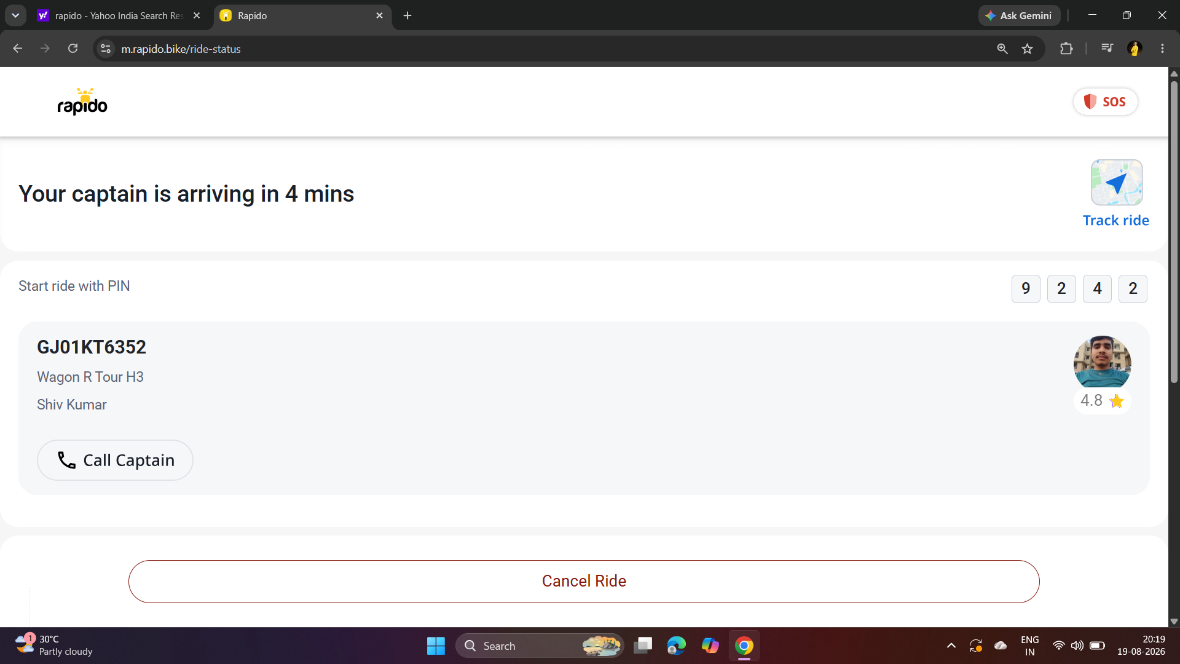

Cancelled Ride Status in My Rides 