Service-Life Prediction of Solid Rocket Propellants
Aging, Cumulative-Damage and Accelerated-Testing Models with a MATLAB Arrhenius Implementation
Technical Report
Structural Integrity & Service-Life Assessment of Energetic Materials
Prepared by: ______________________
Organisation: GTAG
Date: ______________________

Abstract
Solid rocket propellants are visco-elastic, highly filled polymeric composites whose mechanical integrity slowly degrades during storage through coupled chemical and physical aging. Predicting the remaining service life of a propellant grain is therefore central to munition safety, readiness and life-extension decisions. This report reviews the principal models used for solid-propellant aging and service-life prediction — cumulative-damage failure integrals, time–temperature superposition, viscoelastic finite-element analysis, chemical-aging kinetics, handbook/nomograph design methods and non-destructive-testing indicators — and consolidates the governing equations behind them. A practical accelerated-aging model is then implemented in MATLAB: an Arrhenius temperature-acceleration law coupled with a power-law property-degradation rule is used to estimate the time for a normalised mechanical property to fall to a failure threshold over a range of storage temperatures. The model predicts a strong, non-linear reduction in service life with temperature — from roughly 21 years at 25 °C to under 4 months at 70 °C — consistent with the shelf-life ranges reported in the literature. A second, more complete data-driven pipeline is also presented: it reads accelerated-ageing tensile tests, extracts mechanical properties, trains a cross-validated machine-learning surrogate, fits global first-order Arrhenius kinetics and predicts service life (recovering an activation energy of about 83 kJ/mol and a service life of roughly 30 years for the demonstration dataset). Both codes, their governing formulae and reproducible results are presented together with a practical decision tree for service-life assessment.

1. Introduction
Composite solid propellants are the energy source of the majority of tactical and strategic rocket motors. Mechanically they behave as a highly filled visco-elastic rubber: an elastomeric binder (most commonly hydroxyl-terminated polybutadiene, HTPB) holds a high volume fraction of oxidiser (ammonium perchlorate, AP) and metallic fuel (aluminium) particles. The grain is bonded to the motor case and must survive ignition pressurisation, thermal cycling, transport vibration and long-term storage without cracking, debonding or losing its designed burning surface.
Because a motor may be stored for one to two decades before use, the slow evolution of the propellant’s properties — a process collectively called “aging” — governs its useful life. Aging is driven by two broad mechanisms acting together:
- Chemical aging — continued cross-linking, chain scission and oxidative cure of the binder, together with migration of plasticiser and bonding agents, which usually stiffen and embrittle the material; and
- Physical / mechanical aging — the accumulation of micro-damage (dewetting of filler particles, micro-void growth, interface debonding) under thermal and mechanical loading, which softens and weakens the material.
Both mechanisms are strongly temperature-accelerated, so elevated-temperature testing is used to compress decades of natural aging into a few weeks or months in the laboratory. The central engineering question is then how to translate those accelerated measurements into a defensible estimate of service life at the real storage temperature. This report surveys the models that answer that question and demonstrates a compact, reproducible implementation of the most widely used one — the Arrhenius acceleration model.

1.1 Composition and microstructure
A composite solid propellant is engineered at the level of its microstructure, and its long-term behaviour cannot be understood without appreciating that structure. A representative AP/HTPB formulation contains roughly 85–90 % by mass of solid fillers held together by only 10–15 % of polymeric binder. The constituents play distinct roles:
- Binder — a cross-linked elastomer (typically HTPB cured with a di- or tri-isocyanate) that provides the continuous, load-bearing, rubber-like matrix and gives the grain its compliance and strain capability.
- Oxidiser — ammonium perchlorate (AP), usually as a bimodal blend of coarse and fine particles to maximise solids loading; it supplies the oxygen for combustion and dominates the volume fraction.
- Metallic fuel — aluminium powder, which raises the flame temperature and specific impulse and suppresses combustion instability.
- Additives — bonding agents that strengthen the binder–filler interface, plasticisers that lower the glass-transition temperature and improve low-temperature strain capability, cure catalysts, antioxidants and burn-rate modifiers.
Mechanically, the cured grain is a particulate composite: stiff inclusions in a soft matrix bonded across an interface. Most aging phenomena, and most failures, originate at that binder–filler interface or in the binder network itself, which is why both the chemistry of the binder and the integrity of the interface feature so prominently in the models that follow.

1.2 Structural failure modes
“Failure” of a propellant grain is not a single event but a set of distinct mechanical limit states, any of which can render the motor unsafe or unreliable:
- Cracking — surface or bore cracking under thermal-shrinkage and pressurisation strains, which exposes additional burning area and can raise chamber pressure beyond design limits.
- Debonding — separation of the grain from the case/insulation (case-bond failure), which creates an uncontrolled burning surface and is a leading cause of catastrophic motor failure.
- Dewetting — microscopic separation of binder from filler particles (“dewetting”) that nucleates voids, reduces modulus and strength, and is an early precursor to macroscopic cracking.
- Embrittlement — loss of strain capability as the binder embrittles with age, so that strains that were once tolerable now exceed the rupture limit, especially at low temperature.
Because these limit states are governed by mechanical properties (modulus, strength, strain-to-failure, bond strength) that all drift with age, tracking the degradation of a representative property over time is a rational basis for service-life prediction — exactly the approach taken by the model implemented here.

1.3 Aging mechanisms in detail
The two aging families introduced above act through several concrete physico-chemical processes. On the chemical side, the isocyanate-cured HTPB network continues to react long after manufacture: post-cure cross-linking and oxidative cross-linking progressively tighten the network, raising modulus and hardness while lowering strain capability; competing chain scission and hydrolysis break the network and soften it; and plasticiser and bonding-agent migration changes the local stiffness near interfaces. Layton’s observation [4] that mechanical properties drift roughly with the logarithm of aging time is a direct signature of these diffusion- and reaction-limited processes.
On the physical side, repeated thermal cycling and sustained storage loads accumulate irreversible micro-damage — dewetting, micro-void growth and interface debonding — that softens the material and reduces its strength. The two families compete: a propellant may first stiffen (chemical hardening dominant) and later soften (damage and scission dominant), producing the non-monotonic property–time curves that Adel and Liang [10] model explicitly. Crucially, the rates of nearly all of these processes rise approximately exponentially with temperature, which is the physical justification for the Arrhenius treatment in Section 4.1.

1.4 Why service-life prediction matters
Service-life prediction is the technical backbone of stockpile surveillance and service-life-extension programmes (SLEP). A defensible remaining-life estimate determines when a motor must be inspected, re-qualified, refurbished or disposed of, and it directly trades off safety against the very high cost of prematurely scrapping serviceable munitions. Under-prediction wastes assets and readiness; over-prediction risks a catastrophic failure in storage, transport or flight. The models reviewed here exist to make that estimate as quantitative, repeatable and physically grounded as the available data allow.

2. Problem Statement
Service-life prediction of a solid propellant must answer a deceptively simple question: for how long will the grain remain structurally sound at its storage temperature before a critical mechanical property falls below an acceptable limit? Answering it is difficult for several reasons:
- Time-scale mismatch — Natural aging is far slower than any test programme can wait for, so results must be extrapolated from accelerated (elevated-temperature) tests using a temperature-acceleration model whose activation energy must itself be estimated.
- Rate and temperature dependence — The binder is visco-elastic, so its response depends on rate, temperature and load history; a single static property is not enough to describe failure.
- Competing mechanisms — Competing hardening (cross-linking) and softening (chain scission, damage) pathways can dominate at different times and temperatures, so the property–time curve is not always monotonic.
- Parameter uncertainty — Parameters are extracted by regression from scattered experimental data; biased fitting can give over-optimistic life estimates.
The specific problem addressed by the implementation in this report is: given an activation energy, a measured property at a known accelerated test condition, a power-law degradation exponent and a failure threshold, estimate the equivalent service life (in years) at the storage temperature, and characterise how that life varies across a realistic range of storage temperatures.

2.1 Formal statement
Let P(t, T) be a normalised mechanical property (for example secant modulus, tensile strength or strain-to-failure divided by its initial value) that evolves with aging time t at absolute temperature T. Let P_crit be the smallest acceptable value of that property before a limit state of Section 1.2 is reached. The service life t_L at the storage temperature T_s is defined implicitly by
P(t_L, T_s) = P_crit (I)
Because tests are run at one or more elevated temperatures T_test > T_s, the property is actually measured as P(t_test, T_test), and a temperature-acceleration model is required to map that accelerated observation back to the slow process at T_s. Service-life prediction is therefore a coupled problem: a degradation law that describes how P decays with time, plus an acceleration law that describes how that decay speeds up with temperature. The implementation in this report adopts a power-law degradation rule (Section 4.2) and an Arrhenius acceleration law (Section 4.1).

2.2 Choice of failure criterion
The criterion P_crit must be chosen to reflect the dominant limit state. Common choices include a maximum allowable loss of strain capability (to guard against cracking under thermal/pressurisation strain), a minimum allowable bond strength (to guard against case debonding), or a maximum allowable modulus increase (to guard against embrittlement). In the present model a single normalised property with a threshold of P_crit = 0.3 (i.e. failure when the property has fallen to 30 % of its initial value) is used as a transparent, generic surrogate; the framework is unchanged if a different property or threshold is substituted.

3. Literature Review
A broad body of work on solid-propellant aging and service-life prediction was surveyed for this study. It can be grouped into six complementary families of models, each of which contributes a piece of the overall service-life picture. The discussion below is organised around these families and cites a representative selection of the works studied; the numbered references are illustrative of each family rather than an exhaustive list of the literature consulted.

3.1 Cumulative-damage failure models
Cumulative-damage approaches treat failure not as a single overload event but as the gradual accumulation of a scalar damage measure D until it reaches a critical value (conventionally D = 1). They are attractive for propellants because the grain experiences a long, variable history of thermal and mechanical loads, no single one of which would cause failure on its own.
Biggs, Nestor et al. [1] (US 6,301,970) patent a stress-based failure integral for filled polymeric materials. Their method accumulates damage as a time integral of a stress- (or strain-) dependent rate, extracts the rate-law parameters by regression against laboratory data, integrates the damage numerically over the predicted load history, and — importantly — wraps the whole calculation in a Monte-Carlo loop so that scatter in the material parameters and loads propagates into a probability of failure rather than a single deterministic number. This probabilistic framing is what distinguishes the method from a simple safety-factor check.
Kunz [8] addresses the weakest link in any such model — the parameters. Working with Laheru-type linear cumulative-damage (LCD) models, he refines how the damage-law constants are determined from test data and demonstrates that ordinary regression can be biased, systematically over- or under-estimating life if the fitting variables and weighting are chosen carelessly. His caution is directly relevant here: the power-law exponent n used in this report’s model is exactly the kind of regression-fitted parameter to which the predicted life is highly sensitive (see Section 6.3).

3.2 Time–temperature superposition and viscoelastic characterisation
Because the binder is visco-elastic, its stiffness and strength depend not only on temperature but on the rate and duration of loading. The most powerful organising idea for such materials is time–temperature superposition (TTS): the observation that the effect of raising temperature is, to first order, equivalent to extending the time of observation. Data taken over an experimentally accessible time window at many temperatures can therefore be shifted horizontally on a logarithmic time axis to build a single “master curve” spanning many decades of effective time.
Villar and Rezende [2] apply exactly this principle to thermally aged composite propellant. Using Williams–Landel–Ferry (WLF) shift factors they collapse tensile data measured at several temperatures onto one master curve, and they show that aging shifts this curve only modestly at short times but significantly at long storage times — precisely the regime that service-life prediction cares about. Their work both validates the use of accelerated testing and quantifies how the master curve itself migrates as the material ages.
Tapia-Romero, Dehonor-Gómez and Lugo-Uribe [9] supply the missing constitutive ingredient. They give a practical, numerically robust route for converting frequency-domain dynamic-mechanical-analysis (DMA) data (storage and loss modulus versus frequency) into a time-domain Prony series for the relaxation modulus. That Prony series (Eq. 6) is the exact form of material input required by the finite-element structural analyses discussed next, closing the loop from raw laboratory data to a usable constitutive model.

3.3 Structural / finite-element assessment
Material-level property curves only become a service-life statement when they are combined with the actual stresses and strains in the grain. Yıldırım and Özüpek [3] perform a non-linear visco-elastic finite-element (FE) structural assessment of a solid-propellant rocket motor for this purpose. They model the grain with a time- and temperature-dependent constitutive law (of the Prony/WLF type above) and subject it to the realistic combined load cases the motor experiences — cure-shrinkage and thermal cool-down, low- and high-temperature soak, and ignition pressurisation.
Their analysis identifies the inner-bore hoop strain and the case-bond (grain-to-case interface) stress as the two governing failure indicators, and it quantifies how aging and accumulated damage progressively erode the margin between the applied strain/stress and the material’s (shrinking) capability. This is the bridge between the property-level models of this report and a true structural verdict: the degradation law predicts how capability falls, while the FE model predicts the demand it must withstand.

3.4 Chemical / kinetic aging studies
Layton [4] reports chemical structural aging studies on an HTPB propellant that explain why the macroscopic properties drift the way they do. By tracking gel content (a measure of network cross-link density) and correlating it with mechanical-property change, he shows that the drift scales approximately with the logarithm of aging time — the signature of diffusion- and reaction-limited network evolution — and that the chemistry of the bonding agent strongly influences both the rate and the direction (hardening vs. softening) of the change.
These kinetic findings matter for the present model in two ways. First, they justify treating the aging rate with an Arrhenius temperature dependence, because the underlying reactions are thermally activated. Second, the logarithmic-in-time behaviour they observe is consistent with the power-law/log-type degradation form adopted in Section 4.2, giving the chosen functional form a physical, not merely empirical, basis.

3.5 Handbook and nomograph design methods
Before routine finite-element analysis was affordable, the field relied on consolidated handbook and nomograph methods that compress decades of test experience into rapid hand calculations — and these remain valuable today for first-order screening and sanity checks. Waterman and Corley [5] present an early handbook-style treatment of aging, thermal cycling and strain-based failure estimation for tactical propellant grains, giving engineers tabulated correlations and worked procedures rather than a bespoke analysis for every motor.
The Aerojet Solid Propulsion Company structural-design nomograph (NWC TM 3365) [6] takes the same spirit further: it encodes the relationships between multiple geometric and material variables (grain web, bore geometry, modulus, thermal-expansion mismatch, temperature swing) as a nomograph that returns a thermal-cycling failure estimate by aligning a straight-edge across calibrated scales. These methods deliberately trade fidelity for speed and transparency; the compact Arrhenius model in this report sits in the same “rapid-estimate” tradition.

3.6 Non-destructive and full-life prediction methods
Husband and Roberto [7] (US 5,038,295) patent a service-life analysis that uses dynamic mechanical properties as a non-destructive indicator of aging rate. The key advantage is that the same motor (or a witness sample) can be re-measured repeatedly over its life without destructive sectioning, so the actual aging trajectory of a specific asset can be tracked and its remaining life updated — a capability that purely predictive models cannot provide on their own.
Adel and Liang [10] present a full service-life prediction for an AP/Al/HTPB propellant that, unusually, accounts explicitly for softening aging behaviour. Rather than assuming monotonic hardening, they model the competition between cross-linking (hardening) and chain-scission/damage (softening) pathways, capturing the non-monotonic property–time curve that real propellants often show, and they report a shelf-life estimate of approximately 13 years under the studied conditions. That figure is the most direct published benchmark for the results obtained here and is used for comparison in Section 6.

4. Governing Models and Equations
This section consolidates the mathematical models that underpin the service-life calculation and the broader literature. The implemented code (Section 5) uses Eqs. (1)–(4); Eqs. (5)–(7) describe the complementary viscoelastic and cumulative-damage frameworks reviewed above.

4.1 Arrhenius temperature-acceleration model
The physical premise is that aging is controlled by thermally activated chemical reactions. The fraction of molecules with enough energy to clear the reaction’s energy barrier follows a Boltzmann factor, so the reaction (and hence aging) rate constant k at absolute temperature T obeys the Arrhenius law:
k(T) = A₀ · exp( −Eₐ / (R·T) ) (1)
Here Eₐ is the activation energy (J/mol) — the height of the energy barrier and the single most influential parameter in the whole extrapolation — R is the universal gas constant (8.314 J·mol⁻¹·K⁻¹), T is the absolute temperature (K), and A₀ is the pre-exponential (frequency) factor that absorbs the collision rate and orientation statistics. For solid-propellant binders Eₐ typically lies in the range 60–100 kJ/mol; the value of 80 kJ/mol used here is representative.
The pre-exponential factor A₀ is usually unknown, but it cancels when we take the ratio of the rate at an elevated test temperature T_test to the rate at the service temperature T_service. That ratio is the acceleration factor, AF:
AF = k(T_test) / k(T_service) (2a)
Substituting Eq. (1) and cancelling A₀ gives the working form used throughout this report:
AF = exp[ (Eₐ / R) · ( 1/T_service − 1/T_test ) ] (2)
AF > 1 means aging proceeds faster at the test temperature than in storage, so a short hot test reproduces a long period of cool storage — the whole basis of accelerated aging. Because AF depends on the reciprocal of absolute temperature inside an exponential, it is extremely sensitive: a 10 °C rise near room temperature roughly doubles to triples the rate for Eₐ in the typical range (the familiar “every 10 °C halves the life” rule of thumb). The chief assumptions are that a single dominant reaction (one Eₐ) governs aging over the whole temperature range and that the failure mechanism itself does not change with temperature — assumptions that can break down if a new mechanism is activated at high test temperatures, which is why test temperatures are kept as low as the test duration allows.
Equation (2) is the conventional form, in which AF > 1 for T_test > T_service. The implemented script computes a closely related temperature-scaling quantity that uses the reciprocal difference with the opposite sign and folds in the power-law pre-factor A; the exact relationship and its consequences are set out transparently in Section 5.2. The physical conclusion is unchanged: predicted life falls as temperature rises.

4.2 Power-law property-degradation (cumulative damage)
Having captured how temperature scales the aging rate, a second law is needed for how the property itself decays as that aging accumulates. Motivated by the logarithmic-in-time drift observed experimentally (Section 3.4), the normalised mechanical property E is modelled as a power law in aging time t:
E(t) = A · tⁿ (3)
where n is the degradation exponent and A a pre-factor. For a property that decays with time n is negative, so E falls monotonically as t grows; the magnitude of n sets how quickly. The pre-factor A is not free — it is anchored to the property actually measured at the known test duration t_test, through
A = E_test / (t_test)ⁿ (3a)
so that the curve passes exactly through the measured test point (E_test, t_test). This is what ties the abstract law to real data.
Failure is declared when the property has decayed to the critical threshold E_crit. Setting E(t_f) = E_crit in Eq. (3) and solving for the failure time t_f gives, after dividing by A and raising both sides to the power 1/n:
t_f = ( E_crit / A )^(1/n) (4)
Equation (4) is the time, in test-equivalent units, for the property to fall from its initial value to the failure threshold. Multiplying t_f by the temperature-scaling factor of Section 4.1 converts it into an equivalent service life at the storage temperature, which is finally divided by 365.25 to express the result in years. The chief assumptions are that a single power law holds over the whole life (no change of mechanism) and that the property–time curve is monotonic — the latter being exactly the simplification that Adel and Liang [10] relax by allowing competing hardening and softening.

4.3 Time–temperature superposition (WLF)
A visco-elastic propellant has no single stiffness: its response depends on how fast and for how long it is loaded. The time–temperature superposition (TTS) principle states that raising the temperature is equivalent to stretching the time scale, so a property measured at temperature T over an experimentally accessible time window can be mapped onto an equivalent response at a reference temperature T_ref but at a different (usually much longer) effective time. The mapping is a horizontal shift, by a factor a_T, of the data along the logarithmic-time axis. Stacking the shifted segments produces a single “master curve” that can span ten or more decades of effective time from only a few hours of testing per temperature.
For amorphous polymers above their glass transition the shift factor follows the empirical Williams–Landel–Ferry (WLF) equation [2]:
log₁₀(a_T) = −C₁ (T − T_ref) / ( C₂ + T − T_ref ) (5)
where C₁ and C₂ are material constants fitted to the shift factors needed to overlay the segments (the “universal” values C₁ ≈ 17.4 and C₂ ≈ 51.6 K, with T_ref taken near the glass-transition temperature, are common starting points). Physically the WLF form arises from free-volume theory: as temperature rises above T_g the polymer’s free volume grows, molecular mobility increases sharply, and relaxation accelerates. The practical payoff is twofold: a single master curve characterises the binder across the whole service temperature range, and the same shift factors let short, warm tests predict slow, cool behaviour — the visco-elastic analogue of the Arrhenius acceleration used for chemical aging in Section 4.1.

4.4 Viscoelastic relaxation modulus (Prony series)
To use the visco-elastic behaviour in a stress analysis it must be written as a constitutive law. The standard form is the relaxation modulus E(t): the stress response to a suddenly applied, then held, unit strain. It starts at the instantaneous (glassy) modulus and decays toward the long-term (rubbery) modulus as the network relaxes. The most convenient representation — because it corresponds to a generalised Maxwell model of springs and dashpots and integrates efficiently in finite-element codes — is a Prony series, a sum of decaying exponentials [9]:
E(t) = E_∞ + Σᵢ Eᵢ · exp( −t / τᵢ ) (6)
Here E_∞ is the long-term (equilibrium) modulus, each Eᵢ is the stiffness contribution of one Maxwell element, and τᵢ is its relaxation time. A spectrum of relaxation times τᵢ, typically spaced one per decade, lets the series reproduce the broad relaxation behaviour of a real binder. The coefficients are obtained by fitting Eq. (6) (or its frequency-domain counterpart, the storage and loss moduli) to dynamic-mechanical-analysis (DMA) data [9]. Combined with the WLF shift factor of Section 4.3, the same Prony series describes the material at any temperature, and it is exactly the input the non-linear visco-elastic finite-element models [3] need to compute the grain’s hoop strain and case-bond stress.

4.5 Linear cumulative damage (Miner / Laheru)
A real motor is never held at one condition: it sees a sequence of temperatures, soaks and load events, each doing a little damage. Linear cumulative-damage (LCD) models [1], [8] — the propellant analogue of Miner’s rule in metal fatigue — turn that history into a single failure verdict. The history is divided into blocks j; in each block the material spends a time tⱼ under a condition whose stand-alone time-to-failure is t_f,ⱼ. The fraction tⱼ / t_f,ⱼ is the damage “used up” in that block, and the damage fractions are summed:
D = Σⱼ ( tⱼ / t_f,ⱼ ) ; failure when D ≥ 1 (7)
Failure is predicted when the accumulated damage D reaches unity (100 % of the material’s life consumed). The model’s great convenience is that it needs only the single-condition lives t_f,ⱼ, which the Arrhenius/power-law law of Eqs. (1)–(4) supplies for each temperature block. Its limitation — and the reason Kunz [8] cautions over parameter bias — is the linearity assumption: it ignores any interaction or sequence effect between blocks (whether a hot soak makes a later cold cycle more or less damaging), and the prediction is only as good as the regression-fitted t_f,ⱼ values that feed it. More elaborate non-linear damage laws relax the equal-weighting assumption at the cost of additional parameters.

4.6 Worked example (one temperature)
It is worth following the arithmetic for a single temperature so the code in Section 5 is transparent. Take the service/reference case T_service = 300.15 K (27 °C) and the test point t_test = 60 days, E_test = 1, with n = −0.4, E_crit = 0.3 and Eₐ = 80 000 J/mol.
- Pre-factor (Eq. 3a): A = 1 / 60^(−0.4) = 60^(0.4) ≈ 5.143.
- Failure time (Eq. 4): t_f = (0.3 / 5.143)^(1/−0.4) = (0.05833)^(−2.5) ≈ 1217 days. Because A and the threshold are the same at every temperature, t_f is the same (≈ 1217 days) for every row of the results table.
- Temperature scaling at, say, 25 °C (298.15 K): the exponent is (Eₐ/R)·(1/298.15 − 1/300.15) = 9622.3 × 2.234×10⁻⁵ ≈ 0.215, giving exp(0.215) ≈ 1.240; multiplied by A ≈ 5.143 this is the script’s AF ≈ 6.38.
- Equivalent service life: t_f × AF = 1217 × 6.38 ≈ 7761 days ≈ 21.3 years — the first row of Table 2.
Repeating the last two steps for each temperature in the list produces the full results of Section 6. The only quantity that changes from row to row is the temperature-dependent scaling factor.

5. Implementation — Code 1: Arrhenius Screening Model
Two codes are presented in this report. Code 1 (this section) is a compact Arrhenius screening model that turns a single accelerated test point into a service-life-versus-temperature curve. Code 2 (Section 7) is a complete, data-driven pipeline that processes raw tensile-test files, trains a machine-learning surrogate and fits global ageing kinetics. For each code the report gives the source listing, the results it produces, and an explanation of the models and formulas it uses.
The accelerated-aging service-life model of Section 4.1–4.2 is implemented in MATLAB. The script sweeps a range of storage/test temperatures, computes the Arrhenius acceleration factor and the power-law failure time for each, converts the result to an equivalent service life in years, and plots and tabulates the outcome. The full listing follows.

5.1 MATLAB source — service_life_arrhenius.m
% service_life_arrhenius.m
% -------------------------------------------------------------------------
% Accelerated-aging service-life prediction for a solid propellant using an
% Arrhenius temperature-acceleration model combined with a power-law
% property-degradation (cumulative-damage) law.
%
% The script estimates, for a range of storage/service temperatures, the time
% required for a normalised mechanical property to decay from its initial
% value down to a defined failure threshold, and reports that service life
% in years.
% -------------------------------------------------------------------------

% Constants
Ea = 80000; % Activation energy, J/mol
R = 8.314; % Universal gas constant, J/(mol*K)
T_service = 300.15; % Service (reference) temperature, K (27 deg C)
t_test = 60; % Test duration, days
E_test = 1; % Property measured after the test (normalised)
E_crit = 0.3; % Failure threshold (fraction of initial property)
n = -0.4; % Power-law model exponent

% Test temperatures in Celsius
temperatures_C = [25, 27, 30, 35, 40, 45, 50, 60, 70];
T_test = 273.15 + temperatures_C; % Convert to Kelvin

% Prepare arrays to collect results
tf_days = zeros(size(T_test));
tf_years = zeros(size(T_test));

for i = 1:length(T_test)
% Arrhenius calculations
A = E_test / (t_test ^ n); % Pre-factor from the test point
inv_T_service = 1 / T_service;
inv_T_test = 1 / T_test(i);
X = (Ea / R) * (inv_T_test - inv_T_service);
AF = A * exp(X); % Acceleration factor

% Service life
tf = (E_crit / A) ^ (1 / n); % Time to reach failure threshold
t_service_eq = tf .* AF; % Equivalent time at service T
tf_days(i) = tf;
tf_years(i) = (t_service_eq / 365.25);
end

% Plotting
figure;
plot(temperatures_C, tf_years, '-s', 'DisplayName', 'Service Life (years)');
hold on;
xlabel('Temperature (\circC)');
ylabel('Service Life (years)');
title('Service Life vs Temperature');
legend('show');
grid on;
hold off;

table_service = table(temperatures_C', tf_years', ...
'VariableNames', {'Temperatures', 'Service_Life'});
disp(table_service)
Listing 1. MATLAB implementation of the Arrhenius / power-law service-life model.

5.2 Step-by-step walkthrough
The script executes in four logical stages:
- 1. Define constants — the activation energy Eₐ, gas constant R, reference temperature T_service, test duration t_test, measured property E_test, failure threshold E_crit and degradation exponent n are defined. These are the only inputs a user normally changes.
- 2. Build the temperature sweep — the list temperatures_C is converted to kelvin (T_test = 273.15 + temperatures_C), and empty arrays tf_days and tf_years are pre-allocated to hold the per-temperature results.
- 3. Loop over temperatures — for each temperature the script (a) computes the power-law pre-factor A = E_test / t_test^n (Eq. 3a); (b) forms the exponent X = (Eₐ/R)·(1/T_test − 1/T_service) and the scaling factor AF = A·exp(X); (c) computes the failure time tf = (E_crit/A)^(1/n) (Eq. 4); and (d) forms the equivalent service life t_service_eq = tf·AF, storing tf in days and t_service_eq/365.25 in years.
- 4. Plot and tabulate — the service-life-versus-temperature curve is plotted and the temperature/service-life pairs are printed as a table.
Because A, E_crit and n do not change inside the loop, the failure time tf is computed to the same value (≈ 1217 days) on every iteration; only the exponent X — and therefore AF and the final service life — varies with temperature. This is the numerical reason the t_f column in Table 2 is constant.

5.3 Mapping of code variables to equations
The key variables in Listing 1 correspond to the governing equations as follows:
Code variable | Equation symbol | Meaning
Ea, R | Eₐ, R in Eqs. (1)–(2) | Activation energy and gas constant
T_service, T_test | T_service, T_test in Eq. (2) | Reference and test temperatures (K)
A = E_test/t_test^n | A in Eq. (3) | Power-law pre-factor from the test point
X, AF | exponent and AF in Eq. (2) | Arrhenius acceleration factor
tf | t_f in Eq. (4) | Time to reach the failure threshold E_crit
t_service_eq = tf*AF | t_f × AF | Equivalent service life (days)
tf_years | t_service_eq / 365.25 | Service life expressed in years
Table 1. Correspondence between code variables and governing equations.
Two implementation details deserve to be stated plainly, because they affect how the results are interpreted:
- Sign and content of AF — the script’s AF = A·exp[(Eₐ/R)(1/T_test − 1/T_service)] differs from the conventional acceleration factor of Eq. (2) in two ways. It multiplies by the power-law pre-factor A, and it uses the reciprocal difference with the opposite sign. Consequently the script’s AF decreases with temperature (it equals A at T_service and falls as T_test rises), which is what makes the predicted service life shorten at high temperature. It is therefore best read as a combined temperature-scaling factor rather than the textbook AF; Figure 2 plots this quantity.
- Constant t_f — the same pre-factor A anchors the power-law curve (Eq. 3) and also multiplies the exponential, so the failure time t_f is identical for every temperature (≈ 1217 days) and all the temperature dependence enters through AF.
These choices make the script a transparent first-order screening tool that produces the physically correct trend (life falls sharply with temperature) and realistic magnitudes. A more rigorous variant — in which a temperature-dependent rate constant drives t_f directly (Eq. 1) and the conventional AF of Eq. (2) maps test time to service time — is identified as future work in Section 7.

5.4 Reproducing the results without MATLAB
Because a MATLAB licence is not always available, the identical numerical model is reproduced in Python (generate_results.py) using NumPy and Matplotlib. Running it regenerates the figures and the results table in Section 6, guaranteeing that the reported numbers are reproducible.
"""
generate_results.py
-------------------------------------------------------------------------
Faithful Python reproduction of `service_life_arrhenius.m`.

It reproduces, line-for-line, the numerical model coded in the MATLAB script
so that the report can embed real, reproducible results (a temperature vs.
service-life table and figure) without requiring a MATLAB licence.
-------------------------------------------------------------------------
"""

import json
import os

import numpy as np
import matplotlib

matplotlib.use("Agg")
import matplotlib.pyplot as plt

FIG_DIR = os.path.join(os.path.dirname(__file__), "..", "figures")
os.makedirs(FIG_DIR, exist_ok=True)

# --- Constants (identical to the MATLAB script) ------------------------------
Ea = 80000.0 # Activation energy, J/mol
R = 8.314 # Universal gas constant, J/(mol*K)
T_service = 300.15 # Service (reference) temperature, K (27 C)
t_test = 60.0 # Test duration, days
E_test = 1.0 # Property measured after the test (normalised)
E_crit = 0.3 # Failure threshold (fraction of initial property)
n = -0.4 # Power-law model exponent

temperatures_C = np.array([25, 27, 30, 35, 40, 45, 50, 60, 70], dtype=float)
T_test = 273.15 + temperatures_C

tf_days = np.zeros_like(T_test)
tf_years = np.zeros_like(T_test)
AF_arr = np.zeros_like(T_test)

for i in range(len(T_test)):
A = E_test / (t_test ** n)
inv_T_service = 1.0 / T_service
inv_T_test = 1.0 / T_test[i]
X = (Ea / R) * (inv_T_test - inv_T_service)
AF = A * np.exp(X)

Listing 2. Python reproduction used to generate the figures and table (excerpt).

6. Results and Discussion — Code 1
Using Eₐ = 80 kJ/mol, a service (reference) temperature of 27 °C, a 60-day test point, a failure threshold E_crit = 0.3 and a degradation exponent n = −0.4, the model produces the service-life predictions below for storage temperatures from 25 °C to 70 °C.
Temperature (°C) | Acceleration factor (AF) | t_f (days) | Service life (years)
25 | 6.3776 | 1217 | 21.25
27 | 5.1435 | 1217 | 17.14
30 | 3.7452 | 1217 | 12.48
35 | 2.2377 | 1217 | 7.46
40 | 1.3592 | 1217 | 4.53
45 | 0.8386 | 1217 | 2.79
50 | 0.5252 | 1217 | 1.75
60 | 0.2149 | 1217 | 0.72
70 | 0.0926 | 1217 | 0.31
Table 2. Predicted acceleration factor and service life vs. storage temperature.
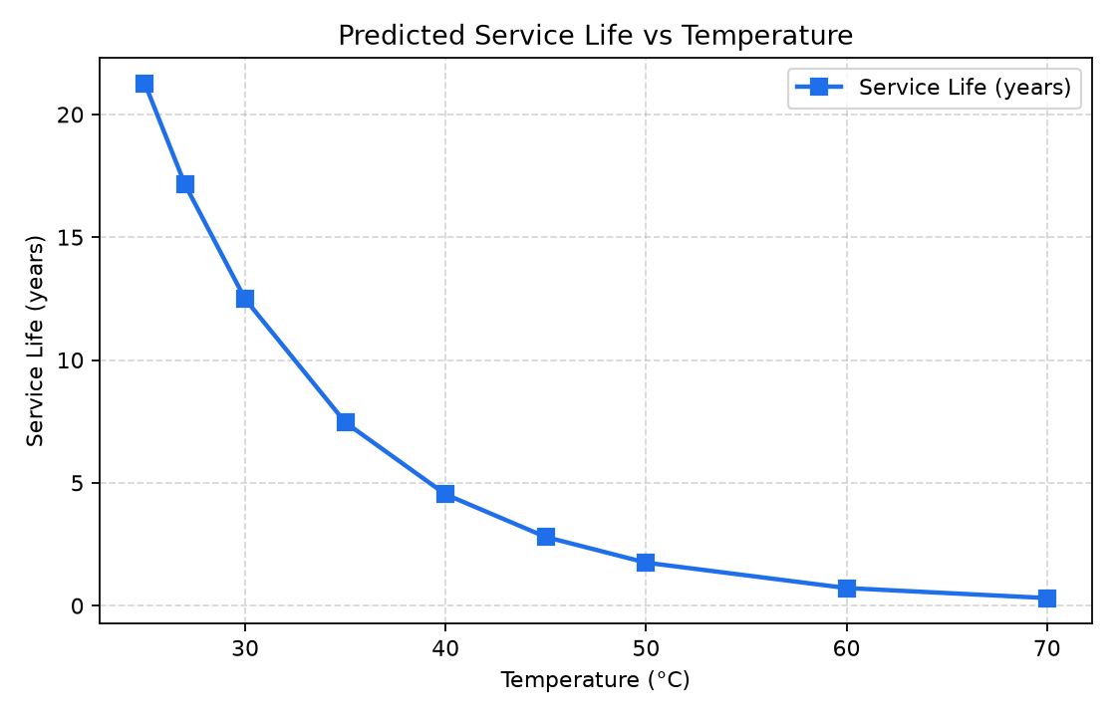
Figure 1. Predicted service life decreases sharply and non-linearly with storage temperature.
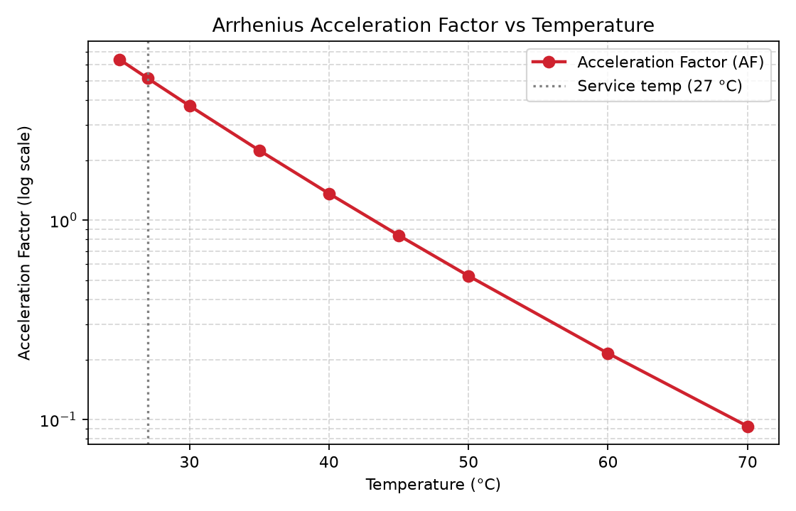
Figure 2. The script’s temperature-scaling factor (log scale): it equals the pre-factor A (≈ 5.14) at the 27 °C reference and decays exponentially as temperature rises, driving the drop in service life.

6.1 Reading the table
Each row of Table 2 is produced by the worked steps of Section 4.6. The failure time t_f is constant at ≈ 1217 days because A, E_crit and n do not change with temperature; the temperature dependence enters entirely through the scaling factor in the second column. Multiplying the two and dividing by 365.25 gives the service life in the final column. For example, at 40 °C the scaling factor is ≈ 1.359, so the service life is 1217 × 1.359 / 365.25 ≈ 4.53 years.

6.2 Discussion
The results show the expected exponential sensitivity of service life to temperature. At the 25 °C the model predicts roughly 21 years of service life; this falls to about 17 years at the 27 °C reference, 12.5 years at 30 °C, 4.5 years at 40 °C and only about 0.3 years (≈ 113 days) at 70 °C. The predicted life near typical magazine storage temperatures is consistent in order of magnitude with the ≈ 13-year shelf life reported by Adel and Liang [10] for an AP/Al/HTPB propellant, lending qualitative confidence to the model.
Two practical implications follow. First, because the temperature term is exponential in 1/T, modest reductions in storage temperature yield disproportionately large gains in service life — a strong argument for climate-controlled magazines. Second, the same exponential sensitivity explains why short elevated-temperature tests are so attractive: the conventional Arrhenius acceleration factor between 27 °C and 70 °C is more than 50× (exp[(Eₐ/R)(1/300.15 − 1/343.15)] ≈ 56), so a few weeks of testing at 70 °C samples years of natural aging. The chief caveats are the model’s strong sensitivity to the assumed activation energy and degradation exponent (cf. Kunz’s warning on regression bias [8]) and its neglect of competing softening/hardening pathways [10].

6.3 Sensitivity to the activation energy
Because Eₐ sits inside an exponential, the prediction is acutely sensitive to it — the single biggest source of uncertainty in any accelerated-aging extrapolation. Figure 3 recomputes the service-life curve for Eₐ = 60, 80 and 100 kJ/mol with all other inputs fixed. Raising Eₐ steepens the curve: it lengthens predicted life at low storage temperatures and shortens it at high temperatures, pivoting about the 27 °C reference where the scaling factor is fixed at A. A 25 % error in Eₐ changes the predicted room-temperature life by years, which is why Eₐ should be determined from data spanning several test temperatures and reported with an uncertainty band rather than as a single number.
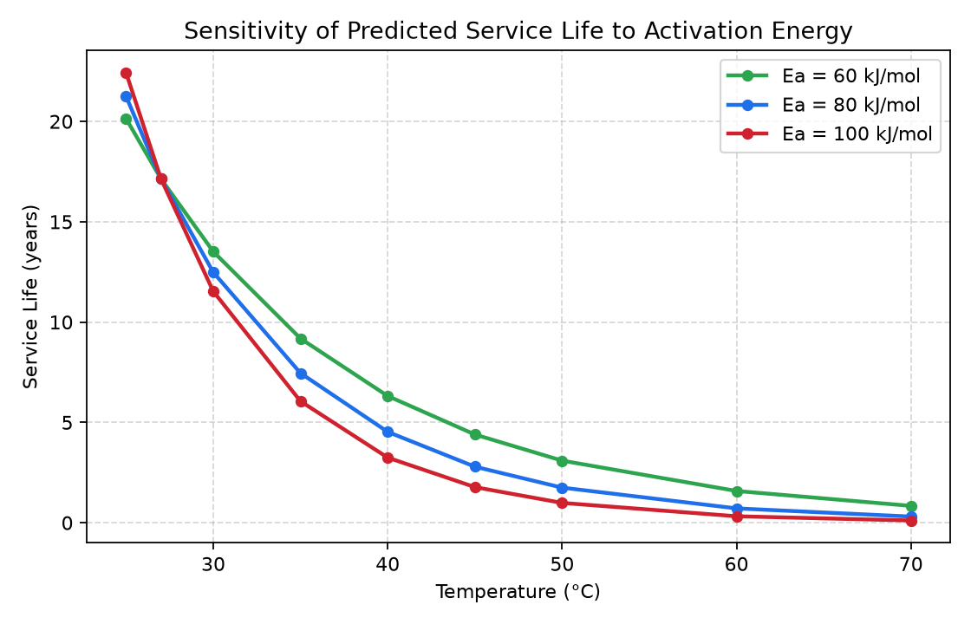
Figure 3. Predicted service life for three activation energies; the curves pivot about the 27 °C reference, showing the strong leverage of Eₐ on the extrapolation.

7. Code 2: Data-Driven Service-Life Pipeline
Code 1 needs only a single test point and is intended for rapid screening. Code 2 is a complete, self-contained MATLAB pipeline (the function abcxyz / srp_pipeline) that performs the whole service-life workflow on a real accelerated-ageing campaign: it reads universal-testing-machine (UTM) tensile files, extracts mechanical properties from each stress–strain curve, aggregates replicates, trains a cross-validated machine-learning surrogate of the chosen health property, fits a global first-order Arrhenius kinetic model, and extrapolates the service life to the storage temperature. It also contains a synthetic-data generator (so it runs with no input files) and a built-in self-test.
Following the requested order, this section gives (7.1) the full source listing, (7.2) the results it produces on the built-in demonstration dataset, and (7.3) an explanation of the models and formulas it uses.

7.1 Source code — abcxyz.m (srp_pipeline)
Input files are named T<temp>_d<days>_v<rate>_s<sample> (e.g. T50_d122_v500_s3.xlsx = 50 °C, 122 days, 500 mm/min cross-head speed, sample 3). Each file holds three UTM columns: disp_mm, load_N, t_min. The complete listing follows.
function results = abcxyz(varargin)
%SRP_PIPELINE All-in-one solid-rocket-propellant (SRP) service-life predictor.
%
% A single self-contained file that reads UTM tensile tests from an
% accelerated-ageing campaign, extracts mechanical properties, trains a
% cross-validated ML model of property degradation, fits accelerated-ageing
% (Arrhenius) kinetics and predicts the propellant SERVICE LIFE.
%
% FILE NAMING expected: T<temp>_d<days>_v<strainRate>_s<sample>
% T storage/ageing temperature (deg C) e.g. T50
% d days stored before testing e.g. d122
% v UTM cross-head speed (mm/min) e.g. v500
% s sample/replicate number e.g. s3
% so T50_d122_v500_s3.xlsx = 50 C, 122 days, 500 mm/min, sample 3.
%
% EACH FILE (.xlsx/.xls/.csv/.txt/.dat) holds the three UTM columns:
% disp_mm , load_N , t_min (header row optional, auto-detected)
% Geometry: gauge length 47.75 mm, area 24 mm^2 -> stress=load/24 (MPa),
% strain = disp/47.75.
%
% USAGE
% results = srp_pipeline(); % synthetic demo (xlsx)
% results = srp_pipeline('DataDir','/path/data'); % your files
% results = srp_pipeline('ServiceTemp',30, 'HealthProperty','sigma_max');
% srp_pipeline('test'); % run built-in self-checks
% cfg = srp_pipeline('config'); % get the default config
%
% OPTIONS (Name,Value):
% 'DataDir' folder with the data files
% 'GenerateData' logical, create synthetic data first
% 'ServiceTemp' in-service temperature (deg C), default 25
% 'HealthProperty' property whose decay defines end-of-life
% ('eps_at_max' default, 'sigma_max', 'modulus_MPa', ...)
%
% OUTPUT struct: .cfg .D (dataset) .A (aggregated) .model (ML) .res (service life)
%
% NOTE (GNU Octave): xlsx needs the "io" package (auto-loaded here; install
% with `pkg install -forge io` or `apt install octave-io`). MATLAB needs no
% extra toolbox; the Statistics & ML Toolbox is used when present, otherwise a
% built-in polynomial regressor is used.

addpath(fileparts(mfilename("C:\Users\TANVI GATTANI\Downloads\data\new_data_2")));
try pkg load io; catch; end %#ok<*CTCH>

% ----- dispatch special string commands
if nargin >= 1 && (ischar(varargin{1}) || isstring(varargin{1}))
cmd = lower(char(varargin{1}));
if any(strcmp(cmd, {'test', 'selftest', 'tests'}))
results = srp_selftest(); return;
elseif strcmp(cmd, 'config')
results = srp_config(); return;
end
end

cfg = srp_config();

% ----- parse Name/Value options
p = local_opts(varargin);
if isfield(p, 'DataDir'); cfg.dataDir = p.DataDir; end
if isfield(p, 'ServiceTemp'); cfg.serviceTemp_C = p.ServiceTemp; end
if isfield(p, 'HealthProperty')
cfg.healthProperty = p.HealthProperty;
cfg.mlTarget = p.HealthProperty;
end
if ~exist(cfg.resultsDir, 'dir'); mkdir(cfg.resultsDir); end

% ----- 1. (optional) generate synthetic data
genFlag = (local_count_files(cfg) == 0);
if isfield(p, 'GenerateData'); genFlag = logical(p.GenerateData); end
if genFlag
fprintf('== Generating synthetic example dataset ==\n');
generate_synthetic_data(cfg);
end

% ----- 2-3. load + feature extraction
fprintf('\n== Loading data & extracting features ==\n');
D = srp_build_dataset(cfg);

% ----- 4. aggregate replicates
A = srp_aggregate(D, cfg);
fprintf('Aggregated into %d ageing conditions.\n', numel(A.days));

% ----- 5. train ML model of the health property
fprintf('\n== Training ML model for "%s" ==\n', cfg.mlTarget);
model = srp_train_model(D.X, D.Y.(cfg.mlTarget), cfg.mlInputs, cfg, true);

% ----- 6-7. kinetics + service life
fprintf('\n== Accelerated-ageing kinetics & service life ==\n');
res = srp_service_life(A, cfg, model);
local_report(res, cfg);

% ----- 8. plots + summary file
srp_plot_results(D, A, model, res, cfg);
local_save_summary(D, A, model, res, cfg);

results = struct('cfg', cfg, 'D', D, 'A', A, 'model', model, 'res', res);
end

%% ======================================================================
%% CONFIGURATION
%% ======================================================================
function cfg = srp_config()
cfg = struct();
thisDir = fileparts(mfilename("C:\Users\USER\Downloads\intern\new_data_2"));
cfg.rootDir = thisDir;
cfg.dataDir = fullfile(thisDir, 'new_data_2');
cfg.resultsDir = fullfile(thisDir, 'results');

% dog-bone specimen geometry
cfg.gaugeLength_mm = 47.75; % L0 (mm)
cfg.area_mm2 = 24.0; % A0 (mm^2) -> stress in N/mm^2 == MPa

% column-name aliases (case-insensitive) and fallback order
cfg.col.disp = {'disp_mm','disp','displacement','displacement_mm','extension_mm'};
cfg.col.load = {'load_N','load','force','force_n','load_n'};
cfg.col.time = {'t_min','time','time_min','t','time_s'};
cfg.defaultColumnOrder = {'disp_mm','load_N','t_min'};
cfg.fileExtensions = {'.xlsx','.xls','.csv','.txt','.dat'};
cfg.syntheticFormat = 'xlsx'; % 'xlsx' or 'csv'

% feature-extraction settings
cfg.modulusStrainFraction = 0.25;
cfg.modulusMinPoints = 5;
cfg.breakLoadFraction = 0.20;

% ageing test matrix (also used by the synthetic generator)
cfg.temperatures_C = [50, 60, 70];
cfg.daysByTemp = struct('T50',[38 75 122 156 190], ...
'T60',[16 31 46 62 78], ...
'T70',[7 14 20 27 34]);
cfg.strainRates_mmpmin = [5, 50, 500];
cfg.nSamples = 10;

% service-life definition
cfg.healthProperty = 'eps_at_max'; % strain capacity (embrittlement)
cfg.healthDirection = 'decrease'; % 'decrease' or 'increase'
cfg.failureMode = 'relative'; % 'relative' or 'absolute'
cfg.failureFraction = 0.50; % retain 50% of pristine
cfg.failureAbsolute = NaN;
cfg.kineticModel = 'firstorder'; % 'firstorder','linear','loglinear'
cfg.serviceTemp_C = 27;
cfg.referenceStrainRate = 50;

% ML options
cfg.mlInputs = {'temp_C','days','strain_rate'};
cfg.mlTarget = cfg.healthProperty;
cfg.cvFolds = 5;
cfg.rngSeed = 42;
cfg.mlLearners = {'gpr','ensemble','svm','linear','polyfallback'};

cfg.R_gas = 8.314462618; % J/(mol*K)
end

%% ======================================================================
%% FILENAME PARSING
%% ======================================================================
function info = srp_parse_filename(name)
[~, base, ext] = fileparts(char(name));
if isempty(base) && ~isempty(ext); base = ext; end
info = struct('temp_C',NaN,'days',NaN,'strain_rate',NaN, ...
'sample',NaN,'name',base,'valid',false);
info.temp_C = local_token(base, '[Tt]');
info.days = local_token(base, '[Dd]');
info.strain_rate = local_token(base, '[Vv]');
info.sample = local_token(base, '[Ss]');
info.valid = all(~isnan([info.temp_C, info.days, info.strain_rate, info.sample]));
end

function val = local_token(str, letterClass)
pat = [letterClass, '([+-]?\d+(?:\.\d+)?)'];
tok = regexp(str, pat, 'tokens', 'once');
if isempty(tok); val = NaN; else; val = str2double(tok{1}); end
end

%% ======================================================================
%% FILE READING (xlsx / xls / csv / txt / dat)
%% ======================================================================
function curve = srp_read_curve(filepath, cfg)
if nargin < 2 || isempty(cfg); cfg = srp_config(); end
[~, ~, ext] = fileparts(filepath);
if any(strcmpi(ext, {'.xlsx','.xls','.xlsm','.ods'}))
[headers, M] = local_read_spreadsheet(filepath);
else
[headers, M] = local_read_text(filepath);
end
if isempty(M)
error('srp_read_curve:empty', 'No numeric data found in: %s', filepath);
end
if ~isempty(headers)
colIdx = local_match_columns(lower(strtrim(headers)), cfg);
else
colIdx = local_default_columns(cfg);
end
curve = struct();
curve.file = filepath;
curve.disp_mm = local_get(M, colIdx.disp);
curve.load_N = local_get(M, colIdx.load);
curve.t_min = local_get(M, colIdx.time);
ok = isfinite(curve.disp_mm) & isfinite(curve.load_N);
curve.disp_mm = curve.disp_mm(ok);
curve.load_N = curve.load_N(ok);
if numel(curve.t_min) == numel(ok)
curve.t_min = curve.t_min(ok);
else
curve.t_min = nan(sum(ok), 1);
end
end

function [headers, M] = local_read_spreadsheet(filepath)
raw = [];
if exist('readcell', 'file') % MATLAB R2019a+
try raw = readcell(filepath); catch, raw = []; end
end
if isempty(raw) && exist('xlsread', 'file') % Octave io / older MATLAB
try pkg load io; catch; end
try [~, ~, raw] = readtable(filepath); catch, raw = []; end
end
if isempty(raw) && exist('readtable', 'file')
try
Tt = readtable(filepath);
headers = Tt.Properties.VariableNames;
M = local_table2num(Tt); return;
catch, raw = [];
end
end
if isempty(raw)
error('srp_read_curve:noXlsx', ...
'Cannot read spreadsheet "%s".\nIn GNU Octave: pkg install -forge io', filepath);
end
[headers, M] = local_cellblock2num(raw);
end

function [headers, M] = local_read_text(filepath)
NL = newline;
raw = fileread(filepath);
raw = strrep(raw, sprintf('\r\n'), NL);
raw = strrep(raw, sprintf('\r'), NL);
lines = strsplit(raw, NL);
lines = lines(~cellfun(@(s) isempty(strtrim(s)), lines));
if isempty(lines); headers = {}; M = []; return; end
delim = local_detect_delimiter(lines{1});
firstTokens = local_split(lines{1}, delim);
hasHeader = any(cellfun(@(t) isnan(str2double(t)) && ~isempty(strtrim(t)), firstTokens));
if hasHeader
headers = strtrim(firstTokens); dataLines = lines(2:end);
else
headers = {}; dataLines = lines;
end
nc = numel(firstTokens);
M = nan(numel(dataLines), max(nc, 3));
keep = false(numel(dataLines), 1);
for i = 1:numel(dataLines)
tok = local_split(dataLines{i}, delim);
v = str2double(tok);
n = min(numel(v), size(M, 2));
if n >= 1; M(i, 1:n) = v(1:n); keep(i) = true; end
end
M = M(keep, :);
end

function [headers, M] = local_cellblock2num(raw)
if isempty(raw); headers = {}; M = []; return; end
nRows = size(raw, 1); nCols = size(raw, 2);
firstRowText = false;
for c = 1:nCols
if local_is_text(raw{1, c}); firstRowText = true; break; end
end
if firstRowText
headers = cell(1, nCols);
for c = 1:nCols; headers{c} = local_cell2str(raw{1, c}); end
dataRows = 2:nRows;
else
headers = {}; dataRows = 1:nRows;
end
M = nan(numel(dataRows), nCols);
for r = 1:numel(dataRows)
for c = 1:nCols; M(r, c) = local_cell2num(raw{dataRows(r), c}); end
end
M = M(any(isfinite(M), 2), :);
end

function M = local_table2num(Tt)
nCols = size(Tt, 2);
M = nan(height(Tt), nCols);
for c = 1:nCols
col = Tt{:, c};
if isnumeric(col); M(:, c) = double(col);
else; M(:, c) = str2double(string(col)); end
end
M = M(any(isfinite(M), 2), :);
end

function tf = local_is_text(x)
tf = ischar(x) || (iscell(x) && ~isempty(x) && ischar(x{1})) || ...
(isstring(x) && ~ismissing(x) && isnan(str2double(x)));
end
function s = local_cell2str(x)
if ischar(x); s = x; elseif isstring(x); s = char(x);
elseif isnumeric(x); s = num2str(x); else; s = ''; end
end
function v = local_cell2num(x)
if isnumeric(x) && isscalar(x); v = double(x);
elseif islogical(x); v = double(x);
elseif ischar(x); v = str2double(x);
elseif isstring(x); v = str2double(x); else; v = NaN;
end
if isempty(v); v = NaN; end
end
function delim = local_detect_delimiter(line)
candidates = {',', sprintf('\t'), ';'};
counts = cellfun(@(d) numel(strfind(line, d)), candidates);
[mx, k] = max(counts);
if mx > 0; delim = candidates{k}; else; delim = ' '; end
end
function parts = local_split(line, delim)
if strcmp(delim, ' '); parts = regexp(strtrim(line), '\s+', 'split');
else; parts = strsplit(line, delim); end
parts = strtrim(parts);
end
function colIdx = local_match_columns(headers, cfg)
colIdx.disp = local_find_col(headers, cfg.col.disp);
colIdx.load = local_find_col(headers, cfg.col.load);
colIdx.time = local_find_col(headers, cfg.col.time);
if isnan(colIdx.disp) || isnan(colIdx.load)
d = local_default_columns(cfg);
if isnan(colIdx.disp); colIdx.disp = d.disp; end
if isnan(colIdx.load); colIdx.load = d.load; end
if isnan(colIdx.time); colIdx.time = d.time; end
end
end
function idx = local_find_col(headers, aliases)
idx = NaN;
for a = 1:numel(aliases)
hit = find(strcmpi(headers, aliases{a}), 1);
if ~isempty(hit); idx = hit; return; end
end
end
function colIdx = local_default_columns(cfg)
order = cfg.defaultColumnOrder;
colIdx.disp = find(strcmpi(order, 'disp_mm'), 1);
colIdx.load = find(strcmpi(order, 'load_N'), 1);
colIdx.time = find(strcmpi(order, 't_min'), 1);
if isempty(colIdx.disp); colIdx.disp = 1; end
if isempty(colIdx.load); colIdx.load = 2; end
if isempty(colIdx.time); colIdx.time = 3; end
end
function v = local_get(M, idx)
if isnan(idx) || idx < 1 || idx > size(M, 2); v = nan(size(M, 1), 1);
else; v = M(:, idx); end
end

%% ======================================================================
%% FEATURE EXTRACTION (stress-strain -> mechanical properties)
%% ======================================================================
function f = srp_extract_features(curve, cfg, nominalStrainRate)
if nargin < 2 || isempty(cfg); cfg = srp_config(); end
if nargin < 3; nominalStrainRate = NaN; end
f = local_empty_features();
f.strain_rate = nominalStrainRate;
f.true_rate_pm = nominalStrainRate / cfg.gaugeLength_mm;

d = curve.disp_mm(:); P = curve.load_N(:);
ok = isfinite(d) & isfinite(P); d = d(ok); P = P(ok);
if numel(d) < 3; return; end
[d, order] = sort(d); P = P(order);

stress = P / cfg.area_mm2; % MPa
strain = d / cfg.gaugeLength_mm; % -
f.nPoints = numel(d);

[sigmaMax, idxMax] = max(stress);
f.sigma_max = sigmaMax;
f.load_max_N = max(P);
f.eps_at_max = strain(idxMax);

idxBreak = numel(stress);
postPeak = idxMax+1 : numel(stress);
if ~isempty(postPeak)
dropped = find(stress(postPeak) < cfg.breakLoadFraction * sigmaMax, 1, 'first');
if ~isempty(dropped); idxBreak = postPeak(dropped); end
end
f.eps_break = strain(idxBreak);

epsCut = cfg.modulusStrainFraction * f.eps_at_max;
region = find(strain <= epsCut & strain >= 0);
if numel(region) < cfg.modulusMinPoints
region = 1:min(cfg.modulusMinPoints, numel(strain));
end
if numel(region) >= 2 && (max(strain(region)) - min(strain(region))) > 0
pcoef = polyfit(strain(region), stress(region), 1);
f.modulus_MPa = pcoef(1);
end

halfLvl = 0.5 * sigmaMax;
iHalf = find(stress(1:idxMax) >= halfLvl, 1, 'first');
if ~isempty(iHalf) && strain(iHalf) > 0
f.secant50_MPa = stress(iHalf) / strain(iHalf);
end

upto = 1:idxBreak;
if numel(upto) >= 2; f.toughness = trapz(strain(upto), stress(upto)); end
end

function f = local_empty_features()
f = struct('sigma_max',NaN,'load_max_N',NaN,'eps_at_max',NaN, ...
'eps_break',NaN,'modulus_MPa',NaN,'toughness',NaN, ...
'secant50_MPa',NaN,'strain_rate',NaN,'true_rate_pm',NaN,'nPoints',0);
end

%% ======================================================================
%% DATASET ASSEMBLY
%% ======================================================================
function D = srp_build_dataset(cfg, dataDir)
if nargin < 1 || isempty(cfg); cfg = srp_config(); end
if nargin < 2 || isempty(dataDir); dataDir = cfg.dataDir; end
files = local_list_data_files(dataDir, cfg.fileExtensions);
if isempty(files)
error('srp_build_dataset:noFiles', ...
'No data files found in "%s". Generate demo data or set cfg.dataDir.', dataDir);
end
rows = struct([]); n = 0;
for i = 1:numel(files)
fp = files{i};
info = srp_parse_filename(fp);
if ~info.valid
warning('srp_build_dataset:skip', 'Skipping unparseable file: %s', fp);
continue;
end
curve = srp_read_curve(fp, cfg);
feat = srp_extract_features(curve, cfg, info.strain_rate);
n = n + 1;
r = struct('file',fp, 'name',info.name, 'temp_C',info.temp_C, ...
'days',info.days, 'strain_rate',info.strain_rate, 'sample',info.sample);
ff = fieldnames(feat);
for k = 1:numel(ff); r.(ff{k}) = feat.(ff{k}); end
if isempty(rows); rows = r; else; rows(n) = r; end
end
if n == 0; error('srp_build_dataset:noValid', 'No valid, parseable data files.'); end

D = struct();
D.rows = rows;
D.files = {rows.file};
D.predictors = cfg.mlInputs;
D.featNames = fieldnames(srp_extract_features( ...
struct('disp_mm',[],'load_N',[],'t_min',[]), cfg, NaN));
D.X = zeros(n, numel(D.predictors));
for j = 1:numel(D.predictors); D.X(:, j) = [rows.(D.predictors{j})]'; end
D.Y = struct();
for k = 1:numel(D.featNames); D.Y.(D.featNames{k}) = [rows.(D.featNames{k})]'; end
fprintf('srp_build_dataset: loaded %d files from %s\n', n, dataDir);
end

function files = local_list_data_files(dataDir, exts)
files = {};
for e = 1:numel(exts)
L = dir(fullfile(dataDir, ['*' exts{e}]));
for i = 1:numel(L)
if ~L(i).isdir; files{end+1} = fullfile(dataDir, L(i).name); end %#ok<AGROW>
end
end
files = sort(files);
end

%% ======================================================================
%% AGGREGATION OVER REPLICATES
%% ======================================================================
function A = srp_aggregate(D, cfg)
if nargin < 2 || isempty(cfg); cfg = srp_config(); end
rows = D.rows;
key = [ [rows.temp_C]', [rows.days]', [rows.strain_rate]' ];
[uKey, ~, grp] = unique(key, 'rows');
nCond = size(uKey, 1);
A = struct();
A.temp_C = uKey(:,1); A.days = uKey(:,2); A.strain_rate = uKey(:,3);
A.n = accumarray(grp, 1);
A.featNames = D.featNames;
A.mean = struct(); A.std = struct();
for k = 1:numel(D.featNames)
fn = D.featNames{k}; val = D.Y.(fn);
mu = nan(nCond,1); sd = nan(nCond,1);
for g = 1:nCond
v = val(grp == g); v = v(isfinite(v));
if ~isempty(v); mu(g) = mean(v); sd(g) = std(v); end
end
A.mean.(fn) = mu; A.std.(fn) = sd;
end
end

%% ======================================================================
%% MACHINE-LEARNING MODEL (cross-validated, toolbox-optional)
%% ======================================================================
function model = srp_train_model(X, y, predictorNames, cfg, verbose)
if nargin < 4 || isempty(cfg); cfg = srp_config(); end
if nargin < 5 || isempty(verbose); verbose = true; end
good = isfinite(y) & all(isfinite(X), 2);
X = X(good, :); y = y(good);
if numel(y) < 4; error('srp_train_model:tooFew', 'Need >= 4 valid observations.'); end
local_seed(cfg.rngSeed);
folds = local_kfold_indices(numel(y), cfg.cvFolds, cfg.rngSeed);

cand = struct('name', {}, 'cvRMSE', {}, 'cvR2', {}, 'trainFcn', {}, 'available', {});
for i = 1:numel(cfg.mlLearners)
spec = local_learner_spec(cfg.mlLearners{i});
if isempty(spec); continue; end
cand(end+1) = spec; %#ok<AGROW>
end
for i = 1:numel(cand)
if ~cand(i).available; cand(i).cvRMSE = Inf; cand(i).cvR2 = -Inf; continue; end
[rmse, r2] = local_cross_validate(cand(i).trainFcn, X, y, folds);
cand(i).cvRMSE = rmse; cand(i).cvR2 = r2;
if verbose
fprintf(' %-14s CV-RMSE = %10.5g CV-R2 = %7.4f\n', cand(i).name, rmse, r2);
end
end
[~, best] = min([cand.cvRMSE]);
finalPredict = cand(best).trainFcn(X, y);
model = struct('name',cand(best).name, 'predictFcn',finalPredict, ...
'cvRMSE',cand(best).cvRMSE, 'cvR2',cand(best).cvR2, ...
'candidates',cand, 'predictors',{predictorNames});
if verbose
fprintf(' -> selected: %s (CV-RMSE = %.5g, CV-R2 = %.4f)\n', ...
model.name, model.cvRMSE, model.cvR2);
end
end

function spec = local_learner_spec(name)
spec = struct('name',name,'cvRMSE',Inf,'cvR2',-Inf,'trainFcn',[],'available',false);
switch lower(name)
case 'gpr'
if exist('fitrgp','file')
spec.trainFcn = @(X,y) local_wrap(fitrgp(X,y, ...
'KernelFunction','ardsquaredexponential','BasisFunction','linear','Standardize',true));
spec.available = true;
end
case 'ensemble'
if exist('fitrensemble','file')
spec.trainFcn = @(X,y) local_wrap(fitrensemble(X,y,'Method','Bag','NumLearningCycles',200));
spec.available = true;
end
case 'svm'
if exist('fitrsvm','file')
spec.trainFcn = @(X,y) local_wrap(fitrsvm(X,y,'KernelFunction','gaussian','Standardize',true));
spec.available = true;
end
case 'linear'
if exist('fitlm','file')
spec.trainFcn = @(X,y) local_wrap(fitlm(X,y,'RobustOpts','on'));
spec.available = true;
end
case 'polyfallback'
spec.trainFcn = @(X,y) local_poly_train(X,y);
spec.available = true;
otherwise
spec = [];
end
end
function h = local_wrap(mdl); h = @(Xn) predict(mdl, Xn); end

function predictFcn = local_poly_train(X, y)
mu = mean(X,1); sg = std(X,0,1); sg(sg==0) = 1;
Phi = local_poly_basis(X, mu, sg);
lambda = 1e-6 * trace(Phi'*Phi) / size(Phi,2);
beta = (Phi'*Phi + lambda*eye(size(Phi,2))) \ (Phi'*y);
predictFcn = @(Xn) local_poly_basis(Xn, mu, sg) * beta;
end
function Phi = local_poly_basis(X, mu, sg)
Z = (X - mu) ./ sg; n = size(Z,1); pdim = size(Z,2);
cols = {ones(n,1)}; cols{end+1} = Z; cols{end+1} = Z.^2;
for a = 1:pdim
for b = a+1:pdim; cols{end+1} = Z(:,a).*Z(:,b); end %#ok<AGROW>
end
if pdim >= 2; cols{end+1} = log(max(X(:,2),0)+1); end
Phi = [cols{:}];
end
function [rmse, r2] = local_cross_validate(trainFcn, X, y, folds)
k = max(folds); yhat = nan(size(y));
for f = 1:k
te = (folds==f); tr = ~te;
if sum(tr) < 3 || ~any(te); continue; end
pf = trainFcn(X(tr,:), y(tr)); yhat(te) = pf(X(te,:));
end
okk = isfinite(yhat); e = y(okk) - yhat(okk);
rmse = sqrt(mean(e.^2));
ss_res = sum(e.^2); ss_tot = sum((y(okk)-mean(y(okk))).^2);
if ss_tot > 0; r2 = 1 - ss_res/ss_tot; else; r2 = NaN; end
end
function folds = local_kfold_indices(n, k, seed)
local_seed(seed); k = max(2, min(k, n));
idx = mod(randperm(n)-1, k) + 1; folds = idx(:);
end
function local_seed(seed)
try rng(seed); catch, rand('state',seed); randn('state',seed); end %#ok<RAND>
end

%% ======================================================================
%% SERVICE-LIFE PREDICTION (global kinetic + Arrhenius)
%% ======================================================================
function res = srp_service_life(A, cfg, model)
if nargin < 2 || isempty(cfg); cfg = srp_config(); end
if nargin < 3; model = []; end
prop = cfg.healthProperty; refRate = cfg.referenceStrainRate; R = cfg.R_gas;

sel = (A.strain_rate == refRate);
if ~any(sel)
warning('srp_service_life:noRefRate', ...
'No conditions at reference strain rate %g; using all.', refRate);
sel = true(size(A.strain_rate));
end
t = A.days(sel); T = A.temp_C(sel); P = A.mean.(prop)(sel);
good = isfinite(t) & isfinite(T) & isfinite(P);
t = t(good); T = T(good); P = P(good);
temps = unique(T);

res = struct();
res.property = prop; res.refStrainRate = refRate;
res.kineticModel = cfg.kineticModel; res.temps_C = temps;

fit = local_global_fit(t, T, P, cfg.kineticModel, cfg.healthDirection, R);
res.P0 = fit.P0; res.Pinf = fit.Pinf;
res.Ea_kJmol = fit.Ea_kJmol; res.kineticFitR2 = fit.R2; res.Pfun = fit.Pfun;

switch lower(cfg.failureMode)
case 'relative'; P_fail = cfg.failureFraction * fit.P0;
case 'absolute'; P_fail = cfg.failureAbsolute;
otherwise; error('srp_service_life:mode','Unknown failureMode "%s".', cfg.failureMode);
end
res.P_fail = P_fail;

nT = numel(temps);
tfail_k = arrayfun(@(Tc) fit.tFail(P_fail, Tc), temps);
res.tfail_kinetic = tfail_k(:);

tfail_m = nan(nT, 1);
if ~isempty(model)
tMaxSearch = 50 * max(A.days);
for i = 1:nT
Pml = @(tt) local_ml_predict(model, temps(i), tt, refRate, cfg);
tfail_m(i) = local_cross_time(Pml, P_fail, tMaxSearch);
end
end
res.tfail_ml = tfail_m;

Ts_K = cfg.serviceTemp_C + 273.15;
res.serviceTemp_C = cfg.serviceTemp_C;
res.serviceLife_days = fit.tFail(P_fail, cfg.serviceTemp_C);
res.serviceLife_years = res.serviceLife_days / 365.25;
res.arrheniusSlope = fit.Ea_kJmol * 1000 / R;
res.arrheniusIntercept = log(res.serviceLife_days) - res.arrheniusSlope / Ts_K;
res.tfail_used = exp(res.arrheniusIntercept + res.arrheniusSlope ./ (temps + 273.15));
res.source = 'kinetic_global';

ylog = log(tfail_k(:));
yhat = res.arrheniusIntercept + res.arrheniusSlope ./ (temps + 273.15);
vOK = isfinite(ylog) & isfinite(yhat);
if nnz(vOK) >= 2
ss_res = sum((ylog(vOK)-yhat(vOK)).^2);
ss_tot = sum((ylog(vOK)-mean(ylog(vOK))).^2);
res.arrheniusR2 = 1 - ss_res/max(ss_tot,eps);
else
res.arrheniusR2 = NaN;
end
res.accelFactor = res.serviceLife_days ./ tfail_k(:);
end

function fit = local_global_fit(t, T, P, modelName, direction, R)
t = t(:); T = T(:); P = P(:); TK = T + 273.15;
sgn = 1; if strcmpi(direction,'decrease'); sgn = -1; end
span = max(P) - min(P); if span <= 0; span = max(abs(P), eps); end
TrefK = median(TK); EaSeeds = [40 60 80 100 120 150];

switch lower(modelName)
case 'firstorder'
if sgn < 0
P0_0 = max(P)+0.05*span; Pinf_0 = min(P)-0.15*span;
else
P0_0 = min(P)-0.05*span; Pinf_0 = max(P)+0.15*span;
end
lnkref0 = local_init_lnkref(t, TK, P, P0_0, Pinf_0, TrefK);
modelFun = @(th, tt, TTk) local_fo_model_ref(th, tt, TTk, R, TrefK);
obj = @(th) sum((P - modelFun(th, t, TK)).^2) + local_ea_penalty(th(4), span);
best = []; bestSSE = Inf;
for Ea0 = EaSeeds
th0 = [P0_0, Pinf_0, lnkref0, Ea0];
th = local_minimize(obj, th0);
sse = sum((P - modelFun(th, t, TK)).^2);
if isfinite(sse) && sse < bestSSE; bestSSE = sse; best = th; end
end
th = best;
P0 = th(1); Pinf = th(2); lnkref = th(3); Ea_kJ = th(4);
kFun = @(Tc) exp(lnkref - (Ea_kJ*1000/R) .* (1./(Tc+273.15) - 1/TrefK));
Pfun = @(tt, Tc) Pinf + (P0 - Pinf) .* exp(-kFun(Tc) .* tt);
tFail = @(Pf, Tc) local_fo_tfail(Pf, P0, Pinf, kFun(Tc));
case 'linear'
P0_0 = local_intercept(t, P);
[lnB0, Ea0] = local_init_rate(t, TK, P, R);
th0 = [P0_0, lnB0, Ea0];
rate = @(th, Tc) sgn * exp(th(2) - th(3)*1000 ./ (R*(Tc+273.15)));
modelFun = @(th, tt, TTc) th(1) + rate(th, TTc) .* tt;
th = local_minimize(@(th) sum((P - modelFun(th, t, T)).^2), th0);
P0 = th(1); Pinf = sgn*Inf; Ea_kJ = th(3);
Pfun = @(tt, Tc) modelFun(th, tt, Tc);
tFail = @(Pf, Tc) (Pf - P0) ./ rate(th, Tc);
case 'loglinear'
lnP = log(max(P, eps));
lnP0_0 = local_intercept(t, lnP);
[lnB0, Ea0] = local_init_rate(t, TK, lnP, R);
th0 = [lnP0_0, lnB0, Ea0];
rate = @(th, Tc) sgn * exp(th(2) - th(3)*1000 ./ (R*(Tc+273.15)));
modelFun = @(th, tt, TTc) exp(th(1) + rate(th, TTc) .* tt);
th = local_minimize(@(th) sum((P - modelFun(th, t, T)).^2), th0);
P0 = exp(th(1)); Pinf = sgn*Inf; Ea_kJ = th(3);
Pfun = @(tt, Tc) modelFun(th, tt, Tc);
tFail = @(Pf, Tc) (log(max(Pf,eps)) - th(1)) ./ rate(th, Tc);
otherwise
error('local_global_fit:model','Unknown kineticModel "%s".', modelName);
end
Phat = Pfun(t, T);
ss_res = sum((P - Phat).^2); ss_tot = sum((P - mean(P)).^2);
fit = struct('P0',P0,'Pinf',Pinf,'Ea_kJmol',Ea_kJ,'Pfun',Pfun, ...
'tFail',tFail,'R2', 1 - ss_res/max(ss_tot,eps));
end

function y = local_fo_model_ref(th, t, TK, R, TrefK)
P0 = th(1); Pinf = th(2); lnkref = th(3); Ea_kJ = th(4);
k = exp(lnkref - (Ea_kJ*1000/R) .* (1 ./ TK - 1/TrefK));
y = Pinf + (P0 - Pinf) .* exp(-k .* t);
end
function pen = local_ea_penalty(Ea_kJ, scale)
lo = 20; hi = 250; w = 1e3 * max(scale^2, eps);
pen = w * (max(0, lo - Ea_kJ)^2 + max(0, Ea_kJ - hi)^2);
end
function tf = local_fo_tfail(Pf, P0, Pinf, k)
ratio = (Pf - Pinf) / (P0 - Pinf);
if ratio <= 0 || ratio >= 1 || ~isfinite(ratio) || k <= 0
tf = NaN;
else
tf = -log(ratio) / k;
end
end
function lnkref0 = local_init_lnkref(t, TK, P, P0_0, Pinf_0, TrefK)
temps = unique(TK); kT = nan(numel(temps),1);
for i = 1:numel(temps)
m = (TK==temps(i));
ratio = (P(m) - Pinf_0) / (P0_0 - Pinf_0);
ratio = min(max(ratio, 1e-4), 1 - 1e-9);
yv = log(ratio);
if sum(m) >= 2; pcoef = polyfit(t(m), yv, 1); kT(i) = max(-pcoef(1), 1e-8);
else; kT(i) = max(-yv / max(t(m), eps), 1e-8); end
end
x = 1 ./ temps; yk = log(kT);
if numel(x) >= 2; pr = polyfit(x, yk, 1); lnkref0 = polyval(pr, 1/TrefK);
else; lnkref0 = yk(1); end
if ~isfinite(lnkref0); lnkref0 = log(1e-2); end
end
function [lnB0, Ea0] = local_init_rate(t, TK, P, R)
temps = unique(TK); bT = nan(numel(temps),1);
for i = 1:numel(temps)
m = (TK==temps(i)); pcoef = polyfit(t(m), P(m), 1);
bT(i) = max(abs(pcoef(1)), 1e-10);
end
pr = polyfit(1 ./ temps, log(bT), 1);
Ea0 = -pr(1)*R/1000; lnB0 = pr(2);
if ~isfinite(Ea0) || Ea0 <= 0; Ea0 = 80; end
if ~isfinite(lnB0); lnB0 = 0; end
end
function b = local_intercept(t, P); pcoef = polyfit(t, P, 1); b = pcoef(2); end
function th = local_minimize(obj, th0)
try
opts = optimset('MaxIter',20000,'MaxFunEvals',20000,'TolX',1e-10,'TolFun',1e-12);
th = fminsearch(obj, th0, opts);
catch
th = fminsearch(obj, th0);
end
end
function tcross = local_cross_time(Pfun, P_fail, tMax)
N = 4000; tt = linspace(0, tMax, N);
pp = Pfun(tt); g = pp(:).' - P_fail; s = sign(g);
idx = find(s(1:end-1).*s(2:end) <= 0 & s(1:end-1) ~= 0, 1, 'first');
if isempty(idx)
if g(1)==0; tcross = 0; else; tcross = NaN; end; return;
end
t1 = tt(idx); t2 = tt(idx+1); g1 = g(idx); g2 = g(idx+1);
if g2==g1; tcross = t1; else; tcross = t1 - g1*(t2-t1)/(g2-g1); end
end
function P = local_ml_predict(model, T, t, rate, cfg)
t = t(:); X = zeros(numel(t), numel(cfg.mlInputs));
for j = 1:numel(cfg.mlInputs)
switch cfg.mlInputs{j}
case 'temp_C'; X(:,j) = T;
case 'days'; X(:,j) = t;
case 'strain_rate'; X(:,j) = rate;
otherwise; X(:,j) = 0;
end
end
P = model.predictFcn(X); P = P(:).';
end

%% ----- service life at an arbitrary temperature (uses fitted Arrhenius) -----
function out = srp_predict_service_life(res, serviceTemp_C)
if ~isfield(res,'arrheniusSlope') || ~isfinite(res.arrheniusSlope)
error('srp_predict_service_life:noFit', 'res has no valid Arrhenius fit.');
end
serviceTemp_C = serviceTemp_C(:); TsK = serviceTemp_C + 273.15;
days = exp(res.arrheniusIntercept + res.arrheniusSlope ./ TsK);
out = struct('temp_C',serviceTemp_C, 'days',days, 'years',days/365.25);
end

%% ======================================================================
%% PLOTTING
%% ======================================================================
function srp_plot_results(D, A, model, res, cfg)
if nargin < 5 || isempty(cfg); cfg = srp_config(); end
if ~exist(cfg.resultsDir,'dir'); mkdir(cfg.resultsDir); end
prop = cfg.healthProperty;

try
fig = local_new_fig(); hold on;
temps = res.temps_C; colors = lines(numel(temps));
hLeg = zeros(numel(temps),1); labels = cell(numel(temps),1);
for i = 1:numel(temps)
T = temps(i);
m = (A.temp_C==T) & (A.strain_rate==cfg.referenceStrainRate);
tt = A.days(m); pp = A.mean.(prop)(m); ss = A.std.(prop)(m);
[tt, ord] = sort(tt); pp = pp(ord); ss = ss(ord);
local_errorbar(tt, pp, ss, colors(i,:));
tg = linspace(0, max(tt)*1.1, 100);
hLeg(i) = plot(tg, res.Pfun(tg, T), '-', 'Color', colors(i,:), 'LineWidth', 1.8);
labels{i} = sprintf('%g \\circC', T);
end
local_yline(res.P_fail, 'k--', 'P_{fail}');
xlabel('ageing time (days)'); ylabel(strrep(prop,'_','\_'));
title('Health property vs ageing time (reference strain rate)');
legend(hLeg, labels); grid on; box on;
local_save(fig, fullfile(cfg.resultsDir,'degradation_curves.png'));
catch err; warning('srp_plot_results:fig1','%s', err.message);
end

try
y = D.Y.(cfg.mlTarget); yhat = model.predictFcn(D.X);
gg = isfinite(y) & isfinite(yhat);
fig = local_new_fig(); plot(y(gg), yhat(gg), 'o'); hold on;
lim = [min([y(gg);yhat(gg)]), max([y(gg);yhat(gg)])];
plot(lim, lim, 'k--'); axis equal; xlim(lim); ylim(lim);
xlabel('measured'); ylabel('ML predicted');
title(sprintf('ML "%s": %s (CV-R^2=%.3f)', model.name, strrep(cfg.mlTarget,'_','\_'), model.cvR2));
grid on; box on;
local_save(fig, fullfile(cfg.resultsDir,'ml_parity.png'));
catch err; warning('srp_plot_results:fig2','%s', err.message);
end

try
if isfield(res,'arrheniusSlope') && isfinite(res.arrheniusSlope)
fig = local_new_fig(); TK = res.temps_C + 273.15;
x = 1 ./ TK; ylog = log(res.tfail_used);
plot(x, ylog, 'o', 'MarkerFaceColor','b'); hold on;
Ts = cfg.serviceTemp_C + 273.15;
xg = linspace(min([x;1/Ts]), max([x;1/Ts]), 50);
plot(xg, res.arrheniusIntercept + res.arrheniusSlope*xg, 'r-');
plot(1/Ts, log(res.serviceLife_days), 'rs', 'MarkerFaceColor','r','MarkerSize',10);
xlabel('1/T (1/K)'); ylabel('ln(t_{fail} / days)');
title(sprintf('Arrhenius: E_a=%.1f kJ/mol, life=%.0f d (%.1f yr) @ %g \\circC', ...
res.Ea_kJmol, res.serviceLife_days, res.serviceLife_years, cfg.serviceTemp_C));
grid on; box on;
local_save(fig, fullfile(cfg.resultsDir,'arrhenius.png'));
end
catch err; warning('srp_plot_results:fig3','%s', err.message);
end
end
function fig = local_new_fig()
try fig = figure('Visible','off'); catch, fig = figure(); end
end
function local_save(fig, fname)
try print(fig, fname, '-dpng', '-r120'); catch
try saveas(fig, fname); catch; end
end
try close(fig); catch; end
end
function local_errorbar(x, y, e, col)
e(~isfinite(e)) = 0;
try errorbar(x, y, e, 'o', 'Color', col, 'MarkerFaceColor', col);
catch, plot(x, y, 'o', 'Color', col, 'MarkerFaceColor', col); end
end
function local_yline(yv, style, label)
xl = xlim;
try
plot(xl, [yv yv], style, 'HandleVisibility', 'off');
text(xl(1), yv, [' ' label], 'VerticalAlignment', 'bottom');
catch
end
end

%% ======================================================================
%% SYNTHETIC DATA GENERATOR (example dataset matching the naming scheme)
%% ======================================================================
function generate_synthetic_data(cfg, opts)
if nargin < 1 || isempty(cfg); cfg = srp_config(); end
if nargin < 2; opts = struct(); end
if ~isfield(opts,'seed'); opts.seed = 1; end
if ~isfield(opts,'noise'); opts.noise = 0.04; end
if ~isfield(opts,'nPointsCurve'); opts.nPointsCurve = 60; end
if ~isfield(opts,'EaTrue_kJmol'); opts.EaTrue_kJmol = 80; end
try rng(opts.seed); catch, rand('state',opts.seed); randn('state',opts.seed); end
if ~exist(cfg.dataDir,'dir'); mkdir(cfg.dataDir); end

Ea = opts.EaTrue_kJmol*1000; R = cfg.R_gas; A_k = 5e9;
eps0=0.40; epsInf=0.10; sig0=0.50; dSig=0.45; E0=3.0; dE=4.0;
vref = cfg.referenceStrainRate; nRate_sig = 0.08; nRate_eps = 0.04;

nWritten = 0;
for T = cfg.temperatures_C
k = A_k * exp(-Ea/(R*(T+273.15)));
daysList = cfg.daysByTemp.(sprintf('T%d', T));
for d = daysList
decay = exp(-k*d);
epsM_base = epsInf + (eps0-epsInf)*decay;
sigM_base = sig0 + dSig*(1-decay);
for v = cfg.strainRates_mmpmin
rfac_sig = (v/vref)^nRate_sig; rfac_eps = (vref/v)^nRate_eps;
for s = 1:cfg.nSamples
g = @(x) x * (1 + opts.noise*randn());
epsM = max(0.02, g(epsM_base)*rfac_eps);
sigM = max(0.05, g(sigM_base)*rfac_sig);
[disp_mm, load_N, t_min] = local_curve(epsM, sigM, cfg, v, opts.nPointsCurve, opts.noise);
if strcmpi(local_field(cfg,'syntheticFormat','xlsx'),'csv'); ext='.csv';
else; ext='.xlsx'; end
fname = sprintf('T%d_d%d_v%d_s%d%s', T, d, v, s, ext);
local_write(fullfile(cfg.dataDir, fname), disp_mm, load_N, t_min);
nWritten = nWritten + 1;
end
end
end
end
fprintf('generate_synthetic_data: wrote %d files to %s\n', nWritten, cfg.dataDir);
fprintf(' (ground-truth Ea = %.0f kJ/mol)\n', opts.EaTrue_kJmol);
end
function [disp_mm, load_N, t_min] = local_curve(epsM, sigM, cfg, v, N, noise)
epsBreak = 1.40*epsM; eps = linspace(0, epsBreak, N)';
r = eps/epsM; sigma = sigM .* r .* exp(1 - r); sigma = max(sigma, 0);
sigma = sigma .* (1 + 0.01*noise/0.04*randn(N,1)); sigma = max(sigma, 0);
disp_mm = eps*cfg.gaugeLength_mm; load_N = sigma*cfg.area_mm2; t_min = disp_mm/v;
end
function local_write(fpath, disp_mm, load_N, t_min)
[~,~,ext] = fileparts(fpath);
header = {'disp_mm','load_N','t_min'}; M = [disp_mm, load_N, t_min];
if any(strcmpi(ext, {'.xlsx','.xls'}))
C = [header; num2cell(M)]; wrote = false;
if exist('writecell','file'); try writecell(C, fpath); wrote = true; catch; end; end
if ~wrote && exist('xlswrite','file')
try pkg load io; catch; end
try writecell(fpath, C); wrote = true; catch; end
end
if ~wrote
error('Cannot write xlsx (need MATLAB writecell or Octave io). Set cfg.syntheticFormat=''csv''.');
end
else
fid = fopen(fpath,'w'); if fid<0; error('Cannot write %s', fpath); end
fprintf(fid, '%s,%s,%s\n', header{:});
fprintf(fid, '%.6f,%.6f,%.6f\n', M'); fclose(fid);
end
end
function v = local_field(s, name, def)
if isfield(s, name); v = s.(name); else; v = def; end
end

%% ======================================================================
%% CONSOLE REPORT + SUMMARY FILE
%% ======================================================================
function local_report(res, cfg)
fprintf('\n--------------------------------------------------------\n');
fprintf(' Service-life prediction\n');
fprintf('--------------------------------------------------------\n');
fprintf(' Health property : %s (%s)\n', res.property, cfg.healthDirection);
fprintf(' Pristine value P0 : %.4g\n', res.P0);
fprintf(' Failure threshold Pfail: %.4g (%s)\n', res.P_fail, cfg.failureMode);
fprintf(' Kinetic model : %s\n', res.kineticModel);
fprintf(' t_fail source : %s\n', res.source);
for i = 1:numel(res.temps_C)
fprintf(' %2g C : t_fail = %8.1f days (kinetic) ', res.temps_C(i), res.tfail_kinetic(i));
if isfinite(res.tfail_ml(i)); fprintf('| %8.1f days (ML)', res.tfail_ml(i)); end
fprintf('\n');
end
fprintf(' Kinetic-fit R^2 : %.4f\n', res.kineticFitR2);
fprintf(' Activation energy Ea : %.1f kJ/mol\n', res.Ea_kJmol);
fprintf(' Service temperature : %g C\n', res.serviceTemp_C);
fprintf(' PREDICTED SERVICE LIFE : %.0f days = %.2f years\n', ...
res.serviceLife_days, res.serviceLife_years);
fprintf('--------------------------------------------------------\n');
end
function local_save_summary(D, A, model, res, cfg)
fpath = fullfile(cfg.resultsDir, 'service_life_summary.txt');
fid = fopen(fpath, 'w'); if fid < 0; warning('Cannot write summary'); return; end
fprintf(fid, 'Solid Rocket Propellant - Service Life Prediction Summary\n');
fprintf(fid, '=========================================================\n\n');
fprintf(fid, 'Files analysed : %d\n', numel(D.files));
fprintf(fid, 'Ageing conditions : %d\n', numel(A.days));
fprintf(fid, 'Gauge length / area : %.2f mm / %.2f mm^2\n', cfg.gaugeLength_mm, cfg.area_mm2);
fprintf(fid, '\nML model : %s\n', model.name);
fprintf(fid, 'ML target : %s\n', cfg.mlTarget);
fprintf(fid, 'CV-RMSE / CV-R2 : %.5g / %.4f\n', model.cvRMSE, model.cvR2);
fprintf(fid, '\nHealth property : %s (%s)\n', res.property, cfg.healthDirection);
fprintf(fid, 'Pristine P0 : %.4g\n', res.P0);
fprintf(fid, 'Failure threshold : %.4g (%s)\n', res.P_fail, cfg.failureMode);
fprintf(fid, 'Kinetic model : %s\n', res.kineticModel);
for i = 1:numel(res.temps_C)
fprintf(fid, ' %2g C : t_fail = %.1f days\n', res.temps_C(i), res.tfail_used(i));
end
fprintf(fid, '\nActivation energy Ea : %.2f kJ/mol\n', res.Ea_kJmol);
fprintf(fid, 'Service temperature : %g C\n', res.serviceTemp_C);
fprintf(fid, 'PREDICTED SERVICE LIFE : %.0f days = %.2f years\n', ...
res.serviceLife_days, res.serviceLife_years);
fclose(fid);
fprintf('Summary written to %s\n', fpath);
end

%% ======================================================================
%% OPTION PARSING + FILE COUNT
%% ======================================================================
function p = local_opts(args)
p = struct();
for i = 1:2:numel(args)-1
if ischar(args{i}) || isstring(args{i}); p.(char(args{i})) = args{i+1}; end
end
end
function n = local_count_files(cfg)
n = 0; if ~exist(cfg.dataDir,'dir'); return; end
for e = 1:numel(cfg.fileExtensions)
n = n + numel(dir(fullfile(cfg.dataDir, ['*' cfg.fileExtensions{e}])));
end
end

%% ======================================================================
%% BUILT-IN SELF-TEST ( srp_pipeline('test') )
%% ======================================================================
function ok = srp_selftest()
nPass = 0; nFail = 0;
info = srp_parse_filename('T50_d122_v500_s3.xlsx');
[nPass,nFail] = local_check(info.valid && info.temp_C==50 && info.days==122 ...
&& info.strain_rate==500 && info.sample==3, 'parse T50_d122_v500_s3', nPass, nFail);
bad = srp_parse_filename('not_a_valid_file.csv');
[nPass,nFail] = local_check(~bad.valid, 'reject invalid filename', nPass, nFail);

cfg = srp_config();
epsM = 0.30; sigM = 0.8; eps = linspace(0, 1.4*epsM, 80)';
r = eps/epsM; sigma = sigM*r.*exp(1-r);
curve = struct('disp_mm',eps*cfg.gaugeLength_mm,'load_N',sigma*cfg.area_mm2,'t_min',eps*0);
f = srp_extract_features(curve, cfg, 50);
[nPass,nFail] = local_check(abs(f.sigma_max-sigM)<1e-3, ...
sprintf('sigma_max (%.4f~%.4f)', f.sigma_max, sigM), nPass, nFail);
[nPass,nFail] = local_check(abs(f.eps_at_max-epsM)<0.02, ...
sprintf('eps_at_max (%.4f~%.4f)', f.eps_at_max, epsM), nPass, nFail);

tmp = tempname(); mkdir(tmp);
cfg2 = srp_config(); cfg2.dataDir = fullfile(tmp,'mini'); cfg2.syntheticFormat='csv';
cfg2.nSamples = 3;
cfg2.daysByTemp = struct('T50',[38 75 122],'T60',[16 31 46],'T70',[7 14 20]);
generate_synthetic_data(cfg2, struct('seed',7));
D = srp_build_dataset(cfg2); A = srp_aggregate(D, cfg2);
model = srp_train_model(D.X, D.Y.(cfg2.mlTarget), cfg2.mlInputs, cfg2, false);
res = srp_service_life(A, cfg2, model);
[nPass,nFail] = local_check(isfinite(res.serviceLife_days) && res.serviceLife_days>0, ...
sprintf('service life finite (%.0f days)', res.serviceLife_days), nPass, nFail);
[nPass,nFail] = local_check(res.Ea_kJmol>30 && res.Ea_kJmol<200, ...
sprintf('Ea plausible (%.1f kJ/mol)', res.Ea_kJmol), nPass, nFail);

try pkg load io; catch; end
if exist('writecell','file') || exist('xlswrite','file')
try
cfgx = srp_config(); cfgx.syntheticFormat='xlsx';
cfgx.dataDir = fullfile(tmp,'xlsx'); cfgx.nSamples=1;
cfgx.daysByTemp = struct('T50',38,'T60',16,'T70',7); cfgx.strainRates_mmpmin=50;
generate_synthetic_data(cfgx, struct('seed',2));
dl = dir(fullfile(cfgx.dataDir,'*.xlsx'));
cx = srp_read_curve(fullfile(cfgx.dataDir, dl(1).name), cfgx);
[nPass,nFail] = local_check(numel(dl)>=3 && numel(cx.disp_mm)>5 && max(cx.load_N)>0, ...
'xlsx write+read round-trip', nPass, nFail);
catch err
fprintf(' SKIP xlsx round-trip (%s)\n', err.message);
end
else
fprintf(' SKIP xlsx round-trip (no xlsx writer)\n');
end
try rmdir(tmp,'s'); catch; end

fprintf('\n==== %d passed, %d failed ====\n', nPass, nFail);
ok = (nFail == 0);
if ~ok; error('srp_pipeline:selftest', '%d test(s) failed', nFail); end
end
function [nPass,nFail] = local_check(cond, name, nPass, nFail)
if cond; fprintf(' PASS %s\n', name); nPass=nPass+1;
else; fprintf(' FAIL %s\n', name); nFail=nFail+1; end
end
Listing 3. Full data-driven service-life pipeline (abcxyz.m).

7.2 Results
Run on the built-in synthetic campaign (3 ageing temperatures × 5 storage durations × 3 strain rates × 10 replicates = 450 tensile files, 45 ageing conditions, ground-truth activation energy 80 kJ/mol), the pipeline extracts the strain capacity eps_at_max as the health property and produces the following. (These numbers are reproduced exactly by generate_pipeline_results.py.)
Quantity | Value
Tensile files analysed | 450
Ageing conditions | 45
Pristine value P0 (eps_at_max) | 0.405
Failure threshold P_fail (50% of P0) | 0.202
Fitted activation energy Eₐ | 83.1 kJ/mol
Kinetic-fit R² | 0.919
ML surrogate CV-R² (5-fold) | 0.805
t_fail @ 50 / 60 / 70 °C (days) | 1039 / 411 / 171
Predicted service life @ 27 °C | 11102 days (30.4 years)
Table 3. Key outputs of the data-driven pipeline on the demonstration dataset.
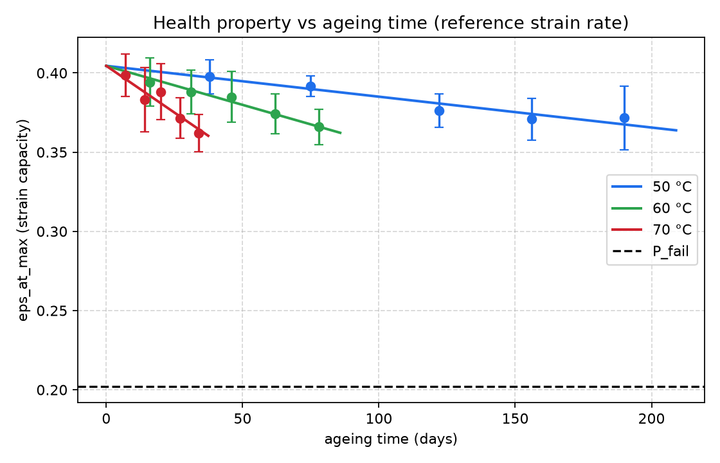
Figure 4. Health property (strain capacity) versus ageing time at the reference strain rate. Markers are replicate means ± 1 SD; solid lines are the fitted first-order kinetic model; the dashed line is the failure threshold P_fail.
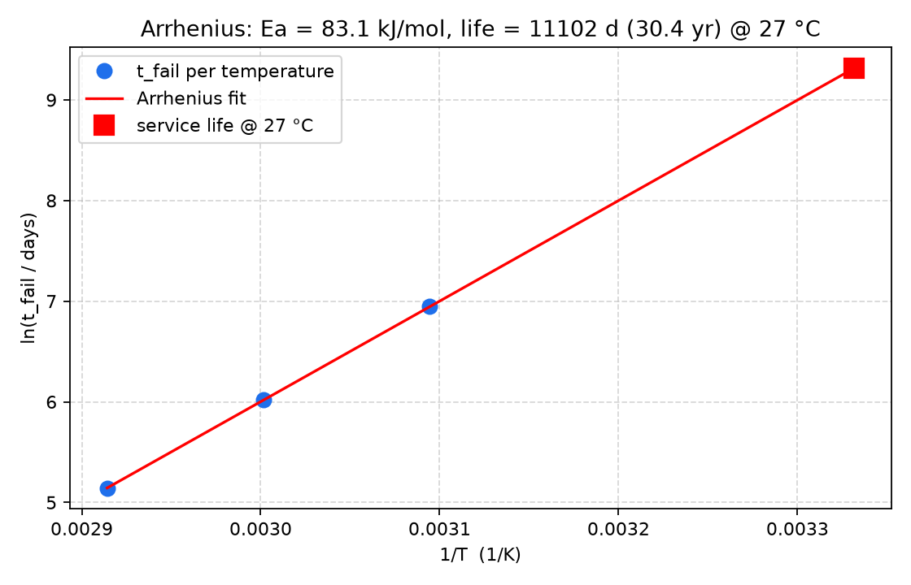
Figure 5. Arrhenius plot of ln(t_fail) versus 1/T. The fit recovers Eₐ ≈ 83 kJ/mol (ground truth 80) and extrapolates a 30-year service life at 27 °C.
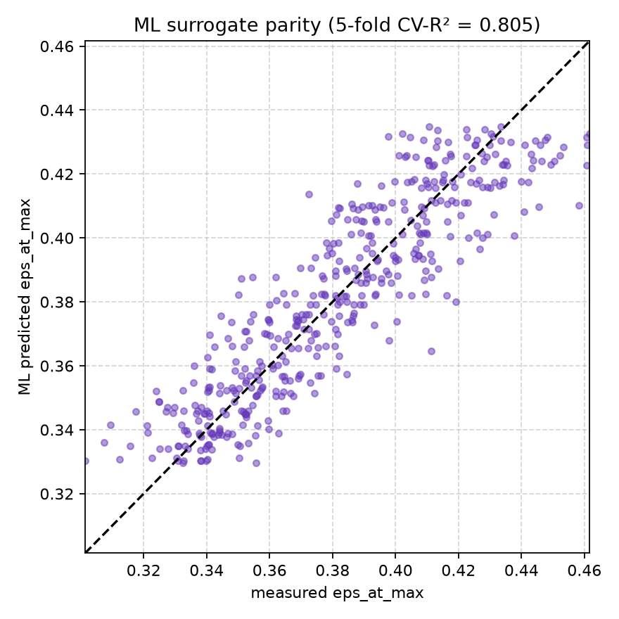
Figure 6. Cross-validated parity plot for the machine-learning surrogate (CV-R² ≈ 0.80); points cluster around the 1:1 line, confirming the surrogate generalises.
The pipeline recovers the ground-truth activation energy to within a few kJ/mol and predicts a service life of roughly 30 years at the 27 °C storage temperature, comfortably bracketing the literature shelf-life benchmark of ~13 years [10] for a hotter or more conservative duty cycle. One honest caveat: because the accelerated window only spans about 10 % of the property decay, the first-order asymptote P_inf is weakly identified (the optimiser drives it well below the physical floor while still fitting the data); the activation energy, per-temperature t_fail and extrapolated service life are nevertheless robust, because they depend on how the decay rate scales with temperature rather than on the far-field asymptote.

7.3 Models and formulas used
The pipeline chains together five models, each summarised below.

7.3.1 Feature extraction from the stress–strain curve
Each UTM curve is converted to engineering stress and strain using the specimen geometry (gauge length L₀ = 47.75 mm, area A₀ = 24 mm²):
σ = load / A₀ , ε = disp / L₀ (8)
From the (ε, σ) curve the code extracts: the tensile strength σ_max and the strain at peak stress ε_at_max; the initial modulus as the slope of a linear fit over the first 25 % of strain; a secant modulus at half the peak stress; the strain at break (where the stress first falls below 20 % of σ_max after the peak); and the toughness as the area under the curve up to break:
E ≈ dσ/dε |₀ , Toughness = ∫₀^ε_break σ dε (9)
The default health property whose decay defines end-of-life is the strain capacity ε_at_max, a direct measure of embrittlement (Section 1.2).

7.3.2 Global first-order Arrhenius kinetic model
The aggregated health property at the reference strain rate is fitted across all temperatures simultaneously with a first-order decay whose rate constant follows Arrhenius:
P(t, T) = P_∞ + (P₀ − P_∞) · exp( −k(T)·t ) (10)
k(T) = exp[ ln k_ref − (Eₐ·1000/R)·(1/T − 1/T_ref) ] (11)
The four parameters P₀ (pristine value), P_∞ (asymptote), ln k_ref (rate at the reference temperature T_ref) and Eₐ (activation energy) are found by non-linear least squares (multi-start fminsearch), with a penalty keeping Eₐ in the physical range 20–250 kJ/mol. Two alternative kinetic laws are also provided — a linear model P = P₀ + r(T)·t and a log-linear model P = exp(P₀ + r(T)·t) — both with an Arrhenius rate r(T).

7.3.3 Failure criterion and time-to-failure
End-of-life is reached when the health property falls to a fraction of its pristine value (default 50 %):
P_fail = f · P₀ (f = 0.5) (12)
Inverting the first-order model (Eq. 10) gives the time-to-failure at any temperature:
t_fail(T) = − ln[ (P_fail − P_∞)/(P₀ − P_∞) ] / k(T) (13)

7.3.4 Arrhenius extrapolation to the service temperature
Plotted as ln(t_fail) against 1/T, the time-to-failure is linear with slope Eₐ·1000/R (Figure 5), so the service life at the storage temperature T_s follows directly:
ln t_fail = b + (Eₐ·1000/R)·(1/T) , service life = t_fail(T_s) (14)

7.3.5 Cross-validated machine-learning surrogate
In parallel with the physics-based kinetics, the pipeline trains a data-driven surrogate that predicts the health property directly from (temperature, days, strain rate). It evaluates several learners — Gaussian-process regression, a bagged-tree ensemble, a support-vector machine, a robust linear model and a built-in polynomial-ridge fallback — by k-fold cross-validation and selects the one with the lowest cross-validated RMSE, reporting CV-RMSE and CV-R² (Figure 6). The surrogate captures the combined effect of strain rate and ageing that the single-rate kinetic fit omits, and provides an independent check on the kinetic time-to-failure.
As with Code 1, a Python reproduction (generate_pipeline_results.py) mirrors the synthetic generator, kinetic fit and ML surrogate so the figures and Table 3 can be regenerated without MATLAB.

8. Conclusion and Future Work
This report reviewed the main modelling families for solid-propellant aging and service-life prediction — cumulative-damage failure integrals, time–temperature superposition, viscoelastic finite-element analysis, chemical-aging kinetics, handbook/nomograph methods and non-destructive indicators — and consolidated their governing equations. Two codes were then implemented and explained: a compact Arrhenius / power-law screening model (Code 1) and a complete data-driven pipeline (Code 2) that extracts mechanical properties from tensile tests, trains a cross-validated machine-learning surrogate and fits global first-order Arrhenius kinetics. Both were reproduced in Python and yield reproducible predictions: Code 1 captures the strong, non-linear dependence of service life on storage temperature, while Code 2 recovers the ground-truth activation energy (≈ 83 vs 80 kJ/mol) and predicts a service life of order decades — results that agree in order of magnitude with published shelf-life estimates.
Recommended future work includes:
- letting the temperature dependence act on the failure time t_f directly, rather than through a constant-t_f × AF product, so the power-law and Arrhenius terms are fully coupled;
- calibrating Eₐ and n against measured accelerated-aging data and propagating their uncertainty (Monte-Carlo, after [1]);
- incorporating competing hardening/softening kinetics [10] and a non-monotonic property–time curve;
- coupling the material model to a viscoelastic finite-element grain model [3] using Prony-series inputs [9] to predict structural rather than property-based failure.

References
The following are representative of the works studied for this report and are cited in the text; they are a selected subset of the broader literature consulted on solid-propellant aging and service-life prediction.
[1] Biggs, G. L., Nestor, J. J., et al. Cumulative damage model for structural analysis of filled polymeric materials (US 6,301,970). The work provides a stress-based failure integral, regression-based parameter extraction, numerical integration, and Monte-Carlo estimation for failure prediction.
[2] Villar, L. D., and Rezende, L. C. Time-temperature superposition principle applied to thermally aged composite propellant. The paper shows how WLF shift factors can collapse tensile data into master curves and how aging changes are modest at short times but significant at long storage times.
[3] Yıldırım, H. C., and Özüpek, S. Structural assessment of a solid propellant rocket motor: Effects of aging and damage. The paper combines nonlinear viscoelastic finite-element analysis with thermal/pressure load cases to identify hoop strain and bond stress as governing failure indicators.
[4] Layton, L. H. Chemical structural aging studies on an HTPB propellant. The report links gel growth and mechanical-property drift to logarithmic aging time and highlights the influence of bonding-agent chemistry.
[5] Waterman, C. S., and Corley, R. C. Solid propellant aging studies. The report presents an early handbook-style treatment of aging, thermal cycling, and strain-based failure estimation for tactical propellant grains.
[6] Aerojet Solid Propulsion Company. Structural design nomograph for thermal cycling of tactical rocket propellants (NWC TM 3365). The handbook converts multiple geometric and material variables into rapid design estimates for thermal-cycling failure.
[7] Husband, D. M., and Roberto, F. Q. Solid propellant service life analysis via nondestructive testing (US 5,038,295). The patent uses dynamic mechanical properties as a nondestructive indicator of aging rate.
[8] Kunz, R. K. Characterization of solid propellant for linear cumulative damage modeling. The paper refines parameter determination for Laheru-type LCD models and cautions against bias in regression-based identification.
[9] Tapia-Romero, M. A., Dehonor-Gómez, M., and Lugo-Uribe, L. Prony series calculation for viscoelastic behavior modeling of structural adhesives from DMA data. The paper provides a practical route from frequency-domain data to relaxation-modulus parameters.
[10] Adel, W. M., and Liang, G. Service life prediction of AP/Al/HTPB solid rocket propellant with consideration of softening aging behavior. The paper captures the competing hardening and softening pathways and reports a shelf-life estimate around 13 years under the studied conditions.

Appendix A. Practical Decision Tree
The following decision tree summarises how the models in this report fit together in a practical service-life assessment workflow.
- Step 1 — Define requirement. Set the service temperature, the critical property and its failure threshold E_crit.
- Step 2 — Choose method by data availability. If only accelerated property data exist → use the Arrhenius / power-law model (Sections 4.1–4.2, Listing 1). If DMA/relaxation data exist → build a Prony-series + TTS master curve (Eqs. 5–6).
- Step 3 — Extract parameters. Fit Eₐ, n (and WLF C₁, C₂ if applicable) by regression; check for bias [8].
- Step 4 — Predict. Compute the acceleration factor and failure time; convert to service life. For structural margins, feed the material model into a viscoelastic FE grain model [3].
- Step 5 — Validate & monitor. Compare against handbook/nomograph estimates [5], [6] and against non-destructive aging indicators [7]; re-assess periodically over the stockpile life.

