PAYOUT-MANAGEMENT-SYSTEM / DOCS / LLD

Low-Level Design
ARCHITECTURE

Layered Structure
Routes handle HTTP only. Services hold all business logic. Models are the ORM layer. Schemas guard the API boundary.
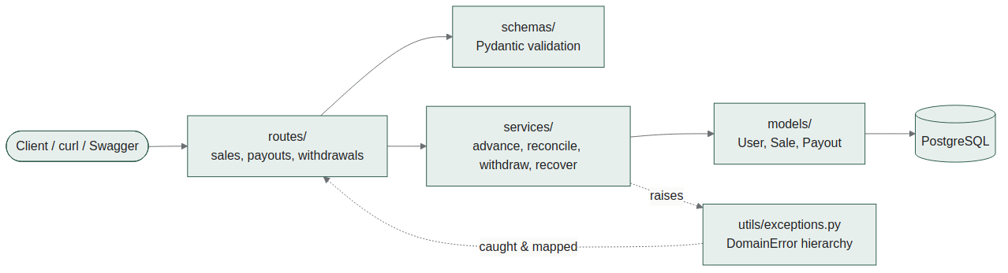
DESIGN RATIONALE

Business Rule Enforcement
How each of the four core rules from the assignment is enforced, at a glance.
RULE 1
Advance Payout Idempotency
Sale.advance_paid starts at 0 and is set once. The job's eligibility check is a single O(1) condition — safe to re-run any number of times.

RULE 2
Final Payout Calculation
Computed inside the same transaction that flips the sale's status. is_reconciled prevents the adjustment from ever being applied twice.

RULE 3
Withdrawal Cooldown
User.last_withdrawal_at checked against now minus 24h. No separate rate-limiter table needed — one timestamp column suffices.

QUESTION 2
Failed Payout Recovery
A status transition into a bad terminal state immediately credits the amount back, stamped with recovered_at. A batch sweep catches anything missed.

DATA INTEGRITY

Transaction Boundaries
Every balance-mutating operation commits atomically per unit of work.
Note: batch reconciliation runs the Reconciliation transaction once per sale independently — not wrapped in one outer transaction. See design-decisions.docx.
SCOPE

Explicitly Out of Scope
Kept out deliberately to match intern-level scope:
- Authentication / authorization (admin vs. user roles)
- Distributed locking across multiple concurrent job workers
- Real payment processor integration (simulated via status-update endpoint)
- Multi-currency / locale support

