PAYOUT-MANAGEMENT-SYSTEM / DOCS / CLASS-DESIGN

Class Design
Python doesn't force an OOP style for business logic. This project uses a hybrid: ORM entities are classes (SQLAlchemy models), while business logic lives in stateless service functions rather than service classes.
ORM LAYER

Model Classes
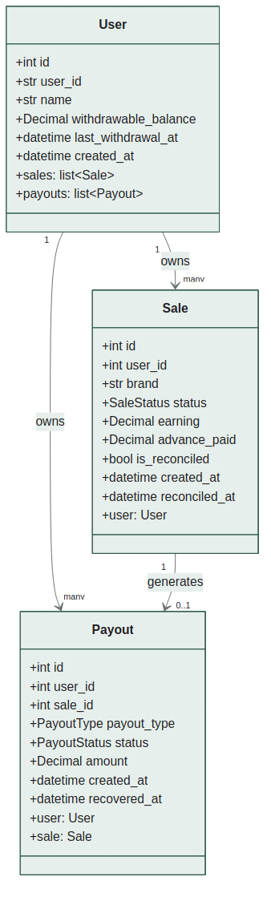
BUSINESS LOGIC

Service Layer Functions
Each service module is a stateless collection of functions taking a Session as an explicit parameter, rather than a class with injected dependencies.
Module | Function | Responsibility
advance_payout_service.py | run_advance_payout_for_user(db, user_id) | Pays 10% advance on eligible pending sales; idempotent
 | run_advance_payout_for_all_users(db) | Batch wrapper across all users
reconciliation_service.py | reconcile_sale(db, sale_id, status) | Reconciles one sale; computes and applies final adjustment
 | reconcile_sales_batch(db, user_id, list) | Reconciles multiple sales; aggregated summary
withdrawal_service.py | withdraw(db, user_id) | Withdraws full balance, enforcing 24h cooldown
recovery_service.py | update_payout_status(db, id, status) | Processor callback; auto-recovers on bad status
 | recover_unrecovered_failed_payouts(db, user_id) | Defensive batch sweep for missed recoveries

API BOUNDARY

Schema Classes
Pydantic BaseModel subclasses define request/response contracts, kept separate from ORM classes so internal-only fields are never accidentally leaked, and external IDs can differ in shape from internal foreign keys.
Key schema classes: SaleCreate, SaleResponse, SaleReconcileRequest, PayoutResponse, AdvancePayoutResult, FinalPayoutResult, UserCreate, UserResponse, WithdrawalRequest, WithdrawalResponse.
ERROR HANDLING

Exception Hierarchy
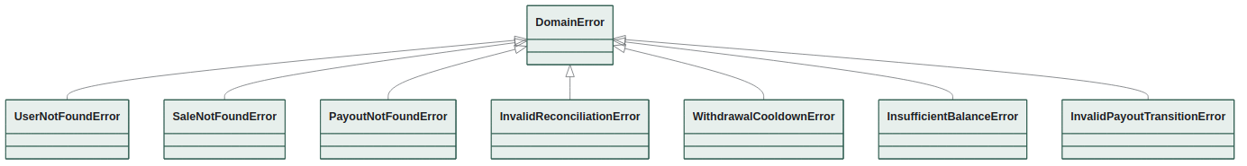
All inherit from a common DomainError base so main.py can register a single catch-all FastAPI exception handler as a defensive fallback, while individual routes still catch specific subclasses for precise HTTP status codes.
DESIGN CHOICE

Why Not Service Classes?
A more Java-influenced design might use AdvancePayoutService, ReconciliationService classes with __init__(self, db) and instance methods. This project intentionally avoids that pattern because:
- There's no per-instance state to hold — every function's only dependency is the db session, passed explicitly, matching how Depends(get_db) already works
- It keeps functions trivially unit-testable — call them directly with a test session, no class instantiation or mocking required
- Wrapping stateless functions in a class adds a layer of indirection without adding any actual encapsulation benefit here

