PAYOUT-MANAGEMENT-SYSTEM / DOCS / DATABASE-SCHEMA

Database Schema
SCHEMA

Entity-Relationship Diagram
One user has many sales and many payouts. A payout may optionally reference the sale that generated it — nullable for withdrawals, which draw from the aggregated balance rather than one sale.
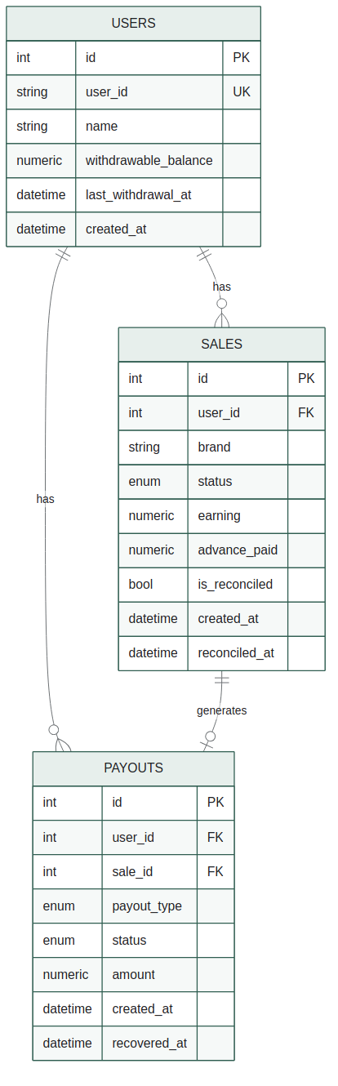
TABLES

Column-Level Detail
users
id | INTEGER PK
user_id | VARCHAR(100) UK
name | VARCHAR(255)
withdrawable_balance | NUMERIC(12,2)
last_withdrawal_at | TIMESTAMPTZ?
created_at | TIMESTAMPTZ

sales
id | INTEGER PK
user_id | FK -> users.id
brand | VARCHAR(100)
status | ENUM
earning | NUMERIC(12,2)
advance_paid | NUMERIC(12,2)
is_reconciled | BOOLEAN
reconciled_at | TIMESTAMPTZ?

payouts
id | INTEGER PK
user_id | FK -> users.id
sale_id | FK -> sales.id?
payout_type | ENUM
status | ENUM
amount | NUMERIC(12,2)
recovered_at | TIMESTAMPTZ?

PERFORMANCE

Indexing Map
Every index maps directly to a real query pattern in the service layer — no speculative indexing.
