# LEVEL 0 DFD

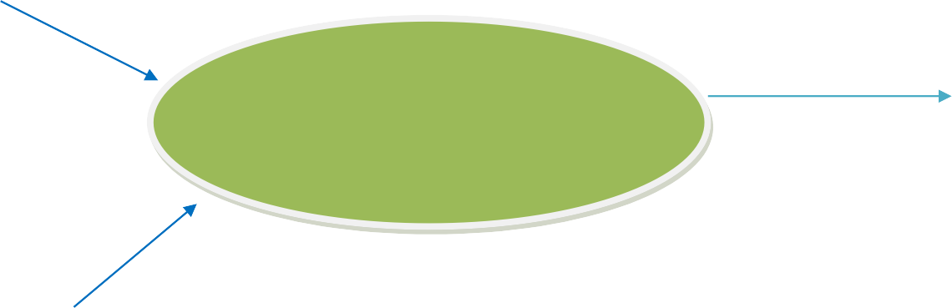

SYMMETRIC DECRYPTION

Plain Text

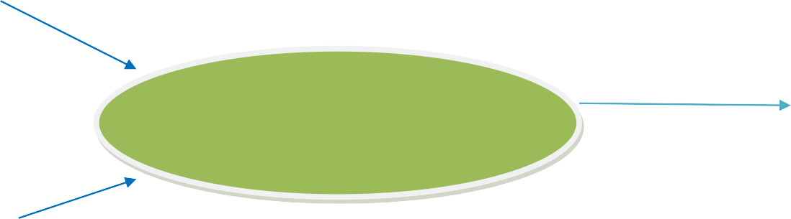

Cipher Text

SYMMETRIC ENCRYPTION

LEVEL 2 DFD

