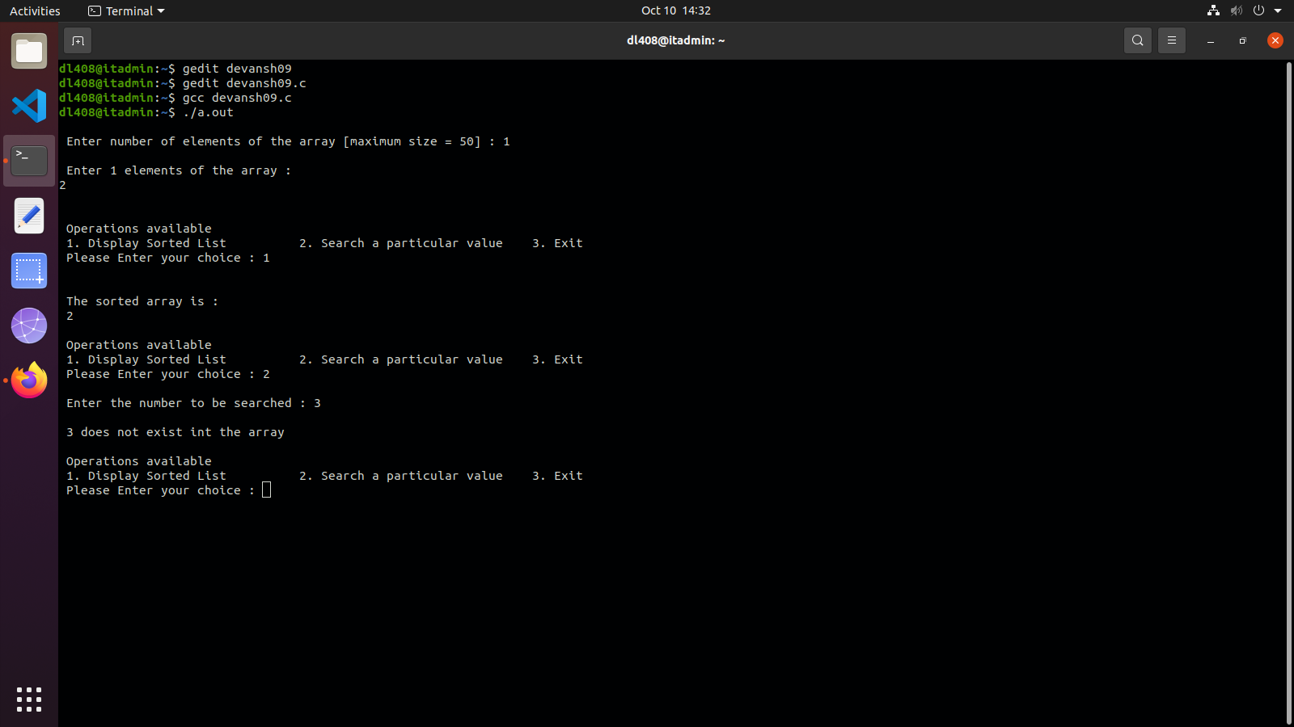
#include <stdio.h>
#include <stdlib.h>
void insertionSort(int arr[], int n);
void main()
{
int arr[50], i, n, x, choice, flag = 0;
printf("\n Enter number of elements of the array [maximum size = 50] : ");
scanf("%d", &n);
printf("\n Enter %d elements of the array : \n", n);
for (i = 0; i < n; i++)
{
scanf(" %d", &arr[i]);
}
insertionSort(arr, n);
do
{
printf("\n\n Operations available ");
printf("\n 1. Display Sorted List \t 2. Search a particular value \t 3. Exit");
printf("\n Please Enter your choice : ");
scanf("%d", &choice);
switch (choice)
{
case 1:
{
printf("\n\n The sorted array is : \n");
for (i = 0; i < n; i++)
{
printf(" %d \t", arr[i]);
}
break;
}
case 2:
{
printf("\n Enter the number to be searched : ");
scanf("%d", &x);
int beg = 0, end = n - 1, mid;
while (beg <= end)
{
mid = (beg + end) / 2;
if (arr[mid] == x)
{
printf("\n %d is present in the sorted array at index : %d", x, mid);
flag = 1;
break;
}
else if (arr[mid] > x)
{
end = mid - 1;
}
else
{
beg = mid + 1;
}
}
if (beg > end || flag == 0)
{
printf("\n %d does not exist int the array", x);
}
break;
}
case 3:
{
printf("\n Program Finished !! Thank You");
break;
}
default:
{
printf("\n Please enter a valid choice 1, 2, 3.");
}
}
} while (choice != 3);
}
void insertionSort(int arr[], int n)
{
int i, j, temp;
for (i = 1; i < n; i++)
{
temp = arr[i];
j = i - 1;
while ((temp < arr[j]) && (j >= 0))
{
arr[j + 1] = arr[j];
j--;
}
arr[j + 1] = temp;
}
}

