A PROJECT REPORT

ON

RANDOM PASSWORD GENERATOR

SUBMITTED IN PARTIAL FULLFILLMENT OF THE REQUIREMENT FOR THE IV SEMSTER

BACHELOR OF TECHNOLOGY

BY

DEVANSH RAUTELA

UNIVERSITY ROLL NO. 2018314

STUDENT ID 20111158



DEPARTMENT OF COMPUTER SCIENCE & ENGINEERING

GRAPHIC ERA HILL UNIVERSITY

DEHRADUN

2021-2022

DECLARATION

I, Devansh Rautela student of B-tech, semester 4, Department of Computer Science and Engineering, Graphic Era Hill University, Dehradun, declare that the technical project work entitled “Random Password Generator Using Python” has been carried out by me and submitted in partial fulfilment of the course requirements for the award of degree in B-tech of Graphic Era Hill University during the academic year 2021-22. The matter embodied in this synopsis has not been submitted to any other university or institution for the award of any other degree or diploma.

Date: 22/02/2022

CERTIFICATE

This is to certify that the project report entitled “Random Password Generator Using Python” is bonafide project work carried out by Devansh Rautela, University Roll No. 2018314, Student ID 200111158. In partial fulfilment of award of degree of B-Tech of Graphic Era Hill University, Dehradun during the academic year 2021-22. It is certified that all correction/suggestions indicated for internal assessment have been incorporated. The project has been approved as it satisfies the academic requirements associated with the degree mentioned.

ACKNOLEDGEMENT

Here by I am submitting the project on “Random Password Generator” as per the scheme of Graphic Era Hill University, Dehradun.

I would like to express our sincere gratitude to , Head of Dept. of Computer Science, for providing a congenial environment to work in and carry out our project.

I consider it mine cardinal duty to express the deepest sense of gratitude to Asst. Professor, Department of Computer Science and Application for the invaluable guidance extended at every stage and in every possible way.

I would like to also thanks Code With Harry Youtuber for helping me in better understanding each component of topic in an interesting way.

Finally, I am very much thankful to all the faculty members of the Department of Computer Science and Technology, friends and our parents for their constant encouragement, support and help throughout the period for their constant encouragement, support and help throughout the period of project conduction.

Devansh Rautela

University Roll No. 2018314

Student Id 200111158

**INTRODUCTION**

We know that passwords are a real security threat. To keep your account safe and prevent your password from being hacked you have to make your password hard enough that nobody can guess.

**Password Generator**

It is a tool that generates passwords based on the given guidelines that you set to create an unpredictable strong password for your accounts.

The Password generator tool creates a random and customized password for users that helps them to create a strong password which provides greater security.

**Password Generator Python Project**

The objective of this project is to create a password generator using python. The password generator project will be build using python modules like Tkinter, random, string, pyperclip.

In this project, the user has to select the password length and then click on the “Generate Password” button. It will show the generated password below. If the user clicks on the “Copy to Clipboard” button, then it will copy the password automatically.

**Project Prerequisites**

To build this project we will use the basic concept of python and libraries – Tkinter, pyperclip, random, string.

* **Tkinter** is a standard GUI library and is one of the easiest ways to build a GUI application.
* **pyperclip** module allows us to copy and paste text to and from the clipboard to your computer
* **The random** module can generate random numbers
* **String** module contains a number of functions to process the standard python string.
* For coding purpose Microsoft Visual Studio ide was used and code was written using python language.

**Project File Structure**

Let’s check the step to build a Password Generator using Python

* Import modules
* Initialized Window
* Select Password Length
* Define Functions

**Methodology**

Building up a project on Random Password Generator was a great piece of experience, it not only help me in getting me in gathering information about new technologies but also made me realize the use of programming in real life.

Discussing about how this learning process started and journey up to building up this project goes like this:

First of all we need to import libraries like tkinter, random, string, pyperclip considering you have already installed python and its related features like pip. Each of these libraries has its own feature from which some are used in building this project.

Then we need to Initialize Window which work as a interface for our application. We initialize window by using function like

* **Tk()** initialized tkinter which means window created
* **Geometry()** set the width and height of the window
* **Resizable(0,0)** set the fixed size of the window
* **Title()** set the title of the window

**Label()** widget use to display on or more than one line of text that users can’t able to modify.

* **root**  is the name which we refer to our window
* **text**  which we display on the label
* **font**  in which the text is written
* **pack**  organized widget in block

#### **Select Password Length**

* **pass_len** is an integer type variable that stores the length of a password.
* To select the password length we use **Spinbox()** widget.
* **Spinbox()** widget is used to select from a fixed number of values. Here the value from 8 to 32

#### **Function to Generate Password**

* **pass_str** is a string type variable that stores the generated password
* **password** = “” is the empty string
* First loop will generate a string of length 4 which is a combination of an uppercase letter, a lowercase letter, digits, and a special symbol and that string will store in password variable.
* The second loop will generate a random string of length entered by the user – 4 and add to the password variable. Here we minus 4 to the length of the user because we already generate the string of length 4.

We have done this because we want a password which must contain an uppercase, a lowercase, a digit, and a special symbol.

Now the password is set to the **pass_str()** variable.

* **Button()** widget used to display button on our window
* **command** is called when the button is click
* **Entry()** widget used to create an input text field
* **textvariable** used to retrieve the current text to the entry widget

**Function to Copy Password**

**pyperclip.copy()** used to copy the text to clipboard

Python Password Generator Output

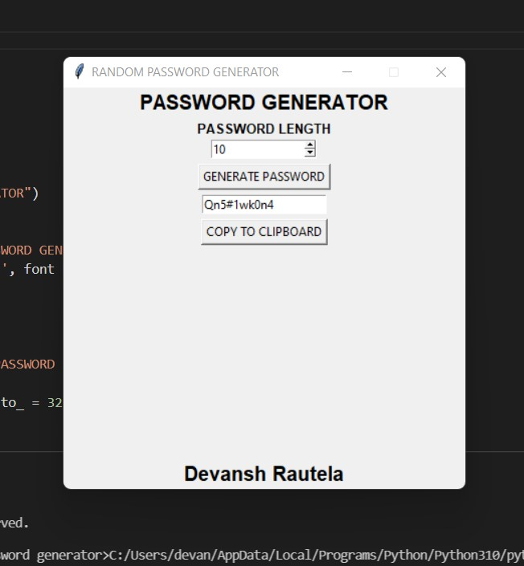

**Conclusion**

The completion of the project went quiet well, I learned much new thing s while I was building up it, and I get up to know various platforms which helps us to learn all this stuff. I was able to learn the practical use of python in making applications. The practical helped me to learn debugging of code, about popular tkinter library to redering graphics in our display window and I also learned about pyperclip and random library.

I learned how to create buttons, input textfield, labels, and spinbox. In this way, I successfully created random password generator python project.

Overall working on this project was great fun as I came up with great piece of knowledge and understanding of the topic.

Reference:

Youtube(Code With Harry)

Geeksforgeeks