INFORMATION TECHNOLOGY DEPARTMENT

AIPORT AUTHORITY OF INDIA

(MINISTRY OF CIVIAL AVIATION)

SAFDARJUNG AIRPORT, NEW DELHI- 110003



PROJECT REPORT

ON

**AIRPORT INFORMATION MANAGEMENT SYSTEM**

UNDER GUIDANCE OF:

**MR. V.K. Sharma**

Asst. General Manager

IT Department, AAI

SUBMITTED BY:

**Software Team : 16-A**

**DECLARATION**

I hereby declare that the project work entitled on “ Airport Information Management System “ is an authentic record of our own work carried out at IT DEPARTMENT , THE AIRPORT AUTHORITY OF INDIA as requirement of 6 weeks internship training for the industrial experience of Btech under the guidance of Mr. VK Sharma , Assistant General Manager, IT Department , Airport Authority of India by the following students:

Mr. Bhaviya Batra

Mr. Prashant Gujela

Mr. Amit Kumar

Ms. Sanya Arora

Mr. Devansh Sachdeva

Mr . Manpreet Singh Ahluwalia

DATE:

SIGNATURE:

**ACKNOWLDEGEMENT**

We are grateful to the authorities of at IT DEPARTMENT, AAI for having permitted us to go ahead with the project on “AIRPORT INFORMATION MANAGEMEMT SYSTEM” for industrial experience on Python Platform and other fundamentals used in IT.

We are thankful to MR V.K Sharma, Assistant General Manager , IT Department , Airport Authority of India for his valuable guidance and advice during the course if this project.

**ORGANIZATION PROFILE**

Airports Authority of India (AAI) was constituted by an Act of Parliament and came into being    on 1st April 1995 by merging erstwhile National Airports Authority and International Airports    Authority of India. The merger brought into existence a single Organization entrusted with the    responsibility of creating, upgrading, maintaining and managing civil aviation infrastructure both    on the ground and air space in the country.

AAI manages 125 airports, which include 18 International Airport, 07 Customs Airports, 78    Domestic Airports and 26 Civil Enclaves at Defense airfields. AAI provides air navigation services over 2.8 million square nautical miles of air space. During the year 2013-14, AAI    handled aircraft movement of 1536.60 Thousand [International 335.95 & Domestic 1200.65],    Passengers handled 168.91 Million [International 46.62 & Domestic 122.29] and the cargo    handled 2279.14 thousand MT [International 1443.04 & Domestic 836.10].

1. **PassengerFacilities**  
   The main functions of AAI inter-alia include construction, modification & management of passenger terminals, development & management of cargo terminals, development & maintenance of apron infrastructure including runways, parallel taxiways, apron etc., Provision of Communication, Navigation and Surveillance which includes provision of DVOR / DME, ILS, ATC radars, visual aids etc., provision of air traffic services, provision of passenger facilities and related amenities at its terminals thereby ensuring safe and secure operations of aircraft, passenger and cargo in the country.
2. **AirNavigationServices**  
   In tune with global approach to modernization of Air Navigation infrastructure for seamless navigation across state and regional boundaries, AAI has been going ahead with its plans for transition to satellite based Communication, Navigation, Surveillance and Air Traffic Management. A number of co-operation agreements and memoranda of co-operation have been signed with US Federal Aviation Administration, US Trade & Development Agency, European Union, Air Services Australia and the French Government Co-operative Projects and Studies initiated to gain from their experience. Through these activities more and more executives of AAI are being exposed to the latest technology, modern practices & procedures being adopted to improve the overall performance of Airports and Air Navigation Services.  
   Induction of latest state-of-the-art equipment, both as replacement and old equipments and also as new facilities to improve standards of safety of airports in the air is a continuous process. Adoptions of new and improved procedure go hand in hand with induction of new equipment. Some of the major initiatives in this direction are introduction of Reduced Vertical Separation Minima (RVSM) in India air space to increase airspace capacity and reduce congestion in the air; implementation of GPS And Geo Augmented Navigation (GAGAN) jointly with ISRO which when put to operation would be one of the four such systems in the world.
3. **Security**  
   The continuing security environment has brought into focus the need for strengthening security of vital installations. There was thus an urgent need to revamp the security at airports not only to thwart any misadventure but also to restore confidence of traveling public in the security of air travel as a whole, which was shaken after 9/11 tragedy. With this in view, a number of steps were taken including deployment of CISF for airport security, CCTV surveillance system at sensitive airports, latest and state-of-the-art X-ray baggage inspection systems, premier security & surveillance systems. Smart Cards for access control to vital installations at airports are also being considered to supplement the efforts of security personnel at sensitive airports.
4. **Aerodrome Facilities**  
   In Airports Authority of India, the basic approach to planning of airport facilities has been adopted to create capacity ahead of demand in our efforts. Towards implementation of this strategy, a number of projects for extension and strengthening of runway, taxi track and aprons at different airports has been taken up. Extension of runway to 7500 ft. has been taken up to support operation for Airbus-320/Boeing 737-800 category of aircrafts at all airports.
5. **HRD Training**  
   A large pool of trained and highly skilled manpower is one of the major assets of Airports Authority of India. Development and Technological enhancements and consequent refinement of operating standards and procedures, new standards of safety and security and improvements in management techniques call for continuing training to update the knowledge and skill of officers and staff. For this purpose AAI has a number of training establishments, viz. NIAMAR in Delhi, CATC in Allahabad, Fire Training Centres at Delhi & Kolkata for in-house training of its engineers, Air Traffic Controllers, Rescue & Fire Fighting personnel etc. NIAMAR & CATC are members of ICAO TRAINER program under which they share Standard Training Packages (STP) from a central pool for imparting training on various subjects. Both CATC & NIAMAR have also contributed a number of STPs to the Central pool under ICAO TRAINER program. Foreign students have also been participating in the training program being conducted by these institution
6. **IT_Implementation**  
   Information Technology holds the key to operational and managerial efficiency, transparency and employee productivity. AAI initiated a program to indoctrinate IT culture among its employees and this is most powerful tool to enhance efficiency in the organization. AAI website with domain name www.airportsindia.org.in or www.aai.aero is a popular website giving a host of information about the organization besides domestic and international flight information of interest to the public in general and passengers in particular.

**The functions of AAI are as follows:**

1. Design, Development, Operation and Maintenance of international and domestic airports and civil enclaves.
2. Control and Management of the Indian airspace extending beyond the territorial limits of the country, as accepted by ICAO.
3. Construction, Modification and Management of passenger terminals.
4. Development and Management of cargo terminals at international and domestic airports.
5. Provision of passenger facilities and information system at the passenger terminals at airports.
6. Expansion and strengthening of operation area, viz. Runways, Aprons, Taxiway etc.
7. Provision of visual aids.
8. Provision of Communication and Navigation aids, viz. ILS, DVOR, DME, Radar etc.

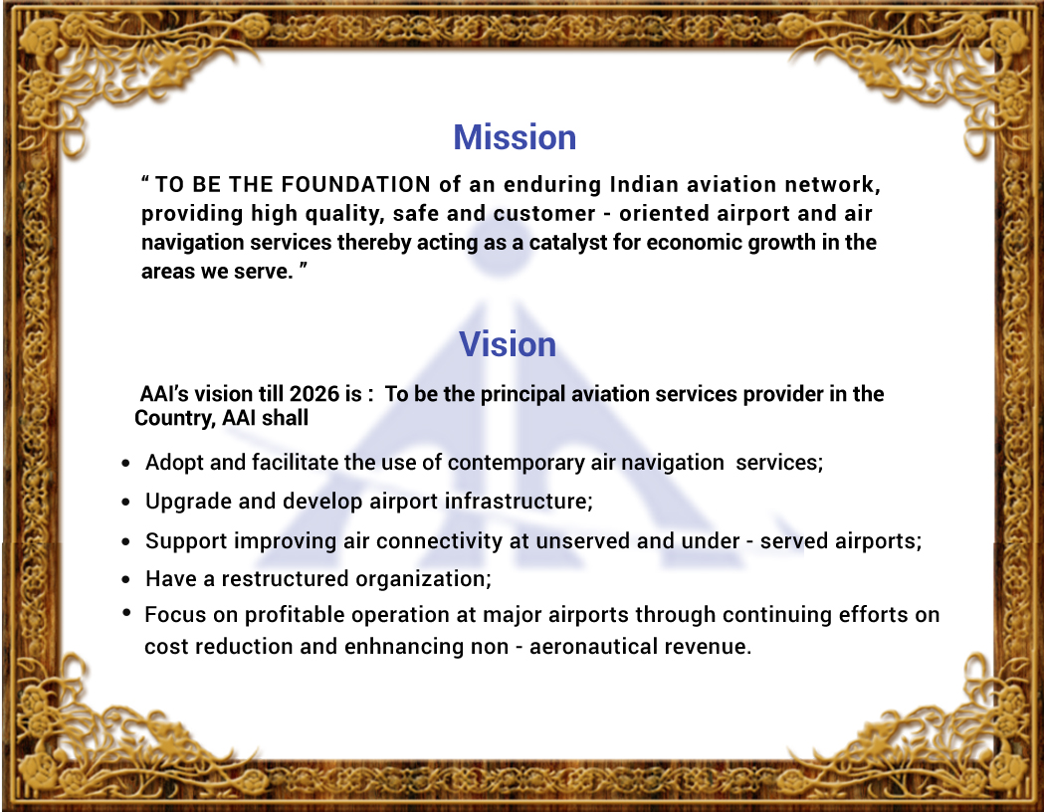

ORGANIZATIOAL STRUCTURE

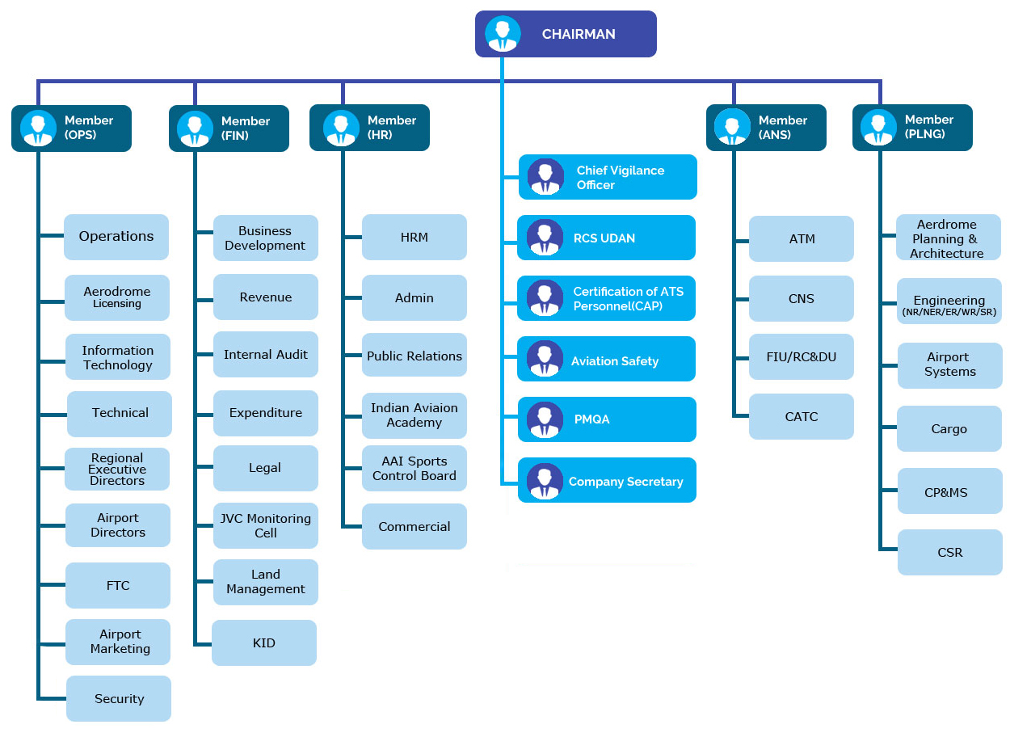

**INFORMATION TECHNOLOGY DEPARTMENT**

Function of IT Department:

1. Development and hosting of AAI website and website management. Use of web based Information Technology as a strategic business tool to improve the business process and efficiency of the organization.
2. Maintenance & Provision of Internet / Intranet services to all the sections and executives of AAI on need basis of enterprise.
3. Provision of corporate email services to all the employees of AAI as a means of professional communication mechanism.
4. Ensuring the availability of all critical applications for AAI officials and general public on intranet of things.
5. Procurement, implementation , integration & standardization of IT systems.
6. Integration of all existing and upcoming systems with AAI Intranet.
7. Planning, development of Centralized softwares like AAI website, ERP, OPMS, GLAMS and Web enabled Application Software.
8. Assessment and planning of IT related Training and in-house application development.
9. Implementation & operation of ERP system in Finance , HR , Material Management and project system.
10. Implementation of E-Tendering and Procurement System ( E-TAPS) for brining transparency to the process.

Table of Contents

1. Abstract…………………………………………………………………….11
2. Introduction…………………………………………………………….. 12
3. Training Description…………………..……………………………..13
4. ER Diagram…………..…………………………………………………..19
5. Project Screenshots…………………………………………………..25
6. Analysis……………..……………………………………………………..30
7. Conclusion..………………………………………………………………30
8. Bibliography…………………..…………………………………………31

List of Figures

1. Figure 1……………………………………………………………….17
2. Figure 2……………………………………………………………… 18
3. Figure 3…………………..……………………………..…………..19

**ABSTRACT**

Airport Information Management System deals with all the information related to the airports starting from terminals to the flights scheduled.

Airport Information Management System is a really big system to work on so this project mainly deals with flight scheduling and all the things related to it. This is basically designed with Admin (backend) perspective. The admin gets a mail on logging into the system, after that he/she fills in the details for Operators, Aircraft type, locations and then schedules a departure or an arrival of flight.

The output is the Schedule of arrived and departed Flights.

**INTRODUCTION**

Airport Information Management System is a web application managed by a single person, which is developed for Airport Authority of India. A national organization devoted in all round development of Civil Aviation Infrastructure of India.

This project is aimed at developing an online application for providing a computer based flight scheduling and tracking. This application can be accessed through proper login over a network, only the authenticated user can access the contents and password is stored as cipher text. All the records getting stored related to different fields have unique ids assigned to them so that they are easily fetched on for later use.

This project was carried out in the IT department of the Airport Authority of India. My position for carrying out this project was that of Full stack developer (front –end plus backend ). The engineering aspects that I learnt during the internship are html, css, JavaScript, bootstrap, JQuery Django and SQLite for database connectivity.

**TRAINING DESCRIPTION**

Training in Airport Authority Of India started with an orientation program on first day headed by senior officials of IT Department of AAI. Mr. V.K Sharma sir briefed us everything about the Airport Authority of India and its working, functioning of IT department and roles of IT department in flying of airplanes. We were told about how communication takes place between ATC and the pilots. After this the project “Airport Information Management System” was allotted. The main aim of the project was to display schedules of flights and store then in a database and store many other technical details related to airport and flights.   
Third day we were briefed by Rahul Sir about the AIMS project and as he told us AIMS has more than 10 modules under it, so we were only concerned with flight scheduling part. This module was also a big challenge to complete in 6 weeks internship as it involved front end and backend technical skills.

First three weeks involved the learning html, css, JavaScript, JQuery and bootstrap and implementing them to design the templates and forms for later backend use. This was followed by hands on experience in Data Center of the AAI (Safdarjung Airport). There we were told about the types of servers used in AAI, how servers are monitored, how it is made sure that security of these servers and networks is maintained. We were shown the different servers in the Data Center and functioning of each server was told.

Later three weeks involved working on the backend – Django Framework. This consumed the most of the time as learning a framework for the first time and implementing it side by side on a project was a very tough challenge. We had to show our progress every week to Mr. V.K Sharma and he told how we could improve upon our work and told us different requirements to work upon keeping in mind the current demands of the industry in technical field.

The project has an admin side, who has the authority to add more user to access the AIMS system to work upon. The user working needs to fill in the details about the New Operator, New Location , Aircraft Type ,New Aircraft and finally he/she can enter details about the flight which to be scheduled.

***HTML AND CSS***

**Hypertext Markup Language** (**HTML**) is the standard markup language for creating web pages and web applications. With Cascading Style Sheets (CSS) and JavaScript, it forms a triad of cornerstone technologies for the World Wide Web

Web browsers receive HTML documents from a web server or from local storage and render the documents into multimedia web pages. HTML describes the structure of a web page semantically and originally included cues for the appearance of the document.

**Cascading Style Sheets** (**CSS**) is a style sheet language used for describing the presentation of a document written in a markup language like HTML. CSS is a cornerstone technology of the World Wide Web, alongside HTML and JavaScript.

CSS is designed to enable the separation of presentation and content, including layout, colors, and fonts. This separation can improve content accessibility, provide more flexibility and control in the specification of presentation characteristics, enable multiple web pages to share formatting by specifying the relevant CSS in a separate .css file, and reduce complexity and repetition in the structural content.

***JAVASCRIPT***

**JavaScript** often abbreviated as **JS**, is a high level, interpreted programming language. It is a language which is also characterized as dynamic, weakly typed, prototype-based and multi-paradigm.

Alongside HTML and CSS, JavaScript is one of the three core technologies of the World Wide Web. JavaScript enables interactive web pages and thus is an essential part of web applications. The vast majority of websites use it, and all major web browsers have a dedicated JavaScript engine to execute it.

Features:

* Universal Support
* Imperative and Structured
* Dynamic
* Prototype-based
* Delegative

***Bootstrap***

**Bootstrap** is a free and open-source front-end framework (library) for designing websites and web applications. It contains HTML- and CSS-based design templates for typography, forms, buttons, navigation and other interface components, as well as optional JavaScript extensions. Unlike many web frameworks, it concerns itself with front-end development only.

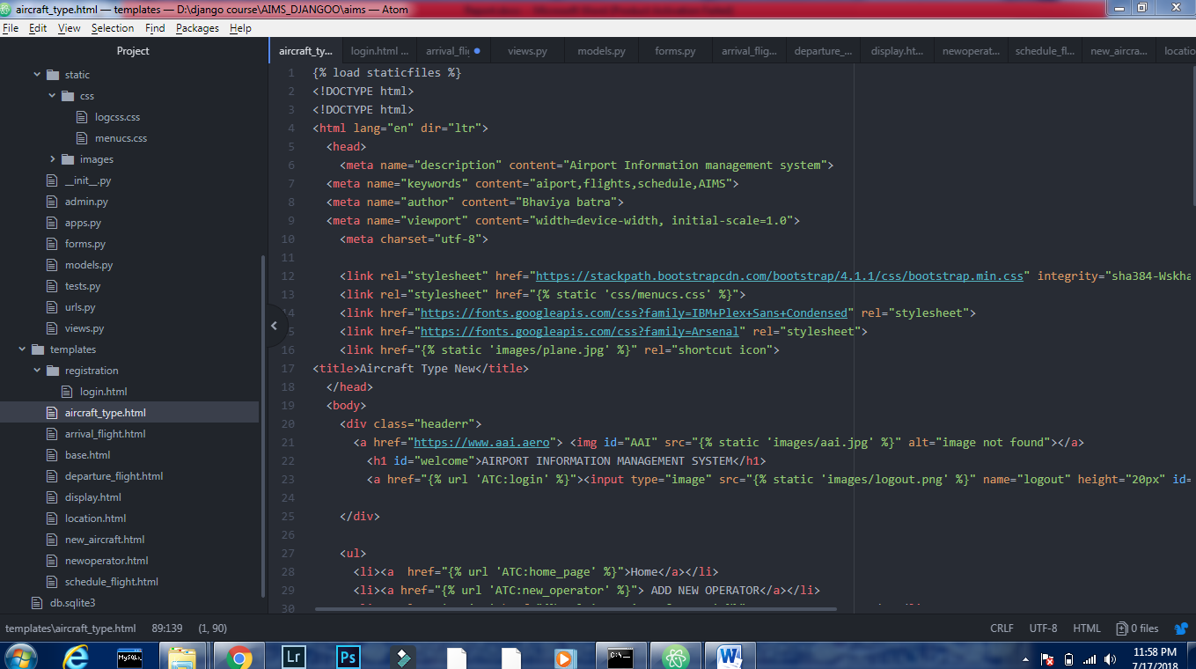

Html and Js code snapshot

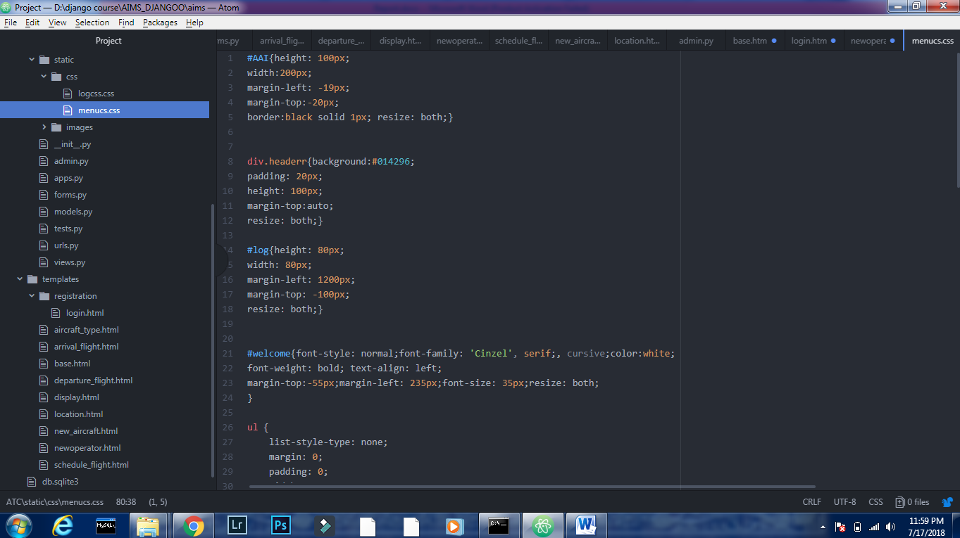

Css file snapshot

***Django-Framework***

**Django** is a free and open-source web framework, written in Python, which follows the model-view-template (MVT) architectural pattern. It is maintained by the Django Software Foundation (DSF), an independent organization established as a 501(c)(3) non-profit.

Django's primary goal is to ease the creation of complex, database-driven websites. Django emphasizes reusability and "pluggability" of components, less code, low coupling, rapid development, and the principle of don't repeat yourself. Python is used throughout, even for settings files and data models. Django also provides an optional administrative create, read, update and delete interface that is generated dynamically through introspection and configured via admin models.

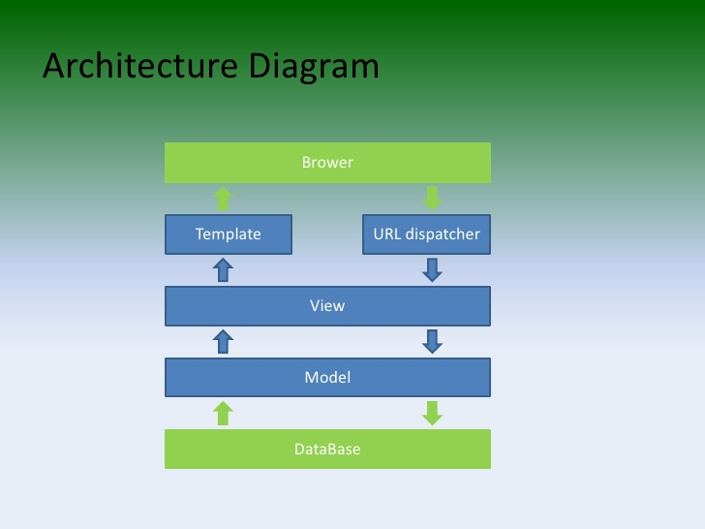

Figure 1

***SQLite***

**SQLite** is a relational database management system contained in a C programming library. In contrast to many other database management systems, SQLite is not a client–server database engine. Rather, it is embedded into the end program.

SQLite is ACID-compliant and implements most of the SQL standard, using a dynamically and weakly typed SQL syntax that does not guarantee the domain integrity.

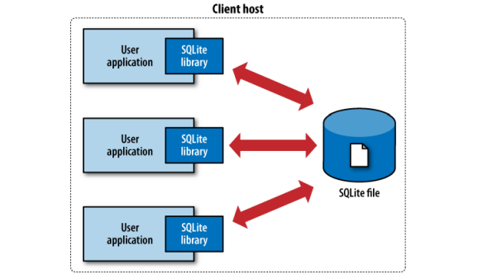

Figure 2

**ER-Diagram**

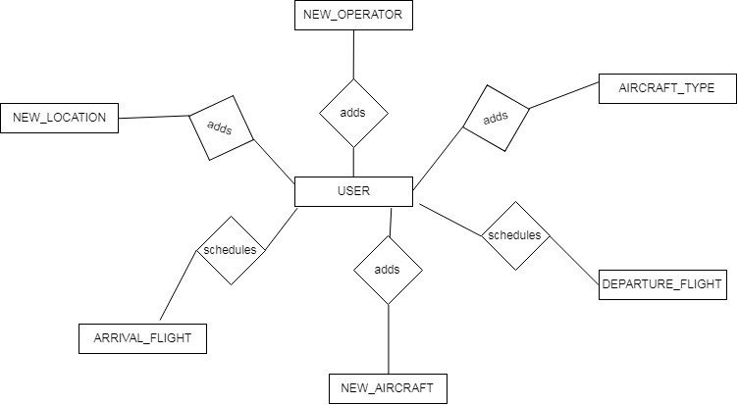

Figure 3

*List of Entities and attributes*

1.NEW_OPERATOR

Attributes:

1. Operator_Name=CharField(max_length=50)
2. Operator_Code= CharField(max_length=50)
3. Phone=CharField(max_length=50)
4. Email= EmailField()
5. Category= CharField(max_length=20)
6. Free_Facility=CharField(max_length=20)
7. Operator_Type= CharField(max_length=20 ,primary_key=True)
8. ROF=CharField(max_length=20)
9. Security_Deposit= IntegerField()
10. Credit_Facility= CharField(max_length=20)
11. PAN_Number=CharField(max_length=50)
12. TAN_Number=CharField(max_length=50)
13. AGC=CharField(max_length=20)
14. Scheduled= CharField(max_length=20)
15. Service_Tax_Reg_No= CharField(max_length=50)
16. Counter_Category= CharField(max_length=20)
17. No_of_Counter_Alloted= IntegerField(default=0)
18. No_of_Own_Counter=.IntegerField(default=0)
19. Monthly_CC_Category= CharField(max_length=20)
20. FAX_NO=CharField(max_length=50)
21. Contact_Person=CharField(max_length=50)
22. GSA_Details=CharField(max_length=50)
23. Use_of_AAI_XRAY=BooleanField(default=False)
24. Use_of_Common_Counter=BooleanField(default=False)
25. Use_of_AAI_Housing=BooleanField(default=False)
26. Use_of_AAI_Parking=BooleanField(default=False)
27. Aero_Bridge=BooleanField(default=False)
28. Include_PSF_in_charge_Bill=BooleanField(default=False)
29. Common_Billing_For_SN=BooleanField(default=False)
30. Common_Charges_for_All_Aircrafts=BooleanField(default=False)
31. Applicable_for_PSF_Discount=BooleanField(default=False)
32. Applicable_for_UDF_Discount=BooleanField(default=False)
33. Use_Ambulift=BooleanField(default=False)
34. Address=TextField(max_length=150)

2. NEW_LOCATION

Attributes:

1. Location_Name=CharField(max_length=50)
2. Location_Code=CharField(max_length=50)
3. IATA_Code=CharField(max_length=50)
4. Location_type=CharField(max_length=20)
5. Airport_Type=CharField(max_length=20)
6. Division=CharField(max_length=20)
7. Region=CharField(max_length=20)
8. Status=CharField(max_length=20)
9. TNLC_DISCOUNT=BooleanField(default=False)
10. ILS=BooleanField(default=False)
11. Uncontrolled=BooleanField(default=False)
12. PCM_Seg=BooleanField(default=False)
13. Address=TextField(max_length=150)

3.AIRCRAFT_TYPE

Attributes:

1. Type_Indentifier=CharField(max_length=50)
2. Long_Name=CharField(max_length=50)
3. Short_Name=CharField(max_length=50)
4. Seating_Capacity=IntegerField()
5. Max_Weight=CharField(max_length=50)
6. Wing_Span=CharField(max_length=50)
7. Gear_Span=CharField(max_length=50)
8. helicopter=BooleanField(default=False)
9. supersonic=BooleanField(default=False)

10.Remarks=TextField(max_length=150)

*4.NEW_AIRCRAFT*

*Attributes:*

1. Registration_Number=CharField(primary_key=True,max_length=50)
2. Max_Weight=CharField(max_length=50)
3. Aircraft_Type=CharField(max_length=20)
4. Registration_Type=CharField(max_length=20)
5. Operator_Code=CharField(max_length=50)
6. Seating_capacity=IntegerField()
7. LCN=CharField(max_length=50)
8. Height=DecimalField(max_digits=10,decimal_places=5)
9. Owner_Name=CharField(max_length=50)
10. Leased_From=CharField(max_length=50)
11. Valid_From=DateField()
12. Valid_Till=DateField()
13. Reference_Number=CharField(max_length=50)
14. Cargo=BooleanField(default=False)
15. Supersonic=BooleanField(default=False)
16. File_Upload=FileField()
17. Remarks=TextField(max_length=150)

*5. ARRIVAL_FLIGHT*

*Attributes:*

1. Nature_Of_Flight=CharField(max_length=20)
2. Schedule_Category=CharField(max_length=20)
3. Schedule_Type=CharField(max_length=20)
4. Aircraft_Type=CharField(max_length=20)
5. RCS_Flight=CharField(=max_length=20)
6. Valid_From=DateField(
7. Valid_Till=DateField()
8. Flight_Number=CharField(max_length=50,primary_key=True)
9. Operator_Code=CharField(max_length=50)
10. Departure_Location=CharField(max_length=50)
11. Flight_Status=CharField(max_length=50,null=True)
12. Scheduled_Time=TimeField()
13. Route=CharField(max_length=50)
14. Mon=BooleanField(default=False)
15. Tue=BooleanField(default=False)
16. Wed=BooleanField(default=False)
17. Thu=BooleanField(default=False)
18. Fri=BooleanField(default=False)
19. Sat=BooleanField(default=False)
20. Sun=BooleanField(default=False)

*5. DEPARTURE_FLIGHT*

*Attributes:*

1. Nature_Of_Flight=CharField(max_length=20)
2. Schedule_Category=CharField(max_length=20)
3. Schedule_Type=CharField(max_length=20)
4. Aircraft_Type=CharField(max_length=20)
5. RCS_Flight=CharField(=max_length=20)
6. Valid_From=DateField(
7. Valid_Till=DateField()
8. Flight_Number=CharField(max_length=50,primary_key=True)
9. Operator_Code=CharField(max_length=50)
10. ARRIVAL_Location=CharField(max_length=50)
11. Flight_Status=CharField(max_length=50,null=True)
12. Scheduled_Time=TimeField()
13. Route=CharField(max_length=50)
14. Mon=BooleanField(default=False)
15. Tue=BooleanField(default=False)
16. Wed=BooleanField(default=False)
17. Thu=BooleanField(default=False)
18. Fri=BooleanField(default=False)
19. Sat=BooleanField(default=False)
20. Sun=BooleanField(default=False)

**PROJECT SCREENSHOTS**

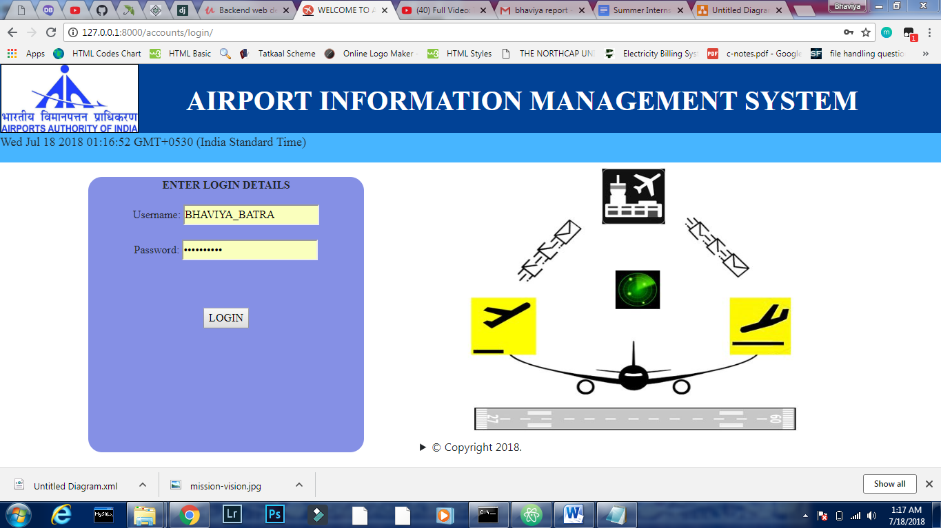

Login Page

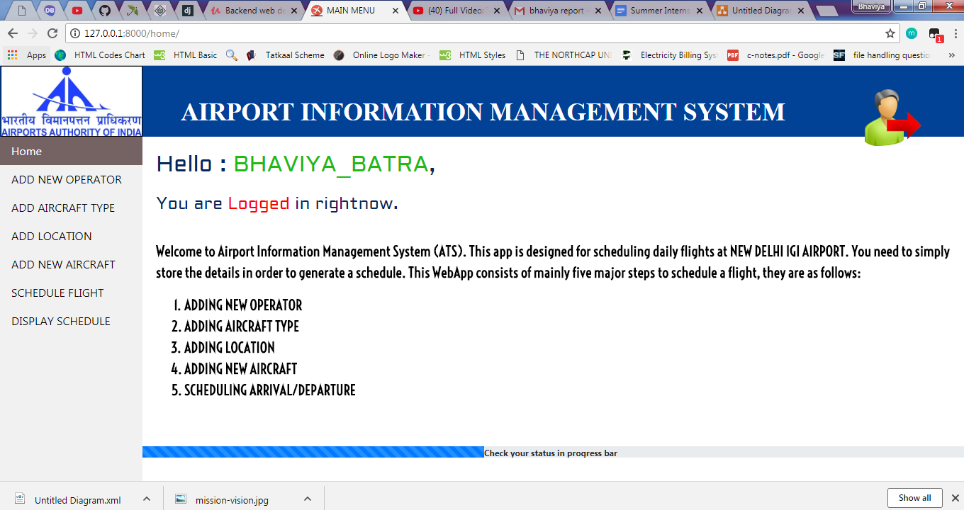

Home page

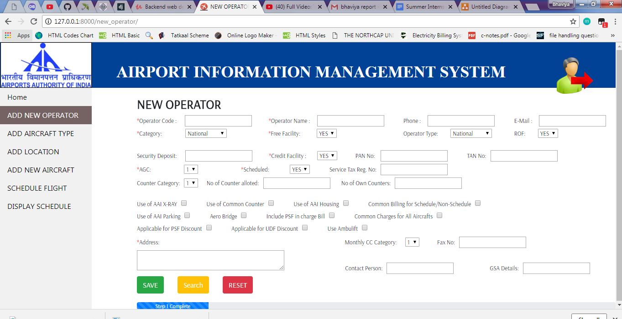

New Operator Page

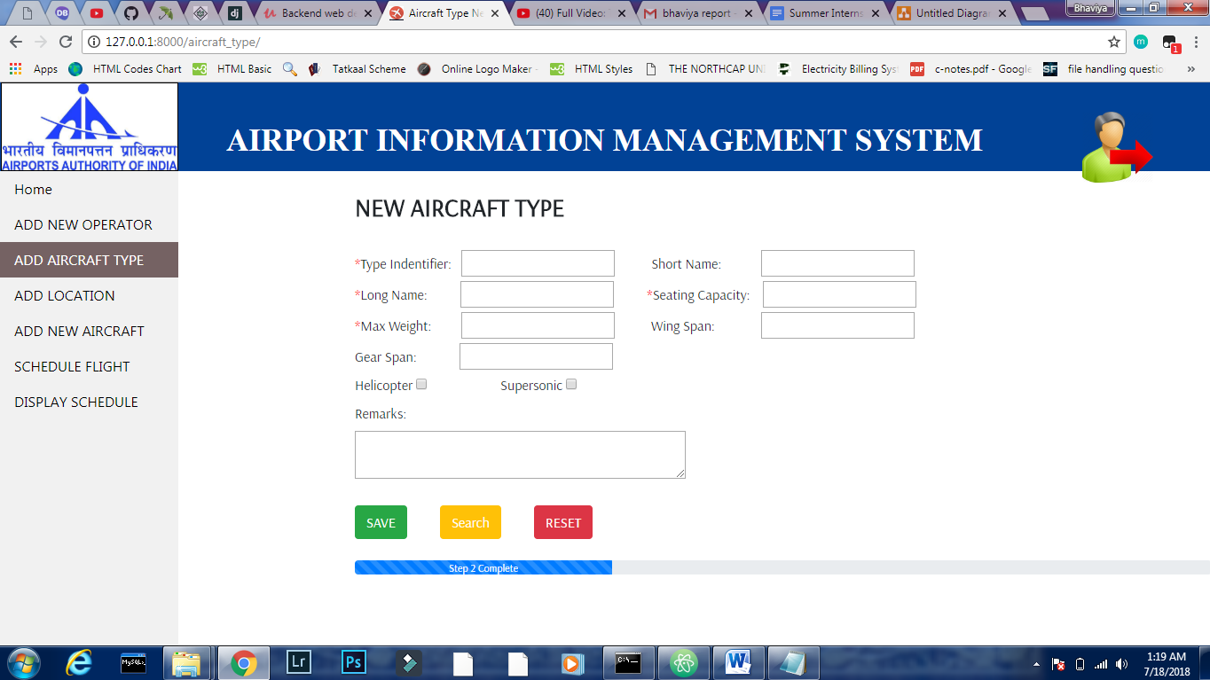

Aircraft type Page

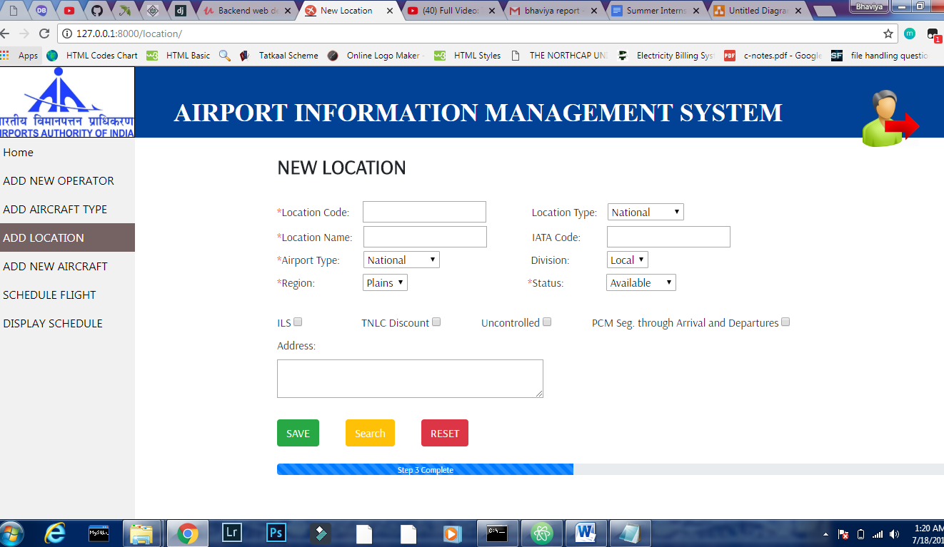

Location Page

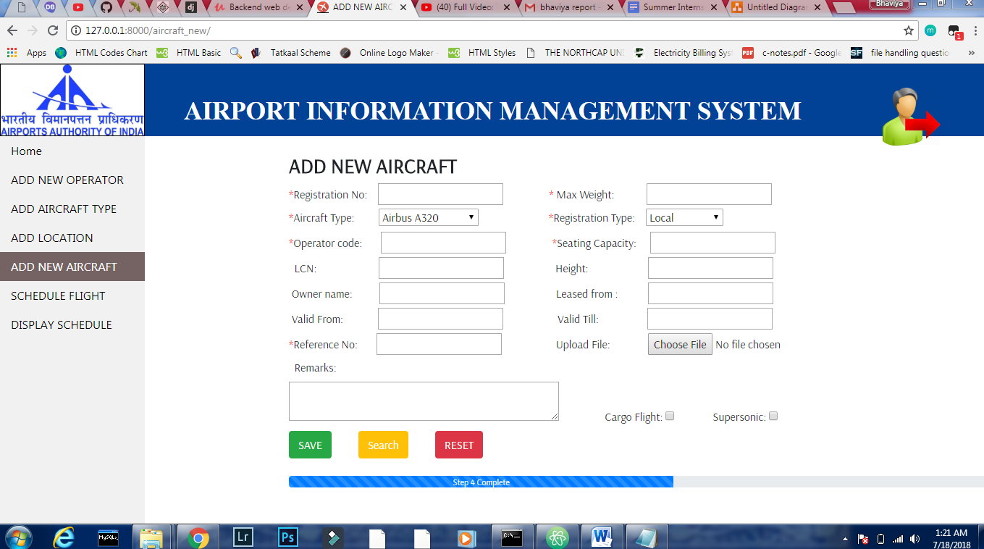

New Aircraft Page

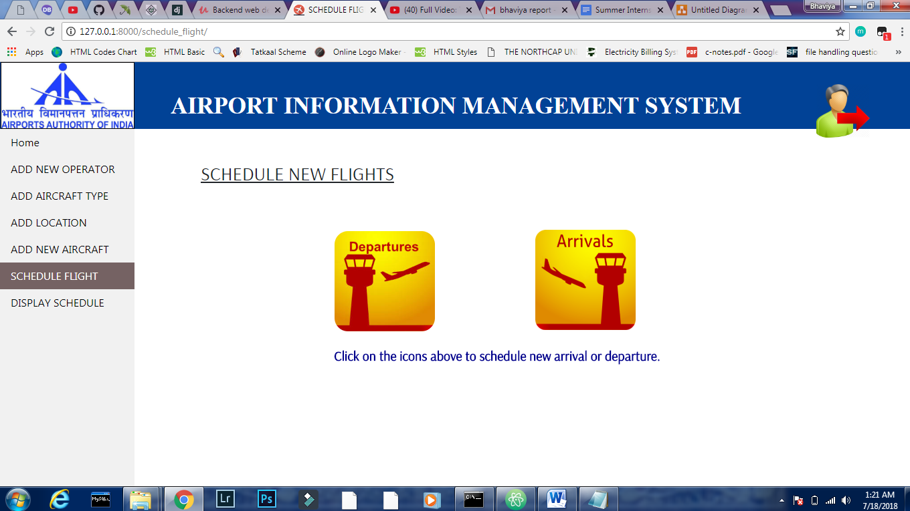

Schedule Flight Page

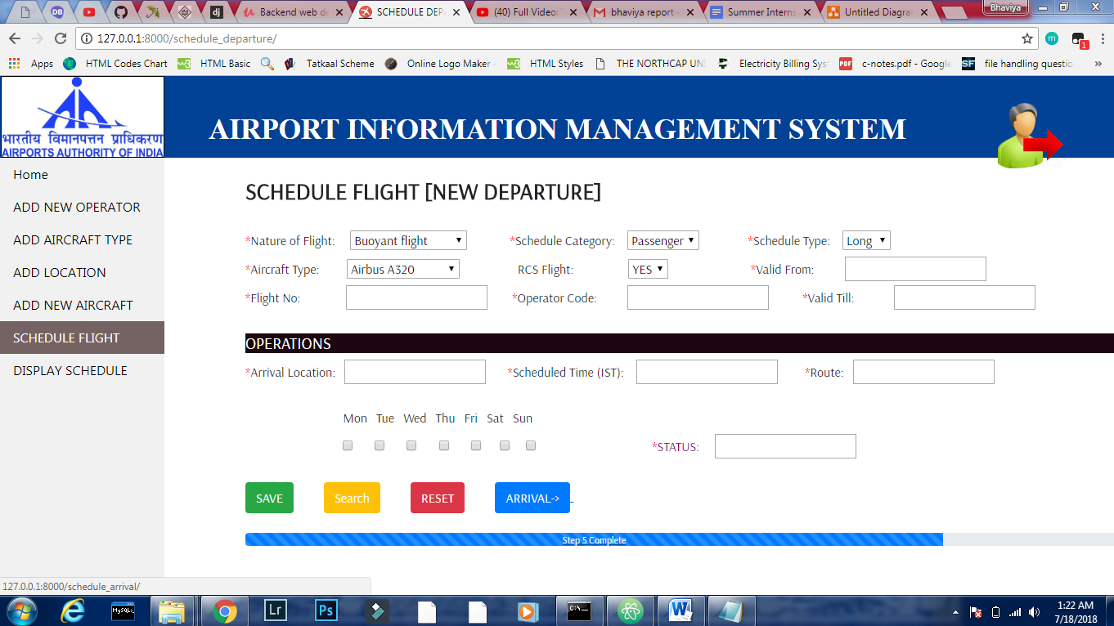

Schedule Departure Page

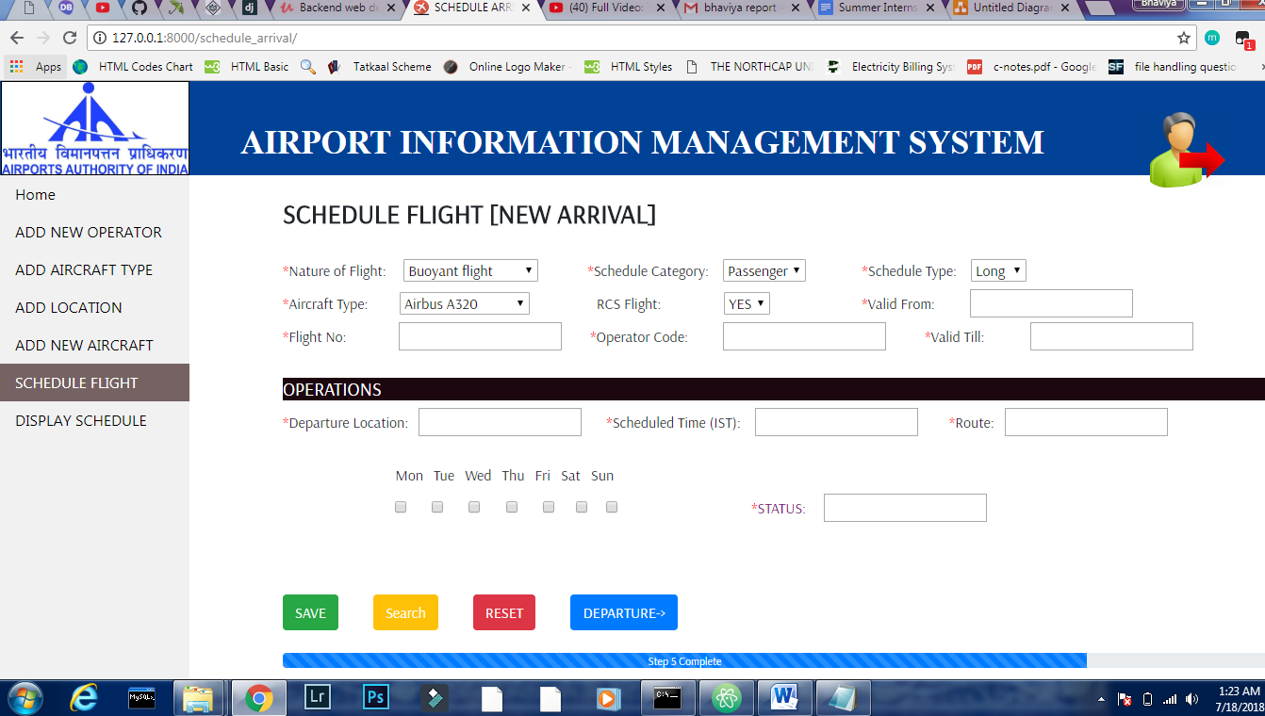

Schedule Arrival Page

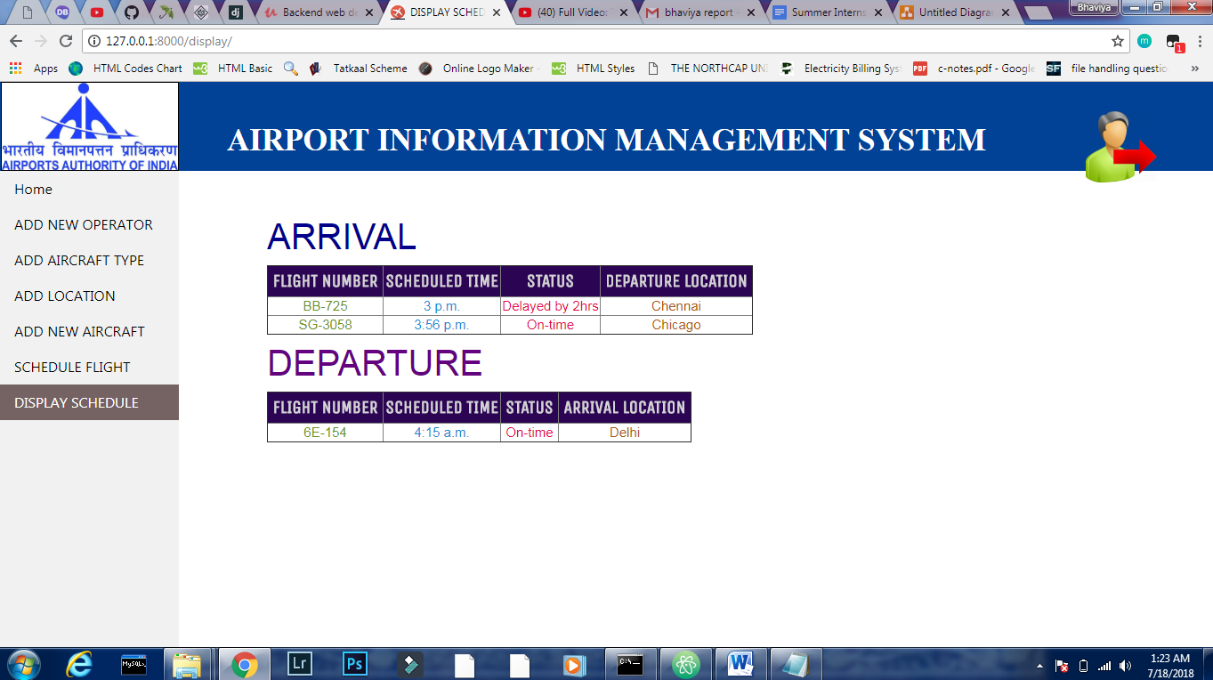

Display Page

**ANALYSIS**

Through this internship I got familiarized with an office environment. How one should be disciplined, punctual, kind to others, respect everyone’s opinion.

Seeing all my seniors working together whole heartidly made me realized that if you love your work there is nothing that can stop you from doing that.

The engineering aspects I learnt are breaking up big problems into smaller one and then solving them like working on webpages one by one, then checking my code thoroughly before executing it. After that if errors are encountered, debugging should be done only by me because I know my code better than anyone else.

If any error was encountered in the company’s database seniors would help out each other and fix that problem very easily. One thing more I have understood is that one needs to have positive approach towards work and should develop happy and friendly environment around him.

**CONCLUSION**

In a nutshell, this internship has been an excellent and rewarding experience. I can conclude that there have been a lot I’ve learnt from my work at Airport Authority of India. Needless to say, the technical aspects of the work I’ve done are not flawless and could be improved provided enough time. As someone with no prior experience with html ,css .JS and Django whatsoever I believe my time spent in research and discovering it was well worth it and contributed to finding an acceptable solution to build a fully functional web service. Two main things that I’ve learned the importance of are time-management skills and self-motivation.

**BIBLIOGRAPHY**

* 1. Mr. V.K. Sharma- Assistant Manager IT department, Airport Authority of India guiding throughout the internship for suggesting changes and requirements in project,
  2. Mr. Rahul – Briefing about AIMS project.
  3. Websites:
* [www.udemy.com](http://www.udemy.com)
* [www.google.com/images](http://www.google.com/images)
* [www.aai.aero](http://www.aai.aero)
* [www.tutorialpoint.com](http://www.tutorialpoint.com)
* [www.stackoverflow.com](http://www.stackoverflow.com)
* [www.djangoproject.com](http://www.djangoproject.com)
* [www.youtube.com/newboston/django](http://www.youtube.com/newboston/django)