BABU BANARASI DAS UNIVERSITY,
LUCKNOW

NoSQL
(Subject Code: BCADSN23202)

LAB FILE

SUBMITTED BY: SUBMITTED TO:

Name: Devansh Singh Mr Harendra Singh
Roll No: 1250258183
Class: BCA - DS23

INDEX

Sr. No | Name of Experiment | Date | Faculty Signature | Remarks
1 | MongoDB Installation
2 | Perform CRUD (Create, Read, Update, Delete) operations on a dataset using MongoDB
3
4
5
6
7
8
9
10
Practical: 1

Definition:
MongoDB Community Server is the free, source-available edition of MongoDB, a NoSQL document-oriented database. Installing it on a computer sets up the database server, the MongoDB Shell (mongosh) and MongoDB Compass, so that databases can be created and managed locally.

Outcomes/Learning:
Learned how to download and install MongoDB Community Server on Windows, check that the MongoDB service is running, and connect to the server using MongoDB Compass and the MongoDB Shell (mongosh).

Required Tool:
Windows computer with an internet connection, a web browser, MongoDB Community Server (MSI installer), MongoDB Compass and MongoDB Shell (mongosh).

Working:
MongoDB Community Server 7.0.14 was downloaded from the official MongoDB website and installed on Windows with the Setup Wizard. The installation was then checked through the Windows Services window, MongoDB Compass and mongosh.
Step 1: Download MongoDB Community Server
Open the official MongoDB website (mongodb.com/try/download/community) in a web browser. Select Windows as the platform and the MSI package, then click the Download button.

The MongoDB Community Server download page.
Step 2: Run the installer
Open the downloaded .msi file. The Setup Wizard for MongoDB 7.0.14 starts. Click Next, accept the license agreement, choose the Complete setup type, keep the options to install MongoDB as a service and to install MongoDB Compass selected, and continue through the wizard.
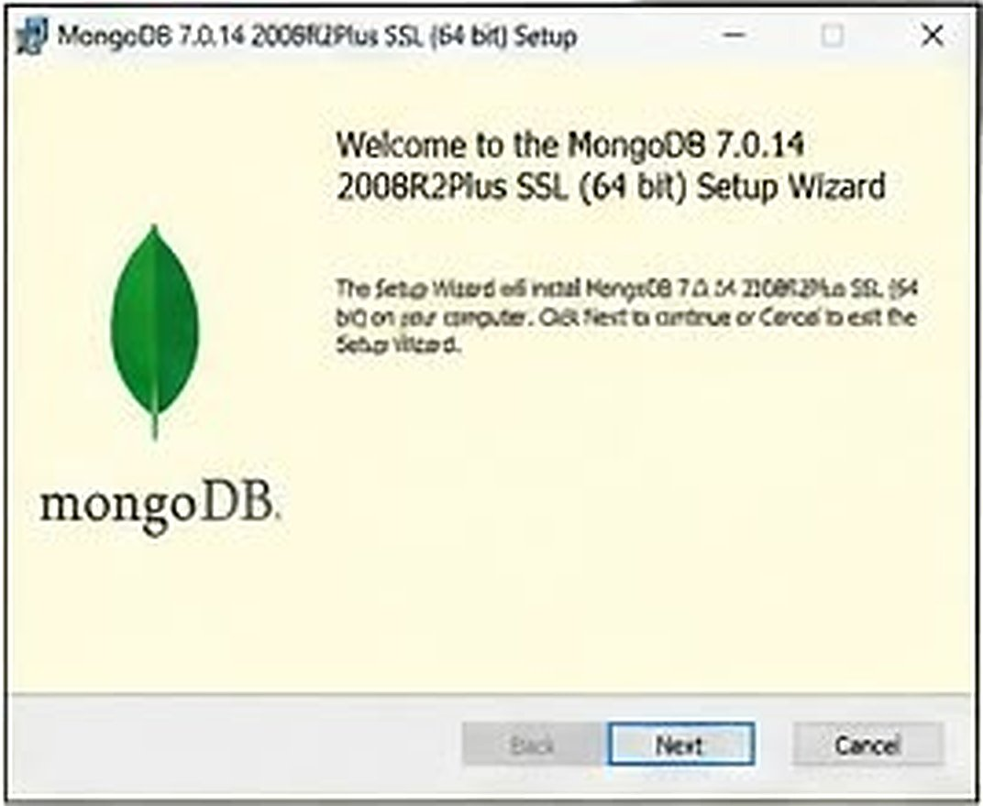
The MongoDB 7.0.14 Setup Wizard welcome screen.
Step 3: Complete the installation
After the files are installed, the wizard shows the completion screen. Click Finish to close the Setup Wizard.
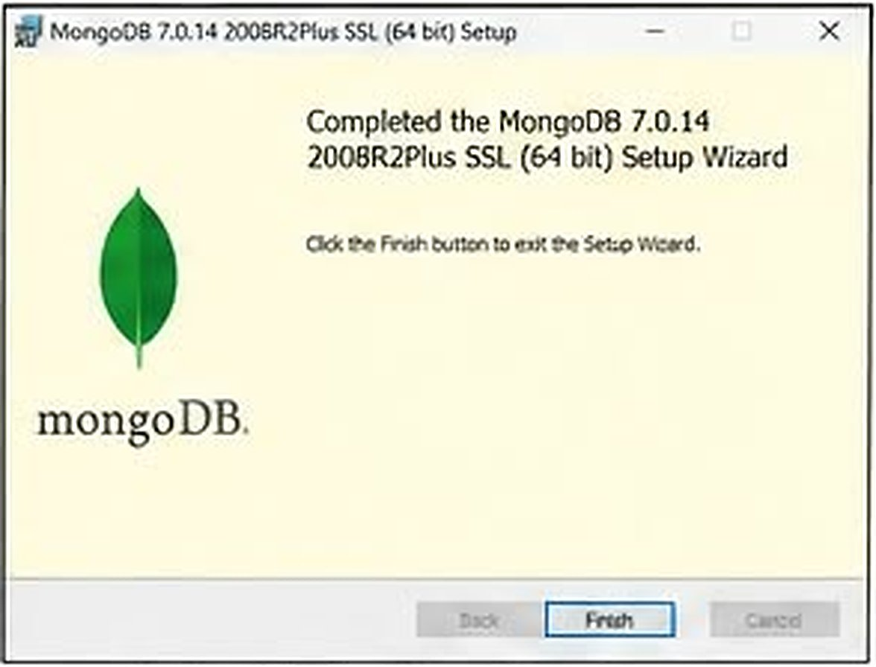
The MongoDB Setup Wizard shows that the installation is complete.
Step 4: Check that the MongoDB service is running
Press Win + R, type services.msc and press Enter to open the Windows Services window. Find MongoDB Server in the list and check that its Status is Running and its Startup Type is Automatic.
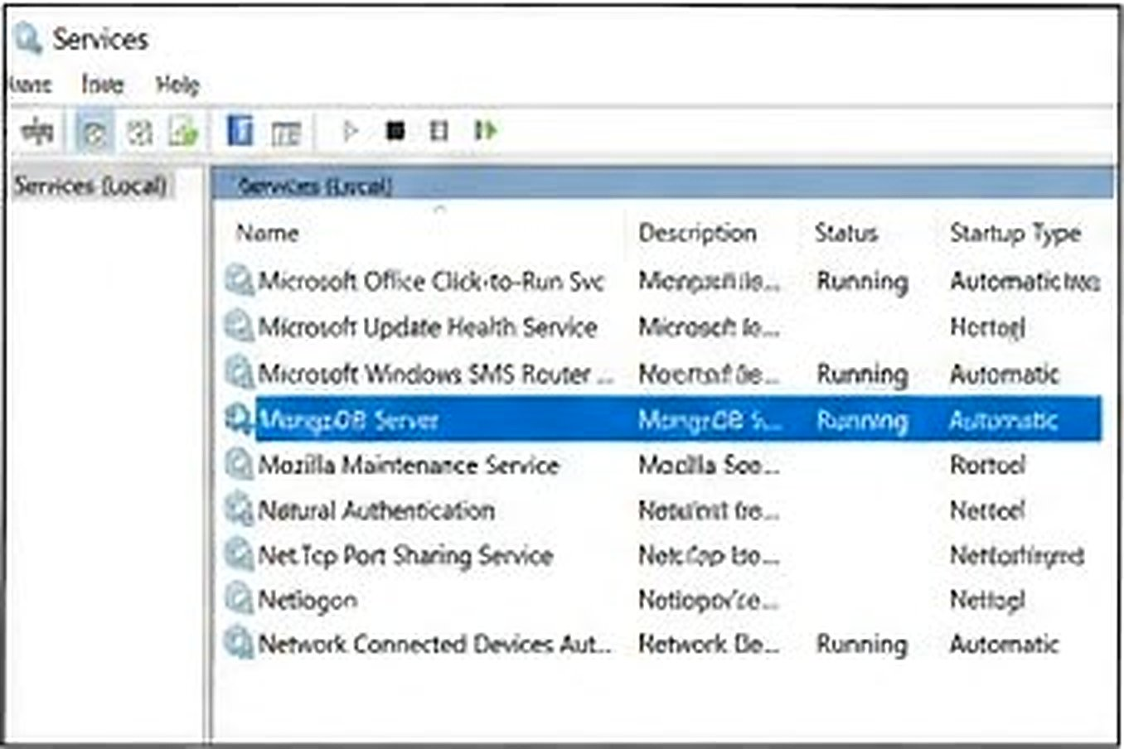
MongoDB Server is running as a Windows service with Automatic startup.
Step 5: Connect using MongoDB Compass
Open MongoDB Compass. In the New Connection window, use the connection string mongodb://localhost:27017 and click Connect to connect to the local MongoDB server.
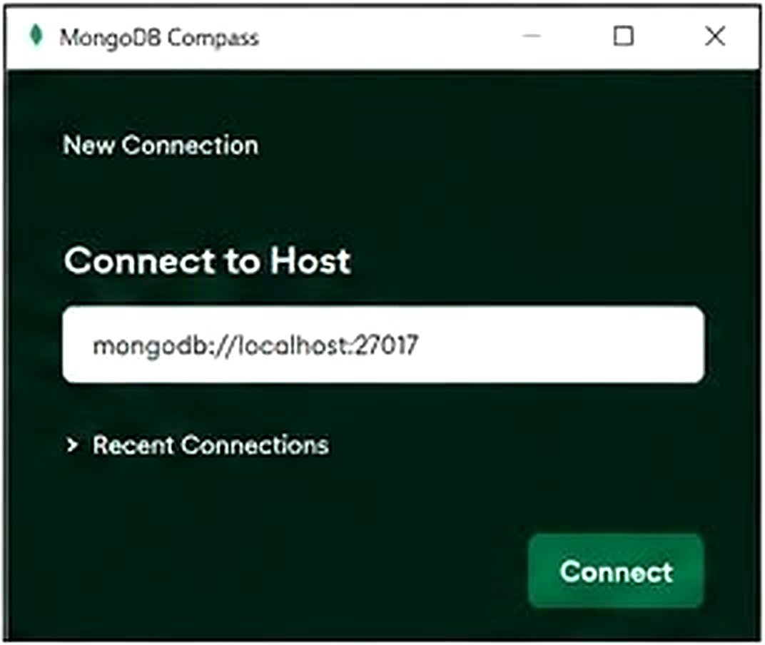
MongoDB Compass connecting to the local host on port 27017.
Step 6: Open the MongoDB Shell (mongosh)
Open the Command Prompt and type mongosh. The shell connects to mongodb://127.0.0.1:27017 and displays the MongoDB version (7.0.14) and the mongosh version (2.2.10). The test> prompt shows that the shell is ready for commands. The startup warning that access control is not enabled is normal for a fresh local installation.
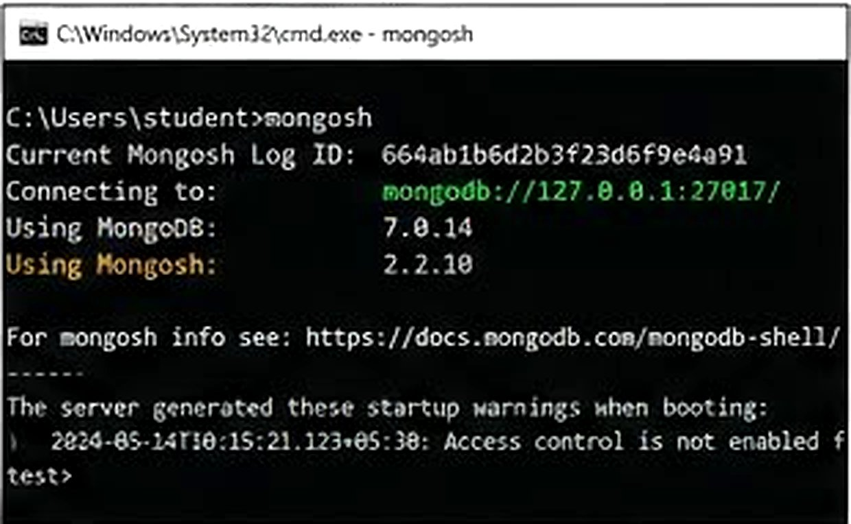
The MongoDB Shell connected to the local server and ready to accept commands.
Result:
MongoDB Community Server 7.0.14, MongoDB Compass and MongoDB Shell (mongosh 2.2.10) were installed successfully on Windows, and the connection to the local server was verified.
Practical: 2

Definition:
MongoDB is a NoSQL, document-oriented database that stores data in flexible, JSON-like documents (BSON) without a fixed schema. CRUD stands for Create (insert), Read (find), Update and Delete, which are the four basic operations performed on any database.

Outcomes/Learning:
Understood the structure of collections and documents in MongoDB and learned to perform insert, find, update and delete operations using query operators and filters.

Required Tool:
MongoDB Community Server, MongoDB Shell (mongosh) and MongoDB Compass.

Working:
A database 'company' and a collection 'employees' were created and 22 employee records were inserted. CRUD operations were then performed step by step using mongosh.

Step 1: Create database and collection

use company
db.createCollection("employees")

Output:

switched to db company
{ ok: 1 }
Database 'company' and collection 'employees' were created successfully.

Step 2: Insert multiple documents (Create)

db.employees.insertMany([
{ emp_id: 1, name: "Devansh Singh", department: "IT",
experience: 5, salary: 62000, city: "Lucknow" },
{ emp_id: 2, name: "Rohit Malhotr", department: "Sales",
experience: 3, salary: 48000, city: "Kanpur" },
{ emp_id: 3, name: "Sanya Kapoor", department: "IT",
experience: 6, salary: 71000, city: "Lucknow" },
{ emp_id: 4, name: "Vikram Rathore", department: "Sales",
experience: 2, salary: 39000, city: "Varanasi" },
{ emp_id: 5, name: "Ishita Bhatt", department: "HR",
experience: 4, salary: 52000, city: "Prayagraj" },
{ emp_id: 6, name: "Karan Mehta", department: "IT",
experience: 7, salary: 78000, city: "Lucknow" },
{ emp_id: 7, name: "Priyanka Joshi", department: "Sales",
experience: 3, salary: 45000, city: "Kanpur" },
{ emp_id: 8, name: "Nikhil Saxena", department: "IT",
experience: 2, salary: 41000, city: "Lucknow" },
{ emp_id: 9, name: "Meenal Trivedi", department: "HR",
experience: 5, salary: 58000, city: "Agra" },
{ emp_id: 10, name: "Aakash Dixit", department: "Sales",
experience: 1, salary: 32000, city: "Noida" },
{ emp_id: 11, name: "Rajeev Nair", department: "Finance",
experience: 8, salary: 82000, city: "Gorakhpur" },
{ emp_id: 12, name: "Tanya Arora", department: "IT",
experience: 6, salary: 75000, city: "Lucknow" },
{ emp_id: 13, name: "Suraj Pillai", department: "Sales",
experience: 2, salary: 36000, city: "Ayodhya" },
{ emp_id: 14, name: "Alka Bhargava", department: "HR",
experience: 3, salary: 49000, city: "Kanpur" },
{ emp_id: 15, name: "Manish Tandon", department: "Finance",
experience: 9, salary: 88000, city: "Varanasi" },
{ emp_id: 16, name: "Ritika Chandra", department: "IT",
experience: 4, salary: 60000, city: "Bareilly" },
{ emp_id: 17, name: "Deepak Rawat", department: "Sales",
experience: 3, salary: 42000, city: "Lucknow" },
{ emp_id: 18, name: "Swati Agnihotri", department: "HR",
experience: 6, salary: 63000, city: "Agra" },
{ emp_id: 19, name: "Gaurav Khanna", department: "Marketing",
experience: 5, salary: 57000, city: "Noida" },
{ emp_id: 20, name: "Neelam Rana", department: "IT",
experience: 8, salary: 91000, city: "Lucknow" },
{ emp_id: 22, name: "Pooja Lakhani", department: "Marketing",
experience: 4, salary: 54000, city: "Kanpur" }
])
Output:

{
acknowledged: true,
insertedIds: {
'0': ObjectId('...'),
'1': ObjectId('...'),
...
'20': ObjectId('...')
}
}
21 employee documents were inserted into the collection using insertMany().

Step 3: Insert a single document and count

db.employees.insertOne(
{ emp_id: 21, name: "Amitabh Sinha", department: "Sales",
experience: 2, salary: 37000, city: "Prayagraj" }
)
db.employees.countDocuments()

Output:

{ acknowledged: true, insertedId: ObjectId('...') }
22
One more document was added with insertOne(); the collection now has 22 documents.

Step 4: View all documents (Read)

db.employees.find().pretty()

Output:

Emp ID | Name | Dept | Exp (yrs) | Salary | City
1 | Devansh Singh | IT | 5 | 62000 | Lucknow
2 | Rohit Malhotra | Sales | 3 | 48000 | Kanpur
3 | Sanya Kapoor | IT | 6 | 71000 | Lucknow
4 | Vikram Rathore | Sales | 2 | 39000 | Varanasi
5 | Ishita Bhatt | HR | 4 | 52000 | Prayagraj
6 | Karan Mehta | IT | 7 | 78000 | Lucknow
7 | Priyanka Joshi | Sales | 3 | 45000 | Kanpur
8 | Nikhil Saxena | IT | 2 | 41000 | Lucknow
9 | Meenal Trivedi | HR | 5 | 58000 | Agra
10 | Aakash Dixit | Sales | 1 | 32000 | Noida
11 | Rajeev Nair | Finance | 8 | 82000 | Gorakhpur
12 | Tanya Arora | IT | 6 | 75000 | Lucknow
13 | Suraj Pillai | Sales | 2 | 36000 | Ayodhya
14 | Alka Bhargava | HR | 3 | 49000 | Kanpur
15 | Manish Tandon | Finance | 9 | 88000 | Varanasi
16 | Ritika Chandra | IT | 4 | 60000 | Bareilly
17 | Deepak Rawat | Sales | 3 | 42000 | Lucknow
18 | Swati Agnihotri | HR | 6 | 63000 | Agra
19 | Gaurav Khanna | Marketing | 5 | 57000 | Noida
20 | Neelam Rana | IT | 8 | 91000 | Lucknow
21 | Amitabh Sinha | Sales | 2 | 37000 | Prayagraj
22 | Pooja Lakhani | Marketing | 4 | 54000 | Kanpur
All 22 employee documents are displayed using the find() method.

Step 5: Find a single employee

db.employees.findOne({ name: "Sanya Kapoor" })

Output:

{
_id: ObjectId('...'),
emp_id: 3,
name: 'Sanya Kapoor',
department: 'IT',
experience: 6,
salary: 71000,
city: 'Lucknow'
}
The document of the employee Sanya Kapoor is returned by findOne().

Step 6: Find employees with a condition

db.employees.find({ department: "IT" })

Output:

Emp ID | Name | Dept | Exp (yrs) | Salary | City
1 | Devansh Singh | IT | 5 | 62000 | Lucknow
3 | Sanya Kapoor | IT | 6 | 71000 | Lucknow
6 | Karan Mehta | IT | 7 | 78000 | Lucknow
8 | Nikhil Saxena | IT | 2 | 41000 | Lucknow
12 | Tanya Arora | IT | 6 | 75000 | Lucknow
16 | Ritika Chandra | IT | 4 | 60000 | Bareilly
20 | Neelam Rana | IT | 8 | 91000 | Lucknow
Only the 7 employees of the IT department are displayed.

Step 7: Use the comparison operator $gt

db.employees.find({ salary: { $gt: 60000 } })

Output:

Emp ID | Name | Dept | Exp (yrs) | Salary | City
1 | Devansh Singh | IT | 5 | 62000 | Lucknow
3 | Sanya Kapoor | IT | 6 | 71000 | Lucknow
6 | Karan Mehta | IT | 7 | 78000 | Lucknow
11 | Rajeev Nair | Finance | 8 | 82000 | Gorakhpur
12 | Tanya Arora | IT | 6 | 75000 | Lucknow
15 | Manish Tandon | Finance | 9 | 88000 | Varanasi
18 | Swati Agnihotri | HR | 6 | 63000 | Agra
20 | Neelam Rana | IT | 8 | 91000 | Lucknow
The 8 employees who earn more than 60,000 salary are displayed using $gt.

Step 8: Use multiple conditions (AND)

db.employees.find({ department: "IT", city: "Lucknow" })

Output:
Emp ID | Name | Dept | Exp (yrs) | Salary | City
1 | Devansh Singh | IT | 5 | 62000 | Lucknow
3 | Sanya Kapoor | IT | 6 | 71000 | Lucknow
6 | Karan Mehta | IT | 7 | 78000 | Lucknow
8 | Nikhil Saxena | IT | 2 | 41000 | Lucknow
12 | Tanya Arora | IT | 6 | 75000 | Lucknow
20 | Neelam Rana | IT | 8 | 91000 | Lucknow
The 6 IT employees who live in Lucknow are displayed using two conditions.

Step 9: Use the $in operator

db.employees.find({ department: { $in: ["Sales", "HR"] } })

Output:

Emp ID | Name | Dept | Exp (yrs) | Salary | City
2 | Rohit Malhotra | Sales | 3 | 48000 | Kanpur
4 | Vikram Rathore | Sales | 2 | 39000 | Varanasi
5 | Ishita Bhatt | HR | 4 | 52000 | Prayagraj
7 | Priyanka Joshi | Sales | 3 | 45000 | Kanpur
9 | Meenal Trivedi | HR | 5 | 58000 | Agra
10 | Aakash Dixit | Sales | 1 | 32000 | Noida
13 | Suraj Pillai | Sales | 2 | 36000 | Ayodhya
14 | Alka Bhargava | HR | 3 | 49000 | Kanpur
17 | Deepak Rawat | Sales | 3 | 42000 | Lucknow
18 | Swati Agnihotri | HR | 6 | 63000 | Agra
21 | Amitabh Sinha | Sales | 2 | 37000 | Prayagraj
The 11 employees of the Sales and HR departments are displayed using $in.

Step 10: Projection, sort and limit

db.employees.find({}, { name: 1, salary: 1, _id: 0 })
.sort({ salary: -1 })
.limit(5)

Output:

Name | Salary
Neelam Rana | 91000
Manish Tandon | 88000
Rajeev Nair | 82000
Karan Mehta | 78000
Tanya Arora | 75000
Name and salary of the top 5 earners are displayed using projection, sort() and limit().

Step 11: Update a single document (Update)

db.employees.updateOne(
{ name: "Devansh Singh" },
{ $set: { salary: 65000 } }
)

Output:

{ acknowledged: true, matchedCount: 1, modifiedCount: 1 }
Salary of Devansh Singh was changed from 62000 to 65000 using $set.

Step 12: Update using the $inc operator

db.employees.updateOne(
{ name: "Vikram Rathore" },
{ $inc: { salary: 3000 } }
)

Output:

{ acknowledged: true, matchedCount: 1, modifiedCount: 1 }
A salary hike of 3000 was given to Vikram Rathore (39000 to 42000) using $inc.

Step 13: Update multiple documents (add a new field)

db.employees.updateMany(
{ city: { $ne: "Lucknow" } },
{ $set: { remote: true } }
)

Output:

{ acknowledged: true, matchedCount: 15, modifiedCount: 15 }
A new field 'remote: true' was added for the 15 employees living outside Lucknow.

Step 14: Update multiple documents (promote employees)

db.employees.updateMany(
{ department: "Sales", experience: { $lt: 3 } },
{ $set: { experience: 3 } }
)

Output:

{ acknowledged: true, matchedCount: 4, modifiedCount: 4 }
4 Sales employees with less than 3 years of experience were promoted to 3 years using updateMany().

Step 15: Delete a single document (Delete)

db.employees.deleteOne({ name: "Suraj Pillai" })

Output:

{ acknowledged: true, deletedCount: 1 }
The record of Suraj Pillai was deleted using deleteOne().

Step 16: Delete multiple documents

db.employees.deleteMany({ salary: { $lt: 40000 } })

Output:

{ acknowledged: true, deletedCount: 2 }
2 employees who earned less than 40,000 salary were deleted using deleteMany().

Step 17: Verify the final collection

db.employees.find().pretty()
db.employees.countDocuments()

Output:

Emp ID | Name | Dept | Exp | Salary | City | Remote
1 | Devansh Singh | IT | 5 | 65000 | Lucknow | -
2 | Rohit Malhotra | Sales | 3 | 48000 | Kanpur | true
3 | Sanya Kapoor | IT | 6 | 71000 | Lucknow | -
4 | Vikram Rathore | Sales | 3 | 42000 | Varanasi | true
5 | Ishita Bhatt | HR | 4 | 52000 | Prayagraj | true
6 | Karan Mehta | IT | 7 | 78000 | Lucknow | -
7 | Priyanka Joshi | Sales | 3 | 45000 | Kanpur | true
8 | Nikhil Saxena | IT | 2 | 41000 | Lucknow | -
9 | Meenal Trivedi | HR | 5 | 58000 | Agra | true
11 | Rajeev Nair | Finance | 8 | 82000 | Gorakhpur | true
12 | Tanya Arora | IT | 6 | 75000 | Lucknow | -
14 | Alka Bhargava | HR | 3 | 49000 | Kanpur | true
15 | Manish Tandon | Finance | 9 | 88000 | Varanasi | true
16 | Ritika Chandra | IT | 4 | 60000 | Bareilly | true
17 | Deepak Rawat | Sales | 3 | 42000 | Lucknow | -
18 | Swati Agnihotri | HR | 6 | 63000 | Agra | true
19 | Gaurav Khanna | Marketing | 5 | 57000 | Noida | true
20 | Neelam Rana | IT | 8 | 91000 | Lucknow | -
22 | Pooja Lakhani | Marketing | 4 | 54000 | Kanpur | true

19 documents remain in the collection after all update and delete operations.
Result: All the CRUD (Create, Read, Update, Delete) operations were successfully performed on the 'employees' dataset using MongoDB, and the outputs were verified at each step.

