HR ANALYTICS DASHBOARD
PROJECT REPORT
Employee Attrition & Workforce Insights | Microsoft Power BI
Prepared from the supplied HR Data workbook and Power BI dashboard screenshots.

1. Executive Summary
This project presents an interactive HR analytics dashboard developed in Microsoft Power BI using a dataset of 1,470 employee records. The analysis focuses on employee attrition, department and job-role patterns, age groups, education fields, job satisfaction, and workforce composition. The dataset records 237 employees marked as having left, producing an overall attrition rate of 16.12%. Average employee age is 36.9 years.

2. Project Objectives
- Monitor workforce size and employee attrition through headline KPIs.
- Compare attrition across departments, job roles, age bands, and education fields.
- Explore job satisfaction and overtime in relation to attrition.
- Provide an interactive report that supports HR investigation and evidence-led discussion.

3. Dataset Overview
The supplied Excel workbook contains 1,470 rows and 41 columns. Each row represents an employee record. Fields include Attrition, Department, Job Role, Education Field, Gender, Age, Marital Status, Over Time, Job Satisfaction, Monthly Income, Total Working Years, Years at Company, and related workforce attributes.
The workbook includes employee-level fields. For a public GitHub repository, use only a dataset that is licensed/authorized for sharing and contains no personally identifiable or confidential information.

4. Methodology
- Loaded the HR Data workbook and reviewed field structure and categorical values.
- Grouped employee records by selected dimensions (department, age band, job role, education field, overtime, marital status, and job satisfaction).
- Calculated attrition count as the number of records with Attrition = Yes.
- Calculated attrition rate as Attrition Yes ÷ total employees in the relevant group.
- Used Power BI visuals and slicers to present KPIs, comparisons, and segmented views.

5. KPI Summary
Metric | Value | Definition
Total employees | 1,470 | Employee records in dataset
Attrition count | 237 | Records with Attrition = Yes
Attrition rate | 16.12% | Attrition count ÷ total employees
Average age | 36.9 years | Mean employee age

6. Analysis & Findings

6.1 Department-level attrition
Sales has the highest department attrition rate, followed by HR and R&D. R&D contributes the largest absolute number of attrition cases because it is the largest department.
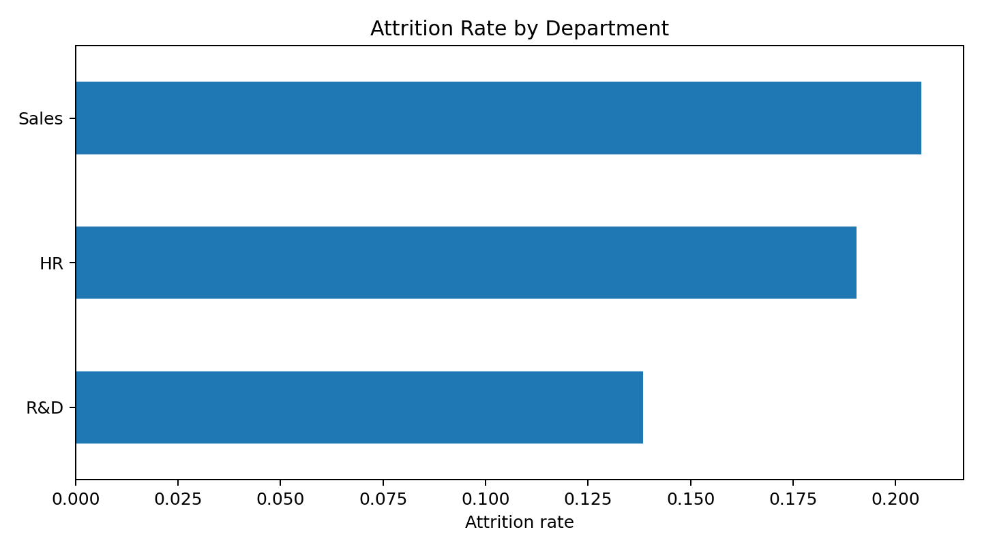
- Sales: 92 departures among 446 employees (20.63%).
- HR: 12 departures among 63 employees (19.05%).
- R&D: 133 departures among 961 employees (13.84%).

6.2 Age-band attrition
Employees under 25 show the highest attrition rate. This is a smaller cohort than the 25–34 and 35–44 groups, so rate and count should be considered together.
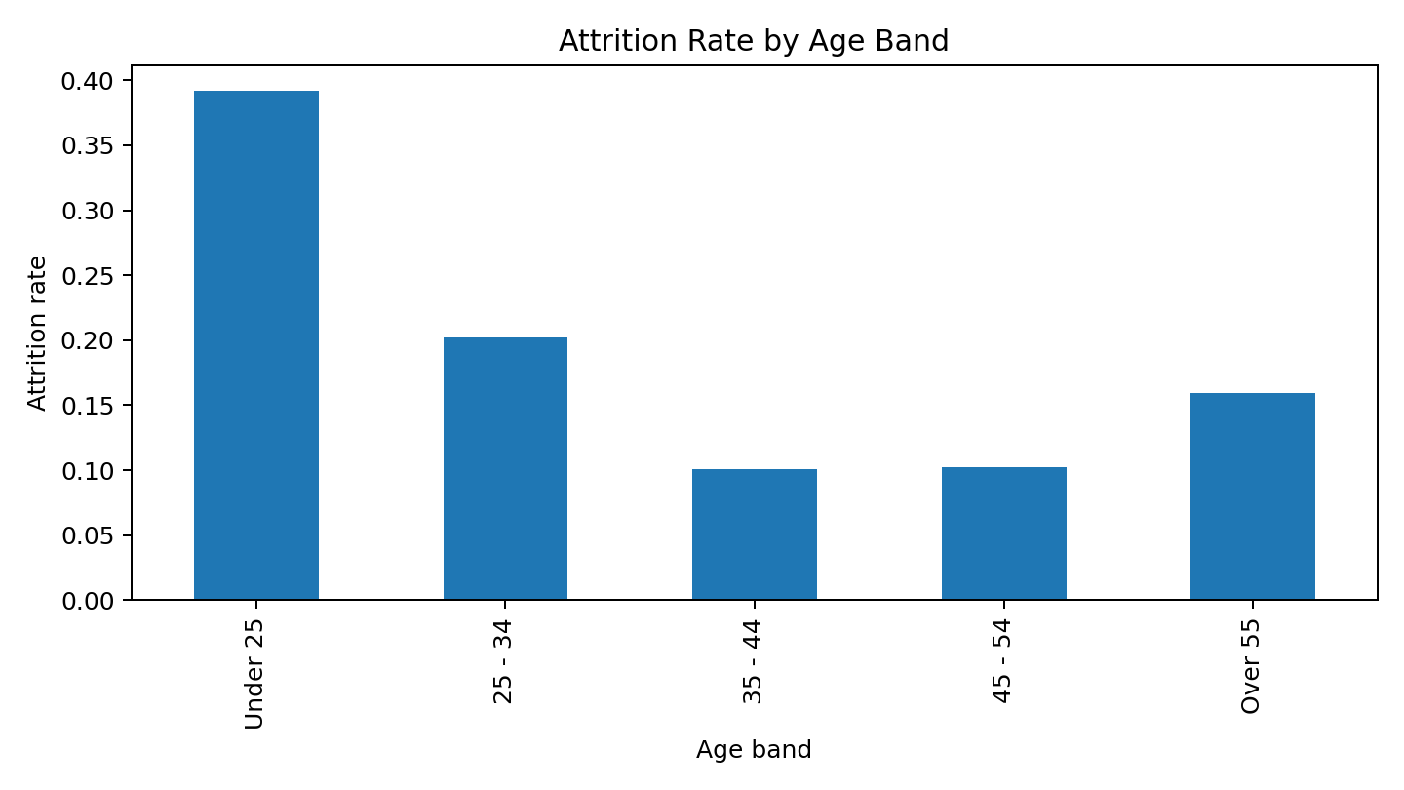
- Under 25: 38 departures / 97 employees (39.18%).
- 25 - 34: 112 departures / 554 employees (20.22%).
- Over 55: 11 departures / 69 employees (15.94%).
- 45 - 54: 25 departures / 245 employees (10.20%).
- 35 - 44: 51 departures / 505 employees (10.10%).

6.3 Job-role attrition
Sales Representatives have the highest attrition rate, followed by Laboratory Technicians and Human Resources. These role-level differences can help HR prioritize deeper review.
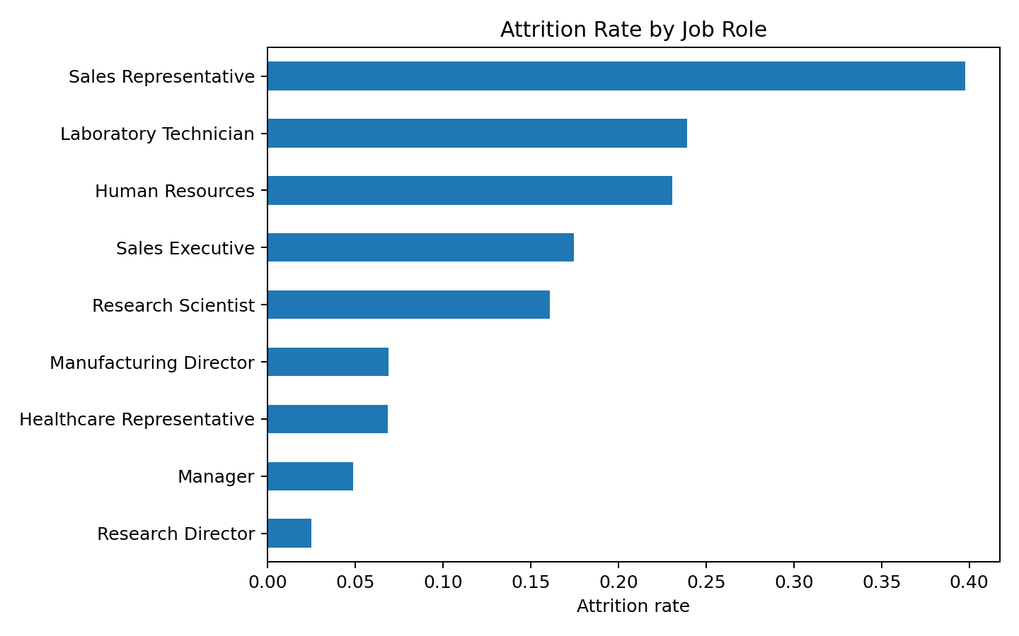
- Sales Representative: 33 departures / 83 employees (39.76%).
- Laboratory Technician: 62 departures / 259 employees (23.94%).
- Human Resources: 12 departures / 52 employees (23.08%).
- Sales Executive: 57 departures / 326 employees (17.48%).
- Research Scientist: 47 departures / 292 employees (16.10%).
- Manufacturing Director: 10 departures / 145 employees (6.90%).
- Healthcare Representative: 9 departures / 131 employees (6.87%).
- Manager: 5 departures / 102 employees (4.90%).
- Research Director: 2 departures / 80 employees (2.50%).

6.4 Education field
Technical Degree and Human Resources education groups have relatively high attrition rates; Life Sciences and Medical fields account for larger headcounts. Small groups should be interpreted cautiously.
- Human Resources: 7 / 27 (25.93%).
- Technical Degree: 32 / 132 (24.24%).
- Marketing: 35 / 159 (22.01%).
- Life Sciences: 89 / 606 (14.69%).
- Medical: 63 / 464 (13.58%).
- Other: 11 / 82 (13.41%).

6.5 Overtime and attrition
Employees marked as working overtime have a 30.53% attrition rate (127/416), compared with 10.44% for employees not marked as overtime (110/1054). This is an association and does not establish causality.

6.6 Marital status
- Single: 120 / 470 (25.53%).
- Married: 84 / 673 (12.48%).
- Divorced: 33 / 327 (10.09%).

6.7 Job satisfaction
Attrition rate is highest among employees with Job Satisfaction rating 1 and lowest among rating 4 in this dataset.
- Rating 1: 66 / 289 (22.84%).
- Rating 2: 46 / 280 (16.43%).
- Rating 3: 73 / 442 (16.52%).
- Rating 4: 52 / 459 (11.33%).

7. Dashboard Design & Interactivity
The Power BI report uses a purple theme and contains KPI cards, department attrition pie chart, age-group employee chart, job-satisfaction matrix, education-field bar chart, and age/gender segmented attrition visuals. The education slicer is visible across the top of the report; selecting an education category changes the displayed KPIs and charts. The uploaded screenshots demonstrate multiple filtered states.

8. Business Recommendations
- Review onboarding, early-career support, and career progression for employees under 25; validate with exit-interview evidence.
- Investigate workload, scheduling, incentives, and manager support in Sales Representative and Laboratory Technician roles.
- Review overtime allocation and workload sustainability; compare overtime frequency with exit reasons and performance data.
- Use job-satisfaction surveys and manager-level follow-up to understand low satisfaction scores.
- Segment retention actions by cohort, but avoid decisions based solely on demographic categories.
- Monitor attrition counts and rates together, especially for small employee groups.

9. Limitations & Responsible Interpretation
- This is observational HR data; correlations and group differences do not prove causes of attrition.
- Small categories can produce unstable rates; always show denominator/headcount with percentage.
- The dashboard is descriptive and does not include predictive modeling or causal inference.
- Confirm data definitions, date coverage, and whether employee records are anonymized before public sharing.
- Do not publish employee-identifiable or confidential information in a public repository or public Power BI embed.

10. Dashboard Screenshots
The following supplied screenshots show the report in different education-field filter states. They are included as visual evidence of report interactivity.
Screenshot 1
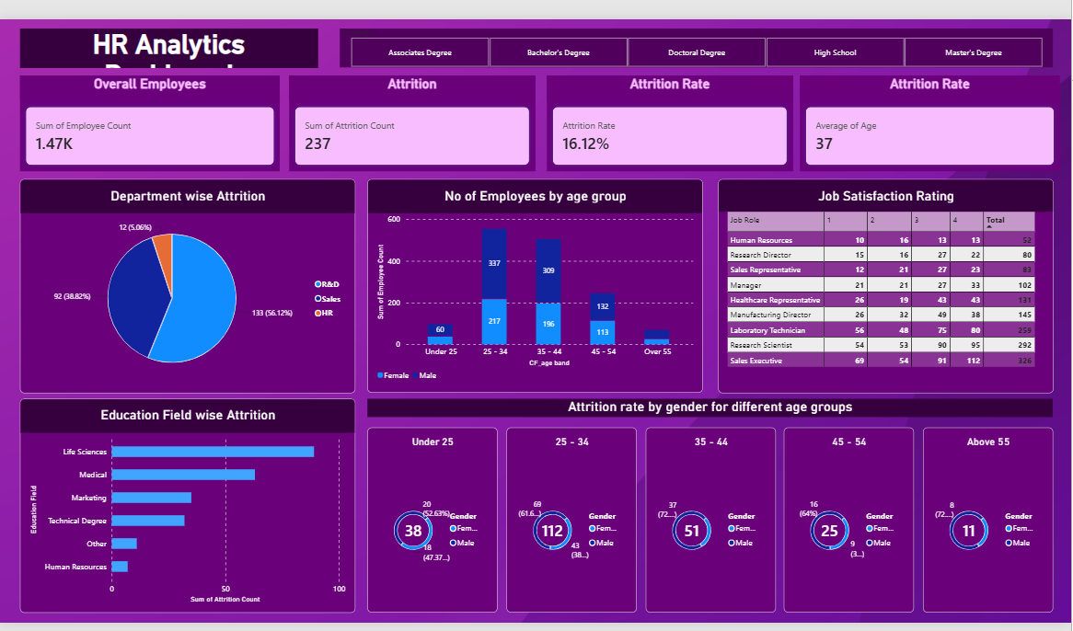
Screenshot 2
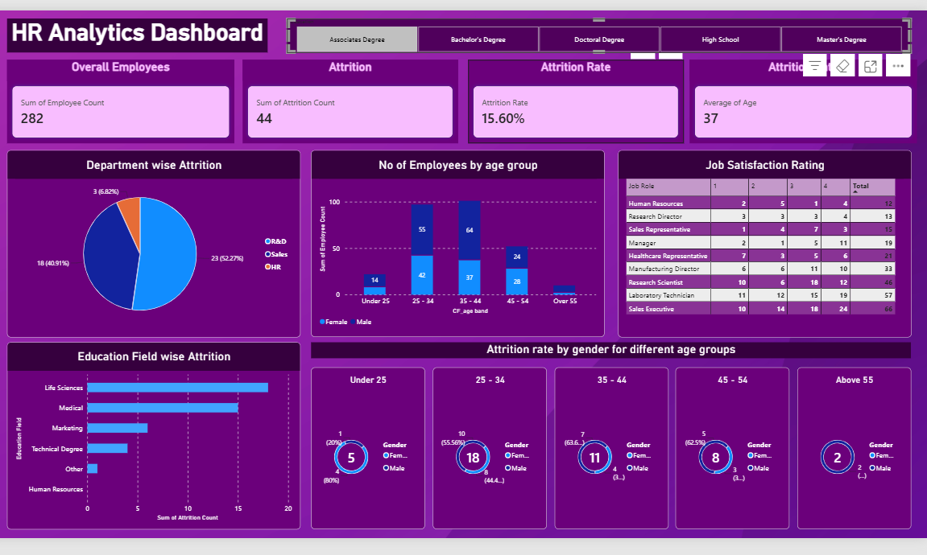
Screenshot 3
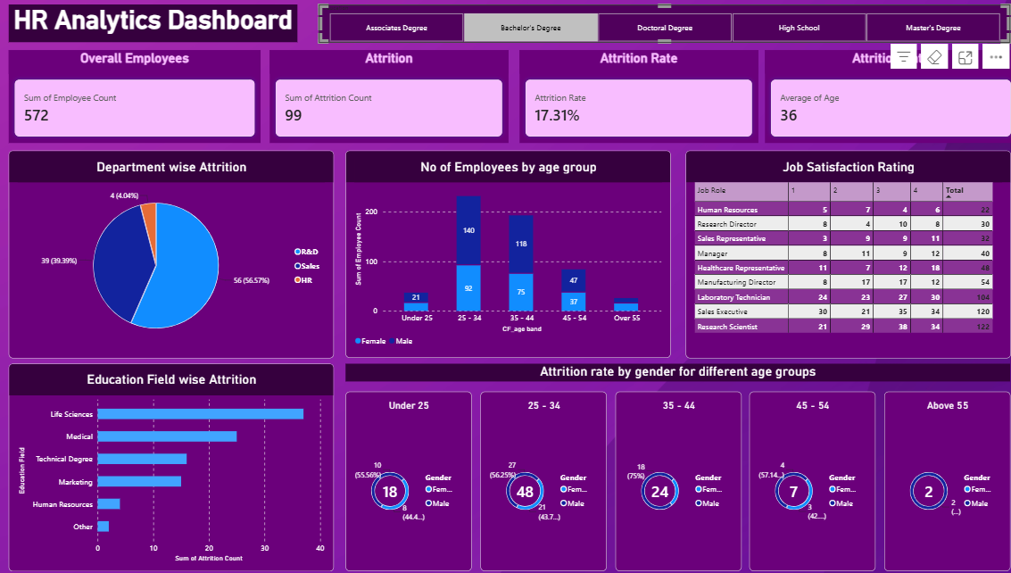
Screenshot 4
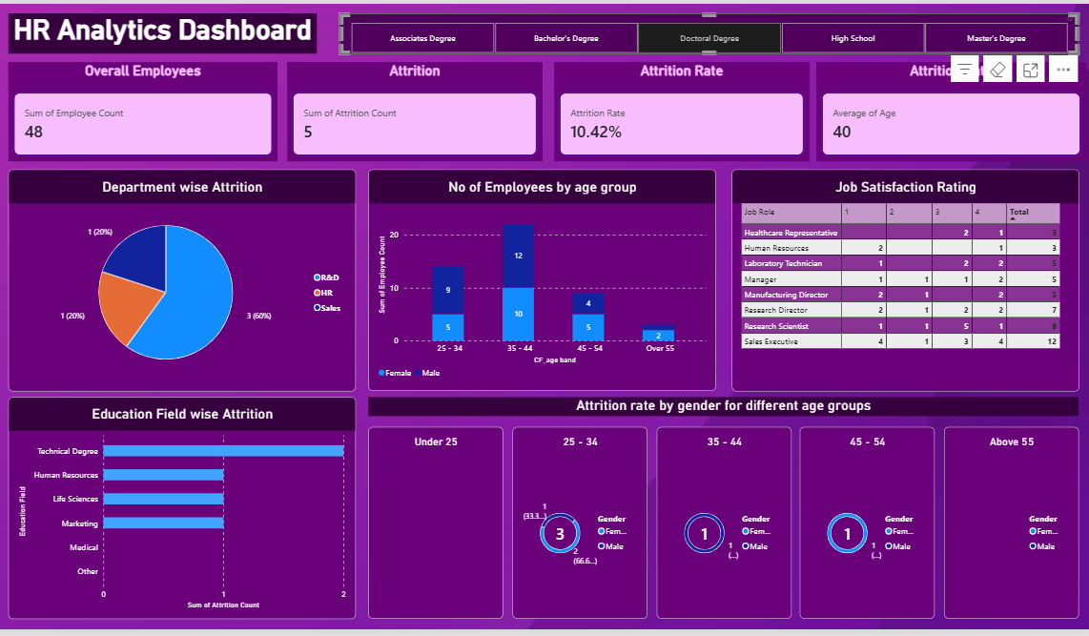
Screenshot 5
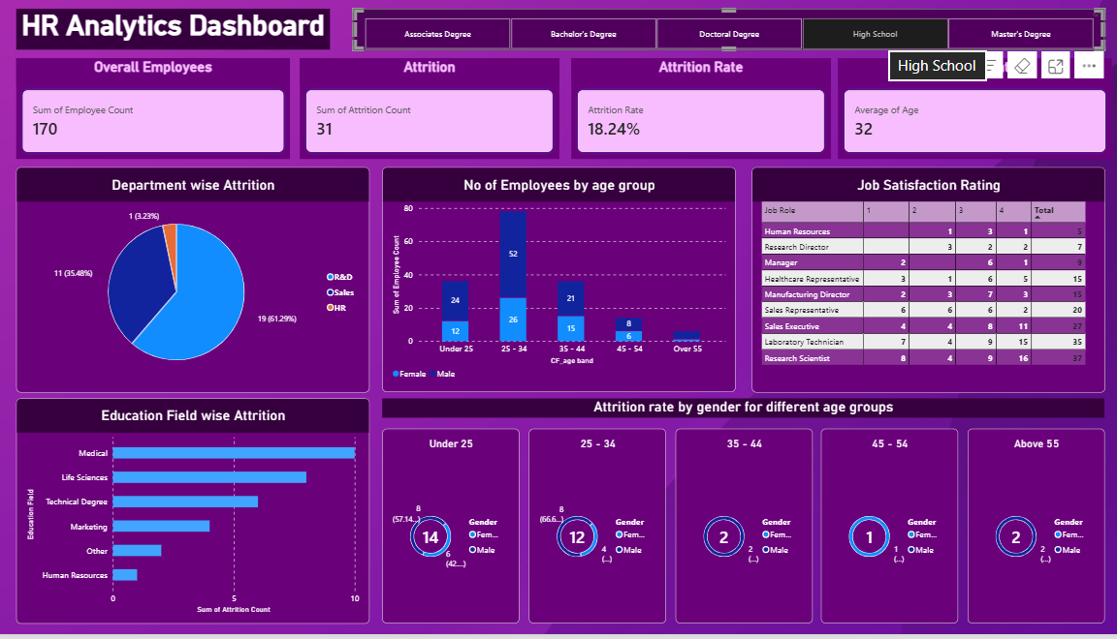
Screenshot 6
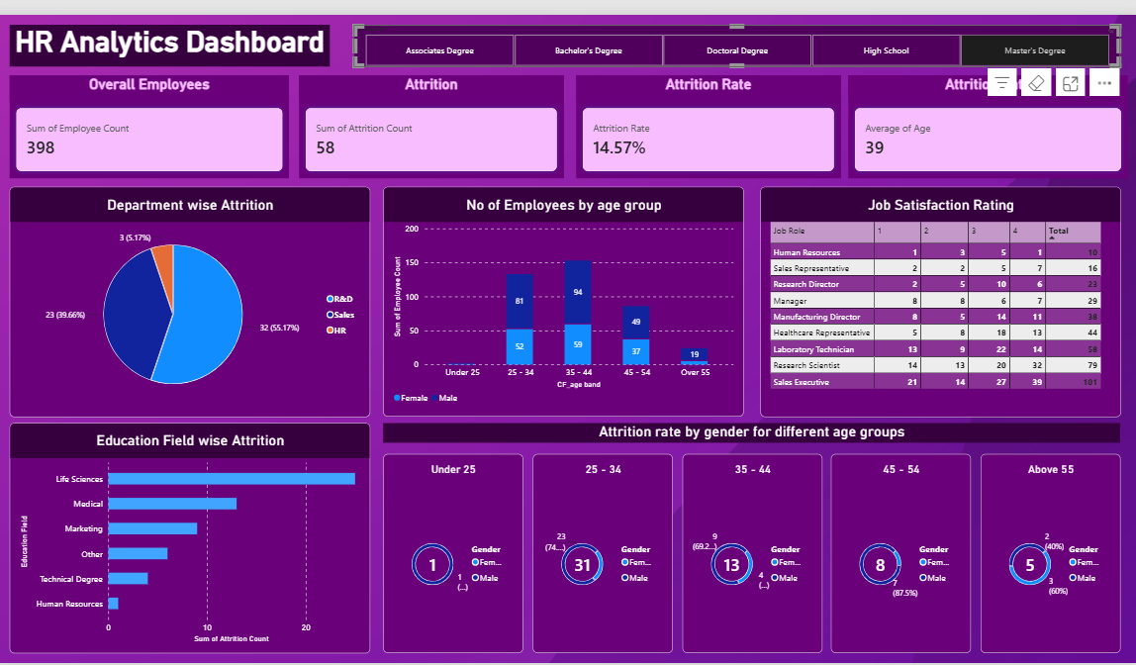

11. Conclusion
The HR Analytics Dashboard consolidates 1,470 employee records into an interactive report and highlights an overall attrition rate of 16.12%. The strongest descriptive signals in this dataset include elevated attrition among employees under 25, Sales Representatives, Sales department employees, overtime workers, and employees reporting low job satisfaction. These patterns can guide further HR investigation, not replace it.

Appendix: Reproducibility & Repository
Suggested repository contents: HR_Analytics_Dashboard.pbix, README.md, screenshots/, and this report. Include the raw workbook only if its source/license explicitly permits redistribution; otherwise document the dataset and omit it or provide a sanitized sample.

