Pizza Sales KPI Analysis Report: SQL-Based Business Insights

- TOTAL REVENUE :
- SELECT SUM(total_price) AS total_revenue FROM pizza_sales;

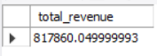

- AVERAGE ORDER VALUE:
- SELECT SUM(total_price)/COUNT(DISTINCT order_id) AS average_order_value FROM pizza_sales;

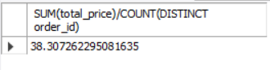

- TOTAL PIZZA SOLD:
- SELECT SUM(quantity) as total_pizza_sold FROM pizza_sales;
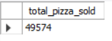

- TOTAL ORDERS:
- SELECT COUNT(DISTINCT order_id) AS total_orders FROM pizza_sales;
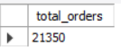

- AVERAGE PIZZA PER ORDER:
5. SELECT SUM(quantity)/COUNT(DISTINCT order_id) AS average_pizza_per_order FROM pizza_sales;

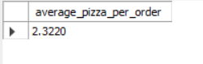

- DAILY TREND FOR TOTAL ORDERS:
6. # Daily Trend:
SELECT DAYNAME(STR_TO_DATE(order_date, '%Y-%m-%d %H:%i:%s')) AS order_day,COUNT(DISTINCT order_id) AS Total_orders
FROM pizza_sales
WHERE order_date IS NOT NULL
GROUP BY DAYNAME(STR_TO_DATE(order_date, '%Y-%m-%d %H:%i:%s'))
ORDER BY Total_orders DESC;

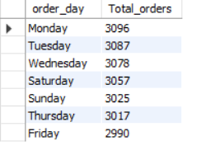

- HOURLY TREND FOR TOTAL ORDERS:
7. # Hourly Trend:
SELECT HOUR(order_time) AS order_hours,COUNT(DISTINCT order_id) AS Total_orders
FROM pizza_sales
WHERE HOUR(order_time) BETWEEN 9 AND 23
GROUP BY HOUR(order_time)
ORDER BY order_hours;
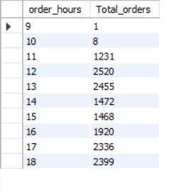
- PERCENTAGE OF SALES BY PIZZA CATEGORY:
8. SELECT pizza_category,SUM(total_price) * 100 / (SELECT SUM(total_price) FROM pizza_sales) AS percentage
FROM pizza_sales
GROUP BY pizza_category;
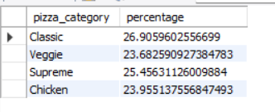

- PERCENTAGE OF SALES BY PIZZA SIZE:
9. SELECT pizza_size,SUM(total_price) * 100 / (SELECT SUM(total_price) FROM pizza_sales) AS percentage # Select pizza category (Veg, Non-Veg, etc.) , Calculate category revenue percentage:(category total revenue / overall total revenue) × 100
FROM pizza_sales # Source table containing all pizza sales records
GROUP BY pizza_size; # Group data by pizza category so revenue is calculated per category
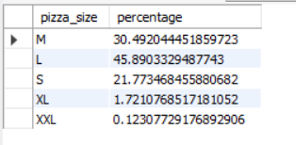

- TOTAL PIZZA SOLD BY PIZZA CATEGORY:
10. SELECT pizza_category,sum(quantity) AS total_pizza_sold
FROM pizza_sales
GROUP BY pizza_category
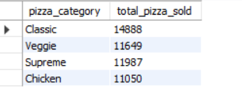

- TOP 5 BEST SELLER PIZZA:
11. SELECT pizza_name, SUM(quantity) AS Total_Pizzas_Sold
FROM pizza_sales
GROUP BY pizza_name
ORDER BY Total_Pizzas_Sold DESC
LIMIT 5;
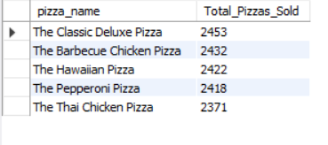

- LAST 5 WORST SELLER PIZZA:
12. SELECT pizza_name, SUM(quantity) AS Total_Pizzas_Sold
FROM pizza_sales
GROUP BY pizza_name
ORDER BY Total_Pizzas_Sold ASC
LIMIT 5;
