A Project Report

on

FORKLICIOUS

carried out as part of the course CSE CS2232 Submitted by

DEVANSHU RASTOGI

209302150

IV-CSE-G

in partial fulfilment for the award of the degree

of

BACHELOR OF TECHNOLOGY

In

Computer Science & Engineering

Department of Computer Science & Engineering,
School of Computing and IT,
Manipal University Jaipur,
March 2022

WEB TECH PROJECT REPORT

Cover page



Abstract

An Online Food Ordering System is proposed here which simplifies the food ordering process. The proposed system shows an user interface and update the menu with all available options so that it eases the customer work. Our main aim was to provide the students in the hostel a convenient way of ordering food whenever they would like to. This web application would also benefit the food chains to help maintain hassle-free process of managing the orders. Students can choose more than one item to make an order and can view order details before logging out. The confirmation of the order is sent to the student. The order is placed in the queue and updated in the database and returned in real time. This system assists the staff to go through the orders in real time and process it efficiently with minimal errors.

- Introduction

The rapid growth of the use of internet and the technologies associated with it, several opportunities are being created on the web or mobile applications. The main problem that arises within our hostel is the non-availability of a proper channel to communicate the orders. For example, while calling a restaurant for placing the order, sometimes the calls don’t get answered or number remains busy talking to the other customers, hence posing a major problem. Another problem is the menu and its changing prices, the students might not be able to remain updated with the changes in the menu and the prices.

Here we propose an “Online Food Ordering System” that has been designed for Fast Food restaurant, Take-Out, or College Cafeterias. The system can also be used in any food delivery industry. This simplifies the process of food ordering for both the customer and the restaurant, as the entire process of taking orders is automated and all the sample problems posed, we have tried to solve them in the best possible way with our web app “Forklicious”.

    - Scope of the Work and Product Scenario

Restaurants can offer electronic ordering through their own online web app and through sites that serve various restaurants, and all restaurants also accept orders via text message more over the credit point and discount coupon out that many restaurants increased sales level as a result of accepting electronic orders. The restaurants nowadays have an interactive and up-to-date menu with all available options in an easy to use manner. Most of Hostellers were more likely to have used online food ordering system. Well-designed self-service ordering systems give customers actual control over the pace of their transaction and allow them to limit the amount of personal interaction of restaurant. In most cases, an increased level of control has been shown to lead to higher level of customer satisfaction and greater intent to use or recommend suggested the service. Perceived convenience of a self-service system also leads to an increase in adoption and satisfaction. In this instance, the definition of convenience is related primarily to access convenience and transaction convenience. A customer will search for a favourite restaurant based on variety, availability, and depending on the expenditure. Payment can be amongst others either by credit card or cash

  - Requirement Analysis

    - Functional Requirements

Atom: Atom is a free and open-source text and source code editor for macOS, Linux, and Microsoft Windows with support for plug-ins written in JavaScript, and embedded Git Control. Developed by GitHub, Atom is a desktop application built using web technologies.

HTML – CSS: The Hypertext Markup Language or HTML is the standard markup language for documents designed to be displayed in a web browser. It can be assisted by technologies such as Cascading Style Sheets and scripting languages such as JavaScript. Cascading Style Sheets is a style sheet language used for describing the presentation of a document written in a markup language such as HTML. CSS is a cornerstone technology of the World Wide Web, alongside HTML and JavaScript.

Javascript: JavaScript often abbreviated JS, is a programming language that is one of the core technologies of the World Wide Web, alongside HTML and CSS. JavaScript is a high-level, often just-in-time compiled language that conforms to the ECMAScript standard.

NodeJS: Node.js is an open-source, cross-platform, back-end JavaScript runtime environment that runs on the V8 engine and executes JavaScript code outside a web browser.

ExpressJS: Express.js, or simply Express, is a back end web application framework for Node.js, released as free and open-source software under the MIT License. It is designed for building web applications and APIs.

MongoDB: MongoDB is a source-available cross-platform document-oriented database program. Classified as a NoSQL database program, MongoDB uses JSON-like documents with optional schemas.

    - Non-functional Requirements

A desktop computer with Intel Core i3 64 bit processor and Graphic card 1 GB RAM, and Microsoft Windows 10 operating system was used.

  - System Design

    - Design Goals

First we would like to add login page for the customer where he/she enters his/her credentials (name, ID and password). Once that has been verified, the customer can place an order specifying the quantity of the food required. Now we get a window that displays the order number, customer ID, food name, price and quantity. Once the customer finalizes his/her order, they are redirected to the payment window where the total price is displayed and then the customer gets a message of confirmation of order.This system is difficult to forge or cheat when compared to other systems in terms of payment for the food. The above mentioned simulation flow is with respect to the customer's point of view.

We will be building a admin side to which will act as a POS system for the restaurants. if you are an admin, you will be able to select the normal login option and enter the admin credentials (email ID and password). Once you enter the admin portal, you get the option of adding food, deleting food or updating food. Any option of choice leads you to the food menu. Once the selected operation is carried out, the end result, i.e, the added food or the updated food list is displayed and updated in the database. If you have deleted a food, that particular food disappears from the main menu.

    - System Architecture

This study adopted convenience sampling. Sampling was done by interviewing randomly selected hostel residents. A structured questionnaire was used for data collection. The questionnaire was divided into three sections, the first section was about the personal profile of residents and second, were designed to evaluate using of consumer overall experiences with the quality of services they had received from the restaurants and the last was dealing with the effect of consumer satisfaction on loyalty.

With the help of this system, people can easily order the food. It can also ensure that the people do not waste their precious time and use their time productively in study. In long run, this will ensure that it helps to reduce labour cost. This system proves to be more cost effective and reliable over other systems. It is very easy to use and has least maintenance. It does not require any human intervention and thus can be called fully automated. There aren’t any limitations as such for this system, however one needs to take care of the smaller parameters like server breakdown while this system is implemented.

- Work Done

  - Development Environment.

We started with using HTML to give structure to our website. Then we used CSS to style all the elements of the webpage. We incorporated the widely used frontend library called Bootstrap. Bootstrap is the most popular CSS Framework for developing responsive and mobile-first websites. We created forms using bootstrap.

We used JavaScript in frontend. Using the JavaScript and its framework jQuery we accessed the elements of html and manipulated them to create a search bar with auto-recommendation.

Then we used NodeJS for backend development. Used GET AND POST request with the help of npm package express. Using ExpressJS we ran the webpage by creating local server with the help of command line. Then we used MongoDB for backend and attached it natively with NodeJS. Posted the feedback data of users on database using MongoDB and NodeJS.

4.2 Results and Discussion

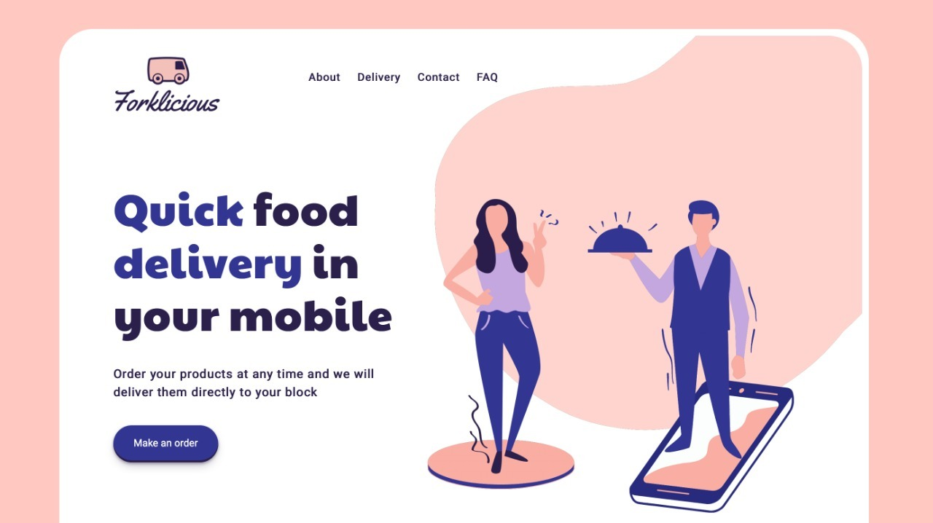

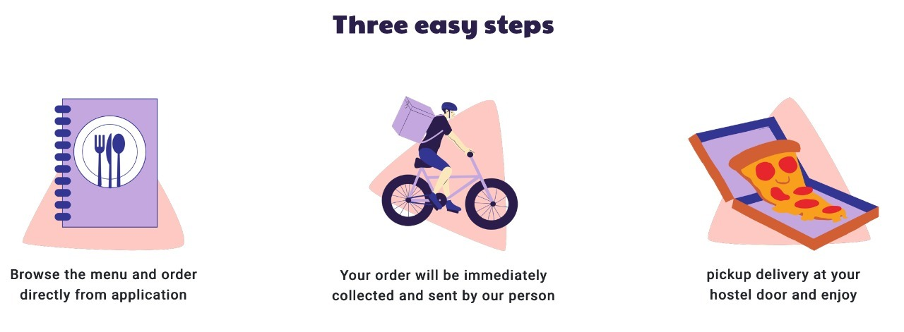

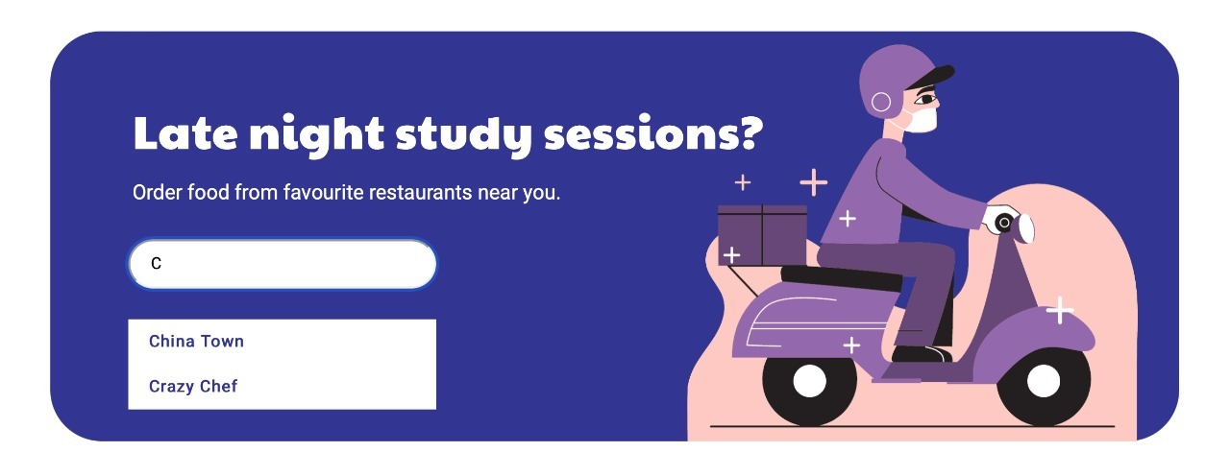

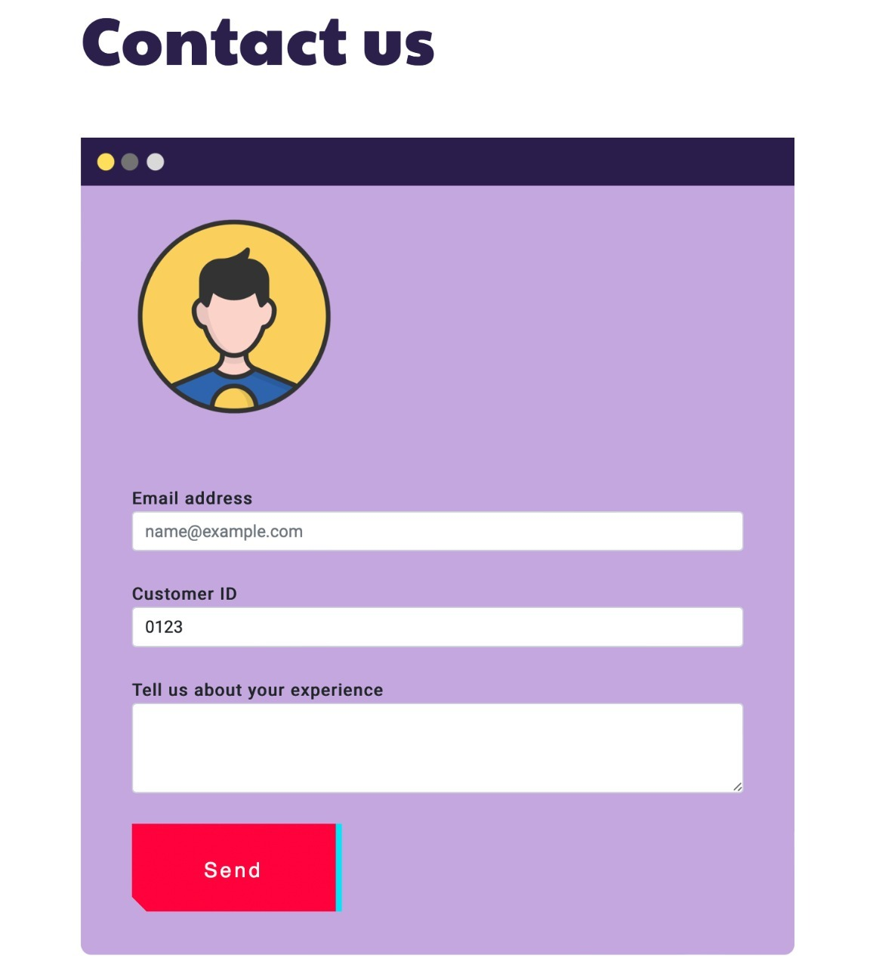

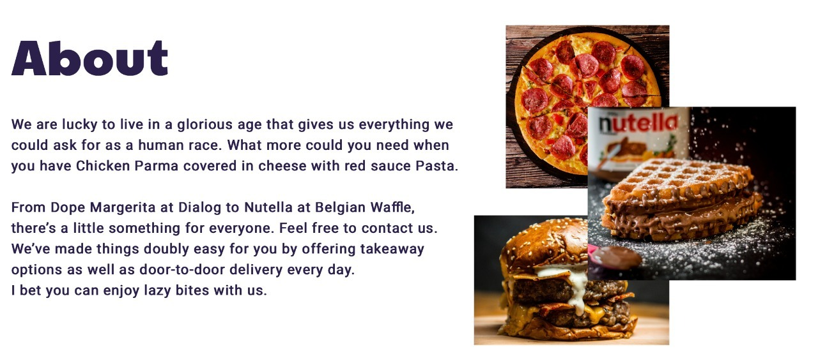

4.3 Individual Contribution of project members

HTML and CSS of Title section and overall layout and positioning of the webpage was done by Devanshu. Feature and Form sections were done by Sarthak. About and outlet search section were done by Vaibhavi. All three members of the group contributed in the designing of webpage. Bootstrap was incorporated by devanshu.

Search recommendation algorithm was created by devanshu. Event listener was added by Vaibhavi. Display and Remove functions with declaration of array was done by Sarthak. Overall JavaScript code was done by all of us as we divided the functions created for the search box.

In backend, NodeJS file was coded by devanshu. MongoDB commands to insert documents in collection were written by both Sarthak and Vaibhavi together.

Introduction and Requirement of report was written by Vaibhavi. System design was written by devanshu. Work done and conclusion and future plan was done by Sarthak.

- Conclusion and Future Plan

An online food ordering system is developed where the students will be able to make an order for the food and avoid the hassles of waiting for the order to be taken by the respective restaurants. Using the application, the students register online, read the E-menu card, and select the food from the e-menu card to order food online. Once the student selects the required food item the restaurant will be able to see the chosen items of the order on their end of the app and start processing the order. This application nullifies the need of a communication medium(phone calls) and reduces the workload on the workers at the restaurant as managing orders becomes easy. Therefore by using this application, the students can directly place the order for food to the restaurant online. In conclusion an online food ordering system is proposed which is easy for the students to access and make use of and order food efficiently and easily.

In future, we are going to connect our website with MongoDB using mongoose and nodejs. We will store the user data, order placed by the user and all the menus on the database. Further on we will also add payment gateway to the web app so that people can make payments online and transaction can be cash free. After completing the website we would like to pitch the business plan to the hostel authorities and would like to be known as contributors to our hostel development.

References:

Dribble.com : For Web Design inspiration.
Canva.com : For designing illustrations which were used in beautifying the website
Bootstrap.com : For designing tables and buttons
Codingartistweb.com : used as reference for the JavaScript code of search box with auto-recommendations
Udemy course by Angela Yu: For help regarding backend development

