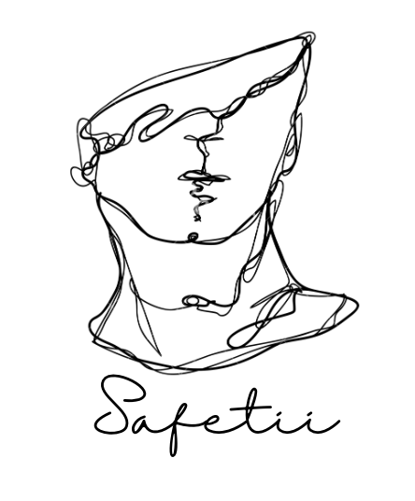

**Project Proposal**

**Safetii**

***IDEA WE ARE WORKING ON -***

Welcome to Stay Safe, the ultimate app designed to prioritize your safety and well-being. Whether you're a man or a woman, we've got you covered with a wide range of features to keep you safe in various situations. Our website is specifically designed to cater to women's health needs, with a built-in period tracker, emergency calling system, and easy access to nearby hospitals. With Stay Safe, you can confidently navigate through life knowing that you have a reliable safety companion in your pocket.

***KEY FEATURES -***

*Period Tracker: Provide a user-friendly interface for women to track their menstrual cycle, including start and end dates, symptoms, and mood. This can help women plan and manage their menstrual health effectively.*

*Emergency Calling System: Offer a quick and easy way for users to call for help in case of an emergency, such as a panic button or a dedicated emergency hotline. This feature can provide a sense of security and assurance for women facing unsafe situations.*

*Availability of Hospitals: Include a directory of hospitals and healthcare facilities that specialize in women's health, including gynecologists, obstetricians, and other relevant specialists. This can help women locate nearby healthcare resources in times of need.*

*Communities and Discussion Forums: Create a platform for users to join communities based on their preferences and interests related to health, wellness, and women's issues. This can foster support, information-sharing, and empowerment among users.*

*Chatbot with OpenAI API: Utilize OpenAI's API to develop a chatbot that can identify and provide preliminary guidance on common health issues. Users can input their symptoms, and the chatbot can offer advice on self-care or when to seek professional medical help, acting as a virtual first aid resource.*

*User-Friendly Interface: Design the website with a user-friendly interface that is easy to navigate, visually appealing, and accessible on various devices, including desktops, tablets, and mobile phones. This can enhance the overall user experience and encourage more women to utilize the website's features.*

TECH-STACK

OpenAI API: We will utilize OpenAI's language models to power your chatbot and enable it to understand and respond to user inputs, providing personalized health advice based on their symptoms or concerns.

React: React is a popular JavaScript library for building user interfaces. You can use it to create a responsive and interactive frontend for your website, allowing users to easily navigate through different features, input data, and interact with the chatbot.

Node.js: Node.js is a JavaScript runtime that allows you to build scalable and efficient server-side applications. We will use it as the backend for your website to handle user requests, process data, and communicate with external APIs, such as the OpenAI API and hospital directory APIs.

Unity 3D: Unity 3D is a powerful game development engine that can be used to create interactive and immersive experiences. As a future implementation.

VISION -

Our vision for this website is to create a safe and empowering online platform for men and women, providing them with tools, resources, and support to take control of their health and well-being. We aim to promote women's safety, facilitate access to healthcare resources, foster community engagement, and provide reliable health information through a chatbot powered by OpenAI API.

GOAL –

Enhance Women's Health: Our website will empower women to track their menstrual cycles, understand their symptoms, and manage their menstrual health effectively. We aim to promote awareness about women's health and provide personalized guidance on common health issues through the chatbot.

Provide Emergency Assistance: We aim to offer a reliable and quick emergency calling system, providing a panic button or a dedicated hotline for women facing unsafe situations. Our goal is to provide a sense of security and assurance for women in distress, helping them to access help when needed.

Facilitate Access to Healthcare: Our website will provide a directory of hospitals and healthcare facilities specializing in women's health, helping women locate nearby healthcare resources easily. We aim to promote access to healthcare services, including gynecologists, obstetricians, and other relevant specialists.

Foster Community Engagement: We will create a platform for women to join communities and discussion forums based on their preferences and interests related to health, wellness, and women's issues. Our goal is to foster support, information-sharing, and empowerment among users, creating a supportive community for women.

Utilize Chatbot for Health Guidance: We will leverage OpenAI's API to develop a chatbot that can identify and provide preliminary guidance on common health issues. Our goal is to offer reliable and accurate health information, acting as a virtual first aid resource and helping users make informed decisions about their health.

User-Friendly Experience: Our website will be designed with a user-friendly interface that is easy to navigate, visually appealing, and accessible on various devices. Our goal is to provide a seamless and engaging user experience, encouraging more women to utilize the website's features and benefit from its resources.