A PROJECT REPORT ON
“VisionEdge”
(AI-Powered Optical Store Management & Virtual Try-On System)
Department of Computer Application

Master of Computer Application

Silver Oak College of Computer Application

Submitted To

Master of Computer Application

Silver Oak College of Computer Application
Silver Oak University

Submitted By
Chaudhari Devanshu Dilipbhai
Enrollment No.: 2504070100284

Under the Guidance of
Ms. Manali Panchal

Academic Year: 2026–27
Date: August 2026

Silver Oak College of Computer Application
Department of Computer Application
Master of Computer Application

CERTIFICATE

This is to certify that the project report entitled “VisionEdge: AI-Powered Optical Store Management & Virtual Try-On System” has been carried out by Chaudhari Devanshu Dilipbhai (2504070100284) under the guidance of Ms. Shilpi Joshi in fulfillment of the requirements of the MCA program at Silver Oak College of Computer Application, Silver Oak University, Ahmedabad, during the academic year 2026–27.

Date: August 2026

DECLARATION

I, Chaudhari Devanshu Dilipbhai (2504070100284), hereby declare that the project report entitled “VisionEdge: AI-Powered Optical Store Management & Virtual Try-On System” is my academic project work carried out under the guidance of Ms. Shilpi Joshi. The report is prepared from the implementation and project artifacts contained in the VisionEdge project source and is submitted for academic evaluation. All referenced external technologies and documentation are acknowledged in the References section.

Chaudhari Devanshu Dilipbhai
2504070100284

Acknowledgement
I express my sincere gratitude to Silver Oak University and Silver Oak College of Computer Application for providing the academic environment and resources required to complete this project. I am thankful to my project guide, Ms. Shilpi Joshi, for her guidance, suggestions, and continuous support throughout the development of VisionEdge. I also acknowledge the role of the open-source frameworks, libraries, and development tools used in implementing the system.
The project helped me gain practical experience in full-stack web development, REST API design, relational database modeling, authentication, AI-assisted prescription processing, computer-vision-based Virtual Try-On, inventory management, order processing, billing, and report generation.

Preface
VisionEdge is a web-based optical store management platform designed to connect customer-facing optical services with administrative and retail operations. The project combines customer management, appointments, eye-test and prescription records, AI-assisted prescription OCR, frame and lens recommendation, Virtual Try-On, inventory, orders, billing, payments, notifications, chatbot assistance, and reporting in one system.
The implementation supplied with the project uses a Python Flask REST API with SQLAlchemy models and a responsive HTML/CSS/JavaScript frontend. The project source also contains dedicated route modules for authentication, appointments, customers, prescriptions, inventory, recommendations, Virtual Try-On, orders, billing, notifications, chatbot, and reports.

Table of Contents
Sr. No. | Title | Page No.
1 | Project Title | 7
2 | Problem Definition | 7
3 | Need of Project | 7
3.1 | Current System and Its Drawbacks | 7
3.2 | Proposed System and Its Features | 8
4 | Requirements | 8
4.1 | Software (Client Side and Server Side) | 8
4.2 | Hardware (Client Side and Server Side) | 9
5 | Time Duration | 9
6 | Technology Used | 9
7 | Functional and Non-Functional Dependency | 10
7.1 | Functional Dependencies | 10
7.2 | Non-Functional Dependencies | 10
8 | Design | 10
8.1 | System Flow Diagram | 10
8.2 | UML / Use Case Diagram | 12
8.2.1 | Activity Diagram | 15
8.2.2 | Sequence Diagram | 18
8.3 | ER Diagram | 19
8.4 | Data Dictionary | 20
8.5 | Screenshots / Visual Assets of Module | 26
9 | Application | 35
10 | Expected Outcomes | 35
11 | Future Scope | 35
12 | References | 35

1. Project Title
“VisionEdge”
AI-Powered Optical Store Management & Virtual Try-On System
VisionEdge is a full-stack web application that digitizes optical-store operations and provides customer-oriented optical assistance. It combines customer relationship management, appointments, eye testing, prescription management, AI-based prescription OCR, face-shape frame recommendation, lens recommendation, Virtual Try-On, inventory, order management, billing, payments, notifications, chatbot support, and reporting.

2. Problem Definition
Traditional optical-store workflows often depend on handwritten prescriptions, separate stock records, manual customer registers, physical frame trials, and disconnected billing processes. These practices make it difficult to maintain consistent customer history and can increase the time required to select frames, recommend lenses, prepare orders, and issue invoices.
- Manual prescription entry can introduce errors while transferring OD/OS values, cylinder, axis, add power, and PD.
- Customers have limited assistance in selecting frames appropriate to face shape and preferences.
- Physical-only frame trials do not provide a convenient remote or digital preview experience.
- Customer records, prescriptions, inventory, orders, billing, and payments may be maintained in separate records.
- Low-stock frames and lenses require timely monitoring to avoid stock shortages.
- Sales staff need a single workflow from customer/eye-test information through recommendation, order, and billing.
- Reporting on sales, inventory, appointments, and customers is difficult when information is fragmented.

3. Need of Project
- Centralized Customer Management: maintain customer profiles, contact details, history, and related optical records in one system.
- Digital Eye-Test and Prescription Management: store structured eye-test values and prescription documents for future reference.
- AI-Assisted Prescription OCR: extract optical values from uploaded prescription images and allow staff verification before use.
- Personalized Frame Recommendation: recommend frames using face-shape information and frame characteristics.
- Virtual Try-On: allow customers to preview selected frames using a webcam or uploaded photo.
- Lens Recommendation: support selection of lens types/coatings using prescription-related information.
- Inventory Control: manage frame/lens stock, suppliers, brands, categories, and inventory transactions.
- Order and Billing Automation: track order status and generate invoices with subtotal, discount, GST, and payment information.
- Communication and Assistance: provide notifications and chatbot functionality for common customer queries.
- Reporting: provide administrative views for sales, inventory, appointments, and customer information.

3.1 Current System and Its Drawbacks
- Paper or spreadsheet-based customer and prescription records.
- Manual frame and lens stock checking.
- Physical frame trials without a digital preview mechanism.
- Manual prescription transcription and recommendation decisions.
- Separate billing records and limited order-status visibility.
- Limited centralized reporting and analytics.
- No integrated customer-to-order workflow.

3.2 Proposed System and Its Features
The proposed VisionEdge system provides an integrated digital workflow for optical retail. The source project contains a Flask backend, SQLAlchemy database models, REST route modules, and a customer-facing frontend with pages for products, frames, lenses, prescriptions, eye testing, recommendations, orders, checkout, profile, and support.
- Role-Based Authentication for Admin, Staff, and Customer users.
- Customer and CRM management with profiles and history.
- Appointment scheduling for eye tests, frame trials, lens consultation, and follow-up.
- Eye-test record management for right/left sphere, cylinder, axis, and PD.
- Prescription image upload and AI-extracted prescription text.
- Face-shape and frame recommendation functionality.
- Lens recommendation functionality.
- Virtual Try-On history and frame overlay workflow.
- Frame and lens inventory management with stock thresholds.
- Order processing and order-status history.
- Billing, GST calculation, payment records, and invoice PDF generation.
- Notifications, chatbot history, audit logs, and administrative reports.

4. Requirements
Category | Description
Technical Requirements | Python Flask backend, SQLAlchemy ORM, MySQL/SQLite database, RESTful JSON APIs, JWT-based authentication, and browser-based frontend.
Frontend Requirements | HTML5, CSS3, JavaScript, responsive layouts, product/catalog pages, forms, dashboards, and browser camera access for VTO.
AI Requirements | AI-assisted prescription image extraction and structured optical-value parsing; outputs require staff verification.
Database Requirements | Relational storage for users, customers, appointments, eye tests, prescriptions, frames, lenses, suppliers, orders, billing, payments, recommendations, notifications, audit logs, and inventory transactions.
Reporting Requirements | Dashboard and report endpoints for sales, inventory, appointments, and customers, with export capabilities in the backend.
Security Requirements | Role-based access, password hashing, JWT/session controls as implemented, protected routes, and audit logging.

4.1 Software (Client Side and Server Side)
Category | Technology / Component
Client Side | HTML5, CSS3, JavaScript (ES6+), responsive web UI
Backend | Python 3.x, Flask 3.0
Database Layer | SQLAlchemy 2.x / Flask-SQLAlchemy
Database | MySQL 8.0 / SQLite
Authentication | Flask-JWT-Extended / PyJWT and project authentication utilities
AI / OCR | Google Gemini Vision API as described in the project SRS
Virtual Try-On | HTML5 Canvas / browser camera workflow
PDF Billing | FPDF / ReportLab components referenced by the project
Development | VS Code / IDE, Git/GitHub, XAMPP/phpMyAdmin for database administration where applicable

4.2 Hardware (Client Side and Server Side)
Category | Minimum / Recommended Requirement
Client Device | Desktop, laptop, tablet, or smartphone capable of running a modern browser.
Camera | Webcam/device camera for Virtual Try-On; camera permission is required.
Display | Responsive interface supporting desktop, tablet, and mobile screen sizes.
Server / Development PC | Multi-core processor with at least 4 GB RAM recommended for development and small deployments.
Storage | Sufficient SSD/HDD space for application files, database, uploaded prescriptions, product media, and generated invoices.
Network | Stable internet connection for API communication and AI service calls where enabled.

5. Time Duration
Phase | Work
Requirement Analysis | Study optical-store workflow, identify modules, define functional requirements.
System Design | Database architecture, API structure, UI flow, UML/ER planning.
Backend Development | Flask application, models, authentication, REST routes, inventory, orders, billing, reports.
Frontend Development | Customer pages, dashboards, product pages, prescription, VTO, checkout and support pages.
AI / Recommendation Integration | Prescription OCR, frame recommendation, lens recommendation, chatbot integration.
Testing & Bug Fixing | API tests, database validation, UI testing, authentication and role testing.

6. Technology Used
- HTML5 & CSS3 — structure and styling of the web interface.
- JavaScript — client-side interactions, forms, dynamic components, browser camera/VTO workflow.
- Python & Flask — backend routing, business logic, REST APIs, authentication, and integration.
- SQLAlchemy — ORM and database modeling.
- MySQL / SQLite — relational persistence.
- JWT / PyJWT — token-based authentication and protected API access.
- Google Gemini Vision API — AI-assisted prescription OCR as documented in the project SRS.
- HTML5 Canvas / browser camera — Virtual Try-On rendering workflow.
- FPDF / ReportLab — invoice PDF generation components.
- Git & GitHub — version control and source management.

7. Functional and Non-Functional Dependency

7.1 Functional Dependencies
- User Authentication — registration/login and role-based authorization are required before protected operations.
- Customer Management — customer records support appointments, eye tests, prescriptions, orders, and history.
- Appointment Management — appointment records connect customers with eye tests, frame trials, consultations, and follow-ups.
- Eye Test Management — eye-test measurements provide clinical values used by prescriptions and recommendations.
- Prescription Management — prescription records can contain uploaded images and AI-extracted information.
- Frame Recommendation — customer/frame data is required to generate and save frame recommendations.
- Virtual Try-On — available frames and VTO image assets are required for preview and history.
- Lens Recommendation — prescription and lens attributes support lens suggestions.
- Inventory Management — frame/lens stock is required for order fulfillment and low-stock monitoring.
- Order Management — orders connect customers, prescriptions, and order items.
- Billing & Payment — billing depends on order totals and records payment status/method.
- Reporting — sales, inventory, appointment, and customer data must exist for meaningful reports.

7.2 Non-Functional Dependencies
- Usability — responsive and understandable interfaces for customers and staff.
- Performance — efficient API/database operations and practical page response times.
- Security — protected authentication, role restrictions, password hashing, and controlled access to customer data.
- Scalability — modular Flask blueprints and SQLAlchemy models support extension of features.
- Maintainability — separate route modules and frontend pages make the application easier to update.
- Reliability — transactional order/billing operations and persistent database records reduce data loss risk.

8. Design

8.1 System Flow Diagram
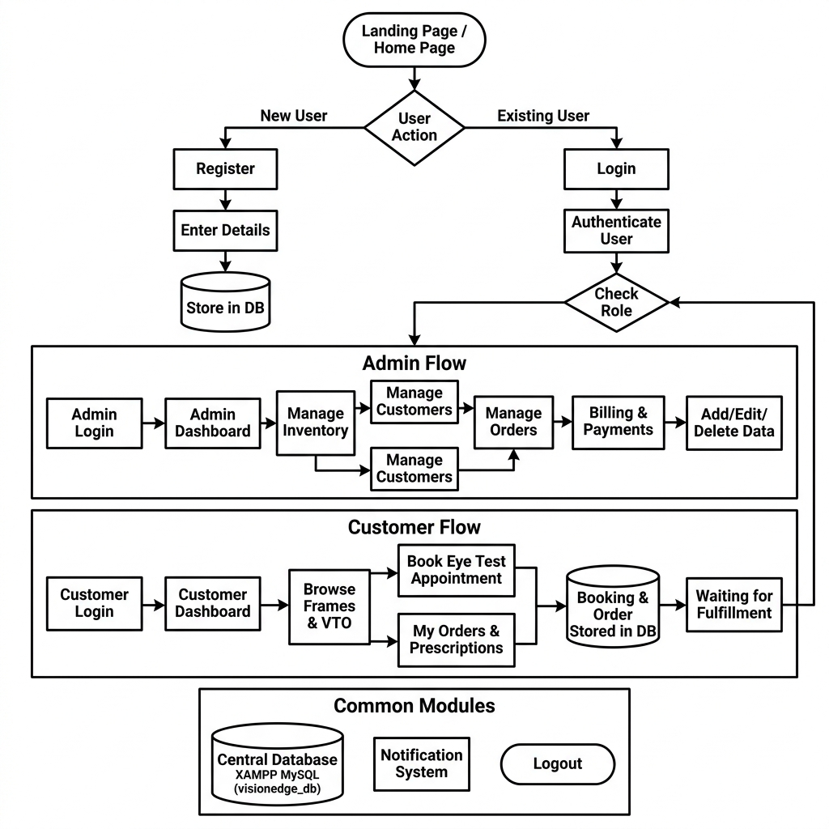
Figure 8.1: VisionEdge System Flow Diagram

8.2 UML OR Class Diagram
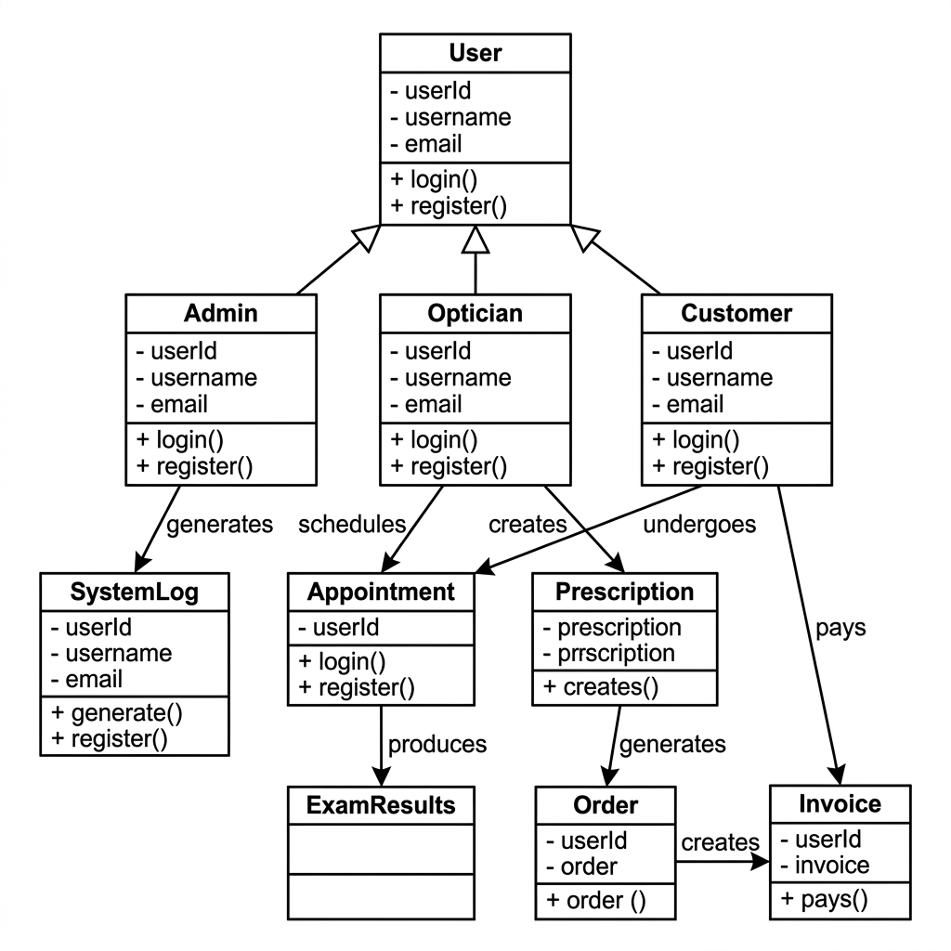 Figure 8.2: VisionEdge UML OR CLASS Diagram

8.2.1 UML / Use Case Diagram
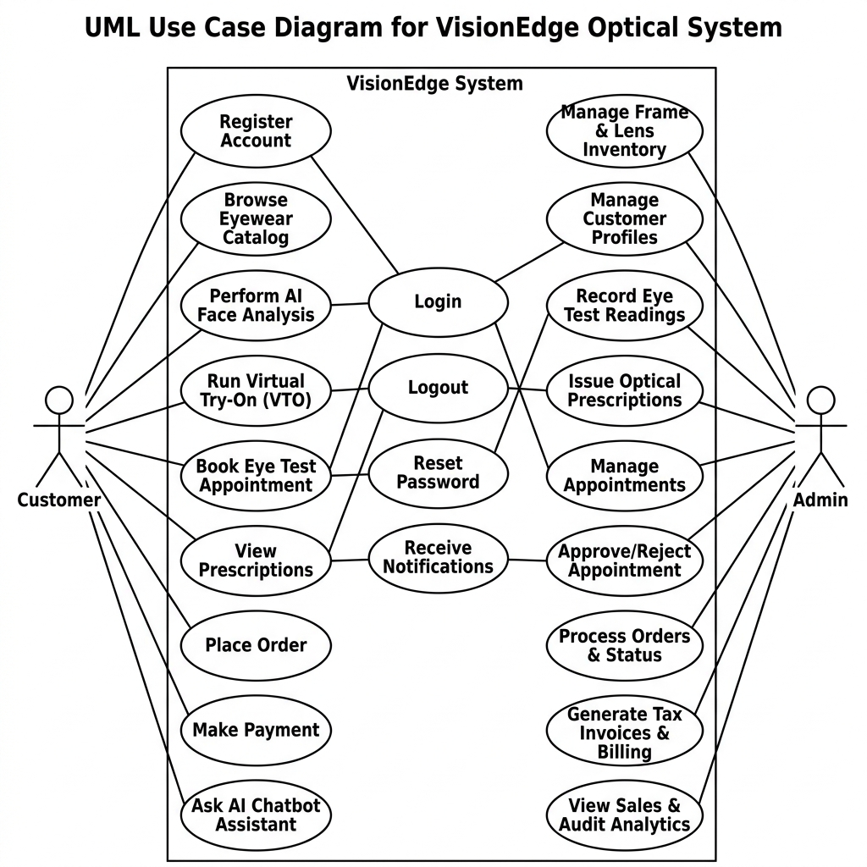
Figure 8.3: VisionEdge Use Case Diagram

8.2.2 Activity Diagram
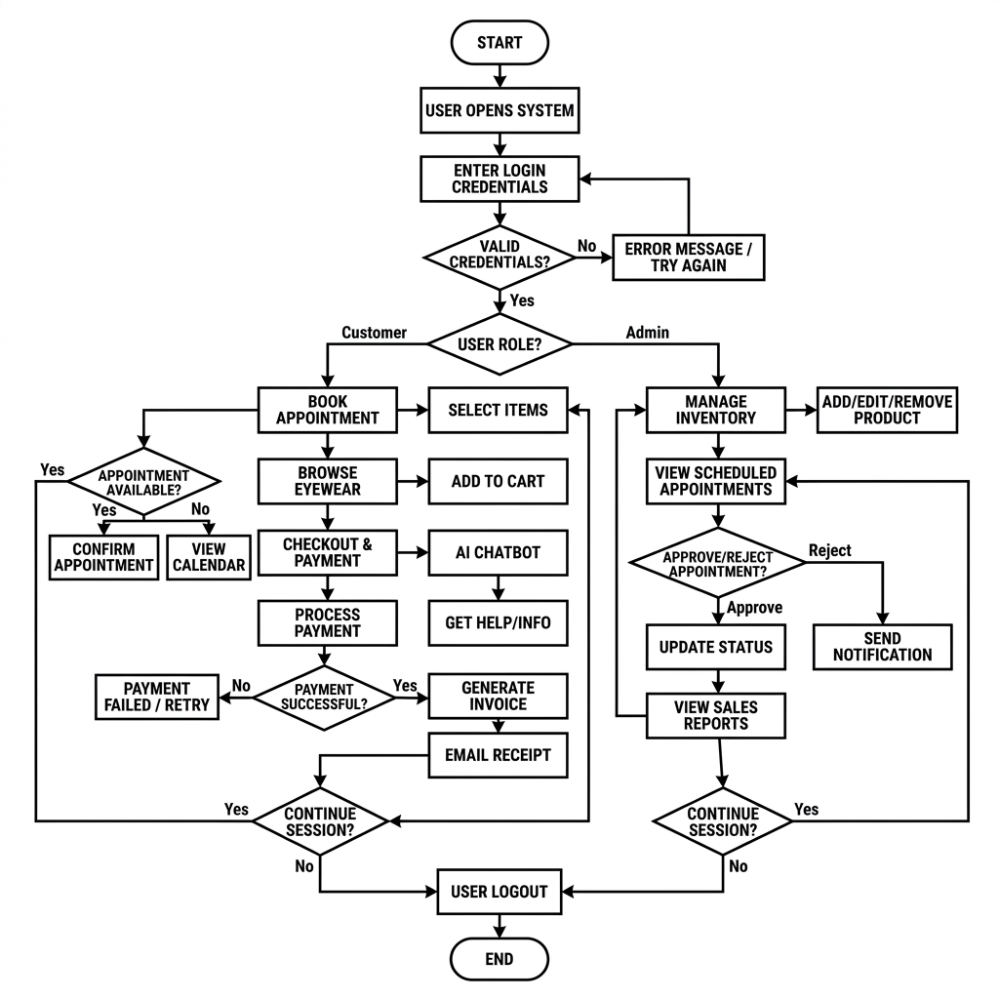

Figure 8.4: Customer Order and Recommendation Activity Flow

8.2.3 Sequence Diagram
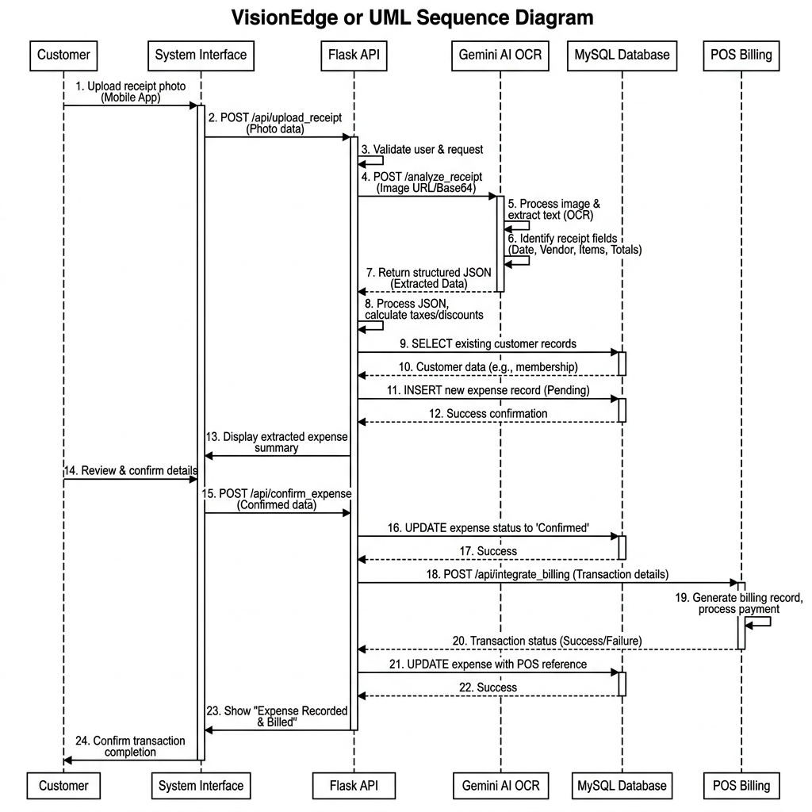
Figure 8.4: Frontend–API–AI–Database Sequence

8.3 ER Diagram
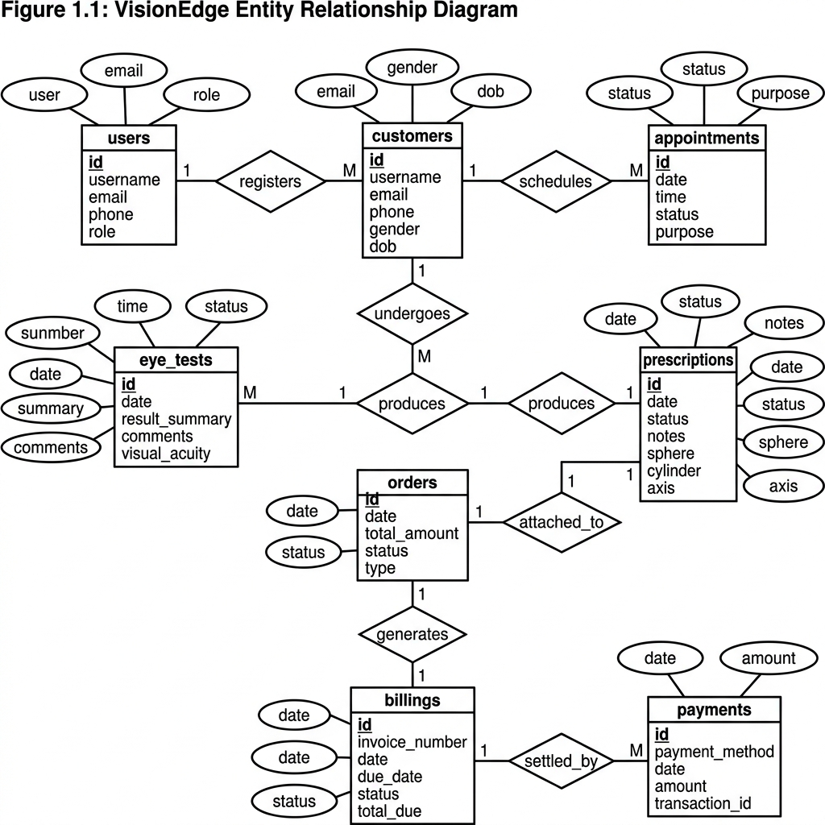
Figure 8.6: Simplified VisionEdge Entity Relationship Diagram

8.4 Data Dictionary
The following tables are derived from the SQLAlchemy models in the uploaded VisionEdge project source. They describe the implemented database entities and the principal fields used by the application.

1. User
Field Name | Datatype | Constraints | Description
id | Integer | primary_key=True | Unique identifier
username | String | unique=True, nullable=False | Login username
first_name | String | nullable=True | First name
last_name | String | nullable=True | Last name
password_hash | String | nullable=False | Secure password hash
email | String | unique=True, nullable=True | Email address
phone | String | — | Primary contact number
gender | String | — | Gender information
date_of_birth | Date | — | Date of birth
address | Text | — | Address
role | String | default='customer' | Authorization role
created_at | DateTime | default=datetime.utcnow | Record creation timestamp

2. Customer
Field Name | Datatype | Constraints | Description
id | Integer | primary_key=True | Unique identifier
customer_code | String | unique=True | Customer reference code
first_name | String | nullable=False | First name
last_name | String | nullable=False | Last name
gender | String | — | Gender information
date_of_birth | Date | — | Date of birth
age | Integer | — | Customer age
phone | String | nullable=False, index=True | Primary contact number
alternate_phone | String | — | Alternate contact number
email | String | index=True | Email address
address | Text | — | Address
city | String | — | City
state | String | — | State
pincode | String | — | Postal code
occupation | String | — | Occupation
photo | String | — | Customer photo path
status | String | default='Active' | Current record status
created_at | DateTime | default=datetime.utcnow | Record creation timestamp
updated_at | DateTime | default=datetime.utcnow, onupdate=datetime.utcnow | Last update timestamp
created_by | Integer | db.ForeignKey('user.id') | User who created the record

3. CustomerProfile
Field Name | Datatype | Constraints | Description
id | Integer | primary_key=True | Unique identifier
customer_id | Integer | nullable=False, unique=True, db.ForeignKey('customer.id') | Associated customer ID
blood_group | String | — | Blood group
eye_conditions | Text | — | Known eye conditions
allergies | Text | — | Known allergies
notes | Text | — | Additional notes

4. Appointment
Field Name | Datatype | Constraints | Description
id | Integer | primary_key=True | Unique identifier
customer_id | Integer | nullable=False, db.ForeignKey('customer.id') | Associated customer ID
appointment_date | Date | nullable=False | Appointment date
appointment_time | Time | nullable=False | Appointment time
appointment_type | String | — | Appointment category
doctor_name | String | — | Doctor / optometrist name
status | String | default='Pending' | Current record status
notes | Text | — | Additional notes
created_at | DateTime | default=datetime.utcnow | Record creation timestamp

5. EyeTest
Field Name | Datatype | Constraints | Description
id | Integer | primary_key=True | Unique identifier
customer_id | Integer | nullable=False, db.ForeignKey('customer.id') | Associated customer ID
appointment_id | Integer | nullable=True, db.ForeignKey('appointment.id') | Associated appointment ID
right_sphere | String | — | Right eye (OD) sphere
right_cylinder | String | — | Right eye (OD) cylinder
right_axis | String | — | Right eye (OD) axis
left_sphere | String | — | Left eye (OS) sphere
left_cylinder | String | — | Left eye (OS) cylinder
left_axis | String | — | Left eye (OS) axis
pd_value | String | — | Pupillary distance
remarks | Text | — | Clinical remarks
created_at | DateTime | default=datetime.utcnow | Record creation timestamp

6. Prescription
Field Name | Datatype | Constraints | Description
id | Integer | primary_key=True | Unique identifier
prescription_number | String | unique=True | Prescription reference number
customer_id | Integer | nullable=False, db.ForeignKey('customer.id') | Associated customer ID
eye_test_id | Integer | nullable=True, db.ForeignKey('eye_test.id') | Associated eye test ID
add_power | String | — | Near add power
prescription_image | String | — | Uploaded prescription image
ai_extracted_text | Text | — | AI-extracted prescription text
confidence_score | Float | — | AI extraction confidence
doctor_name | String | — | Doctor / optometrist name
created_at | DateTime | default=datetime.utcnow | Record creation timestamp
date | Date | default=datetime.utcnow | Date
expiry_date | Date | — | Prescription expiry date
status | String | default='Completed' | Current record status

7. Frame
Field Name | Datatype | Constraints | Description
id | Integer | primary_key=True | Unique identifier
frame_code | String | unique=True | Frame SKU/code
brand | String | — | Brand name
model | String | — | Frame/lens model
name | String | — | Display name
shape | String | — | Frame shape
color | String | — | Frame color
size | String | — | Frame size
material | String | — | Frame material
gender | String | — | Gender information
price | Float | nullable=False | Retail price
selling_price | Float | — | Selling price
stock | Integer | default=0 | Current stock quantity
min_stock | Integer | default=5 | Low-stock threshold
image | String | — | Product image path
vto_image | String | — | Virtual Try-On image path
status | String | default='Available' | Current record status
created_at | DateTime | default=datetime.utcnow | Record creation timestamp
updated_at | DateTime | default=datetime.utcnow, onupdate=datetime.utcnow | Last update timestamp

8. Lens
Field Name | Datatype | Constraints | Description
id | Integer | primary_key=True | Unique identifier
lens_code | String | unique=True | Lens SKU/code
name | String | — | Display name
brand | String | — | Brand name
type | String | — | Product / lens type
lens_type | String | — | Lens type compatibility field
coating | String | — | Lens coating
price | Float | nullable=False | Retail price
selling_price | Float | — | Selling price
stock | Integer | default=0 | Current stock quantity
min_stock | Integer | default=10 | Low-stock threshold
image | String | — | Product image path
status | String | default='Available' | Current record status
created_at | DateTime | default=datetime.utcnow | Record creation timestamp

9. Supplier
Field Name | Datatype | Constraints | Description
id | Integer | primary_key=True | Unique identifier
name | String | nullable=False | Display name
phone | String | — | Primary contact number
email | String | — | Email address
address | Text | — | Address
created_at | DateTime | default=datetime.utcnow | Record creation timestamp

10. Order
Field Name | Datatype | Constraints | Description
id | Integer | primary_key=True | Unique identifier
order_id | String | unique=True | Associated order ID
order_number | String | unique=True | Order reference number
customer_id | Integer | nullable=False, db.ForeignKey('customer.id') | Associated customer ID
prescription_id | Integer | nullable=True, db.ForeignKey('prescription.id') | Associated prescription ID
status | String | default='Pending' | Current record status
total_amount | Float | default=0.0 | Total monetary amount
order_date | DateTime | default=datetime.utcnow | Order date
created_at | DateTime | default=datetime.utcnow | Record creation timestamp

11. OrderItem
Field Name | Datatype | Constraints | Description
id | Integer | primary_key=True | Unique identifier
order_id | Integer | nullable=False, db.ForeignKey('order.id') | Associated order ID
product_type | String | — | Product type
item_type | String | — | Compatibility item type
product_id | Integer | — | Referenced product ID
item_id | Integer | — | Compatibility item ID
quantity | Integer | default=1 | Quantity
price | Float | — | Retail price
total_price | Float | — | Line total price

12. Billing
Field Name | Datatype | Constraints | Description
id | Integer | primary_key=True | Unique identifier
invoice_number | String | unique=True, nullable=False | Invoice number
order_id | Integer | nullable=False, db.ForeignKey('order.id') | Associated order ID
subtotal | Float | default=0.0 | Subtotal before discount/tax
discount | Float | default=0.0 | Discount amount
gst | Float | default=0.0 | GST amount
total_amount | Float | nullable=False | Total monetary amount
payment_status | String | default='Pending' | Payment status
payment_method | String | — | Payment method
invoice_pdf | String | — | Generated invoice PDF path
created_at | DateTime | default=datetime.utcnow | Record creation timestamp

13. Payment
Field Name | Datatype | Constraints | Description
id | Integer | primary_key=True | Unique identifier
billing_id | Integer | nullable=False, db.ForeignKey('billing.id') | Associated billing ID
amount | Float | nullable=False | Payment amount
transaction_id | String | — | Transaction reference
payment_method | String | — | Payment method
payment_date | DateTime | default=datetime.utcnow | Payment date

14. LensRecommendation
Field Name | Datatype | Constraints | Description
id | Integer | primary_key=True | Unique identifier
customer_id | Integer | db.ForeignKey('customer.id') | Associated customer ID
prescription_id | Integer | db.ForeignKey('prescription.id') | Associated prescription ID
recommended_lens | Text | — | Recommended Lens
reason | Text | — | Transaction reason
ai_response | Text | — | Ai Response
created_at | DateTime | default=datetime.utcnow | Record creation timestamp

15. FrameRecommendation
Field Name | Datatype | Constraints | Description
id | Integer | primary_key=True | Unique identifier
customer_id | Integer | nullable=False, db.ForeignKey('customer.id') | Associated customer ID
face_shape | String | — | Detected face shape
face_image | String | — | Face Image
recommended_frames | Text | — | Recommended Frames
selected_frame | String | — | Selected Frame
ai_reason | Text | — | Ai Reason
created_at | DateTime | default=datetime.utcnow | Record creation timestamp

16. VirtualTryOnHistory
Field Name | Datatype | Constraints | Description
id | Integer | primary_key=True | Unique identifier
customer_id | Integer | nullable=False, db.ForeignKey('customer.id') | Associated customer ID
frame_id | Integer | nullable=False, db.ForeignKey('frame.id') | Recommended frame ID
original_image | String | — | Original Image
generated_image | String | — | Generated Image
tryon_image | String | — | Tryon Image
created_at | DateTime | default=datetime.utcnow | Record creation timestamp

17. ChatHistory
Field Name | Datatype | Constraints | Description
id | Integer | primary_key=True | Unique identifier
user_id | Integer | db.ForeignKey('user.id') | User Id
customer_id | Integer | nullable=True, db.ForeignKey('customer.id') | Associated customer ID
question | Text | nullable=False | Question
answer | Text | nullable=False | Answer
created_at | DateTime | default=datetime.utcnow | Record creation timestamp

18. Notification
Field Name | Datatype | Constraints | Description
id | Integer | primary_key=True | Unique identifier
user_id | Integer | nullable=True, db.ForeignKey('user.id') | User Id
customer_id | Integer | nullable=True, db.ForeignKey('customer.id') | Associated customer ID
notification_type | String | nullable=False | Notification Type
title | String | nullable=False | Notification title
message | Text | nullable=False | Chat/notification message
status | String | default='Unread' | Current record status
created_at | DateTime | default=datetime.utcnow | Record creation timestamp

19. AuditLog
Field Name | Datatype | Constraints | Description
id | Integer | primary_key=True | Unique identifier
user_id | Integer | db.ForeignKey('user.id') | User Id
action | String | — | Audit action
module | String | — | Module
timestamp | DateTime | default=datetime.utcnow | Timestamp

20. Brand
Field Name | Datatype | Constraints | Description
id | Integer | primary_key=True | Unique identifier
name | String | nullable=False | Display name

21. Category
Field Name | Datatype | Constraints | Description
id | Integer | primary_key=True | Unique identifier
name | String | nullable=False | Display name

22. InventoryTransaction
Field Name | Datatype | Constraints | Description
id | Integer | primary_key=True | Unique identifier
product_type | String | — | Product type
product_id | Integer | — | Referenced product ID
transaction_type | String | — | Inventory transaction type
quantity | Integer | — | Quantity
notes | Text | — | Additional notes
created_at | DateTime | default=datetime.utcnow | Record creation timestamp

23. OrderStatusHistory
Field Name | Datatype | Constraints | Description
id | Integer | primary_key=True | Unique identifier
order_id | Integer | nullable=False, db.ForeignKey('order.id') | Associated order ID
status | String | — | Current record status
notes | Text | — | Additional notes
created_at | DateTime | default=datetime.utcnow | Record creation timestamp

8.5 Screenshots / Visual Assets of Module
The uploaded project ZIP contains the frontend modules listed in the source tree. It does not contain captured browser screenshots, so the following figures use the visual assets supplied with the project. The report also lists the corresponding frontend modules to document the implemented customer-side interface.

Category Eyeglasses

Figure 8.6: Supplied VisionEdge visual asset — category_eyeglasses.png

Category Sunglasses

Figure 8.7: Supplied VisionEdge visual asset — category_sunglasses.png

Ar Vto Banner
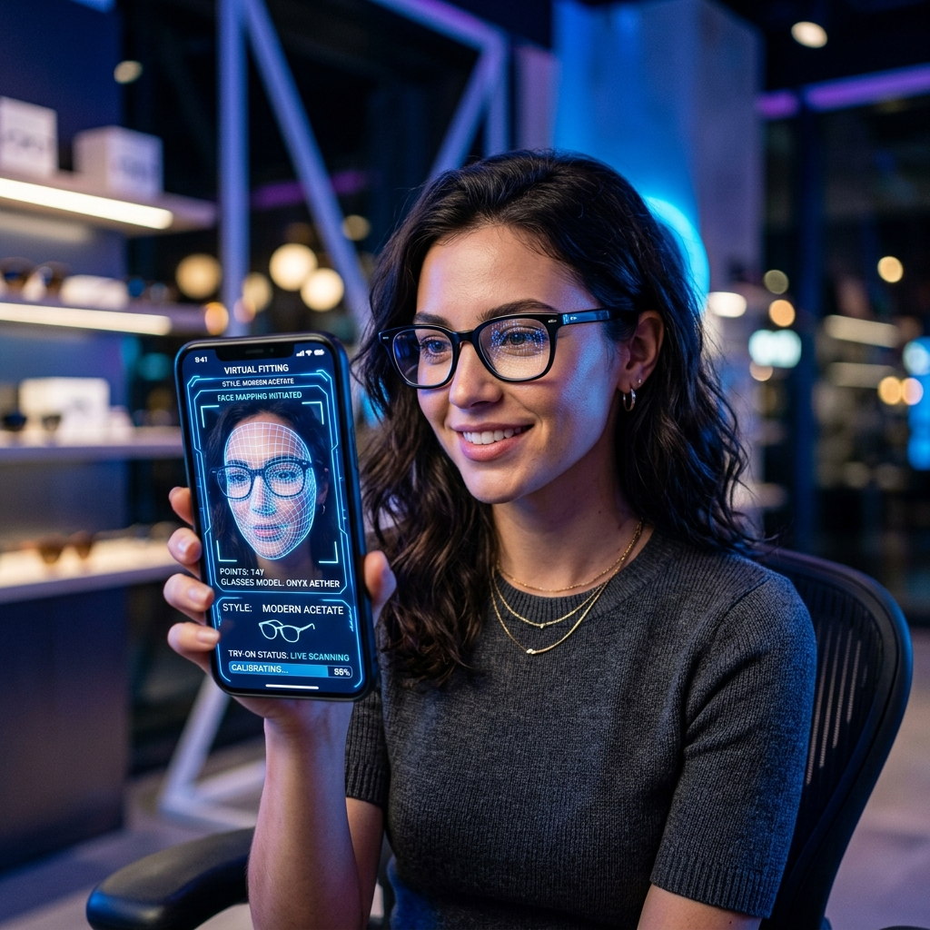
Figure 8.8: Supplied VisionEdge visual asset — ar_vto_banner.png

Computer Glasses

Figure 8.9: Supplied VisionEdge visual asset — computer_glasses.png

Contact Lenses

Figure 8.10: Supplied VisionEdge visual asset — contact_lenses.png

About Optician

Figure 8.11: Supplied VisionEdge visual asset — about_optician.png

Category Kids

Figure 8.12: Supplied VisionEdge visual asset — category_kids.png

Frontend Modules Present in the Project
- index.html — landing/home page
- login.html — customer login
- signup.html — customer registration
- dashboard.html — customer dashboard
- profile.html — customer profile
- eye-test.html — eye-test interface
- prescriptions.html — prescription management
- frames.html — frame catalogue
- lenses.html — lens catalogue
- lens-recommendation.html — lens recommendation
- products.html — products catalogue
- wishlist.html — wishlist
- offers.html — offers
- orders.html — order history
- checkout.html — checkout
- payment-history.html — payment history
- forgot-password.html — password recovery
- about.html, contact.html, faq.html, blog.html — information/support pages

9. Application
- Optical Retail Stores — manage customers, eye tests, prescriptions, inventory, orders, billing, and reports from one platform.
- Optometry / Optical Consultation Desks — record eye-test information and connect prescriptions with recommendations and orders.
- Customer Self-Service — browse frames/lenses, manage profile, view prescriptions, use recommendations, try frames virtually, and place orders.
- Inventory and Stock Management — track frame and lens quantities, brands, categories, suppliers, and stock transactions.
- Administrative Reporting — review sales, inventory, appointments, and customer activity using dashboard/report endpoints.
- Digital Customer Engagement — notifications, chatbot assistance, wishlist/product pages, and order tracking improve the customer experience.

10. Expected Outcomes
- Improved customer record organization through centralized CRM and prescription history.
- Reduced manual transcription effort through AI-assisted prescription extraction with staff verification.
- Faster frame selection through face-shape recommendation and Virtual Try-On.
- Better lens selection support through structured lens recommendation workflows.
- Improved inventory visibility and low-stock awareness for frames and lenses.
- Clear order lifecycle from creation to processing, readiness, and delivery.
- Automated billing with GST calculation and PDF invoice generation.
- Improved communication through notifications and chatbot support.
- Better management visibility through sales, inventory, appointment, and customer reports.

11. Future Scope
- Advanced 3D Virtual Try-On with improved face landmark tracking and frame-fit estimation.
- Mobile applications for Android and iOS.
- Online payment gateway integration for customer checkout.
- Integration with optical diagnostic/refractometer devices where technically and legally appropriate.
- Advanced AI analytics for demand forecasting, stock optimization, and customer preferences.
- Personalized recommendation models trained on anonymized historical purchase and preference data.
- Multi-language support for wider regional accessibility.
- Cloud deployment, centralized backups, monitoring, and scalable media storage.
- Customer loyalty, coupons, membership, and automated marketing campaigns.

12. References
- VisionEdge project source code and VisionEdge_SRS_Document.md supplied with the project ZIP.
- Flask Documentation — https://flask.palletsprojects.com/
- SQLAlchemy Documentation — https://docs.sqlalchemy.org/
- MySQL Documentation — https://dev.mysql.com/doc/
- Google AI / Gemini Documentation — https://ai.google.dev/
- MediaPipe Documentation — https://ai.google.dev/edge/mediapipe/solutions/guide
- MDN Web Docs — https://developer.mozilla.org/
- Python Documentation — https://docs.python.org/3/
- Bootstrap Documentation — https://getbootstrap.com/docs/
- FPDF / ReportLab documentation as applicable to the project implementation.

END OF PROJECT REPORT
VisionEdge — AI-Powered Optical Store Management & Virtual Try-On System
Prepared for academic submission by Chaudhari Devanshu Dilipbhai (2504070100284)

