

ME 605 Computational Fluid Dynamics  
Fall 2021-22

Instructor Prof. Dilip Sundaram

**Project-1**

Name - Devanshu Thakar

Roll no. – 18110174

Contents

Problem Statement 3

Analytical Solution 3

Taylor Series expansion of 4

Polynomial fitting 5

1. Uniform grid with UDS in convection 5

2. Uniform grid with CDS in convection 7

3. Plot of vs. 7

3.1 Plot for part-1 8

3.1.1 Discussion 8

3.2 Plot for part-2 9

3.2.1 Discussion 9

4. With 41 nodes 10

5 Non-uniform and higher order scheme 11

5.1 Non-uniform grids 11

5.1.1 Using FDS to discretize the diffusion term 12

5.1.2 Using CDS to discretize the diffusion term 13

5.2 Higher Order Schemes 14

5.2.1 Using a fourth order polynomial for diffusive term 14

# Problem Statement

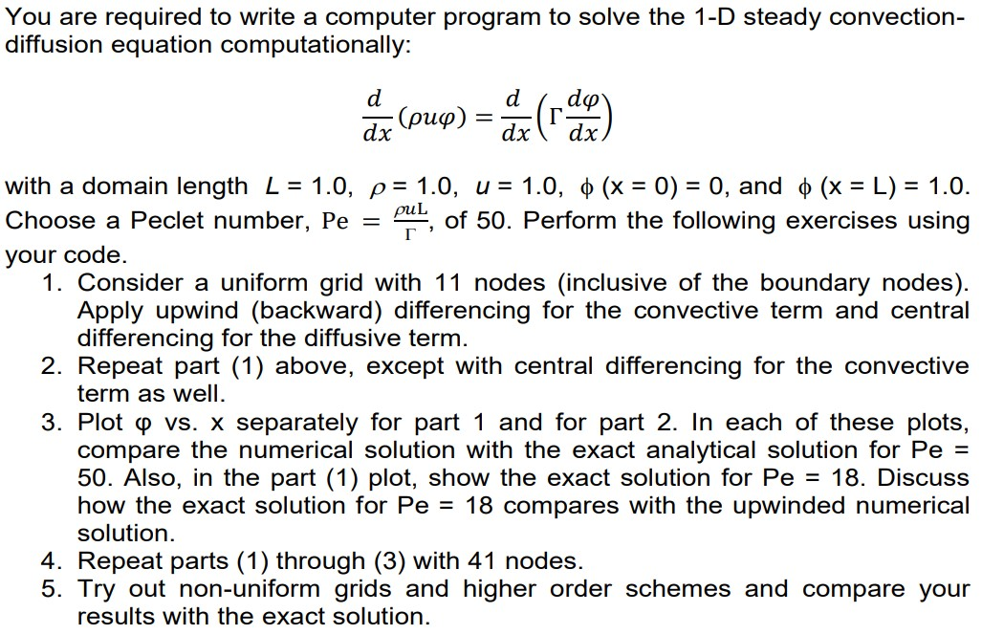

**Solution :**

Analytical Solution **-**

Given , and to be constant, hence independent of . We have

Integrating on both sides

The above equation is a linear differential equation, multiplying with Integrating factor

Integrating on both sides with

At

At = =

and

Substituting and and

Therefore we get the exact analytical solution as -

# Taylor Series expansion of

To obtain the approximations for the first and second order derivatives we use Tayler series expansion

Substituting by in above equation –

Neglecting terms higher than 2nd order derivative we get –

Assuming uniform grids . We get the approximation of the first order derivative by the upwind difference scheme

Approximating Taylor series at both and we get –

Combining both the above equations for a uniform grid we get –

# Polynomial fitting

For deriving a 2nd order approximation of the second order derivative , let be a polynomial of degree 2.

Consider three grid points , and . Let =0 be at the origin. and =. Assuming is increasing with and grid is uniform.

, and

and

On solving for and we get

and

On differentiating once we get CDS expression

On differentiating twice we get CDS expression for second derivative

# 1. Uniform grid with UDS in convection

Uniform grid =11 nodes, with upwind difference scheme in convective term and CDS in diffusive term

The uniform grid will have equal spacing between the grid points. The grid can be visualized as shown below –

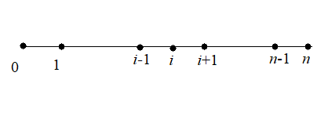

Approximating convective term by upwind (backward)

CDS for diffusion term –

Approximating the first derivative and by a CDS scheme –

and

Since the grid is uniform.

Substituting expression for , and in equation – **1**

Substituting the second and first order derivative approximations –

Equation- (1) is the final form of the discretized equation using upwind (backward) difference scheme for convective term and central difference scheme for the advective term.

Using the notation of to denote the principle diagonal, (east of ) upper diagonal of the principle diagonal and (west of ) as the lower diagonal from the principle diagonal.

Where ; and

At the first interior node (i.e ) = (boundary condition) is known.

Similarly at the last interior node –

In terms on Matrix notation –

where , and

# 2. Uniform grid with CDS in convection

Uniform grid =11 nodes, with CDS in convective term and CDS in diffusive term as well.

The arrangement for the grid points will be the same as in part-1. CDS for the convective term as well. The derivative can be approximated as -

Since the grid is uniform ,

Substituting the approximations for the convective and the diffusive terms

Equation- (2) is the final form of the discretized equation using central difference scheme for convective term and central difference scheme for the advective term.

where ; and

At the first interior node (i.e ) = (boundary condition) is known.

Similarly at the last interior node, =1 ) boundary condition

In terms on Matrix notation –

where , and

# 3. Plot of vs.

## 3.1 Plot for part-1

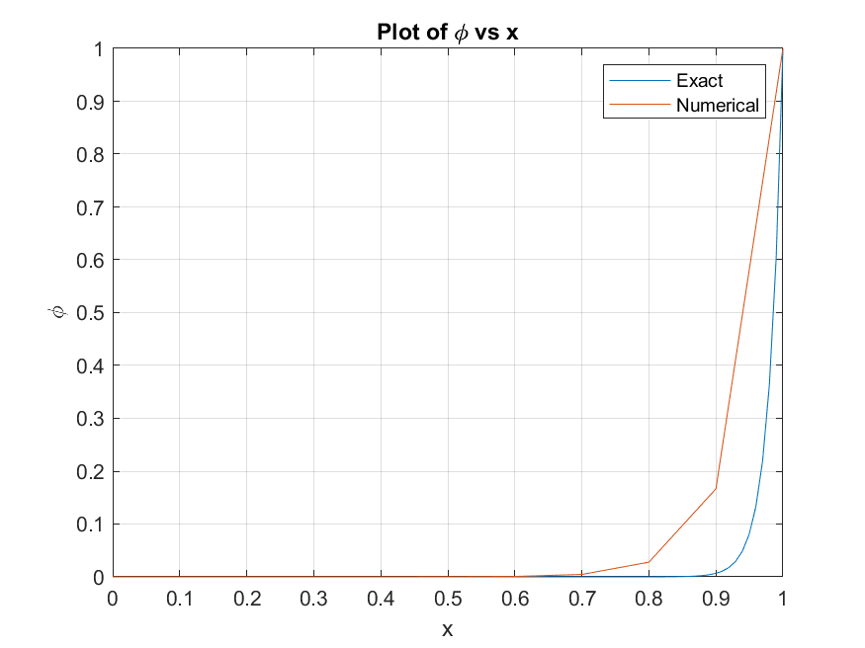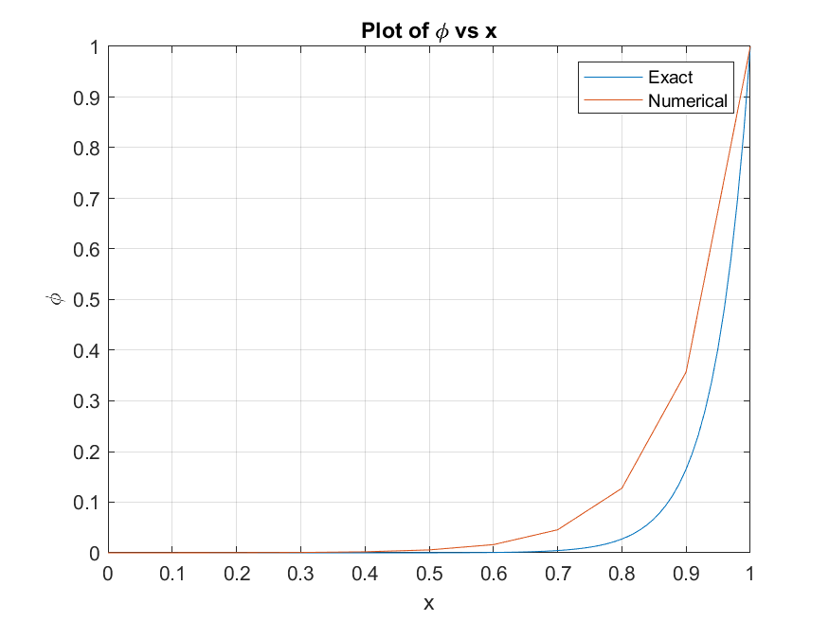

a

b

Figure Plot of ϕ vs. x computed using **11 uniform nodes** (a) with upwind (backward) scheme in convective term, with **Pe=50** (b) with upwind (backward) scheme in convective term, with **Pe=18**

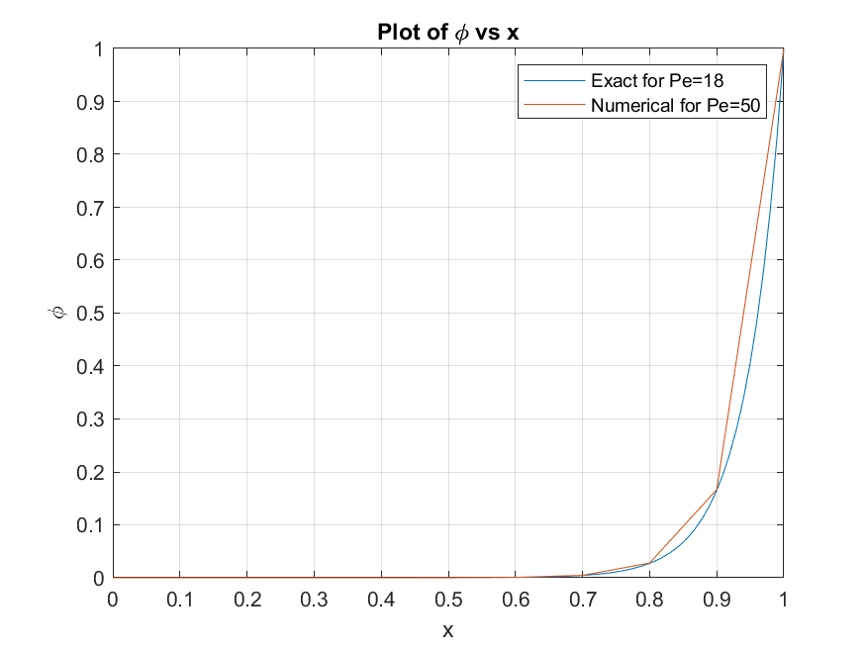

Figure Plot of ϕ vs. x computed using **11 uniform nodes** upwind (backward) scheme in convective term. Exact solution for with numerical solution for

### 3.1.1 Discussion

From the Figure-1 it can be observed that for both the values of =50 and 18 the numerically calculated solution is showing high error beyond or . This is because the undergoes a sudden change in derivative as is increased. Also with the increase in it can be seen that is changing more rapidly for higher . The Peclet number () is a ratio of convection () and diffusion ( diffusivity). Therefore, by reducing we get more diffusion dominated solution. Due to this there is less error for =50 compared to =18.

From Figure-2 it can be seen that the numerical solution for (part-1) is matching very closely to the exact solution with =18. In other words the numerical solution for corrosponds to the exact solution of =18. A lesser value of indicates a diffusion dominated solution. Therefore, it can be said that the upwind (backward) difference scheme (UDS) produces a solution which is having excess diffusion. Thus, the first order UDS is giving over-diffusive solution.

## 3.2 Plot for part-2

The numerical solution by using CDS in diffusive term is shown in Figure-3.

Figure Plot of ϕ vs. x computed using **11 uniform nodes** with CDS scheme in convective term (a) **Pe=50** (b) **Pe=18**

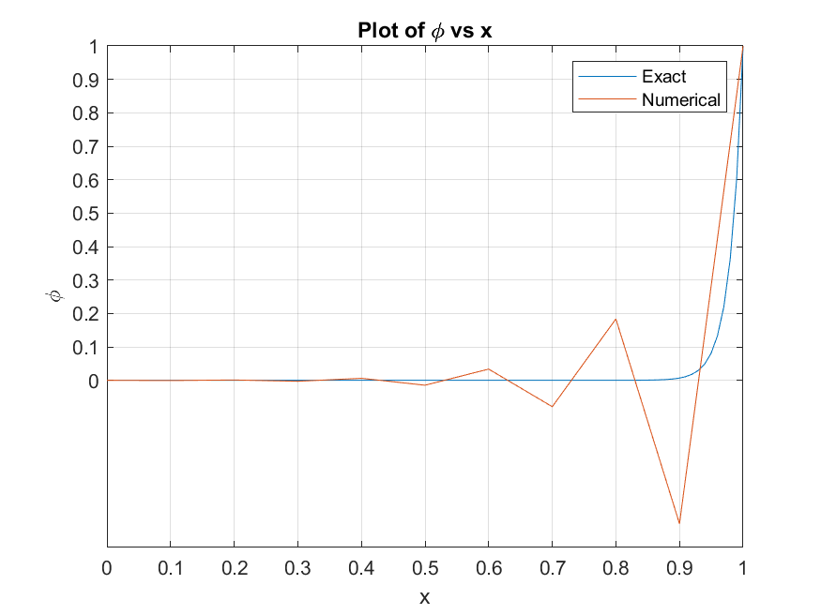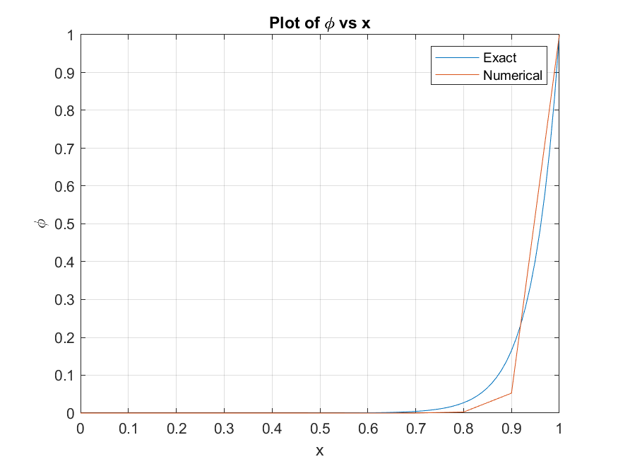

b

a

### 3.2.1 Discussion

It can be observed that for =50 the Central difference scheme in convective term is showing oscillatory nature. By decreasing the oscillatory nature of solution is reduced to a certain extent. However, still the solution is slightly oscillatory as for =0.7 to =0.9 the numerical solution is less than analytical solution and after =0.9 the numerical solution is higher than exact solution. The oscillatory solution in CDS can be attributed to the fact that CDS takes into account the differences from both sides equally. In most of the physical problem there is some sense of direction in which a particular quantality is flowing. CDS is unable to consider the direction of the flow.

Assuming that the flow is from node to a backward difference scheme is used. Upwind difference scheme (UDS) is sometimes better than CDS, as it takes into account the direction of the quantity. Moreover, UDS considers the direction in which information is propagating. The upwind (backward) difference scheme is able to capture a sense of direction of the flow, however, it is giving over diffusive solution.

# 4. With 41 nodes

For uniform grid by increasing the number of grid points, the grid becomes more finer. However, the derivation of the discretized equations remains the same. The only thing that needs to be changed is the value of number of grid points in code Q1.m and Q2.m for part-1 and part-2 respectively. Both the codes were run for 41 uniform grid points with value of =50 and 18. The plots showing calculated numerically with the analytical are shown as follows:

```

Figure 4 Plot of vs. using upwind (backward) scheme in convection term and total **grid nodes=41** (a) For (b) For

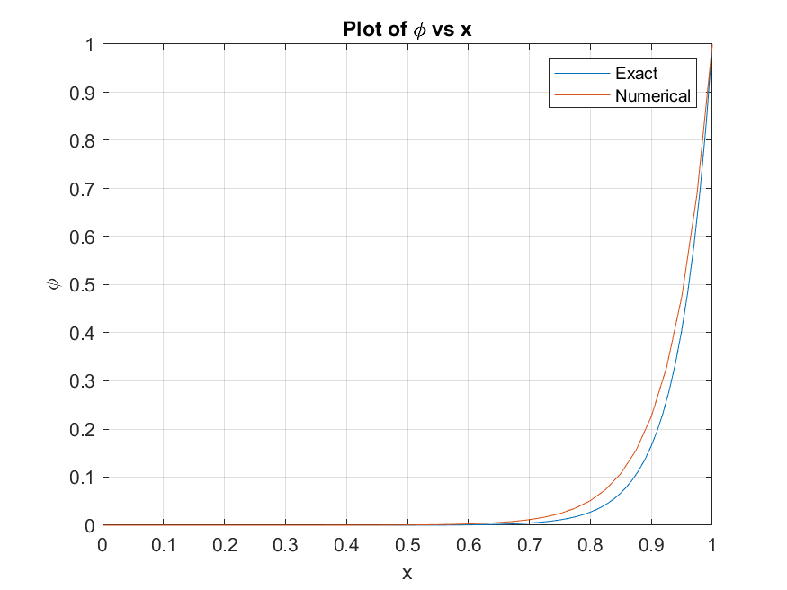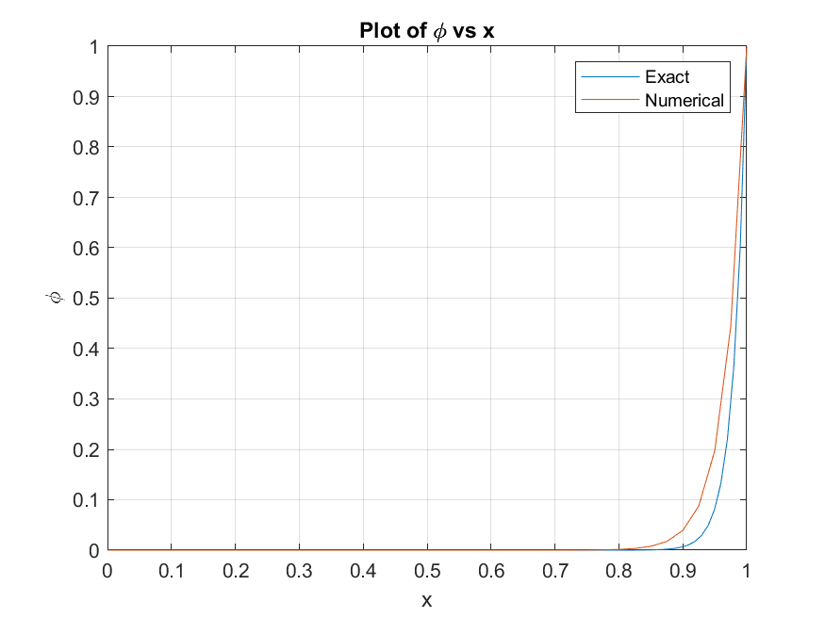

a

b

Using CDS in convective term –

Figure 5 Plot of vs. computed using CDS in convection term and total **grid nodes=41** (a) For (b) For

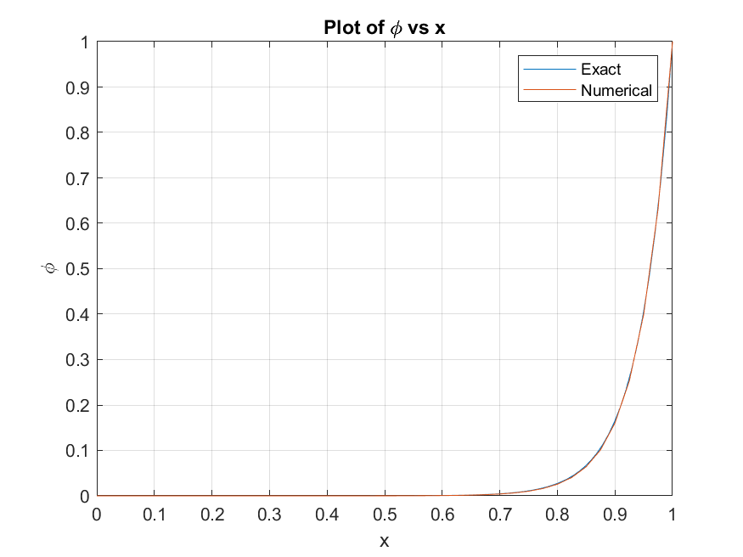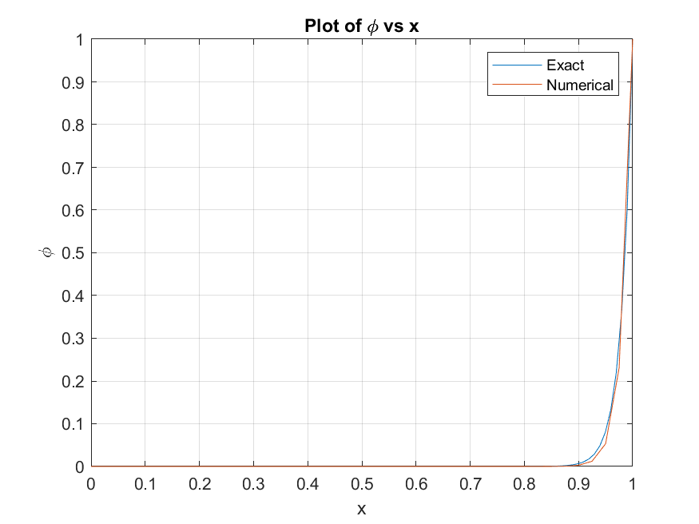

a

b

**References :**

**4.1 Discussion**

From Figure-4 it can be seen that by increasing the number of node points the error in the upwind difference scheme has reduced. Though the numerical solution is still over-diffusive but the extent of over-diffusiveness is reduced. By making the grid finer more points are taken which reduces the error to some extent. However, the numerical solution still have error in regions where there is sharpen increase in derivative of (for larger >0.7). From Figure-5, by refining the grid for CDS in convective term the solution is oscillation free. Therefore refining the grid helps to reduce the error and increases the accuracy of numerical solution.

# 5 Non-uniform and higher order scheme

## 5.1 Non-uniform grids

Truncation error depends not only on the grid spacing but also on the value of the derivative. Therefore, in uniform grid if the value of derivative is high the error would rise. In that situation using a non-uniform grid would be advantageous.

From the plot of vs. from previous sections it can be observed that the value of slope remains approximately zero until =0.7 or 0.8. After that there is a sudden increase in and its slope. Therefore using coarse grids near =0 and finer grids near =1 will help to reduce the error. Let be the largest spacing between the two grid points, and be the expansion factor. In total there are non-uniform grid points. The summation of all the s should be equal to . Let =

Since the grid is contracting <1. Let us choose arbitrarily. Therefore can be computed from the above equation. For we get =0.306

### 5.1.1 Using FDS to discretize the diffusion term

Let the second derivative of the diffusive term be expanded using a FDS (Forward difference scheme). For the inner derivatives, a BDS (backward difference scheme) is used -

Approximating the convective term using a BDS

Therefore the final discretized equation can be represented as

MATLAB code Q5_non_uniform.m was used to solve using non-uniform grid.

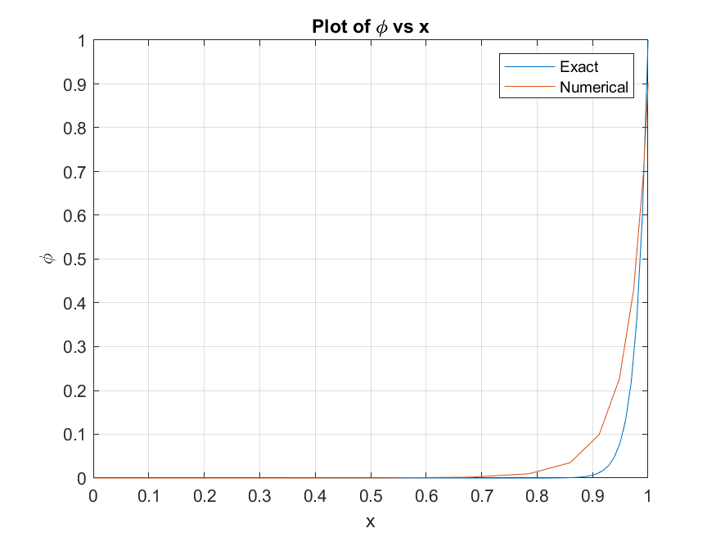

Figure 6 Plot of vs. computed using **11 non-uniform nodes** with upwind (backward) scheme in convective term and FDS in diffusive term, with

### 5.1.2 Using CDS to discretize the diffusion term

Applying a Central Difference scheme for the diffusive terms and also for the first order derivatives occurring in it.

Approximating the convective term using a BDS

Therefore the final discretized equation can be represented as

The same MATLAB program i.e. Q5_non_uniform.m can be used to generate the plot shown below :

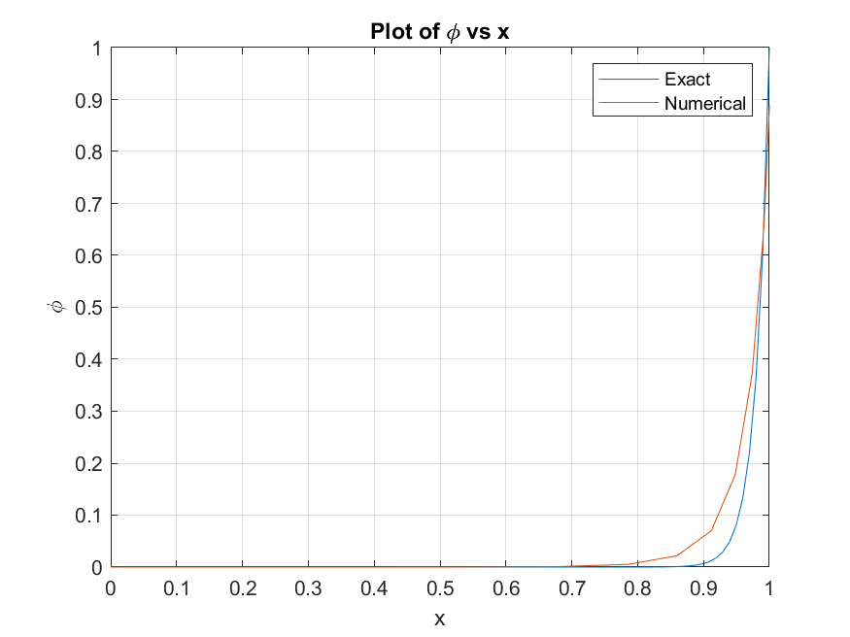

Figure 7 Plot of vs. computed using **11 non-uniform nodes** with upwind (backward) scheme in convective term and CDS in diffusive term, with

## 5.2 Higher Order Schemes

## 5.2.1 Using a fourth order polynomial for diffusive term

The second order diffusion term can be discretized by using a higher order central difference scheme. The second order derivative can be obtained by deriving a polynomial of degree four using five points i.e. ,, , and over a uniform grid. Using a 4th order polynomial to get

The coefficients , , and can be obtained by substituting , and into the polynomial expression.

Approximating the convective term using a upwind backward (BDS )

Substituting into the 1D convective diffusion equation -

However to use the above expression, the value of at the second and second last node is required. Therefore using a unwind backward difference scheme to approximate first order derivative and a CDS to approximate second order derivative. From the part-1 we have

The values of and obtained in part-1 are used in this higher order scheme

From the expression we can evaluate and . Note and . The final Matrix will look like the following –

where , and

The MATLAB code Q5_higher_order.m is developed to solve the above matrix equation. The plot of vs. for 11 uniform node points for =50 and =18 are shown in Figure--8

Figure 8 Plot of vs. computed using **11 uniform nodes** with higher order scheme in diffusive term (a)For (b) For **Pe**-18

a

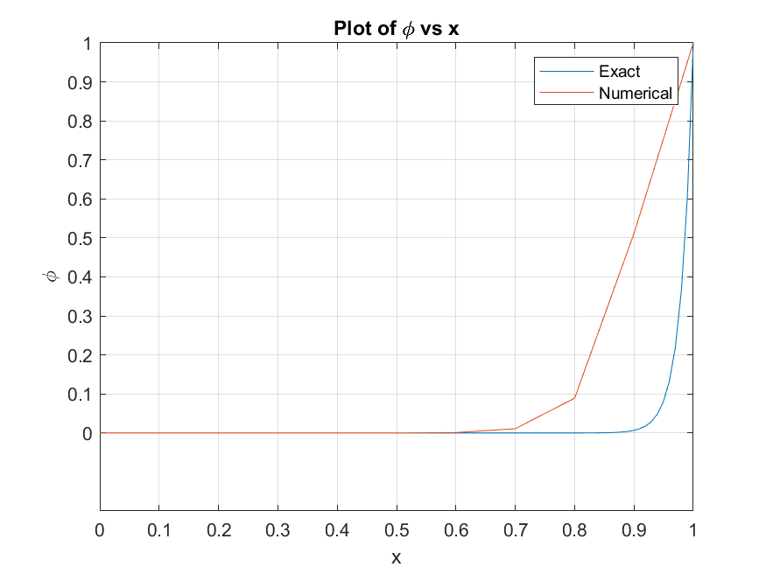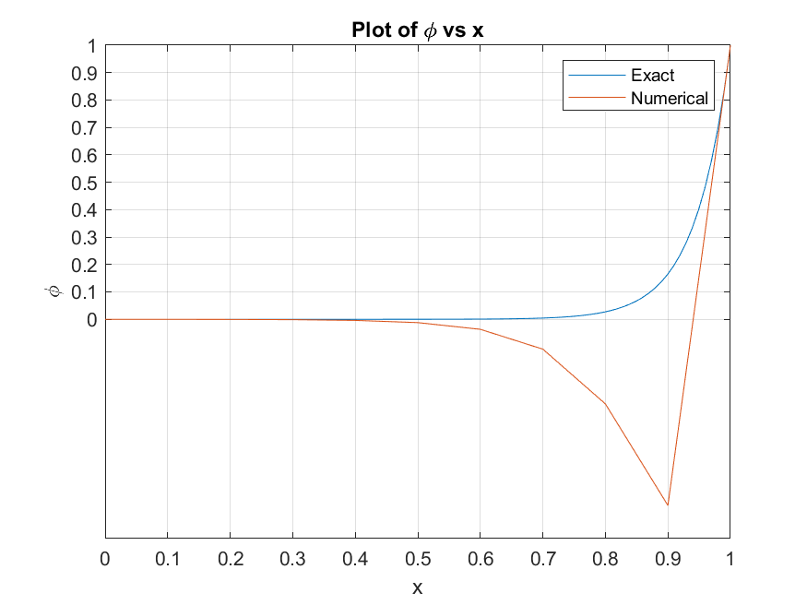

b

# 5.3 Discussion

# 6. Conclusion