Name: Devanshu Dave

Lab4 – Report

Lab 4

Contents

Problem Specification :- 3

Layout - 4

Coding / Actions 10

Outputs -: 13

### Problem Specification :-

The app which I created is about the shopping app for the small company. It solves the problem of small companies which can’t afford to keep big apps for now. My app simply takes high selling products and put them into the view which gives user an ability to pick the products. It can calculate the quantity of each item user wants and also calculates the total price. Along with that it has many small features like sensors, media, images, canvas items. It also gives user the ability to reset the selected item from last screen. This is the description of the app (what does it do) and how it solves the problem.

### Layout -

Screen 2 : Menu

Screen 3 :- Cart

Screen 4 – Thank You screen

## Coding / Actions

Screen 1 –

Screen 2 - 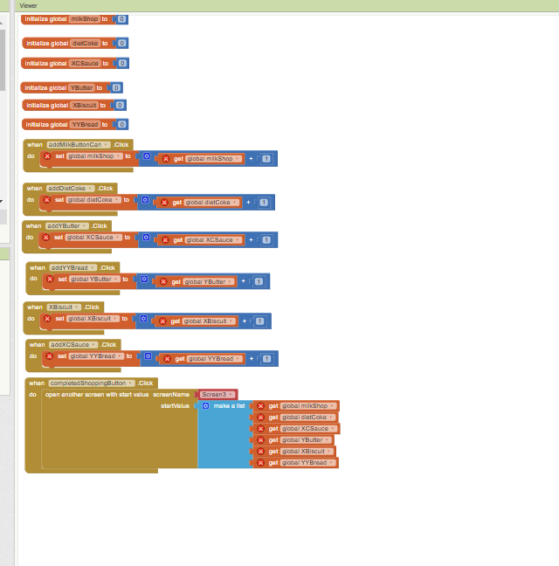\

Screen 3 : - 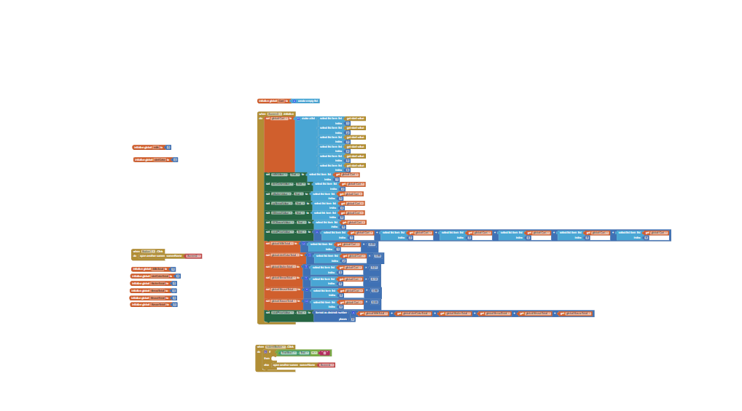

## Outputs -:

Rest are some small features -: like social media , sound and sensor which were not able to capture in screenshot