HOTEL BOOKING DATA CLEANING PROJECT REPORT
Python • Pandas • NumPy • Matplotlib • Seaborn

Project Overview
This project cleans a real hotel booking dataset by identifying missing values, removing duplicate records, filling missing Country values with 'Unknown', and validating the cleaned dataset for analysis.

Dataset Summary (Before Cleaning)
Metric | Value
Rows Before Cleaning | 40060
Columns | 31
Duplicate Rows | 6092
Columns with Missing Values | 1

Screenshot 1: Dataset Preview
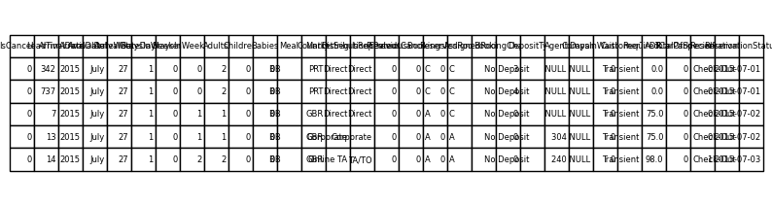

Data Cleaning Process
- Loaded CSV dataset into Pandas DataFrame.
- Checked dataset shape, columns, info(), and describe().
- Identified missing values using isnull().sum().
- Calculated missing value percentages.
- Detected duplicate rows using duplicated().sum().
- Removed duplicate records using drop_duplicates().
- Filled missing values in Country column with 'Unknown'.
- Validated cleaned dataset.

Screenshot 2: Missing Values Before Cleaning
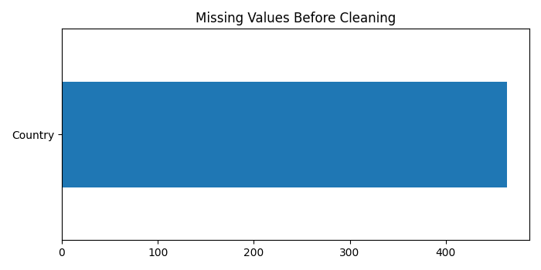

Screenshot 3: Missing Values After Cleaning
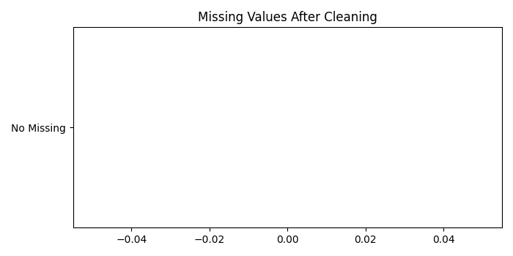

Screenshot 4: Duplicate Records (Before vs After)
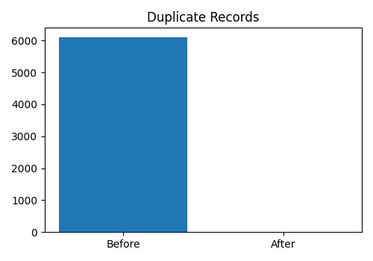

Screenshot 5: Top Countries After Cleaning
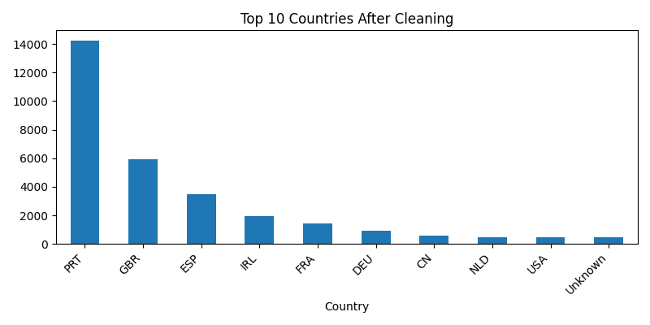

Final Dataset Summary (After Cleaning)
Metric | Value
Rows After Cleaning | 33968
Columns | 31
Duplicate Rows Remaining | 0
Missing Country Values Remaining | 0

Project Outcome
The dataset is cleaned and ready for Exploratory Data Analysis (EDA) and dashboard creation. Duplicate records were removed and missing Country values were successfully handled.

GitHub Description
A Hotel Booking Data Cleaning project using Python and Pandas. This project demonstrates real-world preprocessing techniques including missing value handling, duplicate removal, dataset validation, and preparation for business analytics.

