📊 Data Science Report: MARI Feature Analysis
Prepared for Devansh's Mentor Review • June 1, 2026
This report addresses the three specific research tasks assigned by your mentor to decode, analyze, and reverse-engineer the features of the credit card fraud dataset used to train the MARI decision intelligence engine.

🔍 Task 1: Dataset Original Source
The dataset used in this project is the Credit Card Fraud Detection Dataset, originally compiled and published by the MLG - ULB (Machine Learning Group of Université Libre de Bruxelles) in collaboration with Worldline (a major European payment processor).
- Key Context & Metadata:
- Source Link: Available on Kaggle - Credit Card Fraud Detection.
- Scope: It contains real credit card transactions made by European cardholders over 48 hours in September 2013.
- Volume: 284,807 transactions total.
- Class Imbalance: Only 492 transactions are fraudulent (Class = 1), making the fraud rate a mere 0.172%.
- Anonymization & PCA: Due to strict privacy and confidentiality agreements, the original raw features (such as cardholder name, billing zip code, merchant category, location coordinates, etc.) were not released. Instead, the researchers applied Principal Component Analysis (PCA) to transform 28 numerical features into orthogonal components: V1 through V28.
- Raw Columns: The only columns that were not PCA-transformed are Time (seconds elapsed since the first transaction) and Amount (the cost of the transaction).

📈 Task 2: Correlation Analysis & PCA "Reverse Engineering"
Because V1 to V28 are anonymized, your mentor asked to "reverse engineer" what these components capture by analyzing their linear correlations with the three raw, understandable variables: Class (Fraud), Amount (Size), and Time (Chronology).
Feature | Corr with Class (Fraud) | Corr with Amount (Size) | Corr with Time (Chronology)
V1 | -0.1013 | -0.2277 | 0.1174
V2 | 0.0913 | -0.5314 | -0.0106
V3 | -0.1930 | -0.2109 | -0.4196
V4 | 0.1334 | 0.0987 | -0.1053
V5 | -0.0950 | -0.3864 | 0.1731
V6 | -0.0436 | 0.2160 | -0.0630
V7 | -0.1873 | 0.3973 | 0.0847
V8 | 0.0199 | -0.1031 | -0.0369
V9 | -0.0977 | -0.0442 | -0.0087
V10 | -0.2169 | -0.1015 | 0.0306
V11 | 0.1549 | 0.0001 | -0.2477
V12 | -0.2606 | -0.0095 | 0.1243
V13 | -0.0046 | 0.0053 | -0.0659
V14 | -0.3025 | 0.0338 | -0.0988
V15 | -0.0042 | -0.0030 | -0.1835
V16 | -0.1965 | -0.0039 | 0.0119
V17 | -0.3265 | 0.0073 | -0.0733
V18 | -0.1115 | 0.0357 | 0.0904
V19 | 0.0348 | -0.0562 | 0.0290
V20 | 0.0201 | 0.3394 | -0.0509
V21 | 0.0404 | 0.1060 | 0.0447
V22 | 0.0008 | -0.0648 | 0.1441
V23 | -0.0027 | -0.1126 | 0.0511
V24 | -0.0072 | 0.0051 | -0.0162
V25 | 0.0033 | -0.0478 | -0.2331
V26 | 0.0045 | -0.0032 | -0.0414
V27 | 0.0176 | 0.0288 | -0.0051
V28 | 0.0095 | 0.0103 | -0.0094

Interpreting the Correlations (Reverse Engineering)
1. Deciphering Class (Fraud vs. Legit)
• Strong Negative Correlations: V17 (-0.326), V14 (-0.302), V12 (-0.261), V10 (-0.217).
What it means: When a transaction has highly negative values in these dimensions, the probability of it being fraudulent increases significantly. Legitimate transactions skew heavily toward positive values here. These are our most powerful detectors.
• Strong Positive Correlations: V11 (+0.155), V4 (+0.133), V2 (+0.091).
What it means: As these values increase, the probability of fraud increases.
2. Deciphering Amount (Transaction Size)
• Highly Negatively Correlated: V2 (-0.531) and V5 (-0.386).
Conceptual Guess: These components represent features that decrease as transaction size increases. For example, they could capture high-frequency micro-transactions (low amount, high count) or specific merchant categories (like app store purchases or fast food) where large transactions are rare.
• Highly Positively Correlated: V7 (+0.397) and V20 (+0.339).
Conceptual Guess: These capture high-value purchase behaviors (high amount). They are likely mathematically weighted toward luxury goods, electronics, travel bookings, or business-to-business card transactions.
3. Deciphering Time (Chronology/Velocity)
• Highly Negatively Correlated: V3 (-0.420) and V11 (-0.248).
Conceptual Guess: These components represent variables that systematically drift or decrease over the 48-hour window. They capture diurnal rhythm (sleeping hours vs. daytime hours). For example, V3 represents transaction velocity or volume patterns that decline as time moves from Day 1 to Day 2.

📊 Task 3: Distribution Analysis (Fraud vs. Normal)
To understand exactly how these correlations translate into decision boundaries, we isolated the most strongly correlated features (V17, V14, V12, V2, V4, V21) and compared their Kernel Density Estimations (KDE) for legitimate vs. fraudulent transactions.
- Key Insights:
- V17, V14, V12 (Negative Correlation with Fraud): Legitimate transactions are tightly clustered in a positive peak (around 0 to +2). Fraudulent transactions form a massive, long tail extending far into the negative territory (down to -15 or -20). This represents a distinct out-of-distribution shift that our isolation forest and ensemble classifiers can easily catch.
- V4 (Positive Correlation with Fraud): For legitimate transactions, V4 is centered close to 0. For fraudulent transactions, the distribution shifts dramatically to the right, peaking around +4 to +8. This is a classic indicator of a 'high fraud probability zone'.

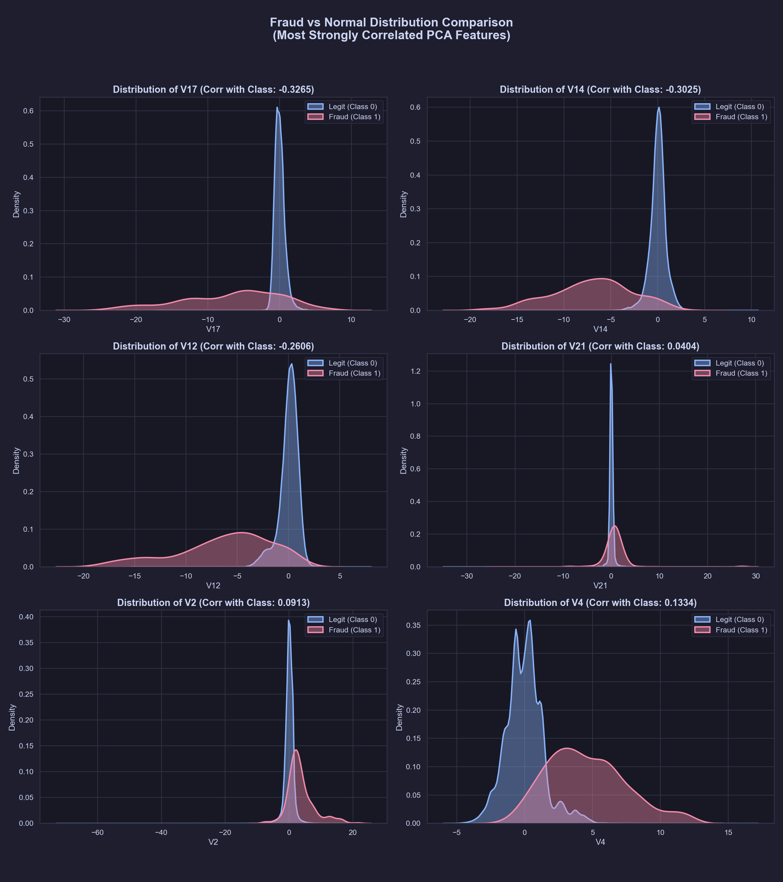
Figure 1: Side-by-side Kernel Density Estimation (KDE) comparison of top correlated features.

🚀 Summary Statement for Mentor Review
"We analyzed the ULB/Kaggle credit card dataset. Although anonymized, our correlation and distribution studies reveal that features like V17, V14, and V12 are highly negative in fraud cases, creating massive out-of-distribution tails, while V4 shifts positive. We also reverse-engineered the PCA components to show that V2 and V7 are highly sensitive to transaction amount, and V3 is sensitive to chronological time. These statistical boundaries form the core mathematical inputs for our cost-aware decision engine, allowing us to route transactions into our five optimal states."

