DAT 475 PROJECT ONE

Preliminary Analysis of Manual Finish Manufacturing Defects
DeVante Bowen
Southern New Hampshire University
DAT 475 - Applied Data Analysis
September 19, 2026
Prepared for the manufacturing supervisor
Analysis period: Inspection weeks 2025-W01 through 2025-W52

Problem Statement and Organizational Need
The Tijuana manufacturing facility is experiencing assembly and soldering defects in the Manual Finish area while product demand is increasing. The data set provided contains 3,150 defect records over 52 inspection weeks in 2025. There are 2,181 or 69.2% records for the three models. These models should be the first target for improvement efforts, investigating component placement, fixtures, wave soldering, inspection and transfer to final assembly.
The organizational problem is that defects that are created in or pass through the Manual Finish create assembly and electronic test problems downstream where repairs take too much production time and skilled labor. The desired results are 20% reduction in welding defects and 20% increase in capacity for the three double production lines without increasing the percentage of defects (Southern New Hampshire University [SNHU], n.d.-a).
If successful, this correction would reduce rework and enable the company to meet the increased demand while still meeting the acceptance requirements described in the case. If they continue, workers will have to spend more time fixing completed assemblies, which cuts into available production capacity and increases the risk of late orders. The case references IPC-A-610E as its acceptance criteria; this report utilizes that requirement as case background.

Most Significant Models and Defects
Figure 2. Pareto chart for all production models
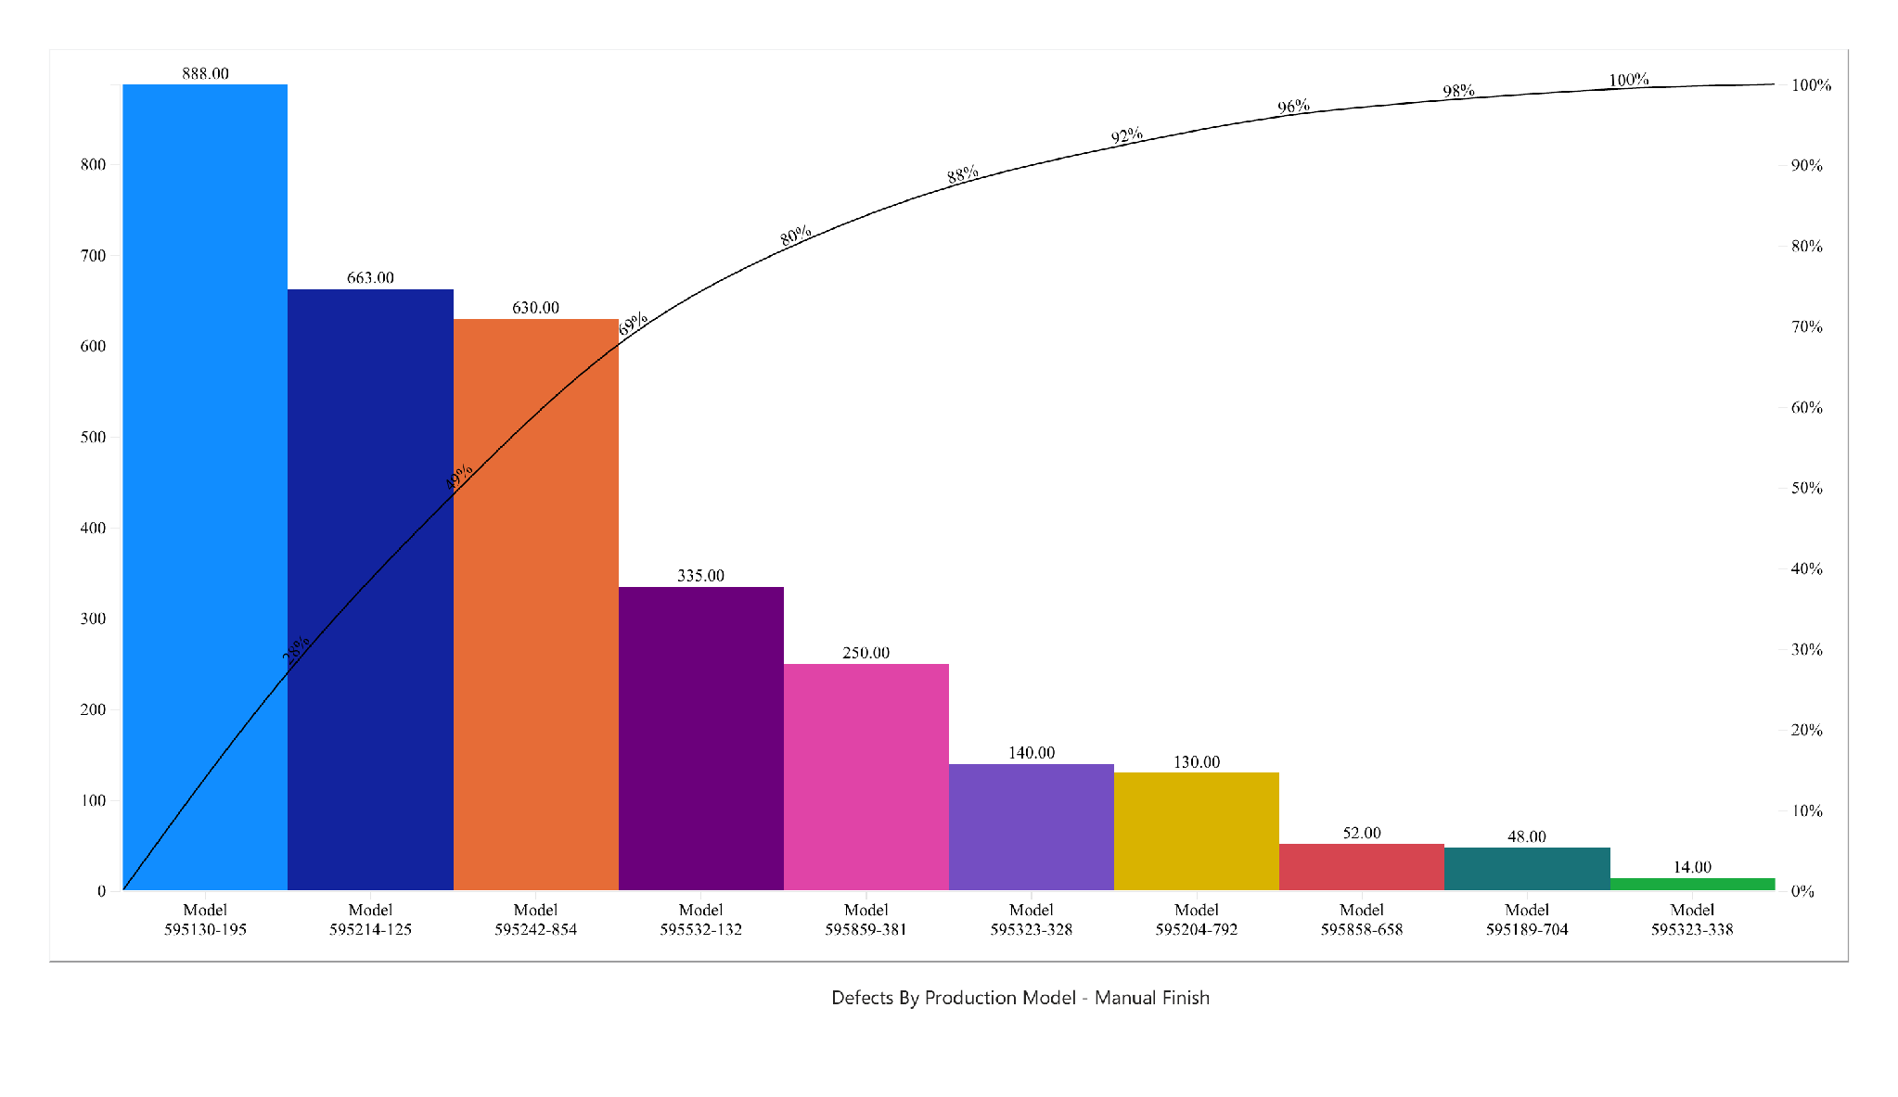
Model 595130-195 has 888 defects, model 595214-125 has 663 defects, and model 595242-854 has 630 defects. Their shares are 28.2%, 21.0%, and 20.0%. Together they make up 69.2% of all records. If we include Model 595532-132, the cumulative share rises to 79.9%. The project requirement drives the focus on three models, not an 80/20 split. This chart focuses the investigation on the largest recorded defect burden. This chart does not prove these models have the highest defect rates.
The three most frequently occurring categories across the whole data set were solder bridge (304; 9.7%), “no property assembled” (272; 8.6%), and “missing/unknown” (239; 7.6%). They make up together 25.9%. The last two labels require clarification before they can inform accurate corrective actions. Original labels are kept, not silently reclassified. All four Pareto charts were supplied as Power BI exports, and counts and percentages were checked against them.

Defect Analysis for Model 595130 195
Figure 3. Pareto chart for Model 595130-195
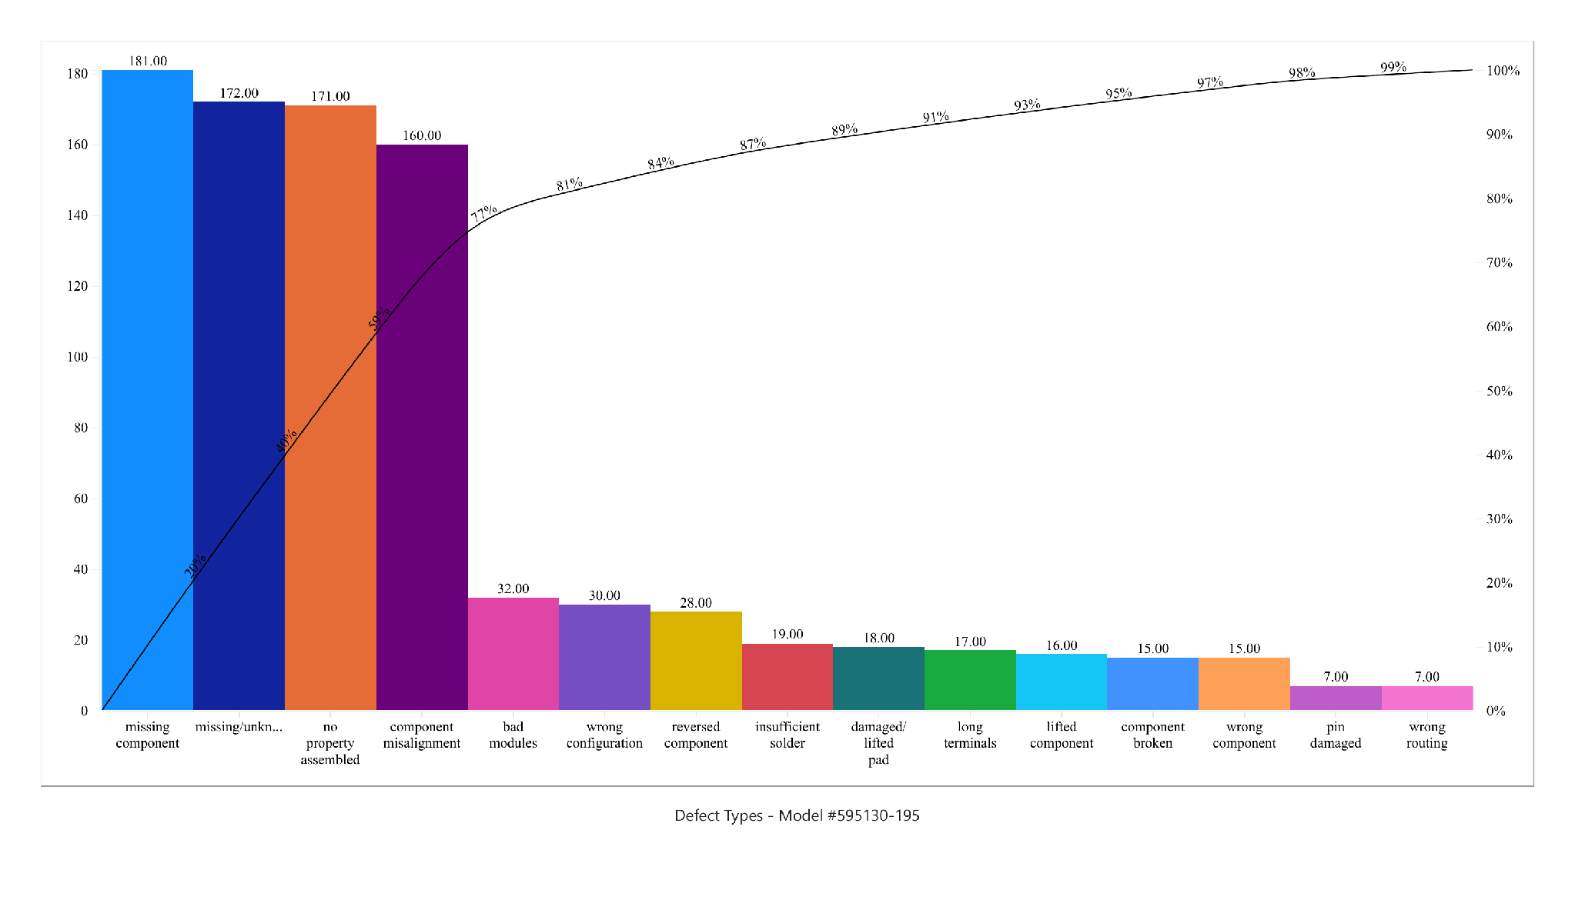
The three largest categories are missing component (181; 20.4%), “missing/unknown” (172; 19.4%), and “no property assembled” (171; 19.3%). These amount to 524 defects or 59.0% of this model’s 888 records. Component misalignment adds 160 records, making the first four categories 77.0%. The short chart label “missing/unkn...” is the data set category “missing/unknown”.
Missing parts and misalignment require an investigation into parts placement and pre-soldering verification. This can be due to missing placement checks, unclear instructions to the model or insufficient support from the fixture. They are hypotheses, not proven findings. The two ambiguous categories should be reviewed with inspectors before merging the two ambiguous categories with missing parts or using them to assign a physical root cause.

Defect Analysis for Model 595214 125
Figure 4. Pareto chart for Model 595214-125
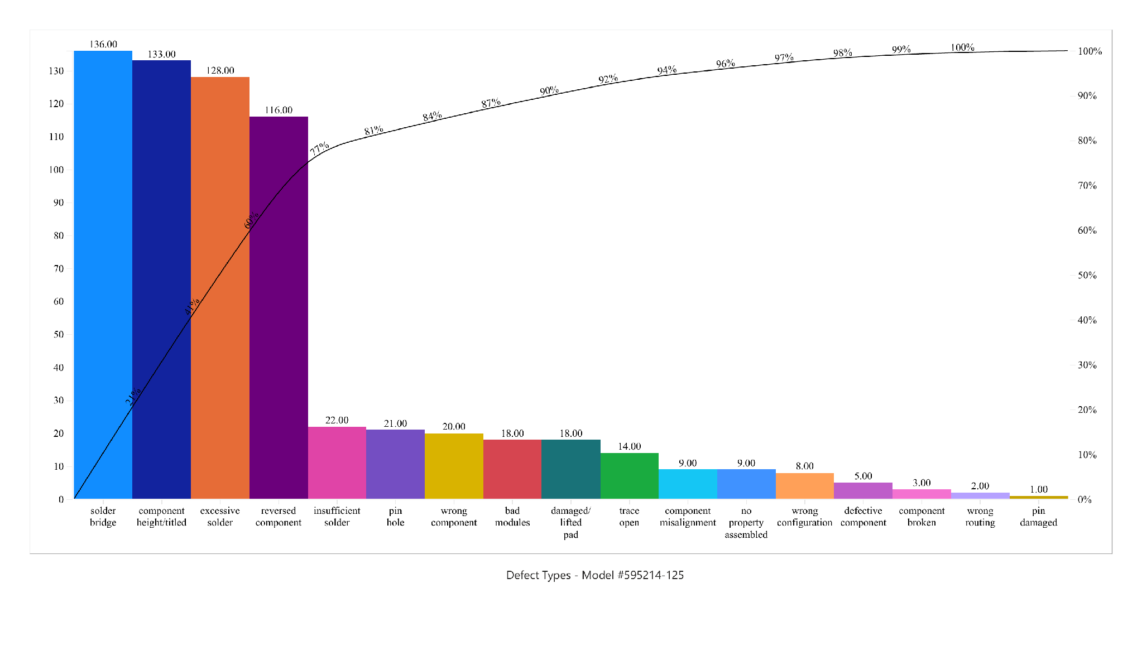
The most common three classes are solder bridge (136; 20.5%), “component height/titled” (133; 20.1%) and excessive solder (128; 19.3%). They account for 59.9% of the 663 defects, or 397. The reversed component contributes another 116 defects, making the first four categories 77.4%. The label “component height/titled” is copied as recorded and needs clarification before final classification.
This pattern allows for the inspection of the placement of the components and the wave soldering machine. Solder bridges and excess solder are logical areas to check for settings, solder application and fixture condition. Height records and reversed components also suggest checking seating and orientation. Thus, Figure 4 relates the priorities of the model to the Machines and Methods branches of the fishbone, not establishing which particular condition resulted in the defects.

Defect Analysis for Model 595242 854
Figure 5. Pareto chart for Model 595242-854
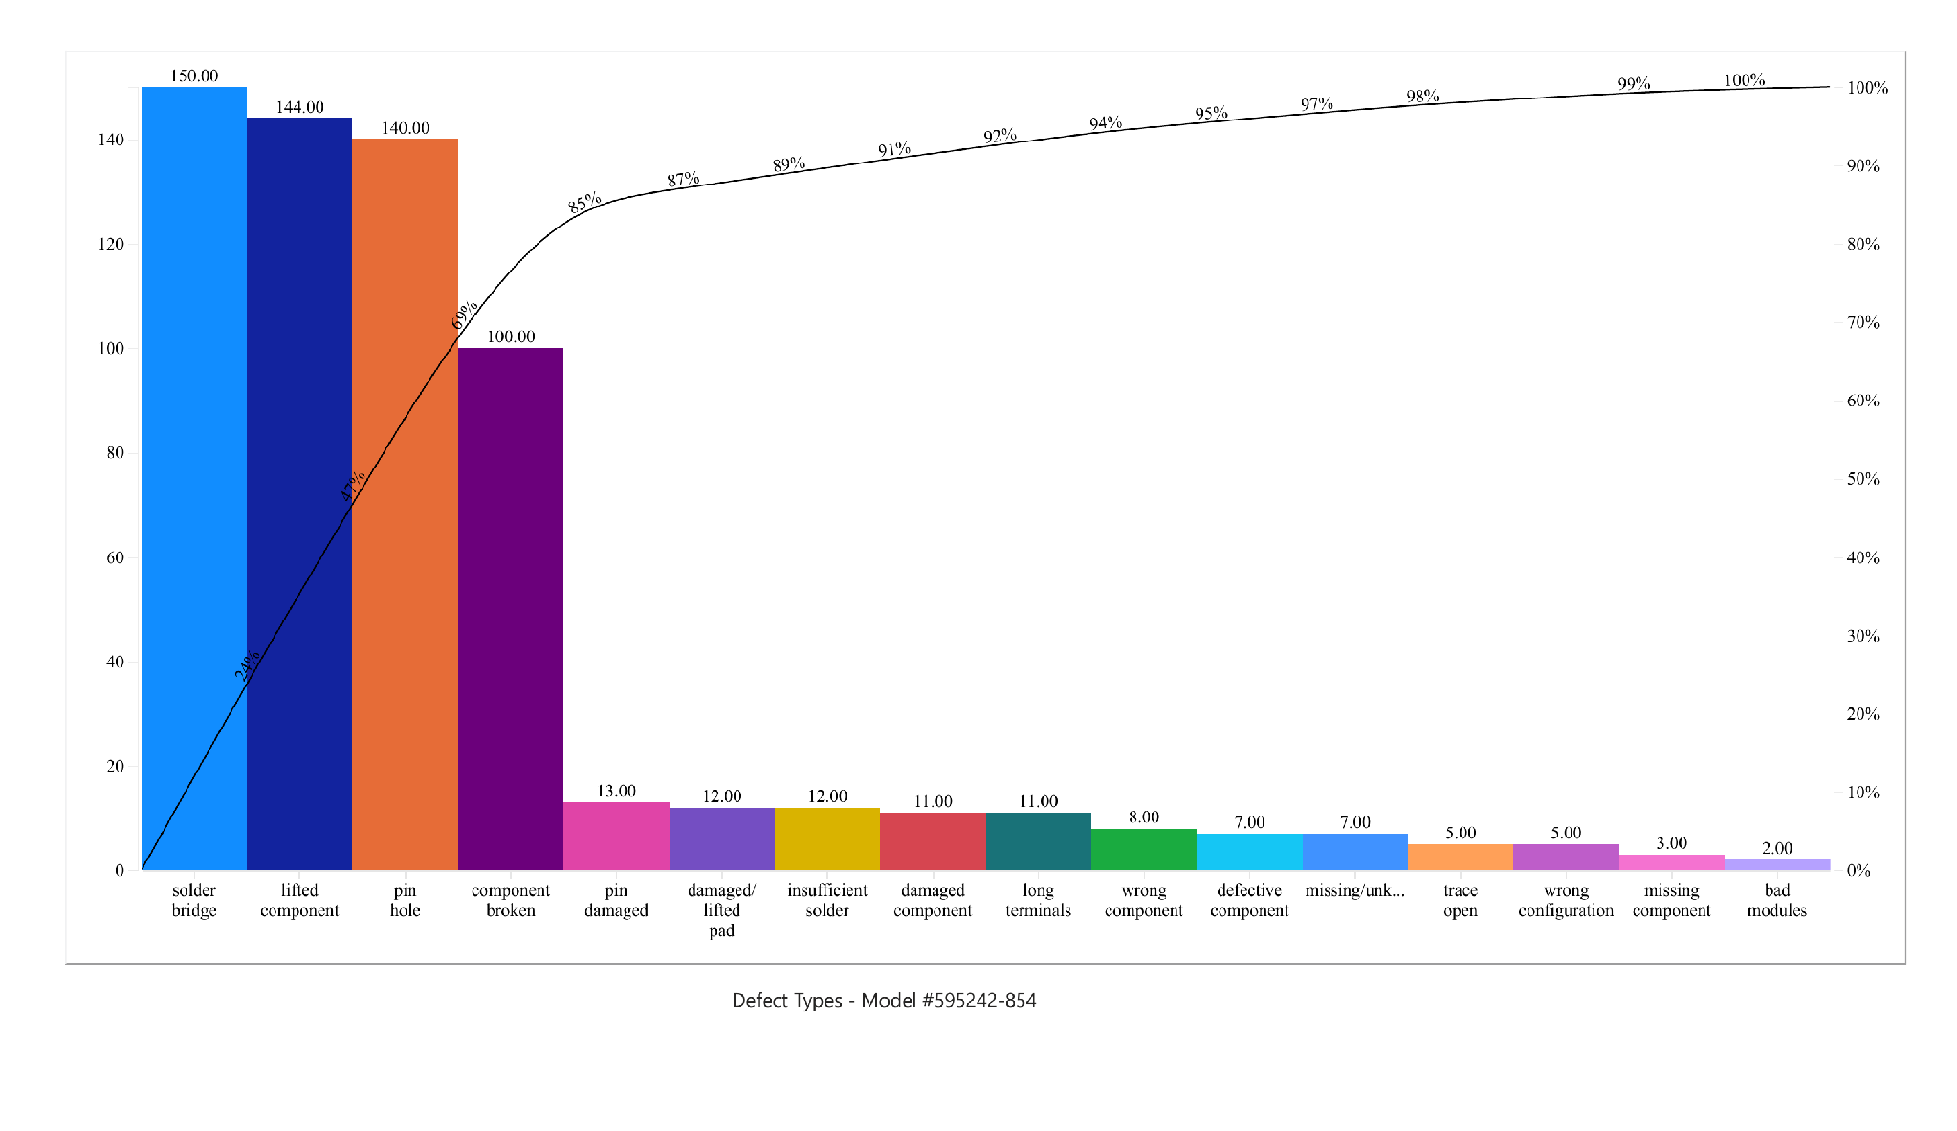
Solder bridge (150; 23.8%), lifted component (144; 22.9%), and pin hole (140; 22.2%) total 434 of 630 records, or 68.9%. Component broken adds 100 records, bringing the first four categories to 84.8%. This is the strongest concentration among the three models. Models 595214-125 and 595242-854 together account for 286 of the floor’s 304 solder bridges, or 94.1%.
Solder bridges across both models justify a shared investigation of wave soldering and fixture conditions. Lifted and broken components also warrant checking seating, restraint, incoming condition, and handling between stations. Pin holes make material condition and soldering conditions potential investigation topics. The chart identifies where to look first; process observations and equipment records are needed to distinguish among these explanations.

Production Line Comparison and Scope
Table 1 compares the three named production lines with downstream inspection areas and the full dataset. The observation-area field does not identify the original line responsible for every defect, so downstream records cannot be reassigned to a source line without additional traceability.
Observation area | Defects | Share of total | Top three models combined
Production Line 1 | 542 | 17.2% | 367 (67.7%)
Production Line 2 | 527 | 16.7% | 384 (72.9%)
Production Line 3 | 544 | 17.3% | 365 (67.1%)
QA Inspection Station | 520 | 16.5% | 373 (71.7%)
Final Assembly Line | 492 | 15.6% | 326 (66.3%)
Unknown | 525 | 16.7% | 366 (69.7%)
Entire dataset | 3,150 | 100.0% | 2,181 (69.2%)
Note. The final column reports the count and percentage within each area belonging to Models 595130-195, 595214-125, and 595242-854. Percentages are rounded.
Production Line 3 has the most recorded defects, but only two more than Line 1 and 17 more than Line 2. These small count differences do not justify identifying one line as the main source. The selected models dominate every area, accounting for 66.3% to 72.9% of its defects, compared with 69.2% overall. This supports investigation across all three lines rather than isolating one line based on volume alone.
Line 1’s largest categories are “no property assembled” (48), solder bridge (47), and “missing/unknown” (44). Line 2 is led by solder bridge (59), “missing/unknown” (50), and “no property assembled” (43). Line 3 is led by solder bridge (62), “no property assembled” (48), and missing component (40). Lines 1 and 2 share the same three leading categories as the full area, while Line 3 has missing component in place of “missing/unknown.”
QA inspection records are led by component misalignment (53), and final assembly records by “no property assembled” (46). The 492 observations at final assembly are consistent with the case’s concern about downstream defects, but they do not show whether each defect escaped inspection or was introduced later. Unknown observation areas account for 525 records, or 16.7%, materially limiting source attribution.
The preliminary scope therefore covers all three Manual Finish lines, their placement and soldering activities, and inspection and transfer into final assembly. Follow-up data should link each defect to its original line, board or batch, model, fixture, inspection stage, and production volume. Records without unique board identifiers are treated as defect observations, not necessarily distinct defective boards.

Root Cause Analysis
Figure 6. Potential causes of Manual Finish assembly and soldering defects
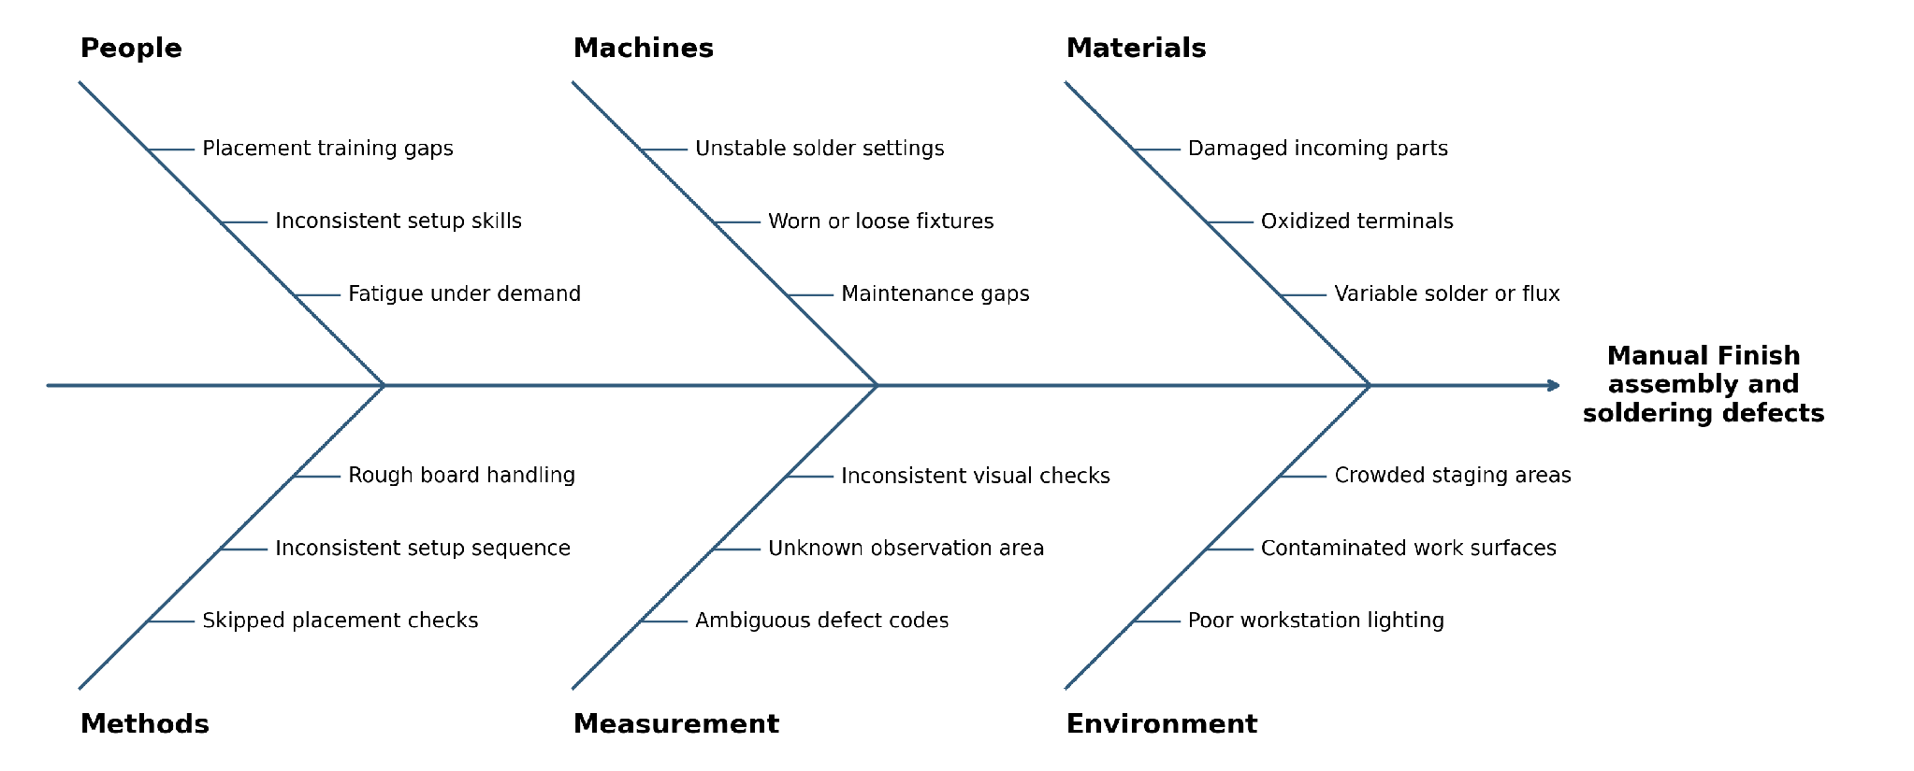
Each branch contains three potential causes. These are investigation hypotheses based on the case process and defect patterns and not verified operating conditions. The Measurement branch has two directly observed data limitations: obscure defect codes and unknown observation areas. The other branches need shop floor observation, setup records, or material checks before a root cause can be confirmed.
The Pareto charts give the priorities for this diagram: Figures 2, 3, 4, and 5 are, respectively, a selection of the models, placement and classification, soldering and positioning concerns, and restraint, handling and material-condition questions. Together, they support a focused investigation of placement and wave soldering controls across the three lines rather than a claim that one machine or worker caused the problem.

Potential Causes and Recommended Follow Up
People and Processes. Check pre-solder, orientation, seating and placement on 3 priority models. Compare actual work to model specific instructions and review if increased demand has affected the pace of task completion or handoffs. There is still the possibility of training holes, fatigue and missed checks. If confirmed, clearer directions and a step for placement verification might fix missing, misaligned and reversed parts.
Machinery and materials. Check the wear of the fixture and its settings, maintenance records and the recorded wave soldering settings. Check the condition of incoming components and the solder or flux lots from affected batches. This would help to test explanations for solder bridges, excess solder, lifted components, and pin holes. Changes should be based on verified process evidence and authorized operating requirements.
Laboratory and Environment. Define “missing/unknown,” “no property assembled,” and “component height/titled” with inspection team and standardize the observation-area field. Check inspectors agreement using the same sample boards. Look over lighting, cleanliness of work surfaces and space to stage. These conditions can impact defect detection or handling. The available data do not suggest that these environmental conditions are deficient.
Then conduct a small pilot on the priority models, implementing changes supported by those checks. Count defects weekly with boards made or inspected, first pass acceptance, rework hours and output per production hour. Comparison of pre- and post-pilot equivalent models and inspection criteria. This phase would be a test of progress toward the case’s goals of reducing defects by 20% and increasing capacity by 20%. No deadline or capacity baseline is given so it has to be created. Raw counts would be misleading if output is growing.

References
DAT 475 project case study [Course handout].
DAT 475 project data set [CSV dataset].

