Computer Aided Numerical Methods – I

Report on Assignment – 1

Problem Statement:

Solve $\left[\begin{matrix}4 & 1 & 1 & 1 \\ 1 & 4 & 1 & 1 \\ 1 & 1 & 4 & 1 \\ 1 & 1 & 1 & 4\end{matrix}\right]\left[\begin{matrix}x_{1} \\ x_{2} \\ x_{3} \\ x_{4}\end{matrix}\right]$ = $\left[\begin{matrix}15.9 \\ 17.7 \\ 13.2 \\ 9.9\end{matrix}\right]$ using LU Decomposition.

1. Find the L and U matrices.
2. Find the solution vector $\vec{x}=[\begin{matrix}x_{1} & x_{2} & x_{3} & x_{4}\end{matrix}]$.

Explanation of Code:

0 – Preprocessing

This program has been coded in C++ language. Hence, the main library ‘iostream’ has been included to allow use of the basic input and output functions of C++. ‘Using namespace std;’ prevents having to prefix those functions with “std::’.

I – LU Decomposition Function

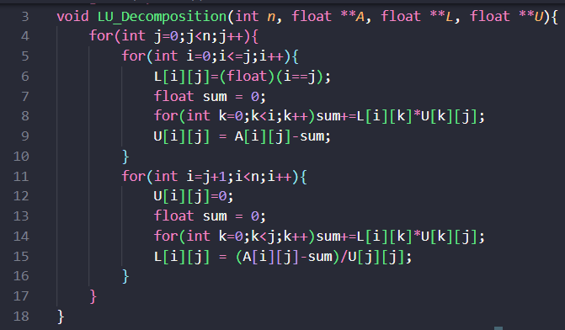This function takes a pointer to the matrix ‘A’, size of A ‘n’ and two empty pointers ‘L’ and ‘U’ as input.

Functionality:

1. Performs LU decomposition to factorize A into a lower triangular matrix L and an upper triangular matrix U, such that $A=L*U$.
2. The outer loop iterates through each column j of matrix A.
3. In the first inner loop, we iterate through each row $i≤j$ such that:
   * The diagonal elements L of are set to 1, whereas the upper diagonal elements of L are set to 0.
   * For each row we compute $U\left[i\right]\left[j\right]=A\left[i\right]\left[j\right]- \sum_{k=0}^{i-1}{L\left[i\right][k]}*U[k][j]$.
4. In the second inner loop, we iterate through each row $i>j$ such that:
   * The lower diagonal elements of U are set to 0.
   * For each row we compute $L\left[i\right]\left[j\right]=(A\left[i\right]\left[j\right]- \sum_{k=0}^{j-1}{L\left[i\right]\left[k\right]}*U\left[k\right]\left[j\right])/U[j][j]$.
5. At the end of the function, we get both matrices L and U.

II – Forward Substitution Function

This function takes a pointer to Lower Triangular Matrix ‘L’, size of L ‘n’, a pointer to nx1 vector ‘b’ as input and returns a pointer to solution vector ‘y’ such that $L*y=b$.

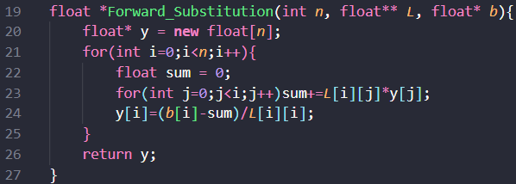Functionality:

1. Performs Forward Substitution to return the solution vector ‘y’ to $L*y=b$, where L is Lower Triangular Matrix and b is nx1 vector.
2. Iterates from row $i=0$ to $i=n-1$.
3. For each y[i] we compute $y\left[i\right]=(b\left[i\right]- \sum_{j=0}^{i-1}{L\left[i\right]\left[j\right]*y\left[j\right]})/L[i][i].$
4. The obtained solution vector y satisfies $L*y=b$.

III – Backward Substitution Function

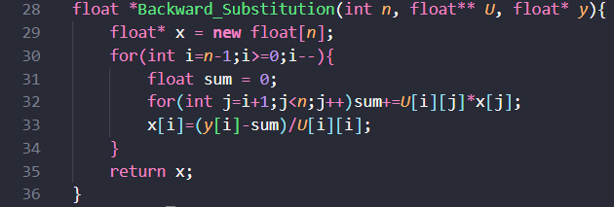This function takes a pointer to Upper Triangular Matrix ‘U’, size of U ‘n’, a pointer to nx1 vector ‘y’ as input and returns a pointer to solution vector ‘x’ such that $U*x=y$.

Functionality:

1. Performs Backward Substitution to return the solution vector ‘x’ to $U*x=y$, where U is Upper Triangular Matrix and b is nx1 vector.
2. Iterates in reverse from row $i=n-1$ to $i=0$.
3. For each x[i] we compute $x\left[i\right]=(y\left[i\right]- \sum_{j=i+1}^{n-1}{U\left[i\right]\left[j\right]*x\left[j\right]})/U[i][i].$
4. The obtained solution vector x satisfies $U*x=y$.

IV – Main Function

This function handles user input, LU decomposition, and solving the system.

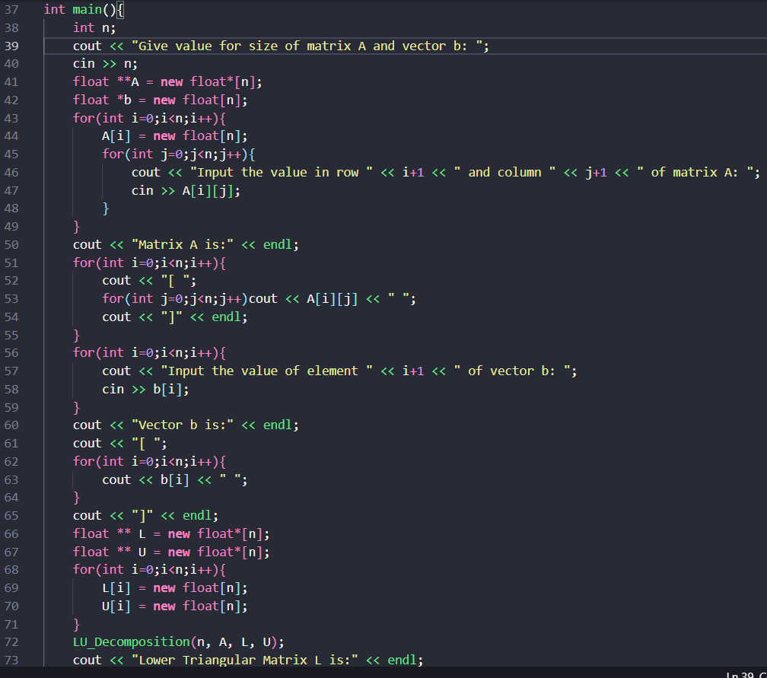Functionality:

1. User Input:
   * Reads matrix size n.
   * Dynamically allocates memory for matrices A, L and U.
   * Accepts user input for A and vector b.
   * Displays the input matrices.
2. LU Decomposition:
   * 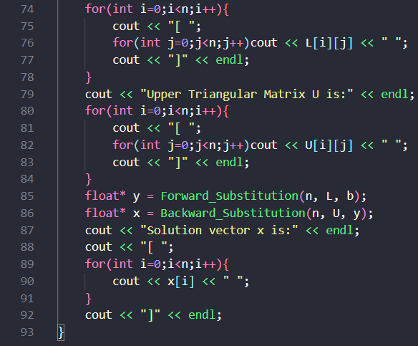 Calls the LU_Decomposition(n, A, L, U) function.
   * Displays matrices L and U.
3. Solving the Linear System:
   * Calls Forward_Substitution(n, L, b) to compute .
   * Calls Backward_Substitution(n, U, y) to compute .
   * Displays the solution vector x.

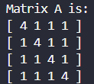Solution to Assignment



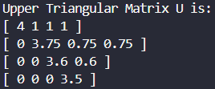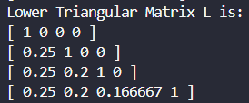

1. 