Computer Aided Numerical Methods – I

Report on Assignment – 3

Problem Statement:

The following table gives equi-spaced data of $f\left(x\right)=e^{0.8x}-1$. Compute error $(P_{k}\left(x\right)-f\left(x\right))$ at $x=2.2$, where $k=2, 3, 4$.

|  |  |
| --- | --- |
| $$x_{i}$$ | $$f(x_{i})$$ |
| $$1$$ | $$1.225541$$ |
| $$1.5$$ | $$2.320117$$ |
| $$2$$ | $$3.953032$$ |
| $$2.5$$ | $$6.389056$$ |
| $$3$$ | $$10.023176$$ |

Explanation of Code:

0 – Preprocessing

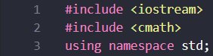This program has been coded in C++ language. Hence, the main library ‘iostream’ has been included to allow use of the basic functions, control-flow statements, etc. of C++. Here the library ‘cmath’ has also been included to allow the use of in-built math functions in C++. ‘Using namespace std;’ prevents having to prefix input and output functions with “std::’.

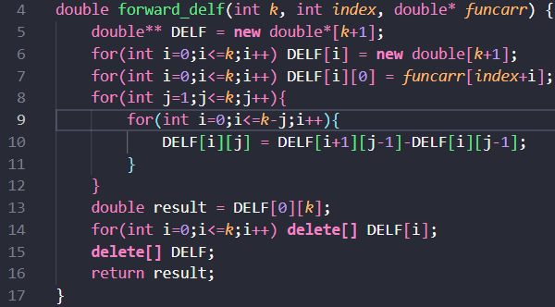1 – Forward Difference Function

This function takes the order of difference, $k$, array consisting of values $f_{0}, f_{1}, f_{2}…., f_{n}$ which we use to find $k^{th}$ order difference, $funcarr$, and the index value corresponding to the $funcarr$ element for which we find the $k^{th}$ order difference, $index$ as inputs and returns $k^{th}$ order difference at index $index$, i.e. $∆^{k}f_{index}$.

Functionality:



1. Creation of Forward Difference Table: Initializes and allocates memory for the Forward Difference Table array of size $\left(k+1\right)*(k+1)$, $DELF$.

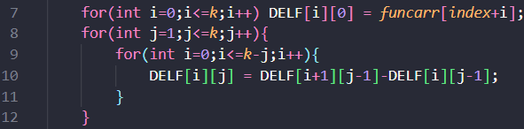

1. Building the Forward Difference Table: We initially set the first column of our table to the elements of $funcarr$ array starting from initial index $index$ to index $\left(index+k\right)$. We then fill the rest of the table using the recursive formula: $∆^{j}f_{index+i}= ∆^{j-1}f_{index+i+1}- ∆^{j-1}f_{index+i}$ and in the Forward Difference Table $DELF$, this formula becomes: $DELF \left[i\right] \left[j\right]=DELF \left[i+1\right] \left[j-1\right]-DELF \left[i\right] \left[j-1\right]$ (Here, we let $∆^{0}f_{index+i }= f_{index+i }$ for the sake of ease of computation) Thus, we get the final Table as:

1. Returning Value of required Forward Difference and Freeing Memory: Clearly from the table, we can get $∆^{k}f_{index}$ by returning $DELF \left[0\right] \left[k\right]$. Then we use ‘delete’ to free up the memory of $DELF$ table as we have no need for it anymore.

2 – Returning Index Function

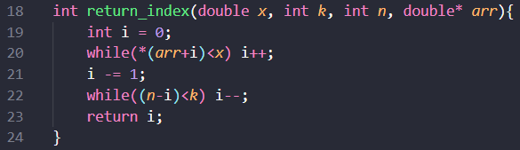This function takes an input $x$, length of required subarray of interpolation points $k$, an array $arr$, and length of $arr$, $n$, and return the starting index to the subarray of length $k$ which we use for our interpolation, $i$.

Functionality:

1. Initialization and Forward Traversal: First, we set index $i = 0$ and then move forward in the array until we find the index $i$ such that $arr[i] ≥ x$, and then move back one step to get the closest left-hand point.



1. Backward Traversal: We check if the remaining points from that index $i$ can form a subarray of length $k$. If not, we move further left until we can find a valid starting point for the subarray and return the final $i$.

3 – Newtonian Polynomial Function (for equi-spaced values)

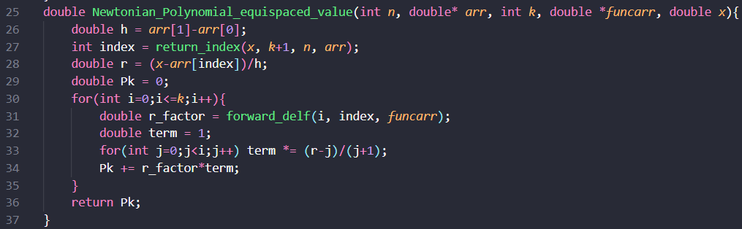This function takes total number of points, $n$, the array of length $n$ containing input values $(x_{i})$, $arr$, order of the Newtonian polynomial, $k,$ array consisting of output values $(f(x_{i}))$, $funcarr$ and the value for which we compute the interpolated output value $x$ using the equi-spaced data as inputs and returns the value of interpolated Newtonian polynomial of order $k$ at $x$.

The general formula for Newtonian polynomial of order $k$ is given by: $P_{k}\left(x\right)=f_{0}+r*{∆f}_{0}+\frac{r\left(r-1\right)}{2!}*{∆^{2}f}_{0}+⋯⋯⋯+\frac{r\left(r-1\right)⋯⋯\left(r-\left(k-1\right)\right)}{k!}*{∆^{k}f}_{0}$

Where $f_{0}$ is corresponding output to $x_{0}$ and $r =\frac{x-x_{0}}{h}$.

( $h$ is the step size, i.e., $h = x_{1}-x_{0} = x_{2}-x_{1} = …… = x_{n}-x_{n-1}$)

Functionality:



1. Step-Size Calculation: Since the data is equi-spaced, step size $h = arr[1] - arr[0]$ is computed.



1. Index Calculation**:** Calls the $return_index$ function to find the starting index of the subarray of length $k+1$ consisting of $x_{i}$ values used for interpolation.



1. **Computing value of r: $r=\frac{x - arr\left[index\right]}{h}$** , which is used in Newton's forward interpolation formula.

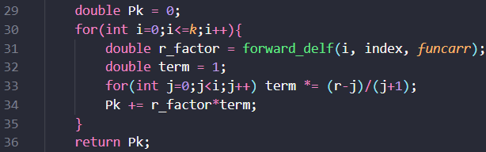

1. Finding the interpolated value of $f(x)$, $P_{k}(x)$ and returning its value:

* First, we set $P_{k}(x) = 0$.
* A loop runs from $i = 0$ to $k$ to compute and sum all terms of the Newtonian polynomial:
  + Calls $forward_delf(i, index, funcarr)$ to get $∆^{i}f_{index}$.
  + Computes $\frac{r\left(r-1\right)...\left(r-(i-1)\right)}{i!}$ in the inner loop.
  + Multiplies with forward difference and adds to result $P_{k}(x)$.
* Finally, the function returns the computed value $P_{k}(x)$.

4 – Main Function

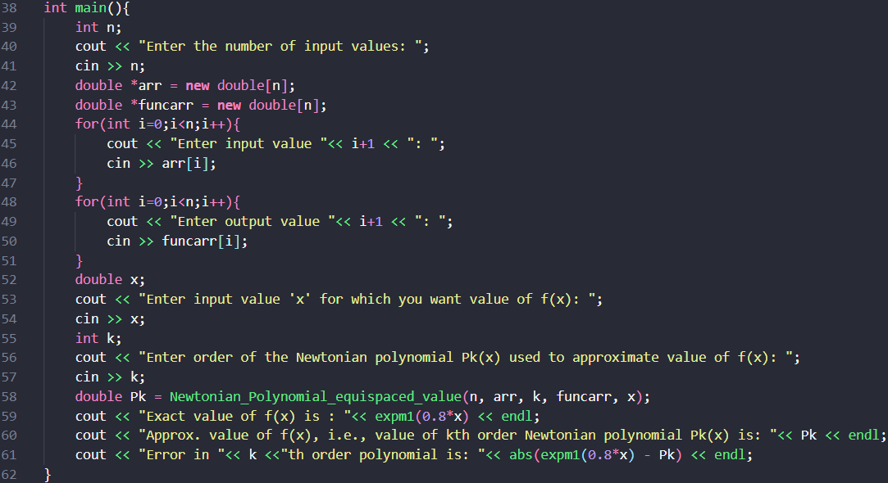

The $main()$ function serves as the driver of the program and handles all user interaction and function calls.

Functionality:

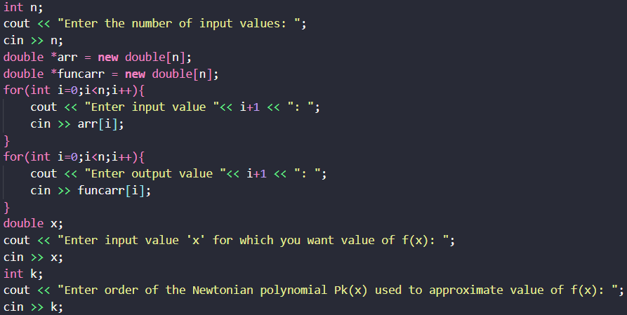

1. Taking Input: The user is prompted to input the total number of data points $n$, all input values $x_{i}$ and corresponding output values $f_{i}=f(x_{i}) (1≤i≤n),$ the value of $x$ for which we find the corresponding interpolated output value $P_{k}(x)≈f(x)$ and order $k$ of interpolated Newtonian polynomial $P_{k}(x)$.



1. Computing and Printing the Output:

* We find $P_{k}(x)$ by calling the $Newtonian_ Polynomial_equispaced_value()$ function and set it to variable $Pk$.
* The exact value of $f(x)=e^{0.8x}-1$ is calculated using the $cmath$ function $expm1(0.8*x).$
* We then calculate error as absolute difference of exact value and approximate value, i.e., $|expm1(0.8*x) – Pk|.$
* Finally, the exact value of $f(x)$, approximate value of $f(x)$, i.e., $P_{k}(x)$ and error in approximation are printed.

Solution to Assignment – 3:

* A close up of a sign

  AI-generated content may be incorrect.Error in approximation at and order, :
* ****Error in approximation at and order, :
* A white text on a black background

  AI-generated content may be incorrect.Error in approximation at and order, :