Autoflex

Product and deployment architecture

STATUS  Proposed |  | OWNER  Product + Engineering |  | LAST UPDATED  July 30, 2026

Authors | Product Owner and Codex
Reviewers | Frontend, Backend, Reviewer/Critic, QA
Related docs | AUTOFLEX_DESIGN_REPORT.docx; README.md; docs/RELEASE_CHECKLIST.md
Scope | Client experience, local persistence, API boundary, and production deployment path

1. Abstract
Autoflex is a responsive React and Vite web application for vehicle ownership, purchase comparison, service records, and owner evidence. The client is intentionally usable without a hosted account, stores current user state in the browser, and ships a generated service worker that precaches the exact production app shell.
A TypeScript Fastify API provides health, profile, feedback, and moderation boundaries. JSON persistence is suitable for staging only; a durable production database and authenticated identity remain launch dependencies for hosted synchronization.

2. Goals and Non-Goals
Goals | Non-goals
Understandable four-screen product flow | A broad social network or content publishing platform
Reliable local-first ownership workflows | Claiming cross-device sync before it exists
Typed API boundary with guarded admin routes | Using JSON persistence as a public-scale database
Repeatable release checks and deployment ownership | Replacing every legacy Kotlin path in this change

3. Background and Problem Statement
The earlier product exposed multiple useful features in one long page and mixed local data with future hosted capabilities. This made navigation, persistence expectations, and the operational deployment path harder to understand.
The system boundary is explicit: the browser owns the current interactive experience and local state; the API owns validated hosted capabilities. UI availability states must reflect whether the API is reachable and must never imply synchronization that has not occurred.

4. Proposed Architecture

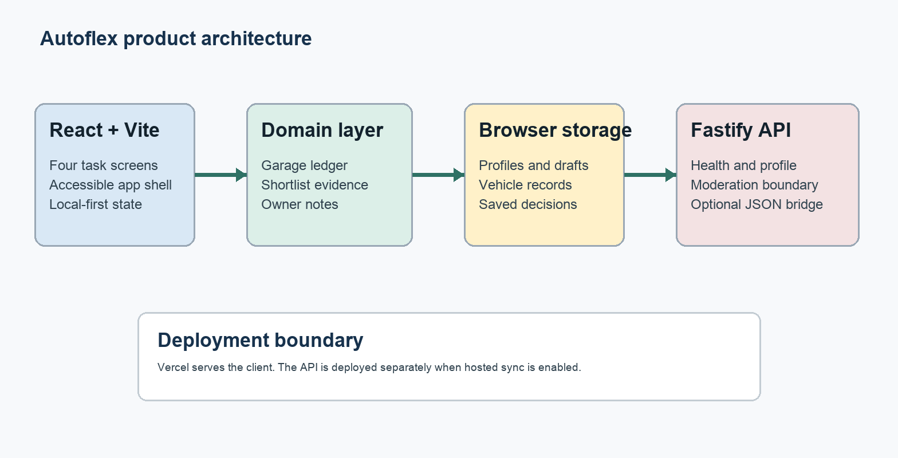
Figure 1. Autoflex product architecture and deployment boundary.

Core components

Component | Responsibility | Primary storage | Failure behavior
React client | Screens, forms, accessibility, derived decisions | Browser memory | Shows local fallback state
Domain helpers | Insights, comparisons, reminders, validation | Typed records | Rejects invalid or incomplete input
Local persistence | Retain user-owned state across sessions | localStorage | Falls back to seeded defaults
Fastify API | Health, profile, feedback, moderation boundary | Memory or JSON bridge | Normalized errors; admin fails closed
Deployment + offline shell | Serve client, headers, and versioned cache | Vercel plus browser Cache API | Last valid shell remains available offline

5. Request Lifecycle
- 1. The generated service worker serves the versioned app shell when available; the Vite bundle then hydrates profile, garage, shortlist, notes, and preference state from browser storage.
- 2. Local data is parsed through typed domain models; invalid values fall back to seeded defaults rather than breaking the app shell.
- 3. The active workspace derives readouts and next actions from current vehicle, evidence, and reminder state.
- 4. A user action updates React state and persists the corresponding local record before the next screen is rendered.
- 5. Hosted requests are attempted only for capabilities with an explicit API contract and visible availability state.
- 6. The Fastify boundary validates roles and administrative credentials, then normalizes errors without leaking internals.
- 7. Release telemetry currently consists of build checks, API health, deployment status, and browser smoke evidence; production observability remains an open launch item.

6. API and Data Contracts

Primary data contract

Field | Type | Required | Description
id | string | Yes | Stable client or server entity identifier
vehicleId | string | By record | Associates reminders and timeline entries to a vehicle
profile.role | enum | Yes | Validated owner, buyer, mechanic, or dealer role
status | enum | By entity | Tracks shortlist or operational state
createdAt | ISO timestamp | For hosted writes | Supports ordering and future audit
payload | typed object | Yes | Validated domain-specific record
schemaVersion | integer | For sync | Enables migration and compatibility checks

Contract guarantees

- Client-local records remain authoritative until a documented synchronization protocol is introduced.
- Identifiers are stable per entity; writes replace or append the matching typed record.
- Profile roles are validated at the API boundary and moderation routes require an administrative token.
- The staging JSON file is not a public-scale source of truth and must not be represented as one.
The current interface is implemented in server-ts/app.ts and covered by server-ts/app.test.ts.
Any hosted client integration must version its payloads and surface offline, local-only, syncing, and failed states.

7. Consistency, Idempotency, and Replay

Local actions are synchronous from the user’s perspective and persist before confirmation text is shown. Future hosted mutations should use client-generated identifiers and idempotency keys so retries do not duplicate service records, notes, or feedback.
Scenario | Expected behavior | Reasoning
Repeated local action | Stable entity id prevents duplicate replacement | Keeps the user’s ledger predictable
Persistence write fails | Keep current screen usable and surface failure | Avoids false confirmation
Hosted API unavailable | Continue local-only and show availability state | Preserves core ownership workflows
Configuration changes | Current request uses the loaded configuration | Prevents mid-action behavior changes

8. Security and Privacy Considerations

- Administrative moderation and feedback-list routes require a non-default server-side token. Ordinary owner profiles must not reveal moderation controls.
- Garage, shortlist, profile, and saved-note data remain on the device unless a user explicitly enables a future hosted sync flow.
- Secrets belong in deployment environment variables and must never be committed, embedded in the Vite bundle, or written to product documentation. Vercel headers restrict framing, origins, capabilities, and executable content.
- Hosted failures default to local-only operation for consumer workflows and fail closed for administrative workflows.
- Before broad launch, define retention, deletion, export, account recovery, and audit policies for the selected production database.

9. Operational Readiness
Signal | SLO or alert | Owner | Launch gate
Release check | Tests, build, and server-offline reload pass | Engineering | Required
API health | Health endpoint succeeds in staging | Backend | Required for hosted features
Layout integrity | No overflow at 390px and 1280px | Frontend + QA | Required
Deployment drift | Production branch and latest release agree | Product owner | Required
Restore integrity | Documented backup and restore drill | Backend + Ops | Required before broad launch

10. Alternatives Considered

Alternative | Why it was considered | Why it was not selected
Single scrolling page | Simple initial implementation | Weak task focus and navigation
Five changing dock actions | Keeps context actions nearby | Destination meaning becomes unstable
Immediate cloud-first rewrite | Cross-device data from day one | Identity and durable storage are not approved
JSON as production database | Low setup cost | Insufficient durability and concurrency

11. Open Questions
- Which production database and migration path will replace JSON-backed persistence?
- What identity model should connect a local garage to an authenticated account?
- Which hosted records need conflict resolution across devices, and which remain device-local?
- What observability, backup, restore, and incident ownership are required before public launch?

12. Decision and Next Steps
Approve the redesigned local-first client as the product baseline. Keep the TypeScript API boundary, resolve Vercel production ownership, then add hosted health detection, authenticated identity, durable storage, and progressive synchronization in separate reviewed milestones.
Milestone | Deliverable | Exit criteria
M1 | Redesigned local-first client | Tests, build, offline reload, accessibility, and responsive QA pass
M2 | Production deployment ownership | Vercel branch, permissions, and rollback verified
M3 | Authenticated durable API | Database, identity, backup, and API contract approved
M4 | Progressive hosted synchronization | Conflict handling, observability, and user consent validated

Use footnotes for definitions, assumptions, or terms that need precision without interrupting the main narrative.

