Devan Wong

November 9, 2020

Assignment 4.4

API Gateway Unit Test 01

WEB 420

1. SoapUI screenshot of the response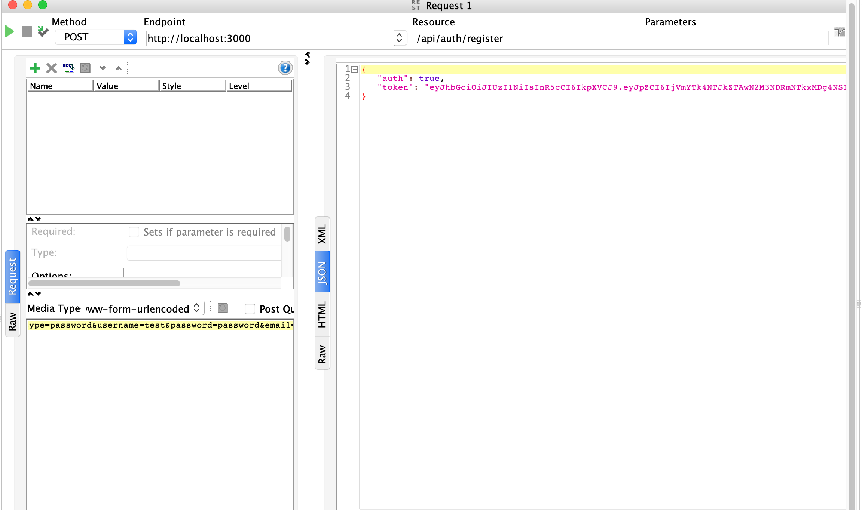
2. screenshot of the terminal windows output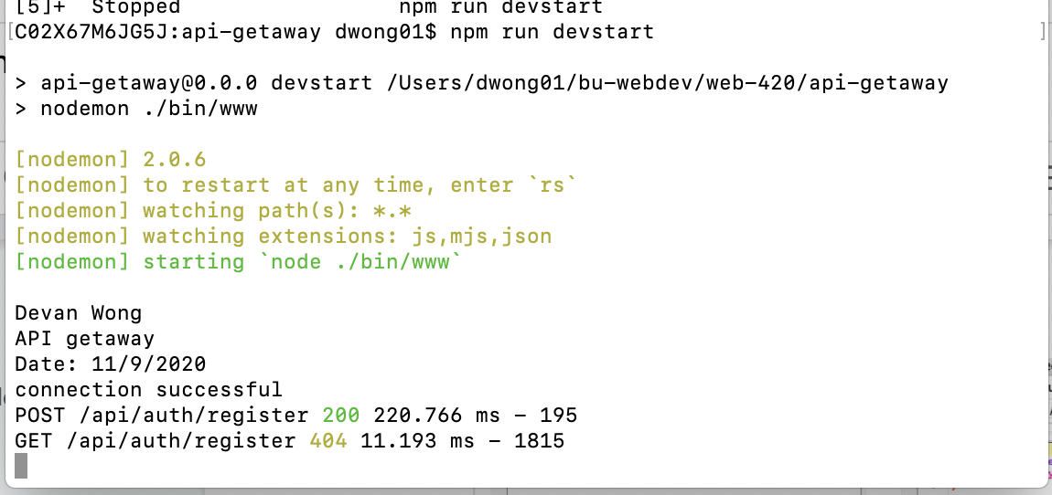
3. Mylab screenshot