API Gateway Unit Test 02

Devan Wong

November 15, 2020

Assignment 5.4

WEB 420

screenshot of the CLI window

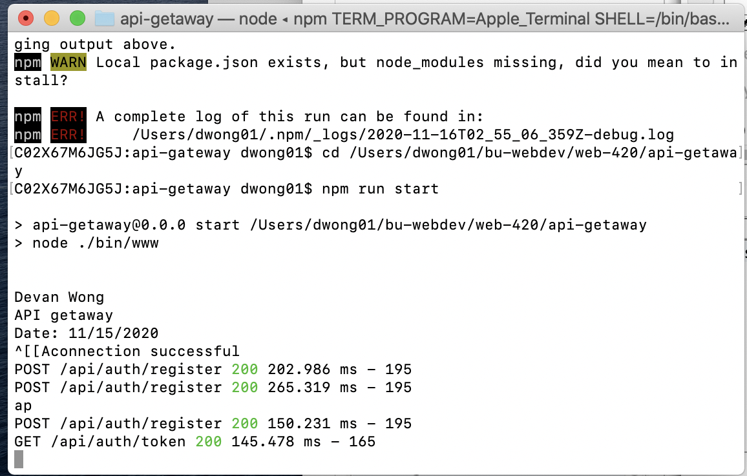

screenshot of the response

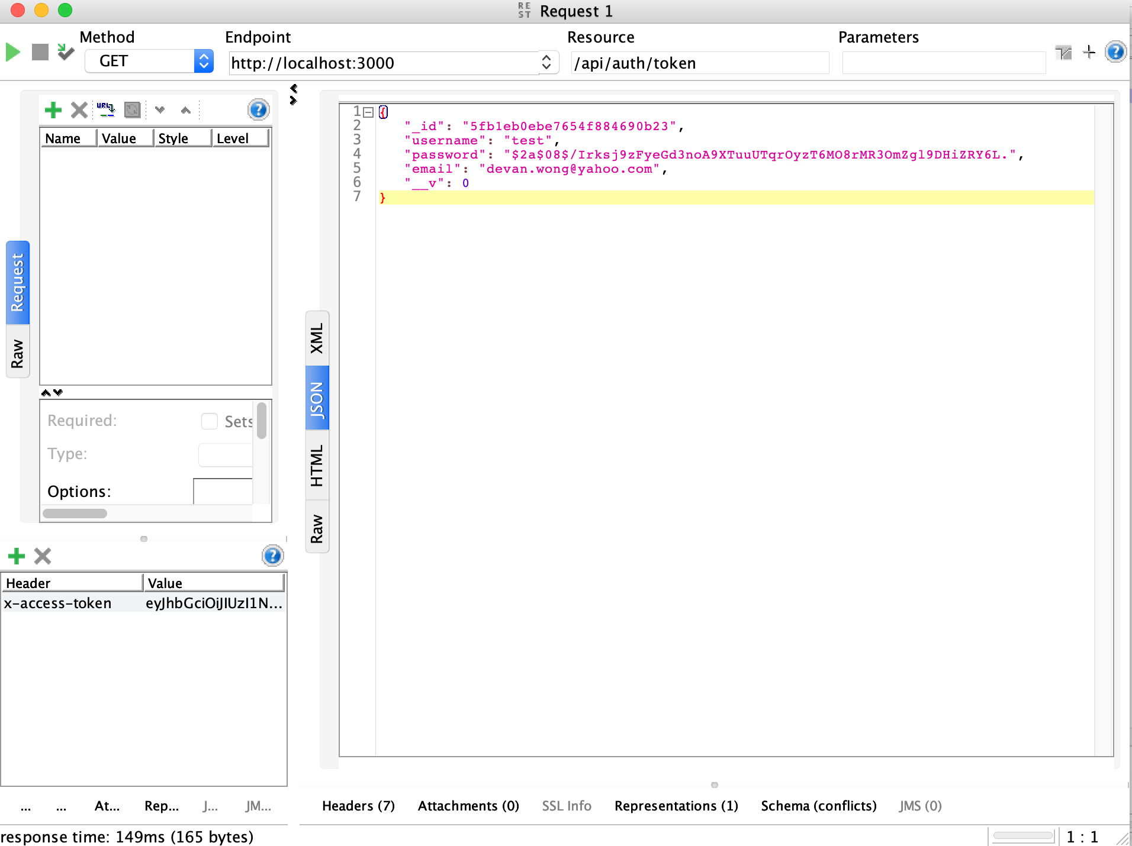

original record in mLab

