Mobile Robot Liberate Swarm Pursuer Using Virtual Force Field And Hamilton Jacobi Bellman Optimal Behavior
Abstract. Decentralized mobile robot swarm pursuit framework combining Virtual Force Field (VFF) navigation with Hamilton-Jacobi-Bellman (HJB) reachability-based optimal control. Implemented in PyBullet with TurtleBot2 robots, the system features a role-swap mechanic where captured evaders become new pursuer chain heads. The VFF component handles inter-agent repulsion and wall avoidance, while the HJB module precomputes Backward Reachable Tubes (BRT) to enable predictive intercept trajectories. Detection triggers when the pursuer's BRT disk intersects the evader's attraction zone, with approach from the 270° rear azimuth for optimal capture. Experiments in a 20×20 m² arena with one pursuer and nine evaders demonstrate 100% capture rates across randomized trials, with stable chain formation scaling as the swarm grows. The integrated architecture provides a robust, scalable solution for decentralized pursuit-evasion without centralized coordination
Keywords: Multi Robot Pursuit, Virtual Force Field, Hamilton-Jacobi-Bellman, Pybullet.
- Introduction
Multi-robot pursuit-evasion has emerged as a foundational problem in robotics, intersecting with critical applications such as surveillance, search-and-rescue, environmental monitoring, and autonomous defense systems. Unlike single-robot scenarios, multi-robot pursuit requires solving concurrent challenges in coordination, formation control, collision avoidance, and target interception under uncertainty. As the number of agents increases, the computational complexity of centralized planning grows exponentially, motivating the need for decentralized approaches where individual robots make decisions based solely on local information and limited inter-agent communication.
A persistent challenge in decentralized pursuit-evasion lies in bridging reactive navigation with predictive optimal control. Purely reactive approaches, such as Virtual Force Field (VFF) methods, enable robots to navigate dynamic environments by responding to local repulsion and attraction forces. However, they lack the foresight to anticipate evader motion or execute optimal intercept trajectories. Conversely, model-based optimal control methods, such as those derived from Hamilton-Jacobi-Bellman (HJB) reachability analysis, provide rigorous guarantees on capture feasibility but suffer from the curse of dimensionality when applied to high-dimensional joint state spaces. This duality suggests that neither paradigm alone is sufficient for scalable, robust pursuit-evasion in realistic multi-robot settings.
This research proposes an integrated framework that combines the strengths of both approaches. We introduce a decentralized swarm pursuit architecture where the Virtual Force Field governs local navigation, formation integrity, and inter-agent collision avoidance, while Hamilton-Jacobi-Bellman reachability module provides predictive intelligence for optimal pursuit behavior. The framework is validated in a high-fidelity PyBullet physics simulation using TurtleBot2 differential-drive robots, where a single initial pursuer the head must capture a set of stationary evaders distributed across a bounded 20×20 m² arena.
A distinguishing feature of the proposed system is the role-swap capture mechanic, inspired by the classic children's game of tag. When an evader enters the pursuer's capture radius, it is converted into the new head of the pursuer chain, while the capturing pursuer is demoted to a follower position. This mechanic transforms the pursuit-evasion problem into a dynamic swarm growth problem, where the pursuer team expands with each successful capture, fundamentally altering the strategic landscape over time. Followers maintain formation through a high-resolution distance-based path-following algorithm, with anti-clumping repulsion forces preventing chain collapse during tight maneuvers.
The HJB reachability component precomputes the Backward Reachable Tube (BRT) the set of initial conditions from which capture is guaranteed within a finite time horizon, regardless of the evader's actions. By querying this precomputed value function in real time, the pursuer can identify when an evader lies within the inevitable capture zone and execute gradient-descent trajectories. Furthermore, the system leverages a circle-meet-circle detection mechanism, where pursuit is triggered when the pursuer's BRT disk intersects the evader's attraction zone visualized as a magnet, ensuring that engagement is initiated at the theoretically sound boundary rather than an arbitrary heuristic distance.
- Mobile Robot Kinematics
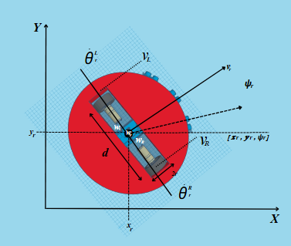
The simulation utilizes the TurtleBot2, a widely adopted differential-drive mobile robot originally developed by Willow Garage and later maintained by Clearpath Robotics and Yujin Robot. The TurtleBot2 is built upon the Kobuki mobile base and features a Hokuyo LiDAR or Kinect sensor stack.
Fig. 1. Kinematics over Turtlebot 2 model
The following describes the equations used in the kinematic model, as shown in equations below.
P_{r} = [x_{r} , y_{r} , ψ_{r} ] (1)
$\dot{\text{P}}\text{r}\text{= [}\text{ẋ}\text{r}\text{ , ẏ}\text{r}\text{ , }\dot{\text{ψ}}\text{r}\text{]}$ (2)
$\dot{\text{q}\text{r}}\text{ = [}{\dot{θ}}_{r}^{L} , {\dot{θ}}_{r}^{R}\text{]}$ (3)

Where the actual robot position P_{r} is represented by x_{r} and y_{r} and the orientation is represented by $\dot{\text{ψ}\text{r}}$, $\dot{\text{q}\text{r}}$represents the robot's wheel velocity. The configuration transition of the robot from base to coordinate Ṗ is expressed below.
$\left[\begin{matrix}\text{ẋ}\text{r} \\ \text{ẏ}\text{r} \\ \dot{\text{ψ}\text{r}} \end{matrix}\right]$=$\left|\begin{matrix}\text{cos}{\text{ψ}\text{r} } & \text{0} \\ \text{sin}{\text{ψ}\text{r} } & \text{0} \\ \text{1} & \text{0}\end{matrix}\right|\left[\begin{matrix}\text{v}\text{r} \\ \text{ω}\text{r}\end{matrix}\right]$ (4)

The position change using forward kinematics with linear velocity $\text{v}\text{r}$ and angular velocity $\text{ω}\text{r}$ of the robot, based on the left wheel velocity ${\dot{θ}}_{r}^{L}$ and right wheel velocity ${\dot{θ}}_{r}^{R}$of the mobile robot, is represented in Equation below.
$\left[\begin{matrix}\text{v}\text{r} \\ \text{ω}\text{r}\end{matrix}\right]$ =$\left|\begin{matrix}{\text{1}}/{\text{2}} & {\text{1}}/{\text{2}} \\ {\text{1}}/{\text{d}} & {\text{1}}/{\text{-d}}\end{matrix}\right|$=$\left[\begin{matrix}{\dot{θ}}_{r}^{L} \\ {\dot{θ}}_{r}^{R}\end{matrix}\right]$ (5)

The position change using inverse kinematics with the robot's wheel velocity $\dot{\text{q}\text{r}}$in terms of linear and angular velocity is represented in Equation below.

$\left[\begin{matrix}{\dot{θ}}_{r}^{L} \\ {\dot{θ}}_{r}^{R}\end{matrix}\right]$ = $\frac{\text{1}}{\text{i}}$ $\left|\begin{matrix}\text{1} & {\text{d}}/{\text{2}} \\ \text{1} & {\text{-d}}/{\text{2}}\end{matrix}\right|$=$\left[\begin{matrix}\text{v}\text{r} \\ \text{ω}\text{r}\end{matrix}\right]$ (6)

- Virtual Force Field (VFF)
Method provides a reactive navigation framework wherein the robot's motion is governed by artificial potential fields generated by environmental features and other agents. In the proposed decentralized swarm pursuit system, the VFF component serves three critical functions: inter-agent collision avoidance, formation integrity maintenance through anti-clumping repulsion, and boundary and obstacle avoidance.
Unlike global planning algorithms, VFF operates purely on local sensor information and relative state data, making it inherently scalable and suitable for decentralized multi-robot systems. The total virtual force acting on each robot is computed as a superposition of attractive and repulsive vector fields.
For a robot r with pose P_{r} = [x_{r} , y_{r} , ψ_{r} ], the position component is denoted as P_{r =} [x_{r} , y_{r} ]. The total virtual force $F_{ r}^{ total}$ acting on robot r is the vector sum of all active field components:

$F_{ r}^{ total}$ = $F_{ r}^{ goal}$+ $Σ_{j≠r }F_{ rj}^{ rep}$+$F_{ j}^{ wall}$ (7)

$F_{ r}^{ goal}$ is the attractive force toward the target (path-following point or evader), $F_{ rj}^{ rep}$ is the repulsive force from neighbor agent $F_{ j}^{ wall}$ is the repulsive force from arena boundaries.

$F_{ r}^{ goal}$ = $k_{att}$ . ($p_{targer}$ - $p_{r}$) (8)

Where $k_{att}$ is the attractive gain. In the implementation, this is realized as a proportional velocity command directed toward the target point. Repulsive force between agents prevents collisions and maintains spacing.

$F_{ rj}^{ rep}$ = $\left\{\begin{aligned}K_{rep}\left(\frac{1}{d_{rj}}- \frac{1}{R_{rep}}\right) \\ 0\end{aligned} \frac{Pr-Pj}{d_{rj}^{3}} \right.if d_{rj} ≤R_{rep}, if d_{rj} >R_{rep}$ (9)

Where $K_{rep}$ is the repulsive gain and $R_{rep}$ is the influence radius. In the implementation, to prevent numerical instability at very small distances, the force magnitude is bounded by a maximum value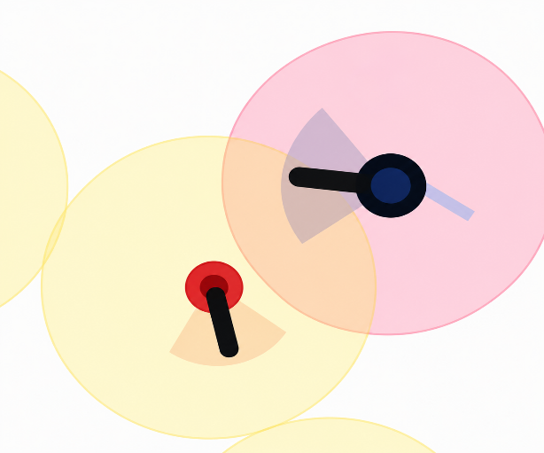

Fig. 5. multi-agent navigation in a shared environment
Schematic illustration of multi-agent navigation in a shared environment. Solid colored circles denote robot positions with directional indicators representing robot heading; translucent colored zones depict influence regions used by the Virtual Force Field (repulsive zones), the HJB value function (reachable sets), and the gradient field that drives the pursuer toward the evader. Overlapping regions indicate agent-to-agent and agent-to-obstacle interaction, which is the operational context of the integrated VFF + HJB framework.

- Hamilton-Jacobi-Bellman(HJB) Reachability
While the VFF component in Equation (7)–(9) provides reactive, local-scale obstacle avoidance, it lacks the predictive capability required to guarantee capture in pursuit-evasion scenarios. To endow the swarm with such foresight, the proposed framework augments VFF with a Hamilton-Jacobi-Bellman (HJB) reachability module that precomputes the optimal cost-to-go from any configuration of the robot. The HJB equation is the continuous-time counterpart of Bellman's principle of optimality, and its solution yields both the optimal value function and the optimal control law in closed feedback form.
To preserve consistency with the kinematic notation of Section 2, the HJB state vector x(t) corresponds directly to the robot pose P_r = [x_r, y_r, psi_r] defined in Equation (1), and the HJB control vector u(t) corresponds to the linear-angular velocity pair [v_r, omega_r]^T that appears in Equation (4). The dynamics function f(x, u, t) is therefore the same unicycle kinematic model already introduced in Equation (4), so that the HJB value function V(x, t) is evaluated over the robot's configuration space.
The continuous-time evolution of the robot state is governed by:
(10)
where x(t) in R^n is the state, u(t) in U subset R^m is the control input drawn from the admissible set U, f is a Lipschitz-continuous vector field, and x_0 is the initial state at time t = 0.
The pursuit objective is formulated as a minimum-cost optimal control problem, where the running cost L penalizes time-to-capture and control effort, and the terminal cost g penalizes the residual distance to the evader at the final time T:
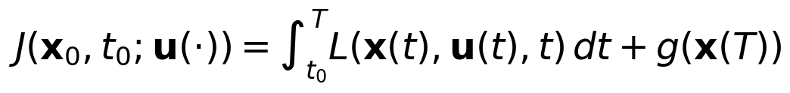
(11)
The optimal value function V(x, t) is defined as the minimum cost-to-go starting from state x at time t:
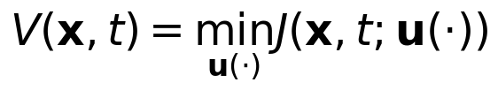
(12)
By invoking Bellman's principle of optimality, taking the limit as the time-step approaches zero, and applying a first-order Taylor expansion of V, the value function is shown to satisfy the Hamilton-Jacobi-Bellman partial differential equation:
(13)
subject to the terminal condition V(x, T) = g(x). The negative gradient -nabla_x V defines the direction of steepest descent in cost-space, which the pursuer follows in closed loop, producing a globally optimal, local-minima-free navigation policy.
Once V(x, t) is computed, the optimal feedback control is recovered pointwise from the minimizer of the Hamiltonian:
(14)
Substituting the unicycle dynamics of Equation (4) into the HJB equation yields the specialized form for differential-drive mobile robots, where the partial derivatives of V are taken with respect to the pose components x_r, y_r, and psi_r:
(15)
Here V_{x_r}, V_{y_r}, and V_{psi_r} denote the partial derivatives of V with respect to each pose component. Solving Equation (15) over the configuration space produces a navigation function whose gradient field induces collision-free, dynamically feasible trajectories for the TurtleBot2 pursuer.
Backward Reachable Tube.
A key concept used by the proposed framework is the Backward Reachable Tube (BRT), defined as the set of all initial states from which capture of the evader is guaranteed within a finite time horizon, regardless of the evader's actions. Using the value function from Equation (13), the BRT is recovered as the sub-level set:
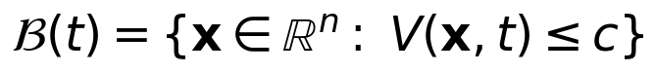
(16)
where c is a threshold chosen so that B(t) encloses all states from which the pursuer can intercept the evader before the time horizon expires. In the implementation, B(t) appears as a circular disk centered on the pursuer, whose radius R_BRT grows with remaining time.
Capture Trigger Condition.
Pursuit is initiated by the circle-meet-circle detection mechanism: when the pursuer's BRT disk of radius R_BRT intersects the evader's attraction zone of radius R_attr, engagement begins. This condition is expressed compactly as:
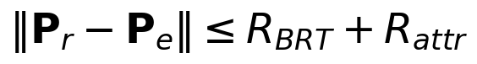
(17)
where P_r is the pursuer pose (Equation 1), P_e is the evader pose, R_BRT is the BRT radius derived from Equation (16), and R_attr is the evader's attraction radius. This ensures that engagement is triggered at the theoretically sound boundary rather than an arbitrary heuristic distance. The HJB module therefore complements the VFF component: VFF governs local inter-agent spacing and obstacle avoidance in real time, while HJB provides the predictive intelligence that guarantees the capture.

