Smart Email Writer 📧
Smart Email Writer is an AI-powered web application built using Streamlit and LangChain. It enables users to convert simple bullet points into well-structured, professional emails leveraging the capabilities of OpenAI’s language models.

Key Features
- Transforms bullet points into structured professional emails
- Automatically generates subject, greeting, body, and closing
- User-friendly interface built with Streamlit
- Secure API key management using environment variables (.env)

Technology Stack
- Python
- Streamlit
- LangChain
- OpenAI API

Project Structure
The project follows a modular and scalable structure with separate components for UI, LLM integration, prompt handling, and chain execution. This ensures maintainability and extensibility.

Setup Instructions
- Clone the repository from GitHub.
- Create and activate a virtual environment.
- Install dependencies using requirements.txt.
- Add your OpenAI API key in a .env file.
- Run the application using Streamlit.

Demo
A demo screenshot to showcase the UI and functionality.
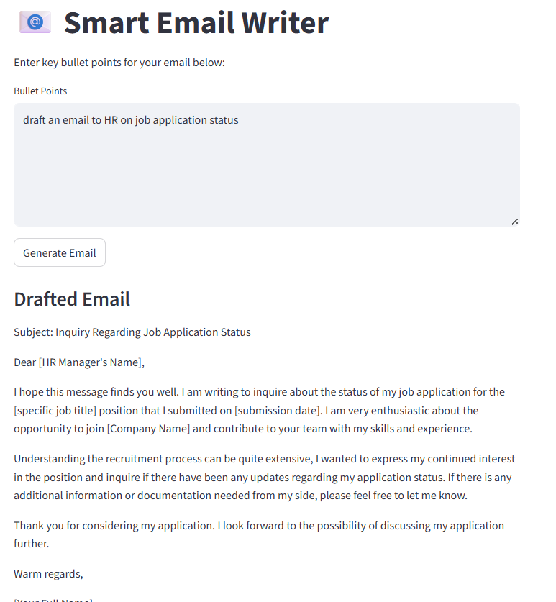

Future Enhancements
- Add tone customization (formal, casual, etc.)
- Enable export of generated emails as PDF or Word documents
- Support for multiple languages

Code used
import streamlit as st
from langchain_openai import ChatOpenAI
from langchain_core.prompts import PromptTemplate
import os
from dotenv import load_dotenv

# Force reload of environment variables (clears cache)
if 'env_loaded' not in st.session_state:
load_dotenv(override=True)
st.session_state.env_loaded = True

# Get API key - verify it's loaded
api_key = os.getenv("OPENAI_API_KEY")
if not api_key:
st.error("❌ OPENAI_API_KEY not found in .env file")
st.stop()

if api_key.startswith("sk-sk-"):
st.error("❌ Invalid API key format detected. Please check your .env file.")
st.stop()

# Initialize the LLM
llm = ChatOpenAI(
api_key=api_key,
model_name="gpt-4o",
temperature=0.5
)

# Define the prompt template
prompt = PromptTemplate(
input_variables=["bullet_points"],
template="""
You are an expert email writer. Using the following bullet points, draft a professional email:

{bullet_points}
"""
)

# Create the LLM Chain using LCEL
chain = prompt | llm

# Streamlit UI
st.title("📧 Smart Email Writer")

st.write("Enter key bullet points for your email below:")

bullet_points = st.text_area("Bullet Points", height=200)

if st.button("Generate Email"):
if not bullet_points:
st.warning("Please enter some bullet points.")
else:
try:
response = chain.invoke({"bullet_points": bullet_points})
# Handle both string and AIMessage responses
email = response.content if hasattr(response, 'content') else str(response)
st.subheader("Drafted Email")
st.write(email)
except Exception as e:
st.error(f"Error: {str(e)}")

