IBM HR Attrition Analysis
- Objective
The objective of this analysis is to identify the key drivers of employee attrition and quantify their impact on overall attrition, enabling data-driven decision-making to reduce employee turnover.
- Business Questions
  - What is the overall attrition rate in the organization?
  - What factors contribute to employees leaving the company?
  - Which departments and job roles are most affected by attrition?
  - Which employee segments contribute the most to overall attrition risk?
- Dataset overview
https://www.kaggle.com/datasets/pavansubhasht/ibm-hr-analytics-attrition-dataset
The dataset consists of employee-level records capturing demographic details, job-related attributes, compensation, work environment, and attrition status. It is designed to analyze patterns and drivers of employee attrition.
- Each row represents an individual employee
- Total employees: 1470
- Target variable: Attrition (Yes/No)
- Feature categories
  - Demographic Information
    - Age – Employee age (numeric)
    - Gender – Male, Female
    - MaritalStatus – Divorced, Married, Single
    - DistanceFromHome – Distance between home and workplace
  - Education & Background
    - Education
      - Below College
      - College
      - Bachelor
      - Master
      - Doctor
    - EducationField
      - Human Resources, Life Sciences, Marketing, Medical, Other, Technical Degree
  - Job & Organization Details
    - Department – Human Resources, R&D, Sales
    - JobRole – Includes roles such as:
      - Sales Executive
      - Research Scientist
      - Laboratory Technician
      - Manager
      - Manufacturing Director
      - Healthcare Representative, etc.
    - JobLevel – Scale from 1 to 5
    - EmployeeNumber – Unique identifier
    - EmployeeCount – Constant value (1 for all records)
  - Compensation & Salary
    - MonthlyIncome – Monthly salary
    - DailyRate / HourlyRate / MonthlyRate – Pay-related metrics
    - PercentSalaryHike – Percentage salary increase
    - StockOptionLevel – Stock options assigned
  - Work Experience & Tenure
    - TotalWorkingYears – Total career experience
    - YearsAtCompany – Tenure in current company
    - YearsInCurrentRole – Time in current role
    - YearsSinceLastPromotion – Promotion gap
    - YearsWithCurrManager – Time with current manager
    - NumCompaniesWorked – Number of previous employers
  - Work Conditions & Behaviour
    - OverTime – Yes / No
    - BusinessTravel – Non-Travel, Travel Frequently, Travel Rarely
    - TrainingTimesLastYear – Number of training sessions attended
  - Satisfaction & Engagement Metrics (Scaled from 1 to 4)
    - EnvironmentSatisfaction – Low to Very High
    - JobSatisfaction – Low to Very High
    - RelationshipSatisfaction – Low to Very High
    - JobInvolvement – Low to Very High
    - WorkLifeBalance – Bad, Good, Better, Best
  - Performance Metrics
    - PerformanceRating (Scaled from 1 to 4)
      - Low, Good, Excellent, Outstanding
- Data Cleaning & Preprocessing
Data cleaning and preprocessing were performed using Python to ensure data quality and reliability before analysis.
  - Missing Values Check
    - Checked for missing values using:
df.isnull().sum()
    - Result: No missing values were found in the dataset.
  - Duplicate Records
    - Checked for duplicate rows using:
df.duplicated().sum()
    - Result: No duplicate records were identified.
  - Unique Value Analysis
    - Analyzed distinct values in each column using:
df.nunique()
    - This helped in:
      - Identifying categorical vs numerical columns
      - Understanding feature distribution
      - Detecting constant or redundant fields
  - Removal of Irrelevant Columns
The following columns were removed as they do not contribute to analysis:
    - EmployeeCount → Constant value (1 for all rows)
    - EmployeeNumber → Unique identifier (no analytical value)
    - StandardHours → Constant value
    - Over18 → Same value across all records
  - Data Preparation for Analysis
    - Converted categorical variables where necessary for analysis
    - Created derived fields such as:
      - Age Group
      - Tenure Group
    - Prepared data for Power BI visualization and DAX calculations
- Approach
This analysis goes beyond simple attrition percentages by introducing an Impact Score to identify not just high-risk groups, but groups that contribute most to overall attrition.
- Key Metrics
  - Attrition Rate
    - $Attrition rate=\frac{Employee who left}{Total employees}$
  - Impact
    - $Impact=Segment attrition rate-Overall attrition rate$
  - Population share
    - $Population share=\frac{Segment size}{Total employee}$
  - Impact score
    - $Impact score=Impact*Population share$
- Key Findings
  - Overall Attrition rate
  - Top drivers of Attrition
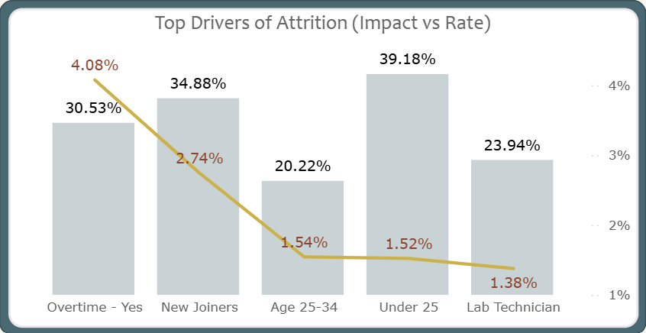
Overtime, employee tenure (new joiners), and age group are the most significant drivers of attrition. Employees working overtime exhibit the highest impact on overall attrition.
  - Departments / Roles with Highest Attrition
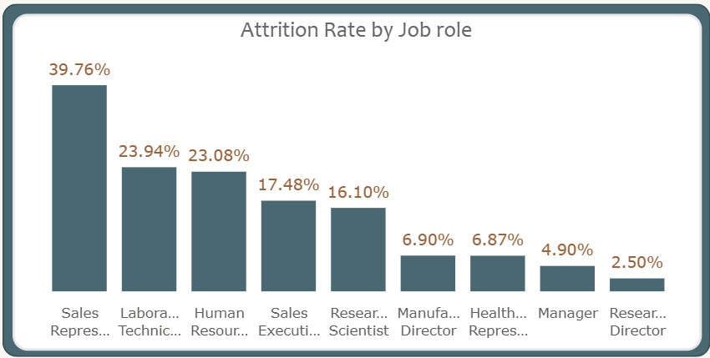
Sales Representatives and Laboratory Technicians show the highest attrition rates among job roles, indicating potential role-specific challenges.
  - High-Risk Employee Segments
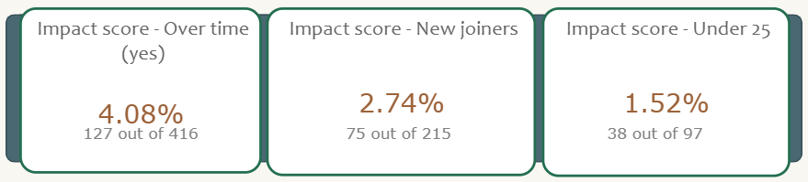
Employees who are working overtime, new to the organization, in their early career stages are at the highest risk of attrition.
- Insights
  - Overtime is the strongest driver of attrition, contributing the highest impact at 4.08%.
  - New joiners contribute 2.74% impact, indicating onboarding or expectation gaps.
  - While Under 25 employees have the highest attrition rate, the 25–34 age group contributes more to overall attrition (1.54% vs 1.52%) due to a larger population.
- Business Implication
  - Reduce excessive overtime through workload balancing.
  - Strengthen onboarding and early employee engagement programs.
  - Provide targeted support for early-career employees.
- Tools & Technologies
  - Python (Data Transformation & Cleaning)
  - Power BI (Data Modelling & Visualization)
  - DAX (Calculated Measures & Impact Score)
- Conclusion
  - This analysis highlights that attrition is driven not just by high-risk groups but by groups that combine risk with scale. By focusing on high-impact segments such as employees working overtime and new joiners, organizations can significantly reduce overall attrition.

