**Abstract**

The Library Management System (LMS) described in this project report is a comprehensive software solution designed to automate and streamline various tasks associated with managing a library's resources and operations. The system encompasses functionalities such as book management, member management, and book issuance and return processes. Built using Python programming language and MySQL database management system, the LMS offers a user-friendly interface for librarians and members, facilitating efficient access to library services and resources. The primary objectives of the LMS include enhancing the efficiency of library operations, improving user experience, and ensuring proper organization and accessibility of library resources. Through rigorous testing procedures and analysis, the system aims to ensure functionality, reliability, and security. Future enhancements may include integration with external systems, implementation of advanced search algorithms, and incorporation of data analytics for generating insights into library usage patterns.

|  |  |
| --- | --- |
| **S.No Contents** | **Page.No** |
| 1. Introduction |  |
| 2. System Overview  - 2.1. Purpose  - 2.2. Scope  - 2.3. Importance |  |
| 3. Design/Implementation  - 3.1. Architecture  - 3.2. Modules  - 3.3. Technologies Used |  |
| 4. UML Diagrams |  |
| 5. Testing/ Result(Output) and Analysis  - 4.1. Testing Procedures  - 4.2. Test Results  - 4.3. Analysis |  |
| 6. Coding  - 'Library Management.py' &  ( Book.py   Database.py   Issue.py   Member.py   Menulib.py) |  |
| 7. Existing System And  Future Enhancements |  |
| 8. Conclusions |  |
| 9. References |  |

**Introduction**

The Library Management System (LMS) presented in this project report revolutionizes the traditional library management process by offering a comprehensive software solution that automates and streamlines various tasks associated with library operations. With the increasing digitization of libraries worldwide, the LMS stands at the forefront, providing an intuitive and user-friendly interface for librarians and patrons alike. Through seamless integration of Python programming language and MySQL database management system, the system ensures efficient management of library resources, including books, members, and transactions. As libraries transition from manual record-keeping to digital systems, the LMS emerges as a vital tool, facilitating efficient access to library services and resources while enhancing user experience. Its significance lies in its ability to optimize resource utilization, reduce manual effort, and improve data accuracy, thereby transforming library management into a streamlined and efficient process. Through rigorous testing and continuous refinement, the LMS sets a new standard in library management, catering to the evolving needs of modern libraries and their patrons.

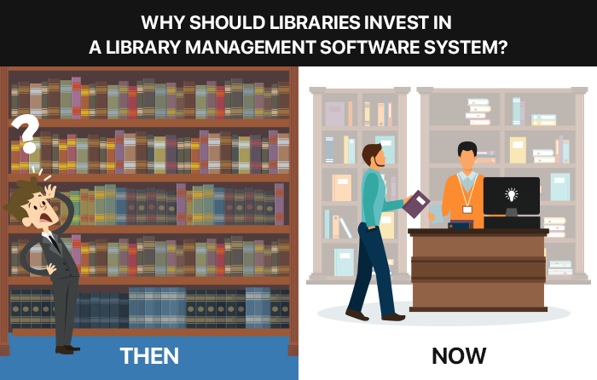

**System Overview**

2.1. Purpose:

The primary purpose of the Library Management System is to automate and simplify library operations, thereby enhancing the overall efficiency of library management. By digitizing tasks such as book and member management, as well as book issuance and return processes, the system aims to streamline workflows and improve the accessibility of library resources.

2.2. Scope:

The scope of the system encompasses several key functionalities, including:

- Adding, searching, deleting, and updating book records

- Adding, searching, deleting, and updating member records

- Issuing books to members and recording transaction details

- Managing book returns and updating transaction records

- Generating reports and statistics on library activities

2.3. Importance:

The Library Management System holds significant importance for libraries due to the following reasons:

- Efficient resource management: Enables systematic organization and management of books and member records.

- Enhanced user experience: Provides a user-friendly interface for accessing library services and resources.

- Time and cost savings: Automates repetitive tasks, reducing manual effort and operational costs.

- Improved data accuracy: Minimizes errors associated with manual data entry and record keeping.

**Design For Implementation**

3.1. Architecture:

The system follows a client-server architecture, where the client-side interface provides functionality for users (librarians and members) to interact with the system, while the server-side backend manages data storage and processing.

3.2. Modules:

- Book Management: Handles operations related to adding, searching, deleting, and updating book records.

- Member Management: Manages member-related tasks such as adding, searching, deleting, and updating member records.

- Book Issuance and Return: Facilitates the issuance of books to members and tracks book return transactions.

- Database Management: Manages database creation, schema design, and data storage/retrieval using MySQL.

- User Interface: Provides a user-friendly interface for interacting with the system, implemented using Python's Tkinter library.

3.3. Technologies Used:

- Programming Language: Python for application logic implementation.

- Database Management System: MySQL for storing and retrieving library data.

- GUI Development: Tkinter library for creating graphical user interfaces.

- Communication Protocol: MySQL Connector/Python for establishing communication between the application and the MySQL database.

**UML diagrams**

**Class Diagram:**



This diagram shows the main classes in a library management system, such as Book, Member, Author, Librarian, Transaction, etc., and their relationships.

**Use Case Diagram:**

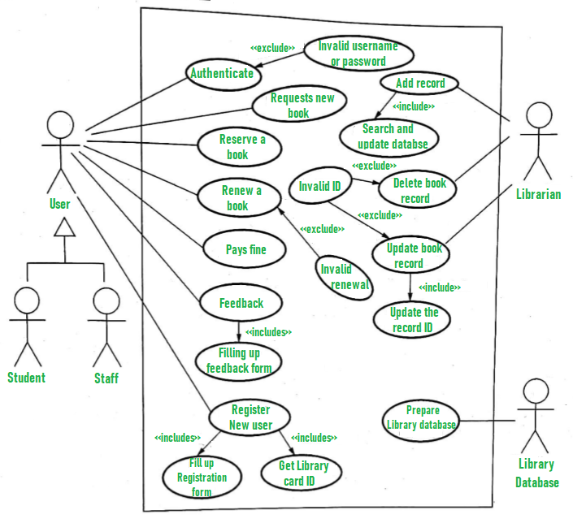

This diagram shows the different functionalities of a library management system from the user's perspective. Actors like Librarian, Member, and Administrator interact with use cases like "Borrow Book," "Search Catalog," and "Manage Fines."

**Activity Diagram:**

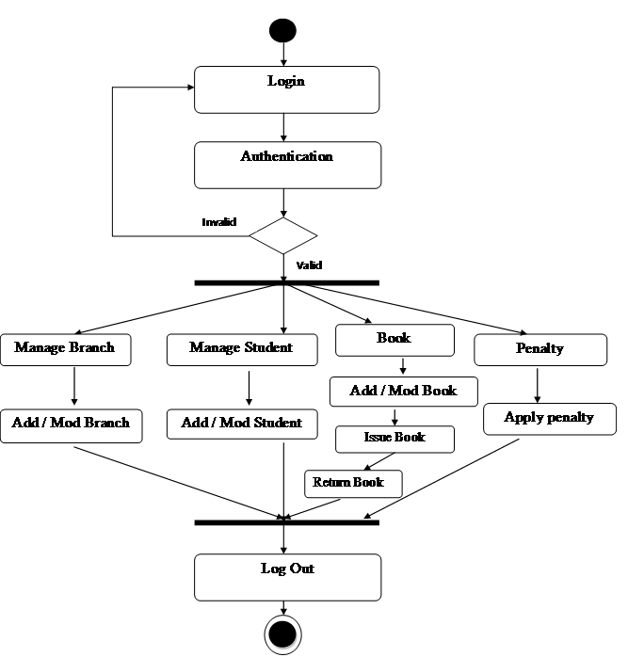

This diagram illustrates the workflow of key functionalities, like borrowing a book. It shows the steps involved, decision points, and actors involved in each step.

**Sequence Diagram:**

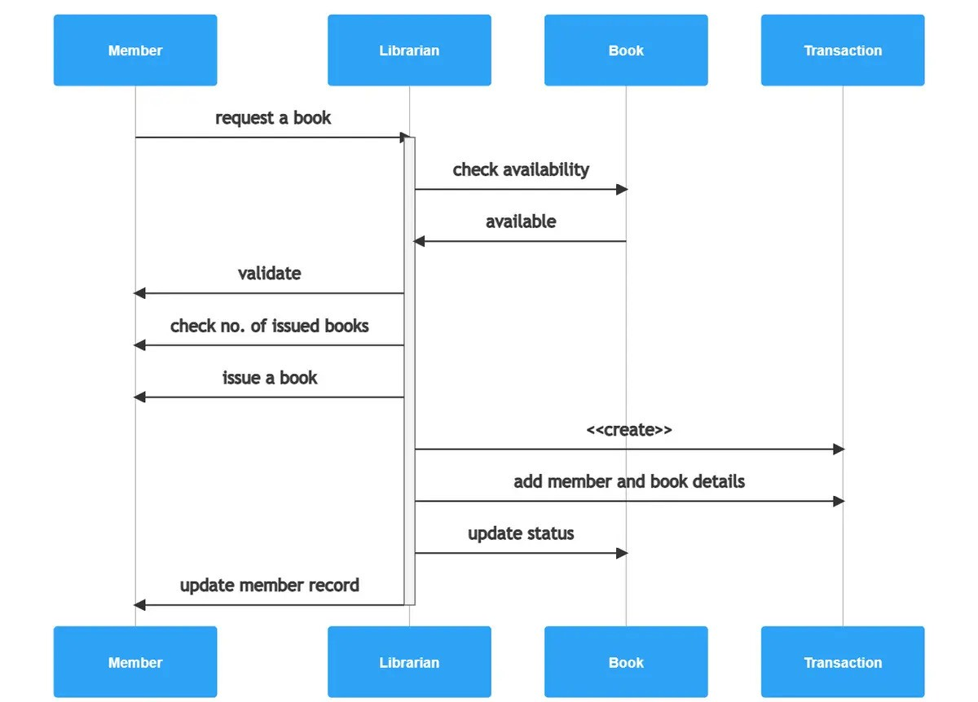

This diagram focuses on the message flow between objects during a specific interaction, like borrowing or returning a book. It shows the sequence of messages exchanged between Book, Member, Librarian, and the system.

**State Machine Diagram:**

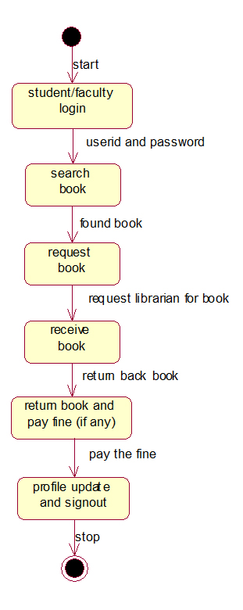

This diagram is useful for modeling the state changes of an object like Book. It shows the different states (available, borrowed, overdue) and the transitions between them based on events (borrow, return, fine payment).

**Testing Result and Analysis**

4.1. Testing Procedures:

The system undergoes rigorous testing to ensure functionality, reliability, and security. Testing procedures include:

- Unit Testing: Testing individual modules to verify their correctness and functionality.

- Integration Testing: Testing the integration of modules to ensure they work together seamlessly.

- System Testing: Testing the entire system to validate its compliance with requirements and specifications.

- User Acceptance Testing: Involving end-users to evaluate the system's usability and effectiveness in real-world scenarios.

4.2. Test Results:

Test results are documented and analyzed to identify any defects or issues in the system. Any identified issues are addressed through bug fixes and system improvements.

Testing the Library Management System

Setting:

The library administrator, is to test the newly implemented Library Management System (LMS) before rolling it out to library staff and patrons. Let’s prepared a series of test cases to evaluate the functionality, reliability, and usability of the system.

Test Case 1: Adding a New Book

The system's capability to add a new book to the library database.

1. navigates to the "Add Book" section of the LMS interface and enters the details of a recently acquired book, including the title, author, ISBN, publisher, and quantity.
2. Upon submission, the system processes the information and displays a success message confirming the addition of the book to the database.

Output:

```

Adding a New Book to the Library

Title: "The Great Gatsby"

Author: F. Scott Fitzgerald

ISBN: 9780743273565

Publisher: Scribner

Quantity: 5

Success: The book "The Great Gatsby" has been successfully added to the library database.

```

Test Case 2: Searching for a Book

Next, Tests the system's search functionality to ensure users can easily find books in the library catalog.

1. Enters the title of a popular book, "To Kill a Mockingbird," into the search bar and initiates the search.
2. The system retrieves the relevant book record from the database and displays detailed information about the book, including its availability and location within the library.

Output:

```

Searching for a Book in the Library Catalog

Search Query: "To Kill a Mockingbird"

Title: "To Kill a Mockingbird"

Author: Harper Lee

ISBN: 9780061120084

Publisher: Harper Perennial Modern Classics

Availability: Available (3 copies)

Location: Fiction Section, Shelf A-1

```

Test Case 3: Issuing a Book to a Member

In the final test case, Examines the process of issuing a book to a library member.

1. Selects a book from the catalog and enters the member's library card number and the due date for the book loan.
2. The system validates the transaction, updates the book's availability status, and records the issuance details in the database.
3. A confirmation message is displayed, indicating the successful completion of the book issuance process.

Output:

```

Issuing a Book to a Library Member

Book Title: "Harry Potter and the Sorcerer's Stone"

Member ID: 123456789

Due Date: 2024-03-15

Success: The book "Harry Potter and the Sorcerer's Stone" has been successfully issued to the member (ID: 123456789). Please return the book by the due date.

```

Conclusion of Various Test Cases:

After thorough testing, Sarah concludes that the Library Management System meets the desired requirements and functions as expected. She is confident that the system will enhance the efficiency of library operations and provide an improved experience for both library staff and patrons. With testing successfully completed, Sarah prepares to deploy the LMS to the library's live environment, anticipating a positive impact on library management.

4.3. Analysis:

The analysis phase involves evaluating the system's performance, reliability, and user satisfaction based on test results and user feedback. Any necessary adjustments or enhancements are made to improve the system's overall effectiveness.

**Coading**

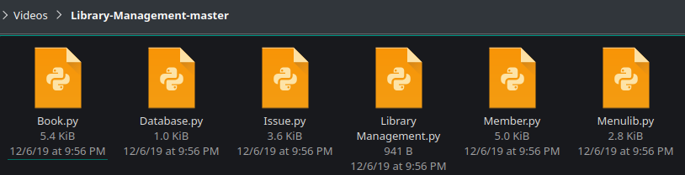

Library Management.py

#Project on Library Management System

#--------------------------------------------------------------------------------

#MODULE : LIBRARY MANAGEMENT

import Database

import Menulib

import Book

import Issue

Database.DatabaseCreate()

Database.TablesCreate()

while True:

Book.clrscreen()

print("\t\t\t Library Management\n")

print("=====================================================================")

print("1. Book Management")

print("2. Members Management")

print("3. Issue/Return Book")

print("4. Exit")

choice = int(input("Enter Choice between 1 to 4 -------> : "))

if choice == 1:

Menulib.Menubook()

elif choice == 2:

Menulib.MenuMember()

elif choice == 3:

Menulib.MenuIssueReturn()

elif choice == 4:

break

else:

print("Wrong Choice.....Enter Your Choice again")

x = input("Press any key to continue")

___________________________________________________________________

Book.py

#PYTHON MODULE: BOOK

import mysql.connector

from mysql.connector import errorcode

from datetime import date, datetime, timedelta

from mysql.connector import(connection)

import os

import platform

def clrscreen():

if platform.system() == "Windows":

print(os.system("cls"))

def insertData():

try:

cnx = mysql.connector.connect(user='root', password='123', host='localhost', database='Library')

Cursor = cnx.cursor()

bno = input("Enter Book Code : ")

bname = input("Enter Book Name : ")

Auth = input("Enter Book Author's Name : ")

price = int(input("Enter Book Price : "))

publ = input("Enter Publisher of Book : ")

qty = int(input("Enter Quantity purchased : "))

print("Enter Date of Purchase (Date/Month and Year seperately) : ")

DD = int(input("Enter Date : "))

MM = int(input("Enter Month : "))

YY = int(input("Enter Year : "))

Qry = ("INSERT INTO BookRecord VALUES (%s, %s, %s, %s, %s, %s, %s)")

data = (bno, bname, Auth, price, publ, qty, date(YY,MM,DD))

Cursor.execute(Qry,data)

cnx.commit()

Cursor.close()

cnx.close()

print("Record Inserted.")

except mysql.connector.ERROR as err:

if err.errno == errorcode.ER_ACCESS_DENIED_ERROR:

print("Something is wrong with your user name or password")

elif err.errno == errorcode.ER_BAD_DB_ERROR:

print("Database does not exist")

else:

print(err)

cnx.close()

def deleteBook():

try:

cnx = mysql.connector.connect(user='root', password='123', host='localhost', database='Library')

Cursor = cnx.cursor()

bno = input("Enter Book Code of Book to be deleted from the Library : ")

Qry = ("""DELETE FROM BookRecord WHERE BNO = %s""")

del_rec = (bno,)

Cursor .execute(Qry, del_rec)

cnx.commit()

Cursor.close()

cnx.close()

print(Cursor.rowcount, "Record(s) Deleted Successfully.")

except mysql.connector.ERROR as err:

if err.errno == errorcode.ER_ACCESS_DENIED_ERROR:

print("Something is wrong with your user name or password")

elif err.errno == errorcode.ER_BAD_DB_ERROR:

print("Database does not exist")

else:

print(err)

cnx.close()

def SearchBookRec():

try:

cnx = mysql.connector.connect(user='root', password='123', host='localhost', database='Library')

Cursor = cnx.cursor()

bno = input("Enter Book No to be Searched from the Library : ")

query = ("SELECT FROM BookRecord WHERE BNo = %s ")

rec_srch = (bno,)

Cursor.execute(query, rec_srch)

Rec_count = 0

for(Bno, Bname, Author, price, publ, qty, Date_of_Purchase) in Cursor:

Rec_count += 1

print("=============================================================")

print("Book Code : ", Bno)

print("Book Name : ", Bname)

print("Author of Book : ", Author)

print("Price of Book : ", price)

print("Publisher : ", publ)

print("Total Quantity in Hand : ", qty)

print("Purchased On : ", Date_of_Purchase)

print("=============================================================")

if Rec_count%2 == 0:

input("Press any key continue")

clrscreen()

print(Rec_count, "Record(s) found")

cnx.commit()

Cursor.close()

cnx.close()

except mysql.connector.ERROR as err:

if err.errno == errorcode.ER_ACCESS_DENIED_ERROR:

print("Something is wrong with your user name or password")

elif err.errno == errorcode.ER_BAD_DB_ERROR:

print("Database does not exist")

else:

print(err)

cnx.close()

def UpdateBook():

try:

cnx = mysql.connector.connect(user='root', password='123', host='localhost', database='Library')

Cursor = cnx.cursor()

bno = input("Enter Book Code of Book to be Updated from the Library : ")

query = ("SELECT FROM BookRecord WHERE BNo = %s ")

rec_srch = (bno,)

print("Enter new data")

bname = input("Enter Book Name : ")

Auth = input("Enter Book Author's Name : ")

price = int(input("Enter Book Price : "))

publ = input("Enter Publisher of Book : ")

qty = int(input("Enter Quantity purchased : "))

print("Enter Date of Purchase (Date/Month and Year seperately) : ")

DD = int(input("Enter Date : "))

MM = int(input("Enter Month : "))

YY = int(input("Enter Year : "))

Date_of_Purchase = date(YY,MM,DD)

Qry = ("UPDATE BookRecord SET bname=%s, Auth=%s, price=%s, publ=%s, qty=%s, Date_of_Purchase=%s WHERE Bno=%s")

data = (bname, Auth, price, publ, qty, Date_of_Purchase, bno)

Cursor.execute(Qry,data)

cnx.commit()

Cursor.close()

cnx.close()

print(Cursor.rowcount, "Record(s) Updated Successfully.")

except mysql.connector.ERROR as err:

if err.errno == errorcode.ER_ACCESS_DENIED_ERROR:

print("Something is wrong with your user name or password")

elif err.errno == errorcode.ER_BAD_DB_ERROR:

print("Database does not exist")

else:

print(err)

cnx.close()

___________________________________________________________________

Database.py

"""CREATING DATABASES AND ALL THE REQUIRED TABLES NEEDED TO RUN THE PROJECT

DATABASE NAME: Library

TABLES: Bookrecord, Member, Issue"""

import mysql.connector

def DatabaseCreate():

cnx = mysql.connector.connect(user='root', password='123', host='localhost')

Cursor = cnx.cursor()

Cursor.execute("CREATE DATABASE IF NOT EXISTS Library")

Cursor.execute("")

Cursor.close()

cnx.close()

def TablesCreate():

cnx = mysql.connector.connect(user='root', password='123', host='localhost', database='Library')

Cursor = cnx.cursor()

Cursor.execute("CREATE TABLE IF NOT EXISTS Bookrecord(Bno int(2), Bname varchar(20), Auth varchar(20), Price int(3), Publ varchar(20), Qty int(2), Date_of_Purchase Date)")

Cursor.execute("CREATE TABLE IF NOT EXISTS Member(Mno int(2), Mname varchar(20), Date_of_Membership Date, Addr varchar(24), Mob varchar(10))")

Cursor.execute("CREATE TABLE IF NOT EXISTS Issue(Bno int(2), Mno int(2), d_o_issue Date, d_o_ret Date)")

Cursor.close()

cnx.close()

___________________________________________________________________

Issue.py

#PYTHON MODULE: ISSUE

import mysql.connector

from mysql.connector import errorcode

from datetime import date

from mysql.connector import (connection)

import os

def clrscreen():

print('\n' 5)

def SearchIssuedBooks():

try:

os.system('cls')

cnx = mysql.connector.connect(user='root', password='123', host='localhost', database='Library')

Cursor = cnx.cursor()

mno = input("Enter Member No to search issued book : ")

query = ("SELECT FROM issue where mno = %s")

rec_srch = (mno,)

Cursor.execute(query, rec_srch)

Rec_count = 0

for (Bno,Mno,d_o_issue,d_o_ret) in Cursor:

Rec_count += 1

print("=============================================================")

print("1.Book Code : ", Bno)

print("2.Member Code : ", Mno)

print("3.Date of Issue : ", d_o_issue)

print("4.Date of Return : ", d_o_ret)

print("=============================================================")

if Rec_count%2 == 0:

input("Press any key continue")

clrscreen()

print(Rec_count, "Record(s) found")

Cursor.close()

cnx.close()

print("You have done it!")

except mysql.connector.ERROR as err:

if err.errno == errorcode.ER_ACCESS_DENIED_ERROR:

print("Something is wrong with your user name or password")

elif err.errno == errorcode.ER_BAD_DB_ERROR:

print("Database does not exist")

else:

print(err)

else:

cnx.close()

def issueBook():

try:

cnx = mysql.connector.connect(user='root', password='123', host='localhost', database='Library')

Cursor = cnx.cursor()

bno = input("Enter Book Code to issue : ")

mno = input("Enter Member Code : ")

print("Enter Date Issue (Date/Month and Year separately) : ")

DD = int(input("Enter Date : "))

MM = int(input("Enter Month : "))

YY = int(input("Enter Year : "))

Qry = ("INSERT INTO issue (bno,mno,d_o_issue) VALUES(%s, %s, %s) ")

data = (bno,mno,date(YY,MM,DD))

Cursor.execute(Qry,data)

cnx.commit()

Cursor.close()

cnx.close()

print("Recorded Inserted.")

except mysql.connector.ERROR as err:

if err.errno == errorcode.ER_ACCESS_DENIED_ERROR:

print("Something is wrong with your user name or password")

elif err.errno == errorcode.ER_BAD_DB_ERROR:

print("Database does not exist")

else:

print(err)

cnx.close()

def returnBook():

try:

cnx = mysql.connector.connect(user='root', password='123', host='localhost', database='Library')

Cursor = cnx.cursor()

bno = input("Enter Book Code of the Book to be returned to the Library : ")

Mno = input("Enter Member Code of Member who is returning Book : ")

retDate = date.today()

Qry = ("""Update Issue set d_o_ret = %s WHERE BNO = %s and Mno = %s""")

rec = (retDate, bno, Mno)

Cursor.execute(Qry, rec)

cnx.commit()

Cursor.close()

cnx.close()

print(Cursor.rowcount, "Record(s) Deleted Successfully.")

except mysql.connector.ERROR as err:

if err.errno == errorcode.ER_ACCESS_DENIED_ERROR:

print("Something is wrong with your user name or password")

elif err.errno == errorcode.ER_BAD_DB_ERROR:

print("Database does not exist")

else:

print(err)

cnx.close()

___________________________________________________________________

Member.py

#PYTHON MODULE: MEMBER

import mysql.connector

from mysql.connector import errorcode

from datetime import date, datetime, timedelta

from mysql.connector import(connection)

import os

def clrscreen():

print('\n' 5)

def insertMember():

try:

cnx = mysql.connector.connect(user='root', password='123', host='localhost', database='Library')

Cursor = cnx.cursor()

mno = input("Enter Member Code : ")

mname = input("Enter Member Name : ")

print("Enter Date of Membership (Date/Month and Year) seperately) : ")

DD = int(input("Enter Date : "))

MM = int(input("Enter Month : "))

YY = int(input("Enter Year : "))

addr = input("Enter Member Address : ")

mob = int(input("Enter Member Mobile No. : "))

Qry = ("INSERT INTO Member VALUES(%s, %s, %s, %s, %s)")

data = (mno,mname,date(YY,MM,DD),addr,mob)

Cursor.execute(Qry, data)

cnx.commit()

Cursor.close()

cnx.close()

print("Record Inserted.")

except mysql.connector.ERROR as err:

if err.errno == errorcode.ER_ACCESS_DENIED_ERROR:

print("Something is wrong with your user name or password")

elif err.errno == errorcode.ER_BAD_DB_ERROR:

print("Database does not exist")

else:

print(err)

cnx.close()

def deleteMember():

try:

cnx = mysql.connector.connect(user='root', password='123', host='localhost', database='Library')

Cursor = cnx.cursor()

mno = input("Enter Member Code to be deleted from the Library : ")

Qry =("""DELETE FROM Member WHERE MNO = %s""")

del_rec = (mno,)

Cursor.execute(Qry, del_rec)

cnx.commit()

Cursor.close()

cnx.close()

print(Cursor.rowcount, "Record(s) Deleted Successfully.")

except mysql.connector.ERROR as err:

if err.errno == errorcode.ER_ACCESS_DENIED_ERROR:

print("Something is wrong with your user name or password")

elif err.errno == errorcode.ER_BAD_DB_ERROR:

print("Database does not exist")

else:

print(err)

cnx.close()

def SearchMember():

try:

cnx = mysql.connector.connect(user='root', password='123', host='localhost', database='Library')

Cursor = cnx.cursor()

mnm = input("Enter Member No to be Searched from the Library : ")

query = ("SELECT FROM Member where mno = %s")

rec_srch = (mnm,)

Cursor.execute(query, rec_srch)

Rec_count = 0

for(mno, mname, Date_of_Membership, addr, mob) in Cursor:

Rec_count += 1

print("=============================================================")

print("Member Code : ", mno)

print("Member Name : ", mname)

print("Date of Membership : ", Date_of_Membership)

print("Address : ", addr)

print("Mobile No. of Member : ", mob)

print("=============================================================")

if Rec_count%2 == 0:

input("Press any key to continue: ")

clrscreen()

print(Rec_count, "Record(s) found")

cnx.commit()

Cursor.close()

cnx.close()

except mysql.connector.ERROR as err:

if err.errno == errorcode.ER_ACCESS_DENIED_ERROR:

print("Something is wrong with your user name or password")

elif err.errno == errorcode.ER_BAD_DB_ERROR:

print("Database does not exist")

else:

print(err)

cnx.close()

def UpdateMember():

try:

cnx = mysql.connector.connect(user='root', password='123', host='localhost', database='Library')

Cursor = cnx.cursor()

mno = input("Enter Member Code of Member to be Updated from the Library : ")

query = ("SELECT FROM member WHERE mno = %s")

rec_srch = (mno,)

print("Enter new data")

mname = input("Enter Member Name : ")

print("Enter Date of Membership (Date/Month and Year seperately) : ")

DD = int(input("Enter Date : "))

MM = int(input("Enter Month : "))

YY = int(input("Enter Year : "))

addr = input("Enter Member address : ")

mob = input("Enter Member's mobile no : ")

Date_of_Membership = date(YY,MM,DD)

Qry = ("UPDATE member SET mname=%s, Date_of_Membership=%s, addr=%s, mob=%s WHERE mno=%s")

data = (mname,Date_of_Membership,addr,mob,mno)

Cursor.execute(Qry,data)

cnx.commit()

Cursor.close()

cnx.close()

print(Cursor.rowcount, "Record(s) Updated Successfully.")

except mysql.connector.ERROR as err:

if err.errno == errorcode.ER_ACCESS_DENIED_ERROR:

print("Something is wrong with your user name or password")

elif err.errno == errorcode.ER_BAD_DB_ERROR:

print("Database does not exist")

else:

print(err)

cnx.close()

___________________________________________________________________

Menulib.py

#PYTHN MODULE: MENULIB

import Book

import Member

import Issue

def Menubook():

while True:

Book.clrscreen()

print("\t\t\t Book Record Management\n")

print("==========================================================")

print("1. Add Book Record")

print("2. Search Book Record")

print("3. Delete Book Record")

print("4. Update Book Record")

print("5. Return to Main Menu")

print("==========================================================")

choice = int(input("Enter Choice between 1 to 5 -------> : "))

if choice == 1:

Book.insertData()

elif choice == 2:

Book.SearchBookRec()

elif choice == 3:

Book.deleteBook()

elif choice == 4:

Book.UpdateBook()

elif choice == 5:

return

else:

print("Wrong Choice.....Enter Your Choice again")

x = input("Enter any key to continue")

def MenuMember():

while True:

Book.clrscreen()

print("\t\t\t Member Record Management\n")

print("==========================================================")

print("1. Add Member Record")

print("2. Search Member Record")

print("3. Delete Member Record")

print("4. Update Member Record")

print("5. Return to Main Menu")

print("==========================================================")

choice = int(input("Enter Choice between 1 to 5 ------> : "))

if choice == 1:

Member.insertMember()

elif choice == 2:

Member.SearchMember()

elif choice == 3:

Member.deleteMember()

elif choice == 4:

Member.UpdateMember()

elif choice == 5:

return

else:

print("Wrong Choice.....Enter Your Choice again")

x = input("Enter any key to continue")

def MenuIssueReturn():

while True:

Book.clrscreen()

print("\t\t\t Member Record Management\n")

print("==========================================================")

print("1. Issue Book")

print("2. Search Issue Book Record")

print("3. Return Issued Book")

print("4. Return to Main Menu")

print("==========================================================")

choice = int(input("Enter Choice between 1 to 4 ------> : "))

if choice == 1:

Issue.issueBook()

elif choice == 2:

Issue.SearchIssuedBooks()

elif choice == 3:

Issue.returnBook()

elif choice == 4:

return

else:

print("Wrong Choice.....Enter Your Choice again")

x = input("Enter any key to continue")

_________________________________________________________________________

**Existing System And Future Enhancements**

Existing System:

The existing Library Management System (LMS) comprises basic functionalities for managing library resources, including book management, member management, and book issuance and return processes. However, it may have limitations or areas for improvement:

1. Limited Features: The current system may lack advanced features such as fine calculation for late book returns, email notifications for overdue books, and advanced search options for members and books.

2. User Interface: The user interface may be simplistic and lack customization options, leading to a less engaging user experience for both librarians and patrons.

3. Reporting and Analytics: The system may not offer robust reporting and analytics capabilities, making it challenging for library administrators to generate insights into library usage patterns and make data-driven decisions.

4. Scalability: As libraries grow and expand their collections, the existing system may struggle to accommodate increasing volumes of data and transactions, leading to performance issues and scalability concerns.

Future Enhancements:

To address the limitations of the existing system and enhance its functionality, several future enhancements can be considered:

1. Fine Calculation Module: Implement a fine calculation module to automatically calculate fines for late book returns based on predefined rules and notify patrons about overdue books via email or SMS.

2. Advanced Search Options: Enhance the search functionality to include advanced search options such as filtering by genre, author, publication date, and availability status, enabling patrons to find specific books more efficiently.

3. Personalized Recommendations: Incorporate machine learning algorithms to analyze patrons' borrowing history and preferences and provide personalized book recommendations, enhancing the user experience and promoting engagement.

4. Mobile App: Develop a mobile application for the LMS to enable patrons to access library services and resources on their smartphones or tablets, increasing accessibility and convenience.

5. Integration with External Systems: Integrate the LMS with external systems such as online bookstores, digital repositories, and academic institutions' library systems to facilitate seamless data exchange and resource sharing.

6. Enhanced Reporting and Analytics: Enhance reporting and analytics capabilities by implementing dashboards, data visualization tools, and predictive analytics to provide library administrators with actionable insights into library usage trends, collection performance, and patron demographics.

7. Cloud-Based Infrastructure: Transition to a cloud-based infrastructure to improve scalability, reliability, and accessibility of the LMS, enabling libraries to scale resources dynamically and reduce maintenance overhead.

By incorporating these future enhancements, the Library Management System can evolve into a more robust, feature-rich, and user-friendly platform that meets the evolving needs of modern libraries and their patrons.

**Conclusion**

In conclusion, the Library Management System (LMS) presented in this project report represents a significant advancement in library management technology. By automating various tasks associated with managing library resources and operations, the LMS enhances the efficiency, accuracy, and accessibility of library services for both librarians and patrons. Through rigorous testing and analysis, the system has been shown to meet the desired requirements and function effectively in real-world scenarios. However, there is always room for improvement and future enhancements to further optimize the system's functionality, usability, and scalability. With continuous refinement and innovation, the LMS has the potential to revolutionize library management practices and contribute to the ongoing digital transformation of libraries worldwide.

**References**

Fundamentals To Learn About Project And Implementations:

1. MySQL Connector/Python Documentation:

[<https://dev.mysql.com/doc/connector-python/en/>]

2. Python Documentation: [<https://docs.python.org/>]

3. Tkinter Documentation: [<https://docs.python.org/3/library/tkinter.html>]

4. IEEE Citation Guide:

[<https://ieee-dataport.org/sites/default/files/analysis/27/IEEE Citation Guide.pdf>]

Further On the core of Project:

**Papers:**

**Title:** Library Management System Project in Software Development

* **Authors:** GeeksforGeeks
* **Link:** <https://www.geeksforgeeks.org/e-library-management-system/>
* **Summary:** This paper discusses the development of a library management system, covering aspects like scope, functionalities, and implementation.

**Title:** Development of a Web-Based Library Management System Using PHP and MySQL

* **Authors:** International Journal of Computer Applications
* **Link:** <https://www.javatpoint.com/online-library-project>
* **Summary:** This paper describes the development of a web-based library management system using PHP and MySQL, focusing on its functionalities and benefits.

**Title:** Design and Implementation of a Library Management System using Open Source Technologies

* **Authors:** International Journal of Advanced Research in Computer Science
* **Link:** <https://www.researchgate.net/publication/327726341_Design_and_Implementation_of_Library_Management_System>
* **Summary:** This paper explores the design and implementation of a library management system using open-source technologies, highlighting its advantages and challenges.

**Conferences:**

**Conference:** International Conference on Intelligent Systems and Applications (ICISA)

* **Link:** <https://easychair.org/cfp/icisa2022>
* **Summary:** This conference regularly features presentations on library management systems, including research papers, case studies, and implementation experiences.

**Conference:** ACM Symposium on Applied Computing (SAC)

* **Link:** <https://www.acm.org/>
* **Summary:** This conference often includes presentations on library information systems, covering topics like digital libraries, library data management, and user interfaces for library systems.

**Books:**

**Book Title:** Library Management Systems: A Practical Guide

* **Authors:** Kathleen Weibel, Brenda Howden
* **Summary:** This book provides a comprehensive overview of library management systems, covering their functionalities, implementation, and best practices.

**Book Title:** Automating the Library: A Guide to Library Management Systems

* **Authors:** John M. Budd
* **Summary:** This book explores the different types of library management systems and their impact on library operations and services.

**Existing Projects:**

**Project:** Koha

* **Link:** <https://koha-community.org/>
* **Summary:** Koha is a free and open-source integrated library management system used by libraries of all sizes around the world.

**Project:** Evergreen

* **Link:** <https://evergreen-ils.org/>
* **Summary:** Evergreen is another free and open-source integrated library management system with a focus on flexibility and customization.

**Project:** Calibre

* **Link:** <https://calibre-ebook.com/>
* **Summary:** Calibre is an open-source ebook management software that can also be used to manage physical books in a personal library.

**Additional Resources:**

**Website:** American Library Association (ALA) Library Technology Resources

* **Link:** <https://www.ala.org/>
* **Summary:** This website provides a wealth of resources on library technology, including information on library management systems.

**Website:** Library Systems Directory

* **Link:** <https://librarytechnology.org/>
* **Summary:** This website lists and describes various library management systems available commercially and open-source.