

DEPARTMENT OF ELECTRONICS AND COMMUNICATION ENGINEERING

**RELEVANCE TO PO’s & PSO’s :**

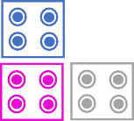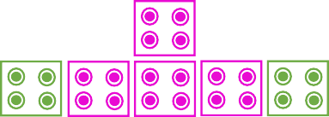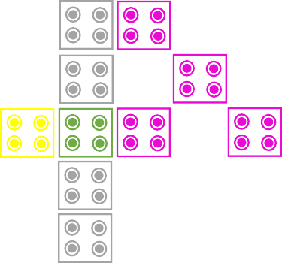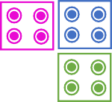

C

**Project Title : Implementation of 4-Bit RCA using Quantum Dot Cellular Automata and Mentor Graphics.**

# Guide Name: T. Anjaiah, M.Tech(Ph.D), ,Associate Professor. Students Name : D.Harsha(20P31A04J4)

# P.Harshitha(20P31A04J5)

# V.Dhanu Piya(20P31A04O1)

# M.Sharan Teja(20P31A04L5)

|  |  |  |
| --- | --- | --- |
| **ABSTRACT** | **PO’s**  **Mapping** | **PSO’s**  **Mapping** |
| QCA technology is a new platform, which is a transistor less and wire-less technology, hence it is one of the best alternatives to CMOS technology for developing low power and high- speed digital circuits at nano-scale level. The limitations of CMOS technology such as large number of transistors and wire connections in a small area was overcome by QCA technology. Therefore, we have chosen the QCA technology. Adder is a basic architecture in constructing all digital circuits. First, a full adder is designed in both QCA as well as Mentor Graphics which has improved performance in propagation delay and cell count. Then with the help of 4 full adders a 4-Bit Ripple Carry Adder is implemented in QCA and compared the results with the existing RCA in QCA. From the comparison, it is found that the proposed ripple carry adder has better performance than the existing adder circuits. | **PO1 PO3 PO5 PO8 PO9 PO10 PO12** | **PSO1 PSO2** |

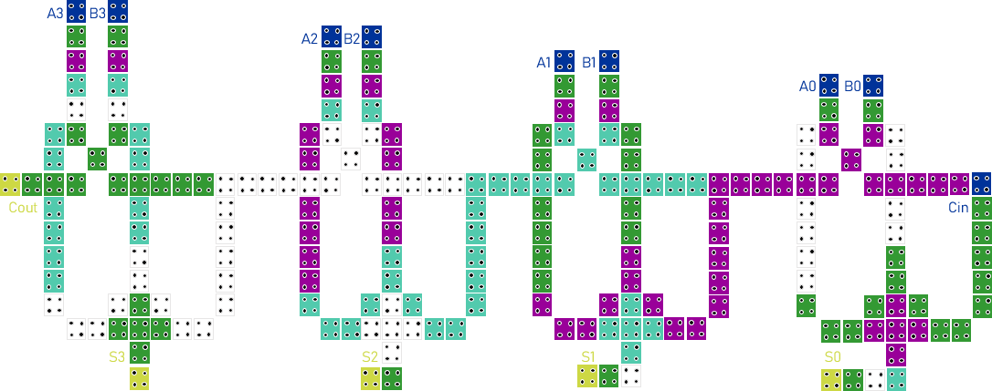

|  |  |  |  |  |  |
| --- | --- | --- | --- | --- | --- |
| **PO1** | | To implement the knowledge of VLSI to implement RCA. | | | |
| **PO3** | | Designed the QCA of 4-Bit RCA by using gates. | | | |
| **PO5** | | We used modern tool named QCA to design the RCA. | | | |
| **PO8** | | The basic rules have been followed while developing this  project. | | | |
| **PO9** | | Able to work effectively as an individual ,and as a  leader/member of team. | | | |
| **PO10** | | Good communication among members for better output. | | | |
| **PO12** | | The modifications can be done to this model for the other purpose. | | | |
|  | PO1  Engineering Knowledge | | PO2  Problem Analysis | | PO3  Design &Development of  Solution |
|  | PO4  Investigations | | PO5  Modern toolusage | | PO6  The Engineer& Society |
|  | PO7  Environment &  Sustainability | | PO8  Ethics | | PO9  Individual &team  work |
|  | PO10  Communication | | PO11  ProjectManagement &Finance | | PO12  Life-longLearning |
|  | PSO1  Industry-ready in the area of electronics & communications,  VLSI. | | | PSO2  To provide well equipped laboratory infrastructure where an individual is mentored to develop  innovative electronics project | |

**CONCLUSION:** QCA full adder circuit is proposed which is designed with minimum number of QCA cells. The proposed full adder requires only 39 QCA cells, an area of 0.06 μm2 to implement its function. Then an efficient 4-bit Ripple Carry Adder (RCA) is designed based on the proposed full adder that performs higher end addition in an effective way. Also, the simulation results shows that the proposed 4-bit Ripple Carry Adder (RC A) requires only 208 QCA cells, an area of 0.3 μm2 and delay of about 1.25 clock cycles to implement its function with enhanced performance in terms of delay, area and cell count. In future, high-speed adders which play an important role in multiplier designs could be designed and its computational performance could be improved further.