**All interview Questions**

**1.)What is the usage of iframe in HTML?**

Ans)a)<iframe> - specifies inline frame.

b)Used to embed documents,videos,interactive media within a page.

c)Ex:<iframe src=”http://w3schools.com”></iframe>

**2)What is output ?**

**Ul li+li{**

**Color:orange;**

**}**

**<ul>**

**<li>List item1</li>**

**<li>List item1</li>**

**<li>List item1</li>**

**<li>List item1</li>**

**</ul>**

Ans)



**Refernce Links:**

**-----------------------------**

**1)<https://www.w3schools.com/tags/tag_doctype.asp>**

**2)** [**https://www.w3schools.com/w3js/w3js_selectors.asp**](https://www.w3schools.com/w3js/w3js_selectors.asp)

**3)** **https://developer.mozilla.org/en-US/docs/Web/CSS/::after**

4) https://www.tutorialspoint.com/javascript/javascript_overview.htm

**3)<div class=”parent”>**

**<div class=”child”>TEXT</div>**

**</div>**

**<style>**

**.parent{**

**color:orange;**

**}**

**.child{**

**color:Currentcolor;**

**}**

**</style>**

Ans)TEXT

**4)What is the usage of marquee ?**

Ans)The Usage of Marquee tag , it defines scroll the element from right to left.

**5)What is hosting in Javascript?**

Ans) Hoisting is JavaScript's default behavior of moving all declarations to the top of the current scope.

**6)What is javascript declaration?**

Ans) JavaScript applications consist of statements with an appropriate syntax. A single statement may span multiple lines.

**7)What is DOM?**

Ans) The Document Object Model (DOM) is a programming interface for web documents. It represents the page so that programs can change the document structure, style, and content. The DOM represents the document as nodes and objects; that way, programming languages can interact with the page.

**8) <!document html> ?**

Ans) All HTML documents must start with a <!DOCTYPE> declaration.

The declaration is not an HTML tag. It is an "information" to the browser about what document type to expect.

In HTML 5, the declaration is simple:

**9)What is that difference between bootstarp4 and bootsrap5?**

Ans)

| BASIS OF | BOOTSTRAP 4 | BOOTSTRAP 5 |
| --- | --- | --- |
| **Grid System** | It has 5 tier (xs, sm, md, lg, xl). | It has 6 tier (xs, sm, md, lg, xl, xxl). |
| **Color** | It has limited colors. | Extra colors added with the looks, A card improved color palette. there are various shades available to choose. |
| **Jquery** | It has jquery and all related plugins. | Jquery is removed and switched to vanilla JS with some working plugins |
| **Internet Explorer** | Bootstrap 4 supports both IE 10 and 11. | Bootstrap 5 doesn’t support IE 10 and 11. |
| **Form elements** | Radio buttons, checkboxes have different look in different OS and browsers. The form uses whatever default browsers provide. | The look of form elements will not change, on different OS or browser. The forms can be customized and form controls can be added, they would not depend on browser. |
| **Utilities API** | We cannot modify utilities in bootstrap 4 | Bootstrap 5 gave freedom to modify and also create our own utility |
| **Gutter** | We use .glutter with fontsize in px | We use .g* with fontsize in rem |
| **Vertical Classes** | Columns can be positioned relative | Columns cannot be positioned relative |
| **Bootstrap Icons** | Bootstrap 4 doesn’t have its own SVG icons, we have to use font-awesome for icons. | Bootstrap 5 have its own SVG icons |
| **Jumbotron** | It supports. | It doesn’t support jumbotron. |
| **Card deck** | The card deck is used to create a set of cards with equal width and height. | Card deck class in removed in bootstrap |
| **Navbar** | We have inline-block property and we will get white dropdown as default for dropdown-menu-dark class. | Inline-block property is removed and we will get black dropdown as default for dropdown-menu-dark class. |
| **Static Site Generator** | Bootstrap 4 uses Jekyll software. | Bootstrap 5 uses Hugo software as it is fast static site generator. |
| **flexbox grid** | this makes easier to implement vertical designs, and the columns and rows can easily be implemented. the classes justify-center-content can directly be used to align according to the requirement. | advanced grid system is made available , also columns don’t have relative positions. |
| **RTL Support** | It does not enable RTL(Right to Left) switching. | It enables RTL(Right to Left) switching. |
| **Offcanvas Component** | It does not support Offcanvas Component. | It supports Offcanvas Component(that is it is available now). |

**10)How would you rate yourself on the scale 1 to 10 with respect to javascript?**

Ans) I will rate myself **8 out of 10** because I would never like to think that there should be a room left for putting in more efforts. That thought will create an interest in learning the things. Thank you very much for giving me this wonderful opportunity.

**11)JS Selectors?**

## Ans) More Selector Examples

|  |  |  |
| --- | --- | --- |
| **Selector** | **Description** | **Example** |
| ("*") | Selects all elements in the document | [Try it](https://www.w3schools.com/w3js/tryit.asp?filename=tryw3js_selectors_all) |
| (this) | Selects the current HTML element | [Try it](https://www.w3schools.com/w3js/tryit.asp?filename=tryw3js_selectors_this) |
| ("p.intro") | Selects all <p> elements with class="intro" | [Try it](https://www.w3schools.com/w3js/tryit.asp?filename=tryw3js_selectors_p_intro) |
| ("div p") | Selects all <p> element inside all <div> elements | [Try it](https://www.w3schools.com/w3js/tryit.asp?filename=tryw3js_selectors_div_p) |
| ("div p:first-child") | Selects the first <p> element inside all <div> elements | [Try it](https://www.w3schools.com/w3js/tryit.asp?filename=tryw3js_selectors_p_first) |
| ("[href]") | Selects all elements with an href attribute | [Try it](https://www.w3schools.com/w3js/tryit.asp?filename=tryw3js_selectors_href) |
| ("a[target=_blank]") | Selects all <a> elements with a target attribute value equal to "_blank" | [Try it](https://www.w3schools.com/w3js/tryit.asp?filename=tryw3js_selectors_a_target) |
| ("p:nth-child(even)") | Selects all even <p> elements |  |

**12) What are the 5 types of selectors?**

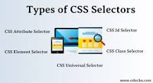

**Types of CSS Selectors**

* CSS Universal Selector.
* CSS Element Selector.
* CSS Id Selector.
* CSS Class Selector.
* CSS Attribute Selector.

**13) What are selectors in JavaScript?**

Ans) Selectors are **used to "find" (select) HTML elements based on their tag name, id, classes, types, attributes, values of attributes and much more**.

**14) <h1>main heading</h1>**

**<p> paragraph one</p>**

**<p>paragraph two</p>**

**<h6>Another heading</h6>**

**a)p:nth-child(2){**

**color:red;**

**}**

**b)p:nth-of-type(2){**

**color:red;**

**}**

**Which 1 is correct and what is that output?**

Ans)B ans correct and output:

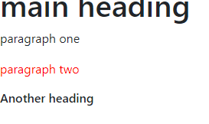

**15)** **var a=1;**

**console.log(a++);**

Ans) 1

**16)Differnce between display:none and visibility :hidden ?**

Ans) visibility:**hidden hides the element, but it still takes up space in the layout.** display:none removes the element from the document. It does not take up any space.

**17)** **Differnce between transform:scale and transform:rorate**

Ans)

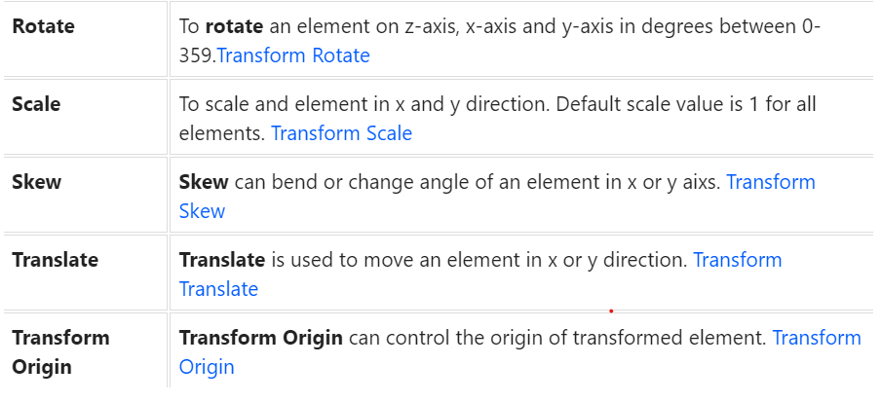

**18)what is version control system?**

Ans) Version control systems, often shortened to VCS, are specialized software whose primary goal is to manage changes to codebases over time, a process called version control. The main aim of such a system is to be able to recall specific versions later.

**19)CSS Tailwind?**

Ans) Tailwind CSS **makes it quicker to write and maintain the code of your application**. By using this utility-first framework, you don't have to write custom CSS to style your application. Instead, you can use utility classes to control the padding, margin, color, font, shadow, and more of your application.

Tailwind CSS is basically a Utility first CSS framework for building rapid custom UI. It is a highly customizable, low-level CSS framework that gives you all of the building blocks that you need. Also, it is a cool way to write inline styling and achieve an awesome interface without writing a single line of your own CSS.

Basically Tailwind is available on npm and you can install it using the following command:

npm install tailwindcss

* After that create ad Tailwind configuration file using the following command:

npm tailwind init {name of file}

**Refernce Link:** <https://ide.geeksforgeeks.org/tryit.php>

**20)** **what is difference between DOM and BOM and BEM?**

**Ans)**

* The DOM is the **Document** Object Model, which deals with the document, the HTML elements themselves, e.g. document and all traversal you would do in it, events, etc.
* The BOM is the **Browser** Object Model, which deals with browser components aside from the document, like history, location, navigator and screen (as well as some others that vary by browser).
* BEM (which stands for Block-Element-Modifier) is **a naming convention standard for CSS class names**. It has fairly wide adoption and is immensely useful in writing CSS that is easier to read, understand, and scale.

**What is the DOM?**

The DOM is a W3C (World Wide Web Consortium) standard.

The DOM defines a standard for accessing documents:

"The W3C Document Object Model (DOM) is a platform and language-neutral interface that allows programs and scripts to dynamically access and update the content, structure, and style of a document."

**DOM Methods:**  
document.getElementById(id)  
document.getElementsByTagName(name)  
document.getElementsByClassName(name)  
document.createElement(element)  
document.removeChild(element)

**Properties:**  
document.body  
document.cookie  
document.doctype  
document.documentElement  
document.documentMode

**The Browser Object Model (BOM)**  
There are no official standards for the Browser Object Model (BOM).

Since modern browsers have implemented (almost) the same methods and properties for JavaScript interactivity, it is often referred to, as methods and properties of the BOM. It consists:

* window
* screen
* location
* history
* navigator
* popup alert
* timing
* cookies

Why BEM

BEM naming provides three specific benefits:

* It communicates purpose or function
* It communicates component structure
* It sets a consistent low-level of specificity for styling selectors

**21)What is the purpose of javascript?**

Ans)develop to create logic and to control html content structure and style.

22)While clicking button how to change button color in javascript?

Ans)     <h2 id="dl">button click</h2>

        <button onclick="text()" id="colorchange">button color change</button>

 <script>

            //button click color changes starts here

            function text(){

                document.getElementById("colorchange").style.backgroundColor="orange";

                debugger;

            }

            //ends here

        </script>

23)flex properties?

Ans)1.d-flex:I am a flexbox continer

(d-sm-flex)

2.d-inline-flex:I am ainline flexbox container

(d-inline-flex)

3.flex-row:to set a horizontal direction

(flex-row)

4.flex-row-reverse:to start the horizontal direction from the opposite side.

(flex-row-reverse)

5.flex-column:to set a vertical direction

flex-md-column

6.flex-column-reverse:to start the vertical direction from the opposite side.

flex-md-column-reverse

7. justify-content:center or end or between or around evenly

(flex-direction:column) justify-content-sm-start

8.align-items: start or end or baseline or stretch

(flex-direction:column) align-items-sm-start

9.align-self: start or end or baseline or stretch

(flex-direction:column) align-self-sm-start

24)order ?

Ans)

<div class="container">

<div class="row">

<div class="col">

First in DOM, no order applied

</div>

<div class="col order-5">

Second in DOM, with a larger order

</div>

<div class="col order-1">

Third in DOM, with an order of 1

</div>

</div>

</div>

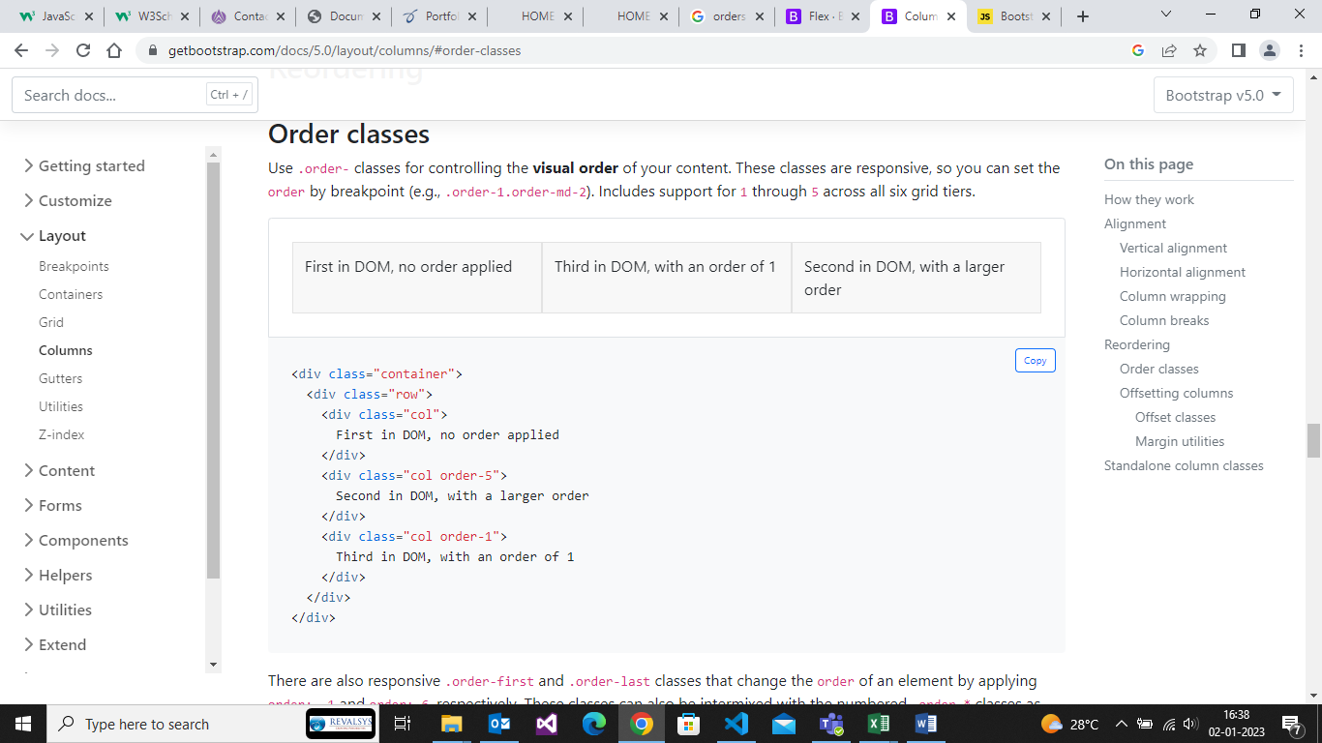

<div class="container">

<div class="row">

<div class="col order-last">

First in DOM, ordered last

</div>

<div class="col">

Second in DOM, unordered

</div>

<div class="col order-first">

Third in DOM, ordered first

</div>

</div>

</div>

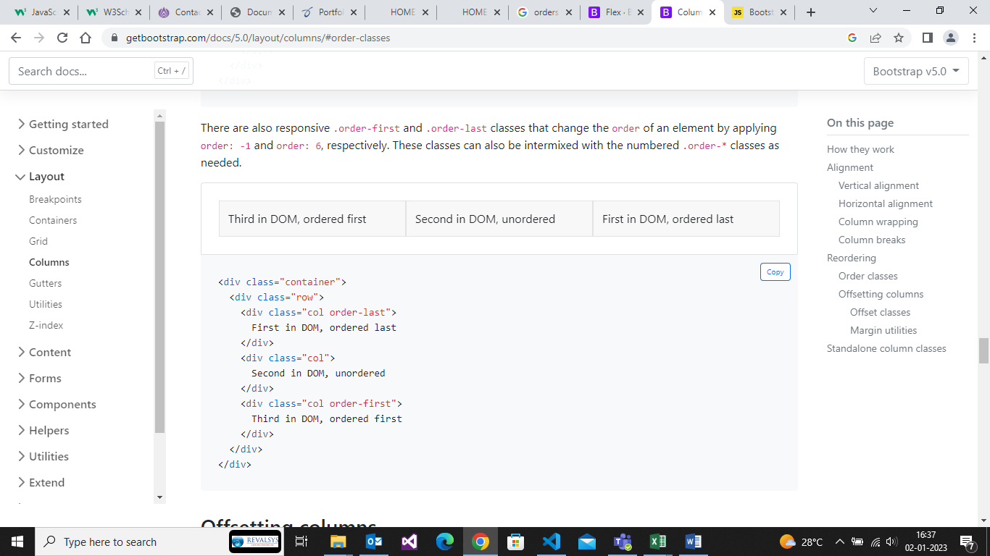

25)offset?

Ans)

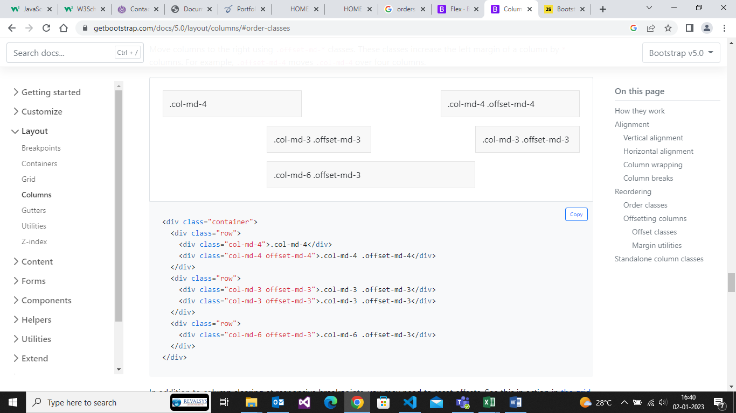

26)callback function?

Ans)A callback function is a function passed into another function as an argument,which is incoked inside the outer function to complete some kind of routine or action.

 var ar1 = [10,20,30,40,50];

        ar1.forEach(function(a,b,c){

            console.log("hello",a,b,c);

        })//forEach()

    var ar2 = [10,20,30,40,50];

        ar2.map(function(a,b,c){

            console.log("hello",a,b,c);

        })//map()

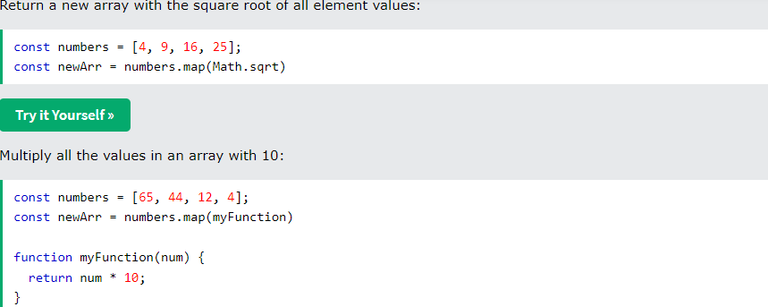

27) What modules consist

-declarations

-this is where we will add all the component of the module

-imports

-we can import modules inside a module

-providers

-services that we need will be injected here

-Bootstrap

-what is the first component, the module should load

-exports

-is to export the component outside of the module.

28)What is decorator?

Ans)@ stymbol is called decorator .It gives information

Notes:

component decorator inside the component.ts file

selector -> unique identifier for the component

->id of the component

->using this selector we will use the component

29)Can we change the default”app” prefix?

Yes –we can change it through the app

“app” –> “arc-tutorials”

30)What will happen If I change?

Nothing happens .Only thing you can change,make sure you update latest.

