1. **What is JavaScript?**

Ans)JavaScript it can control the style and content of the html .

1. **What is the difference between writing java-script in head and body?**

Ans)If I am writing JavaScript in head and body is

i) If I write java-script in HEAD section function are executed first after id is loaded so function doesn't work so no id is called .

Ii)If I write java-script in BODY section first id is loaded after function executed so output works properly.

1. **What is the purpose of Javascript?**

Ans)To create the logic and control the content of HTML structure and css

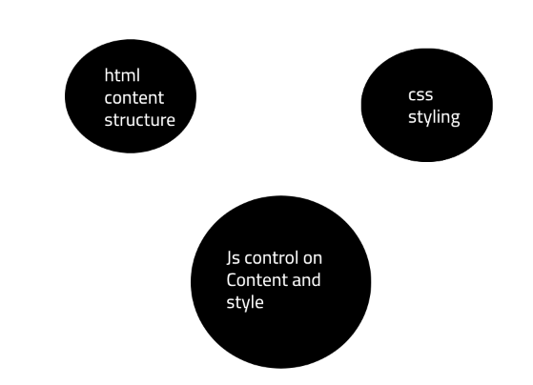

1.)1.hml and 1.js

console.log("hello world");

**Output:**hello world

2)

var x;

console.log(x);

**Output:**undefined

3)

var x=100;

console.log(x);

console.log(typeof(x));

Output:100

number

4)

x="manjula";

console.log(x);

console.log(typeof(x));

Output:manjula

string

1. **Var and let differnce**

Ans)Scope level difference

var x;

let y;

{

    var z=199;

    let w=133;

    console.log(z);

    console.log(w);

}

console.log(z);

console.log(w);

Output:199

133

199

1.js:28 Uncaught ReferenceError: w is not defined

at 1.js:28:13

1. **Block level scope?**

Ans)

for(let i=0;i<=10;i++)

{

    console.log(i);

}

console.log(i);

Output:1

2

3

4

5

6

7

8

9

10

1.js:23 Uncaught ReferenceError: i is not defined

at 1.js:23:13

/*let example start*/

if(10<30){

    let p=99;

}

console.log(p);

Output:error

/*let example end*/

/*var example start*/

if(10<30){

    varp=99;

}

console.log(p);

**Output**:99

/*var example end*/

Ans)

for(var i=0;i<=10;i++)

{

    console.log(i)

}

console.log(i)

**Output:0**

**1**

**2**

**3**

**4**

**5**

**6**

**7**

**8**

**9**

**10**

**11**

1. **For loop**

Ans)for (initializer; condition; iterator) { *// statements* }

### 1) initializer

The for statement executes the initializer only once the loop starts. Typically, you declare and initialize a local loop variable in the initializer.

### 2) condition

The condition is a boolean expression that determines whether the for should execute the next iteration.

The for statement evaluates the condition before each iteration. If the condition is true (or is not present), it executes the next iteration. Otherwise, it’ll end the loop.

### 3) iterator

The for statement executes the iterator after each iteration.

The following flowchart illustrates the for loop:

[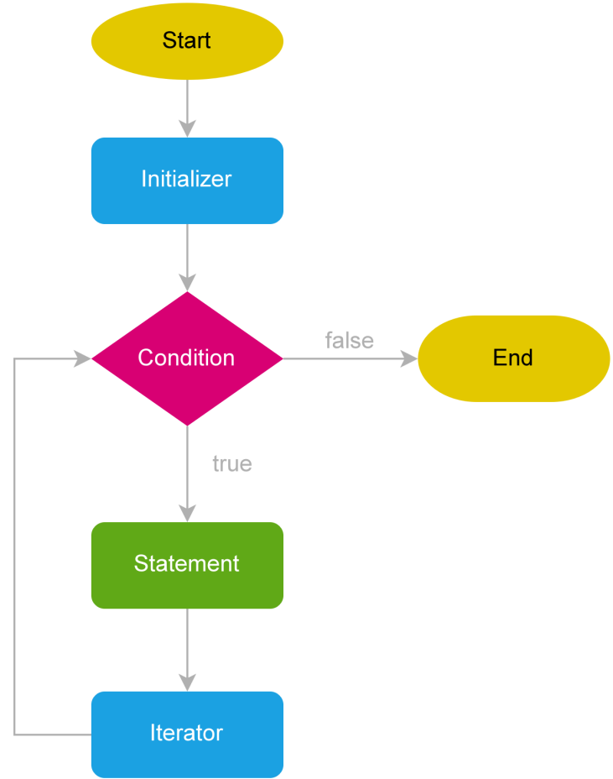](https://www.javascripttutorial.net/wp-content/uploads/2022/01/javascript-for-loop.svg)

**Example:** for (let i = 1; i < 5; i++) { console.log(i); }

**Output:**1 2 3 4

**Link:**

[JavaScript for Loop By Examples (javascripttutorial.net)](https://www.javascripttutorial.net/javascript-for-loop/)

**Const**

i)The const keyword creates a read-only reference to a value. The readonly reference cannot be reassigned but the value can be changed.

ii)The const declaration creates an immutable reference to a value. It does not mean the value it holds is immutable — just that the variable identifier cannot be reassigned. For instance, in the case where the content is an object, this means the object's contents (e.g., its properties) can be altered. You should understand const declarations as "create a variable whose identity remains constant", not "whose value remains constant" — or, "create immutable [bindings](https://developer.mozilla.org/en-US/docs/Glossary/Binding)", not "immutable values".

//Example

var a =200

const x = a;

console.log(x);

a = 900;

console.log(x);

Output:200

200

//x we cant change a value we can change

//Example

const o = {a:300,b:400};

o={k:"manjula"};

console.log(o);

//o is const a and b values we can change

Constants are block level scope.

//scope on const

if(10<90){

    const r = 88;

}

console.log(r);

Output:error

//error

Single line comments

Ans)Sinle line comments start with //

Any text between // and the end of the line will be igonred by javascript (will not executed).

Example :

//change heading

Notes:

**id=”d1”**

1)onclick=”xxx()” based on above id we

2)onmouseover=”xxx()”