Data Entry and Update:

**Menu_Item**

1. **Create**

1. **Insert**

1. **Select**

**Staff**

1. **Create**

1. **Insert**

1. **Select**

**Customer**

1. **Create**

1. **Insert**

1. **Select**

**Bill**

1. **Create**

1. **Insert**

1. **Select**

**Reservation**

1. **Create**

1. **Insert**

1. **Select**

**Feedback**

1. **Create**

1. **Insert**

1. **Select**

**Payment**

1. **Create**

1. **Insert**

1. **Select**

**Order_Item**

1. **Create**

1. **Insert**

1. **Select**

Data Retrieval and Simple Reports

1. Retrieve the staff members who have processed orders of the highest total amount

1. Retrieve the menu items along with the average rating and the count of feedback received for each item

1. Query to retrieve the staff members who have handled orders with the highest total amount

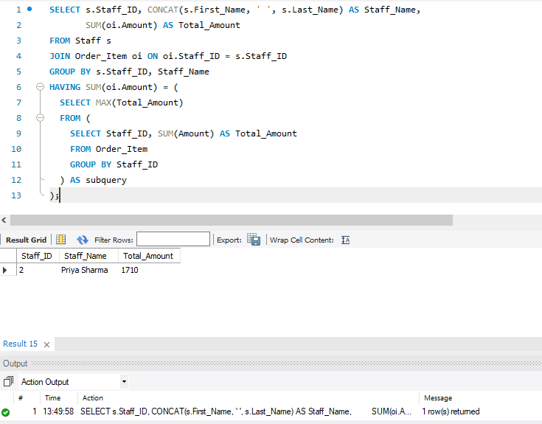

1. Query to retrieve the customers who have provided feedback along with their average rating

1. Retrieve the menu items that have been ordered by customers who have provided feedback with a rating greater than the average rating

1. Retrieve the staff members who have handled orders for menu items in a specific category and have a salary greater than the average salary of all staff members

