1.
We know that there are N number of tweets. We need to obtain a uniform sample of size s (s<<N). Make a Boolean Array of Size N. Use random function to generate a number (1,N) inclusive . Mark the boolean of Generated index true. If index repeated discard. Repeat the process till s tweets are collected.
Pseudo Code(Consider Array Index Starts from 1)
A is Boolean Array with N false
Count = 0
While(Count<S){
B = Random Integer (1,N) inclusive;
If(A[B]==false){
A[B]=true;
Count+=1;
}
}
Our Sample is tweets corresponding to Boolean Trues in A

2.e.
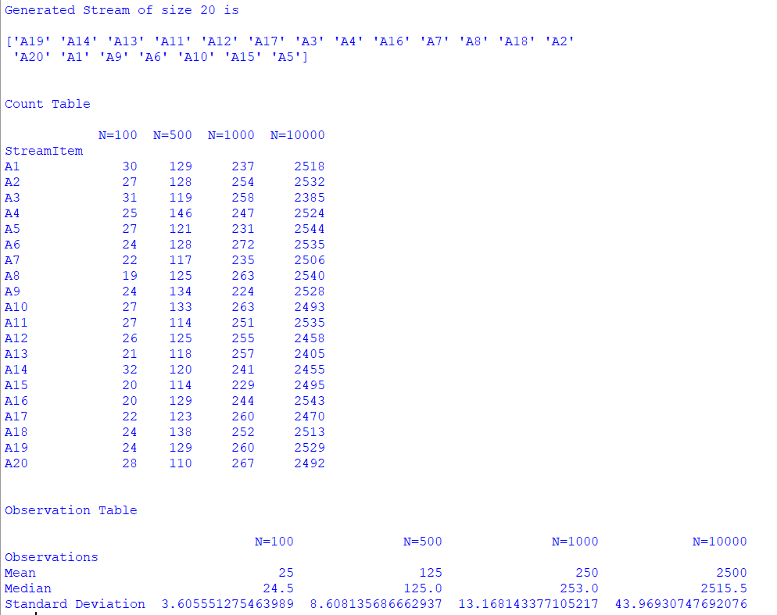
We can clearly observe the rate of standard deviation increasing is very less when compared to N.
Sampling is not biased because when we run same algorithm for 100,500,1000,10000 times each time different stream point has repeated maximum even though generated stream is same. The Sampling Process is unbiased and it is Random Sampling.
It is a Randomized Algorithm. (Reservoir Algorithm)
In next Question we also proved the probability of each element including is also same.

2.f.
Extra Credit: Prove that after N stream points have arrived, the probability of any stream point being included in the sample of size s as created by the process described in 2(b) is same; and is equal to s/N.

Sol:

We can Prove this by Induction

Base Case:
When N = s
Each stream point is kept with probability “1”
s/N = s/s = 1

Induction Hypothesis:
N = k
Let the Probability of a Stream Point to be included in sample be s/N = s/k

When N = k+1 (i.e k+1th Stream Point arrived)
By Algorithm the k+1th stream point has s/(k+1)th chance for being in Sample
The probability of a previous item in sample to be in sample has 2 cases
Case 1 : New Item is not selected
- (1-(s/(k+1)))
Case 2 : New Item selected and replaced with any other s-1 stream points.
- (s/(k+1))*((s-1)/s)

The probability of a stream point to be in sample when k stream point arrived is s/k.

So the probability of a stream point which is in sample has to be in sample when k+1th stream point added is (1-(s/(k+1))) + ((s/(k+1))*((s-1)/s)) = k/(k+1)

So for a stream point to be included in sample when k+1th stream point arrived is (s/k)*(k/(k+1)) = s/(k+1) == s/N

Hence Proved

