Machine Learning for Business Intelligence
HW1

Tanuj Devara
(put your name above)

Total grade: _______

There are 4 numbered questions. Please answer them all.
1) Choose the data technology (Q,H,U, or S) that is most appropriate for each of the following business questions/scenarios. (24pts)
Q – SQL Querying
H – Statistical Hypothesis Testing
U – Unsupervised Learning
S – Supervised Learning

a) _H__ For my on-line advertising the decision tree model yields a response rate of 0.5% and the old, manual targeting model yields 0.3%. Is the decision tree model really better? (4pts)

b) _U__ I want to know which of my customers are the most profitable. (4pts)

c) _S__ I need to get data on all my on-line customers who were exposed to the special offer, including their registration data, their past purchases, and whether or not they purchased in the 15 days following the exposure. (4pts)

d)_Q__ I would like to segment my customers into groups based on their demographics and prior purchase activity. I am not focusing on improving a particular task, but would like to generate ideas. (4pts)

e) S___ I have a budget to target 10,000 existing customers with a special offer. I would like to identify those customers most likely to respond to the special offer. (4pts)

f) _Q__ I want to know what characteristics differentiate my most profitable customers. (4pts)

2) MTC (MegaTelCo) has decided to use supervised learning to address its problem of churn in its wireless phone business. As a consultant to MTC, you realize that a main task in the business understanding/data understanding phases of the data mining process is to define the target variable. In one or two sentences, please suggest a definition for the target variable. Be as precise as possible—someone else will be implementing your suggestion. (Remember: it should make sense from a business point of view, and it should be reasonable that MTC would have data available to know the value of the target variable for historical customers.) (15pts)
--The target variable should be the probability of a customer leaving the company, this allows ranking the customers based on this probability to focus certain incentives or offers to keep them at the company.

3) Plumbing Inc. has been selling plumbing supplies for the last 20 years. The owner, Joe, decides that next year it is time to diversify by adding gardening tools to the products. Having had success using customer data to build predictive models to guide direct mail campaigns for special plumbing offers, he considers that data mining could help him to identify a subset of customers who should be good prospects for his new set of products. Is Joe ready to solve this as a supervised learning problem? (15pts)
Yes. The target variable here would be if the customer is a prospect for purchasing gardening tools or not. It would be a Yes or No value that would try to predict if a given customer would be inclined to purchase gardening tools from the company. Based on previous purchases with the company, that data can be utilized to predict patterns for an individual if they do their house hold repairs themselves. Despite the data available not being specifically for gardening but for plumbing , the nature of the customers can be analyzed to have a decent prediction on prospective new buyers.

4) Predict the churn for MegaTelCo using a Decision Tree. MegaTelCo’s customer data is provided with this homework. See the variables below for this data set. Share your model with your TA. Your model will be tested against a separate test set that is not available to you. Top performing 5 models will get the following bonus points. Provide your answers to the sections from a to f below. (46 pts)

- 5 pts
- 4 pts
- 3 pts
- 2 pts
- 1 pt

Variable | Explanation
College | Is the customer college educated?
Income | Annual income
Overage | Average overcharges per month
Leftover | Average number of leftover minutes per month
House | Estimated value of dwelling (from census tract)
Handset_Price | Cost of phone
Long_Calls_Per_Month | Avg number of long calls (15+ mins) per month
Average_Call_Duration | Avg duration of a call
Reported_Satisfaction | Reported level of satisfaction
Reported_Usage_Level | Self-reported usage level
LEAVE (Targe variable) | Did the customer stay or leave (churn)?

- Plot (bar graph) the absolute value of correlation coefficient between each independent variable and target variable. (5 pts)

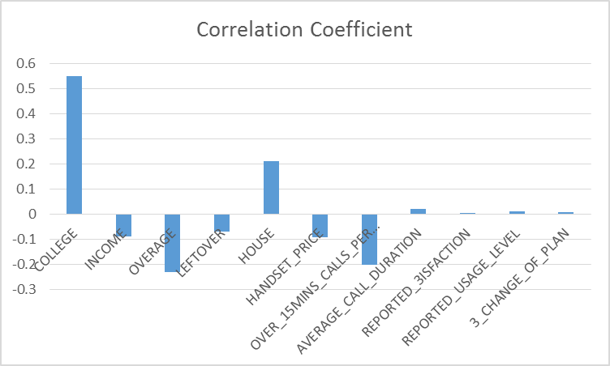

- Plot (bar graph) the information gain for each independent variable. (5 pts)

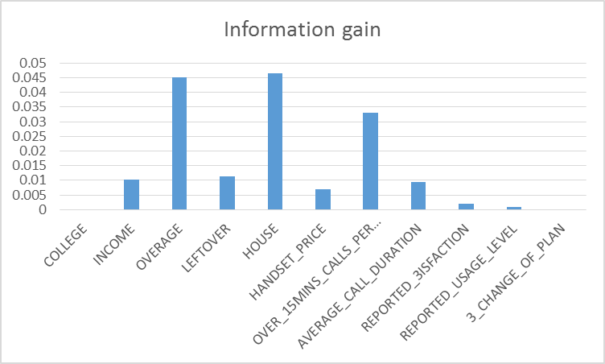

Ranked Attributes based on Information Gain
- House
- Overage
- Over 15 Min Calls
- Leftover
- Income
- Avg Call Duration
- Handset Price
- Reported Satisfaction
- Reported Usage level
- College
- Considering change.

Income
Leftover
Overage
Income
Overage
House

<= 550000 > =550001

<= 95 >= 96 <= 100000 >= 100001
Leftover
Probability = 0.28
(STAY)

Probability = 0.71
(CHURN)

<= 40 >=41 <= 140 >=141
Leftover
Probability = 0.84
(CHURN)

Probability = 0.53
(CHURN)

1 0 <=24 >=25
College
Overage
Probability = 0.17
(STAY)

Probability = 0.43
(CHURN)

1 0 <= 18 >=19
Probability = 0.57
(CHURN)

Probability = 0.12
(STAY)

Average_Call_ Duration

<= 58000 >=58001 <= 7 >7
Probability = 0.54
(STAY)

Probability = 0.67
(CHURN)

Probability = 0.76
(CHURN)

Probability = 0.35
(STAY)

