**Project Report**

**On**

**“Student Management System”**



As partial fulfillment for the degree of

**Bachelor of Computer Application**

**At**

**K.S.K.V. Kachchh University,**

Bhuj.

(March - 2021)

**Submitted by:**

[ Dharmanshu Agravat (18BCA001)

Devarsh Antani (18BCA002 )

Mayank Rathod (18BCA040 ) ]

Dhiraj Solanki Mr. Archit A. Vohra Mr. Chintan P. Morabia

Project Guide I/c. Principal Director

**SANSKAR INSTITUTE OF MANAGEMENT & INFORMATION TECHNOLOGY**



**CERTIFICATE**

This is to certify that the project entitled “Student Management System” is a bonafide work carried out by Dharmanshu Agravat (18BCA001), Devarsh Antani (18BCA002), Mayank Rathod (18BCA040) for the degree of Bachelor of Computer Application at **Sanskar Institute of Management & Information Technology, Bhuj, Gujarat**.

To the best of our knowledge and belief, this work embodies the work of candidates themselves, has duly been completed, fulfills the requirement of the ordinance relating to the Bachelor degree of the university and is up to the standard in respect to content, presentation and language for being referred to the examiner.

Dhiraj Solanki

Project Guide

ACKNOWLEDGEMENT

First of All, We are very thankful to the authority of the Indrabai Girls High School for allowing us to work for them. We would like to take this opportunity to express our heart full gratitude to them.

We would like to thank all those people who helped us directly or indirectly to complete our project. Whenever we found our self n problem our all faculties encouraged us and boosted our moral to accomplish this project.

Last but not least, We would like to express our gratitude to those friends or faculties who directly or indirectly helped in final year project.

Dharmanshu Agravat (18BCA001)

Devarsh Antani (18BCA002)

Mayank Rathod (18BCA040)

|  |  |  |  |  |
| --- | --- | --- | --- | --- |
|  |  |  | **INDEX** |  |
| **Sr.No** |  |  | **Topic** |  |
| 1. | Introduction…………………………………………………… | | | [1page] |
| 2. | Organization Profile………………………………………… | | | [1page] |
| 3. | Existing System……………………………………………… | | | [1page] |
| 4. | Problem areas and need for the new system………… | | | [1–3pages] |
| 5. | Proposed system | |  |  |
|  | 5.1. | Development tools and technologies used…. | | [1page] |
|  | 5.2. | Business process description (Theory or Diagram) | | [1page] |
|  | 5.3. | System Features | |  |
|  |  | 5.3.1. | Assumptions (if applicable)………………… | [1page] |
|  |  | 5.3.2. | Data Flow diagram..........................………. |  |
|  |  | 5.3.3. | Use case diagram…………. |  |
|  |  | 5.3.4. | Activity diagram………… |  |
|  |  | 5.3.5. | Entity-relationship diagram……………….. |  |
|  |  | 5.3.6. | Data Dictionary………… |  |
|  |  | 5.3.7. | Screen Layouts…………. | [1page] |
|  |  | 5.3.8. | Report Layouts…………. |  |
|  |  | 5.3.9. | Coding System (if applicable)………….. |  |
| 6. | Proposed Enhancement | | | [1Page] |
| 7. | Conclusion | |  | [1Page] |
| 8. | Bibliography | |  | [1Page] |

Name :- Indrabai Girls High School.

Address :- Opp. Bus Station Rd, Ghanshyam Nagar, Bhuj, Gujarat 370001.

Indrabai Girls High School is a government school established in ______ in BHUJ-KUTCH . It consists of class 9, 10, 11 and 12 with Science, Commerce, Arts and Home Science streams. It is a well known organization for its quality education.

Currently firm is using Registers and Excel files to manage students and all school's data. They Create Different Registers for Different classes to manage data. There is no dedicated system for data management .

Project Definition:-

This system is prepared for a Student Management System which deal with student data.

This system will allow admin to manage student and teacher data.

DFD LEVEL 0

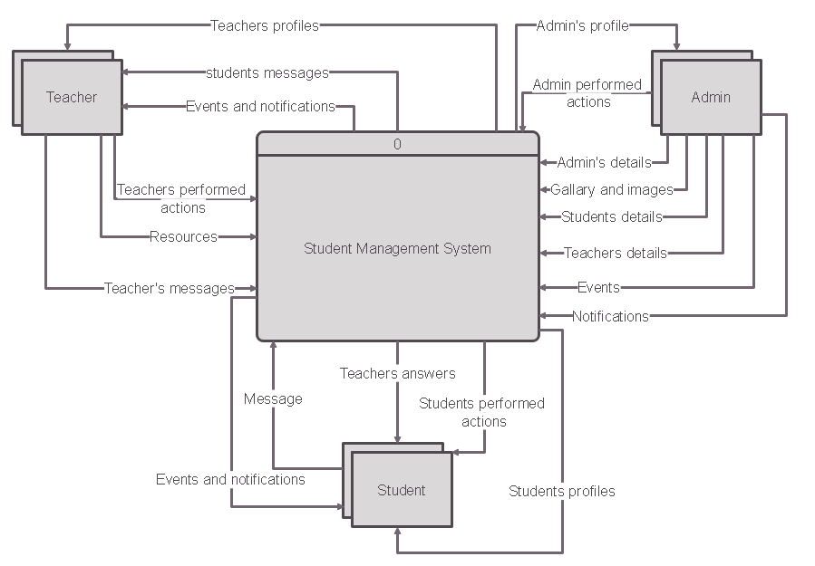

DFD LEVEL 1

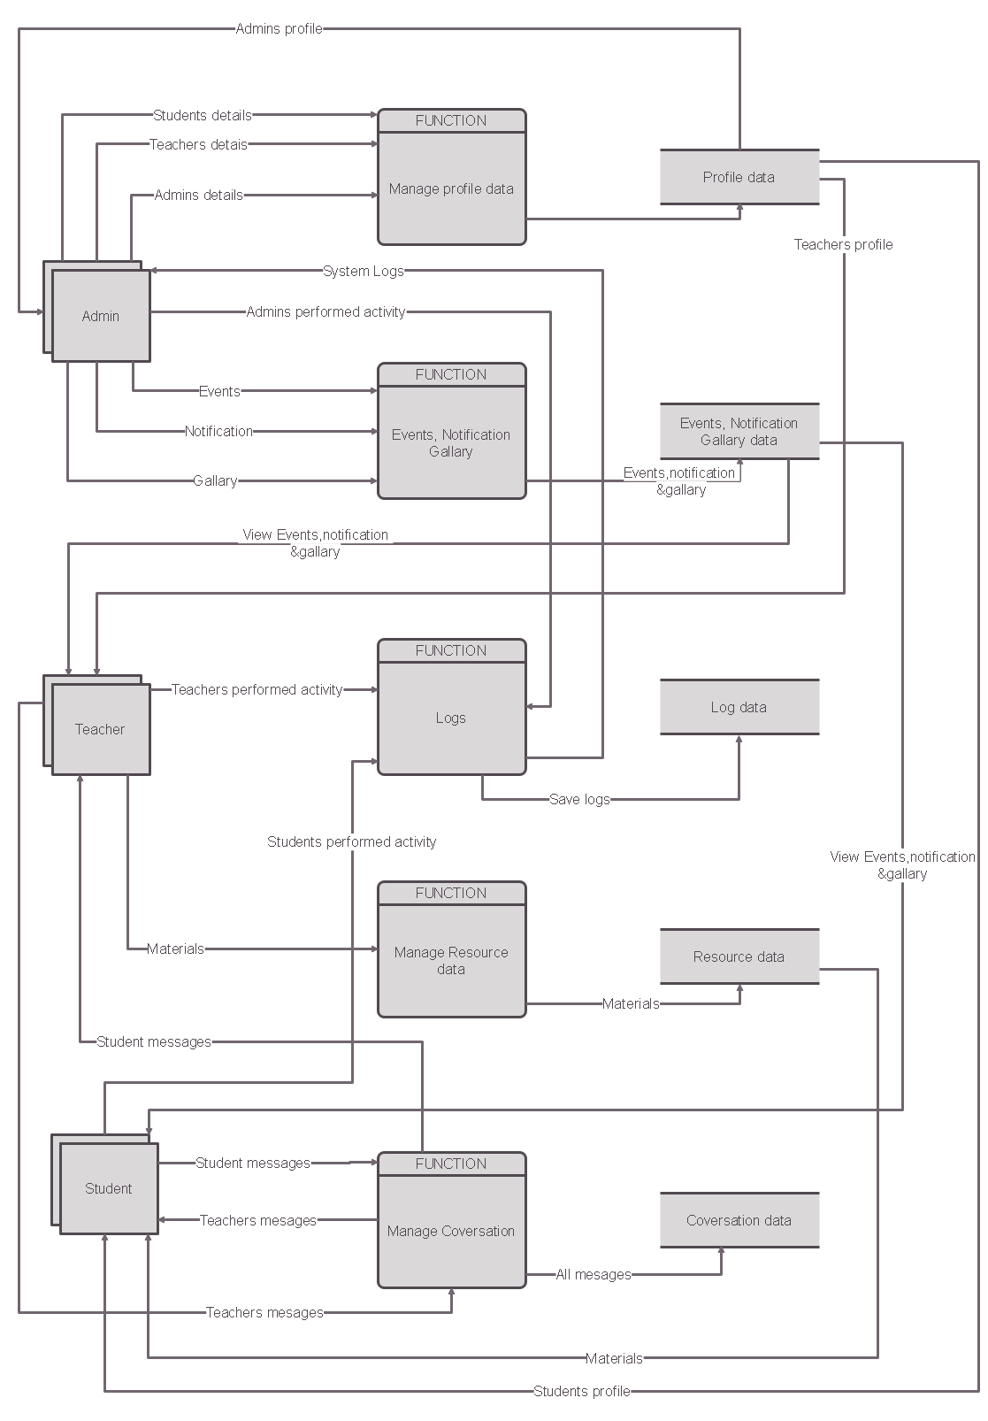

USECASE DIAGRAM

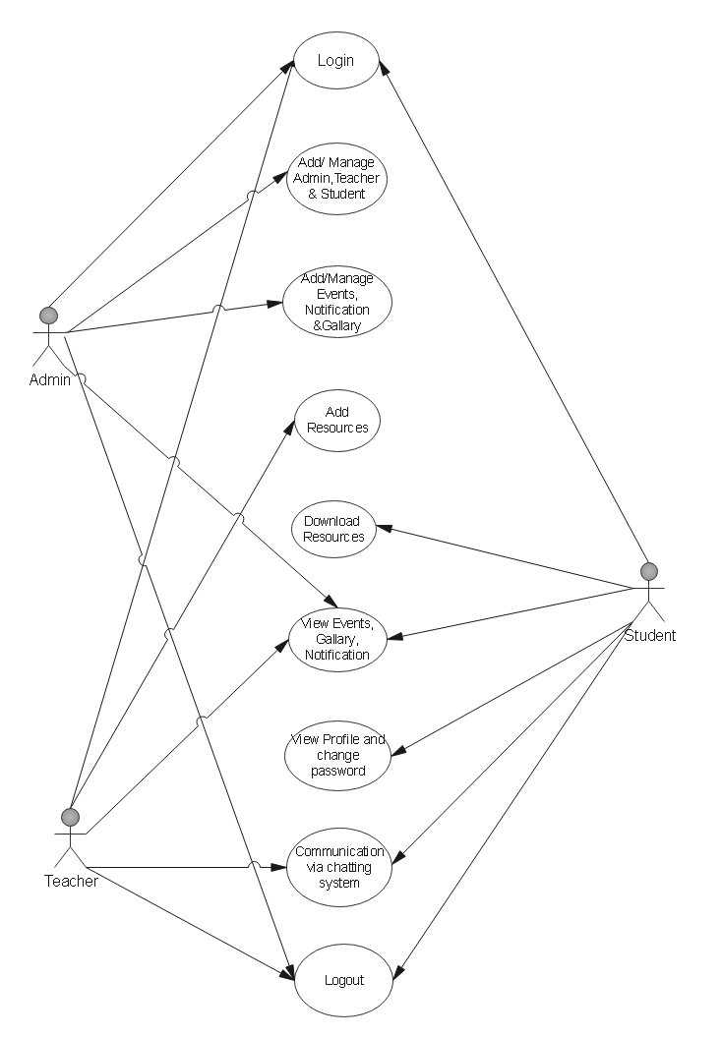

Admin’s Activity Diagram

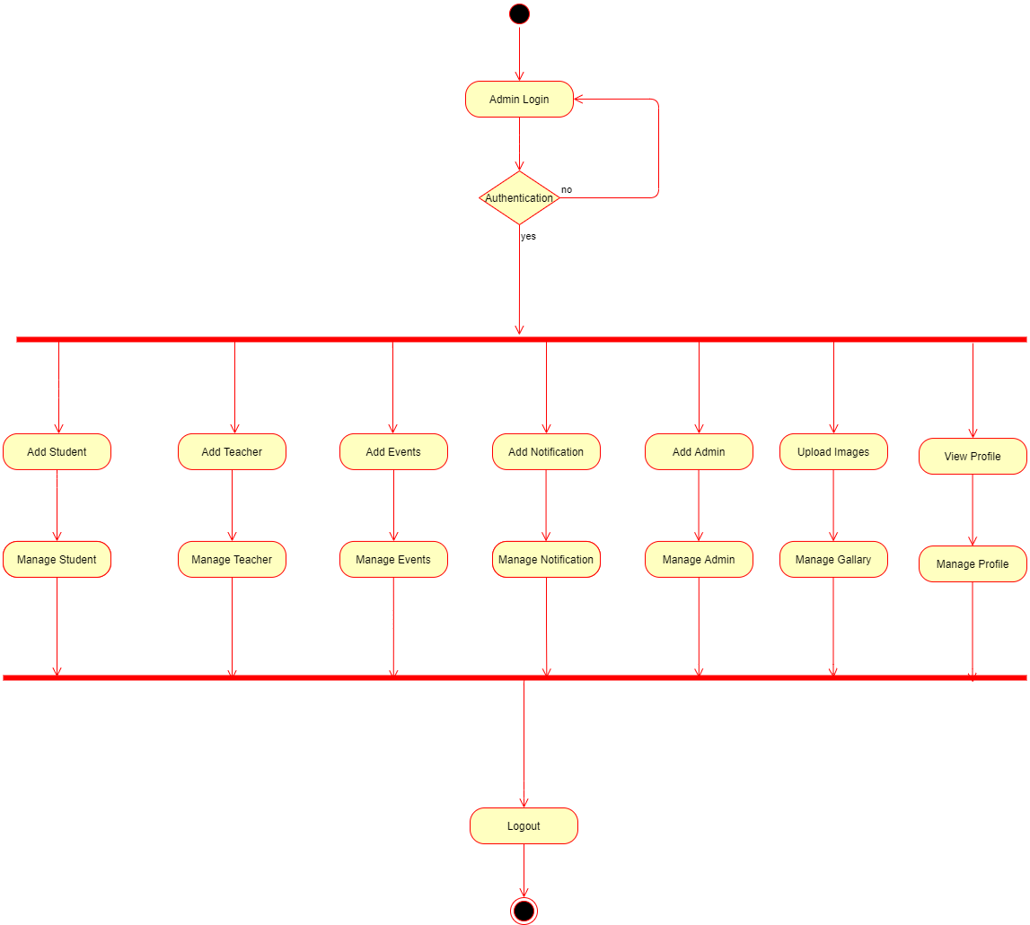

Teacher’s Activity Diagram

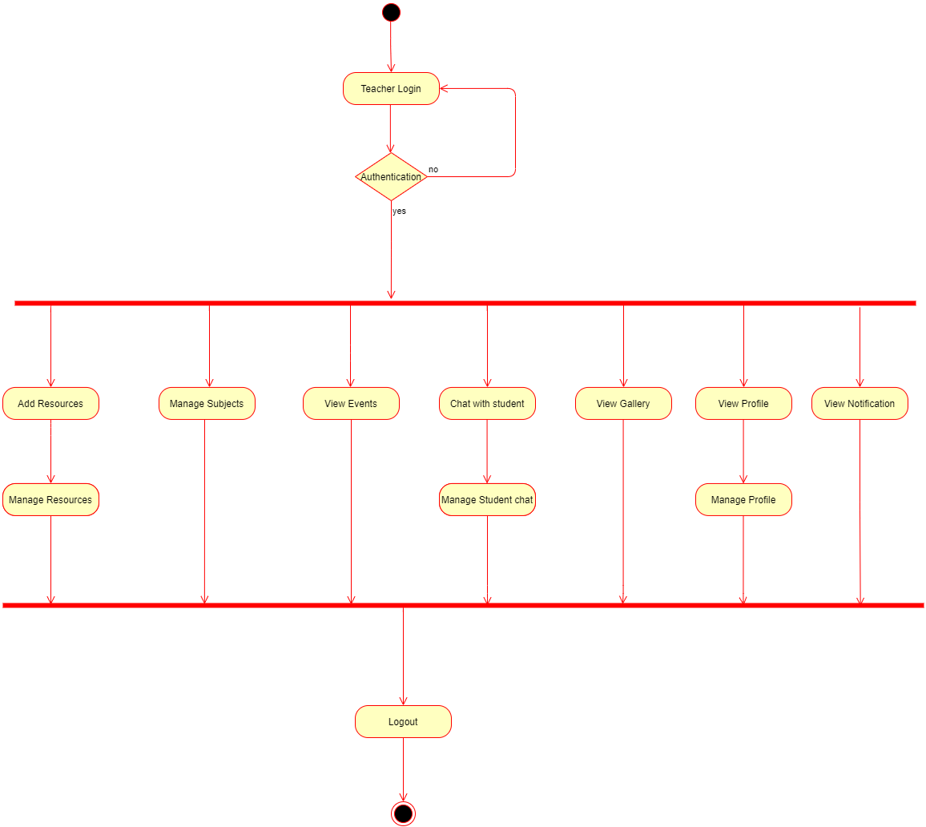

Student’s Activity Diagram

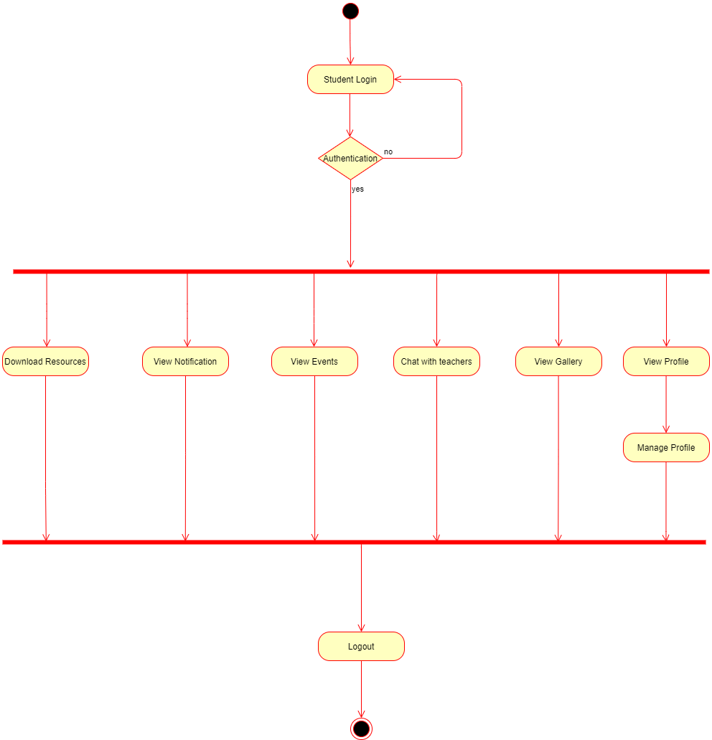

Entity Relationship Diagram

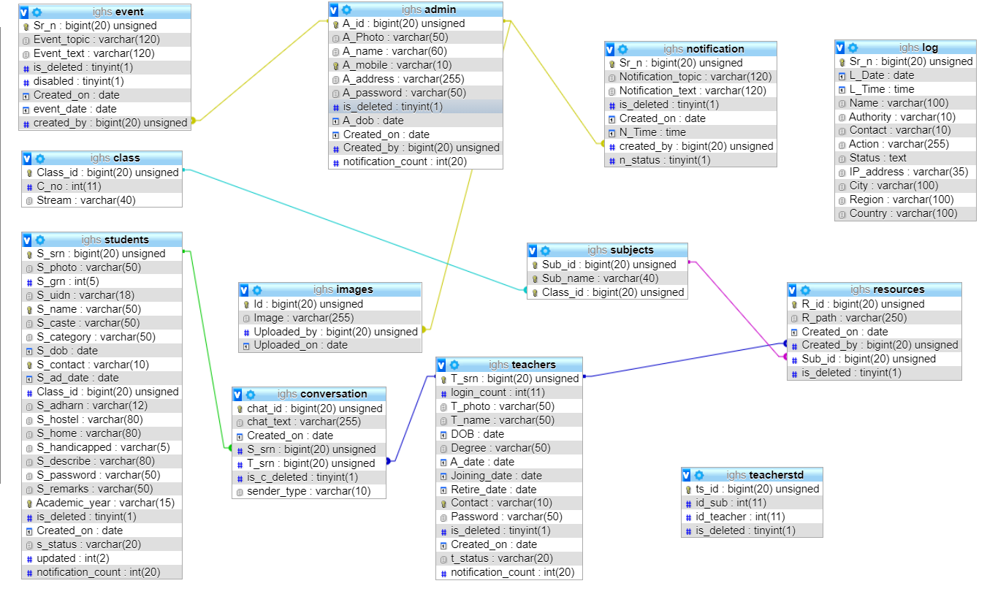

Teacher

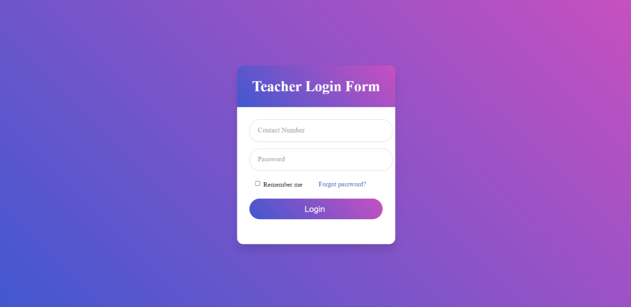

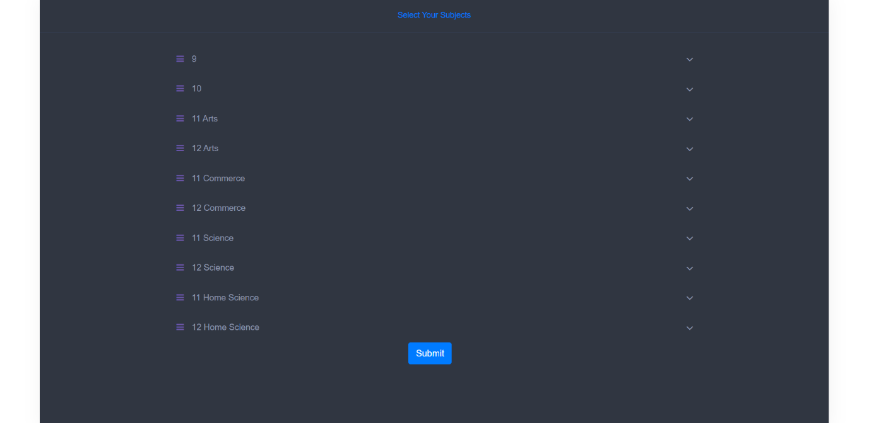

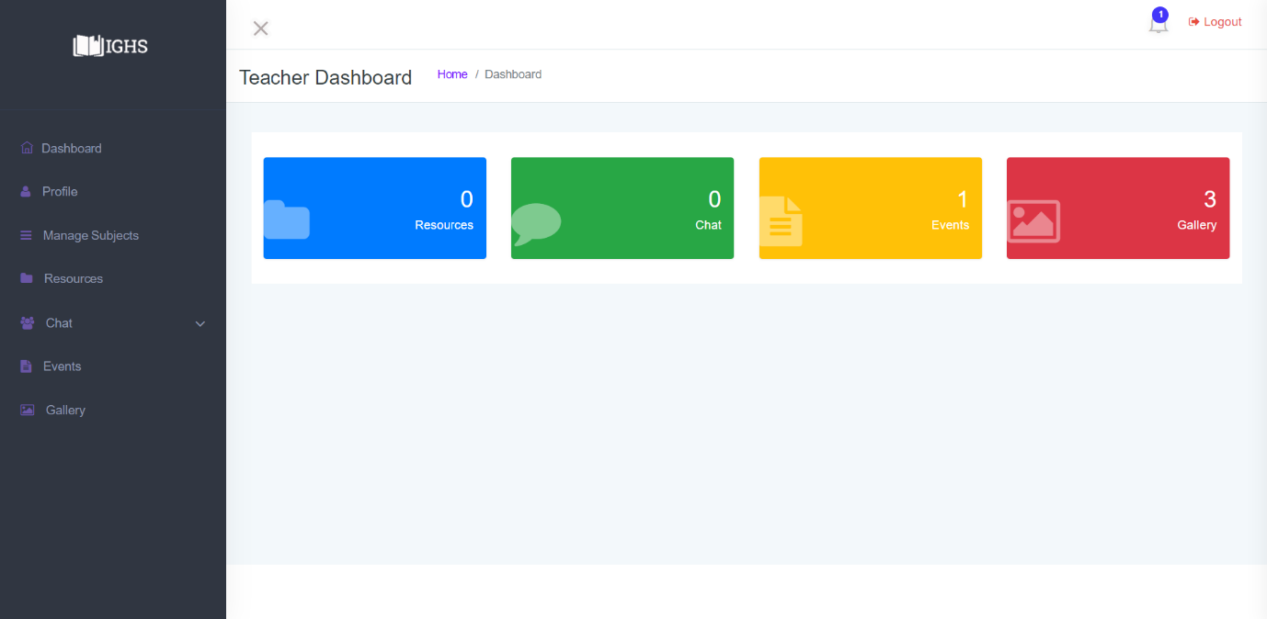

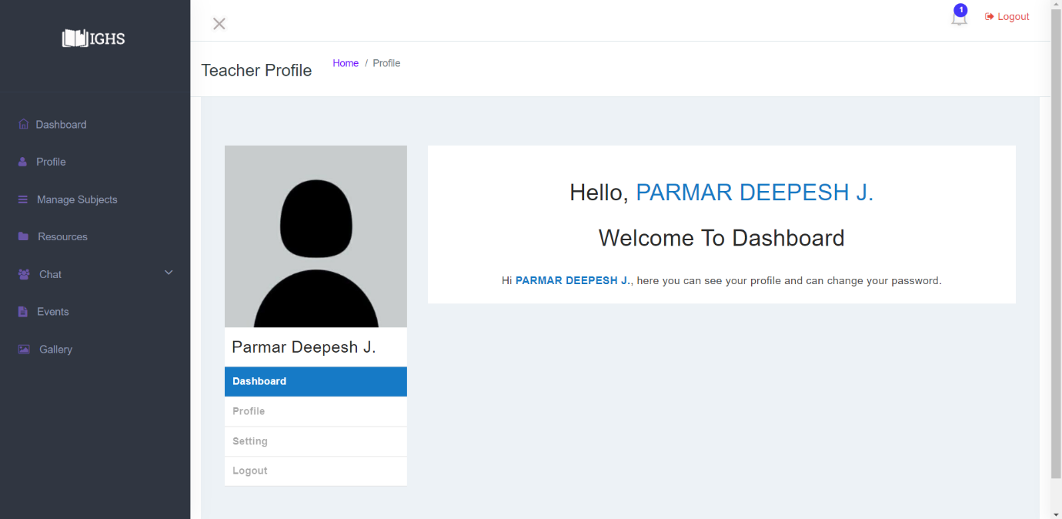

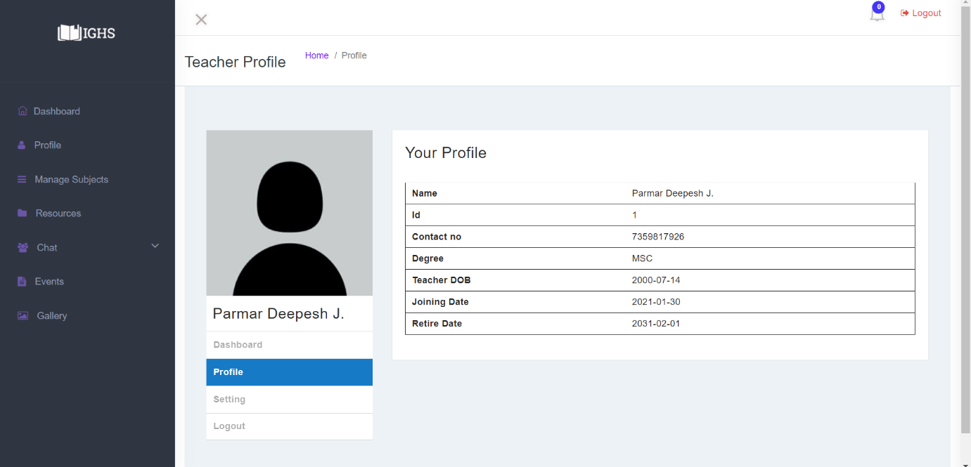

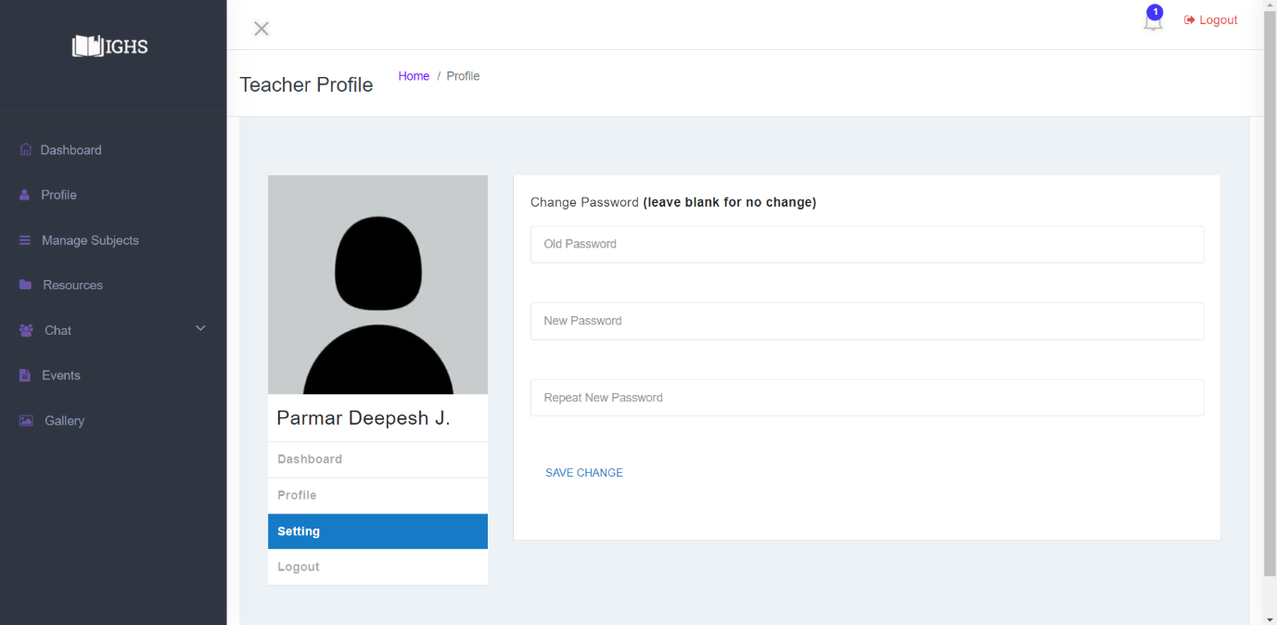

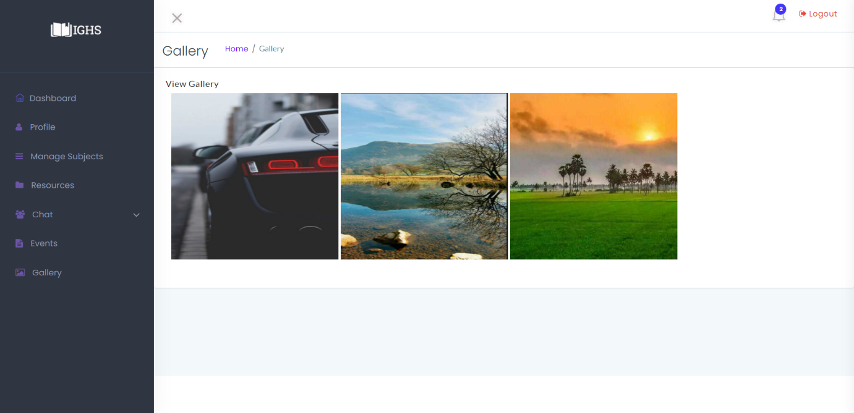

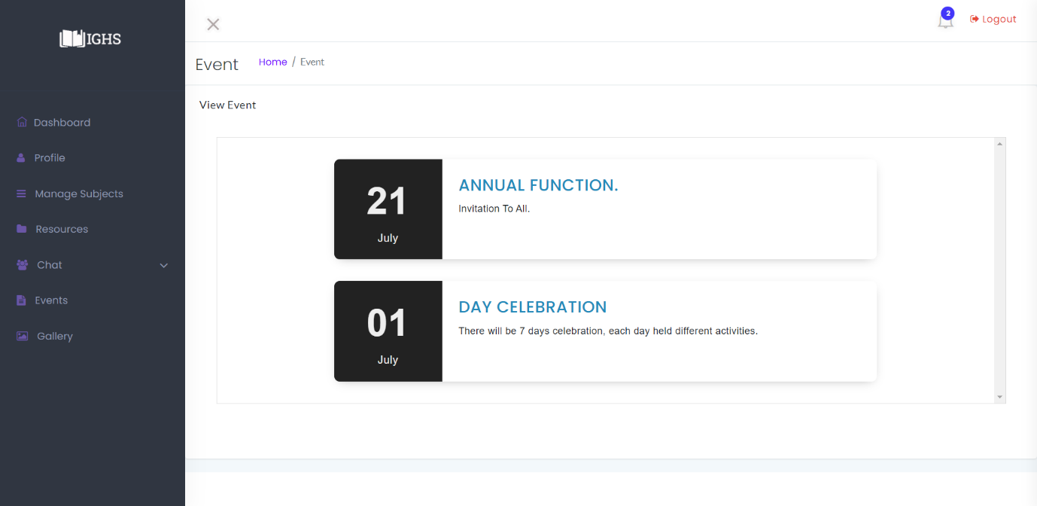

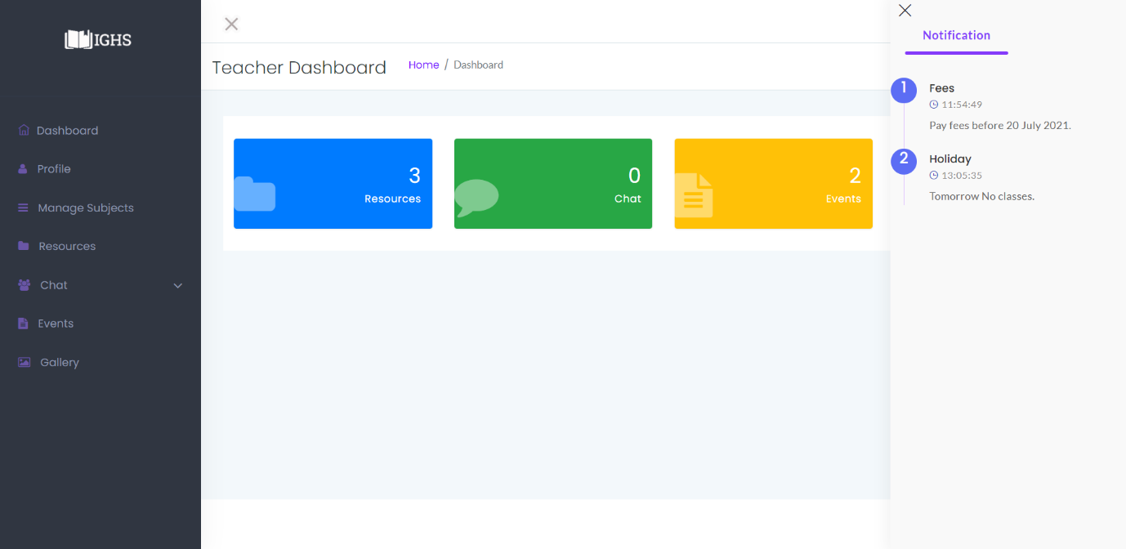

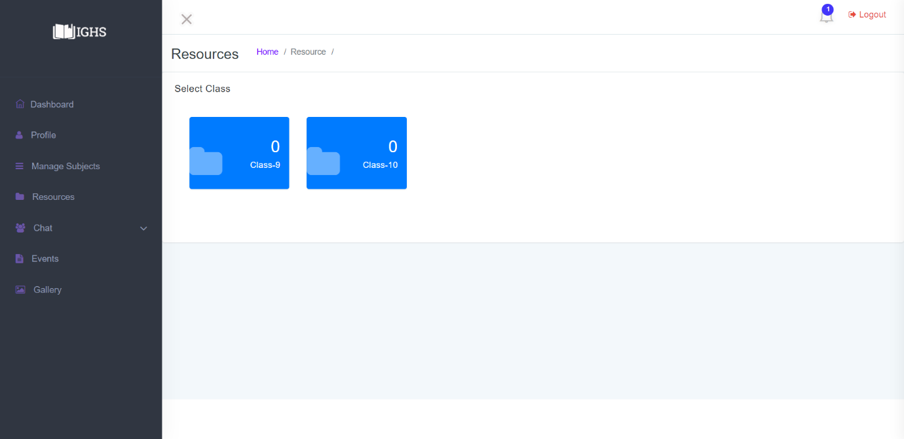

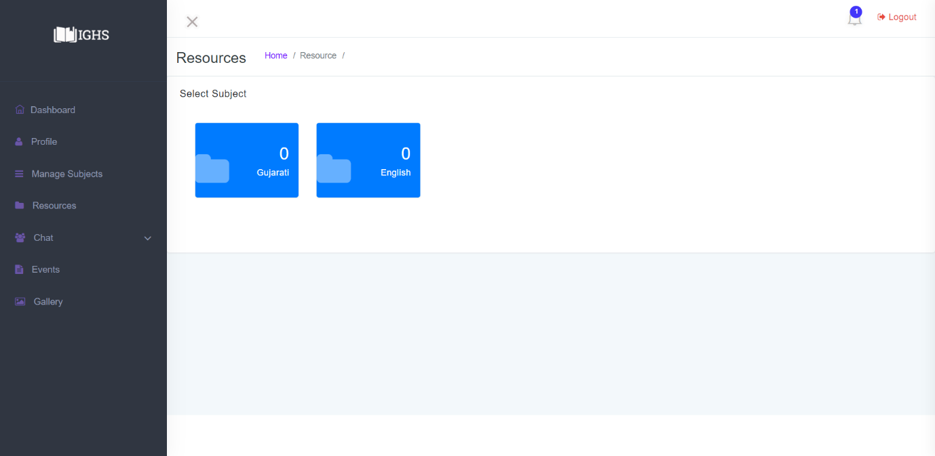

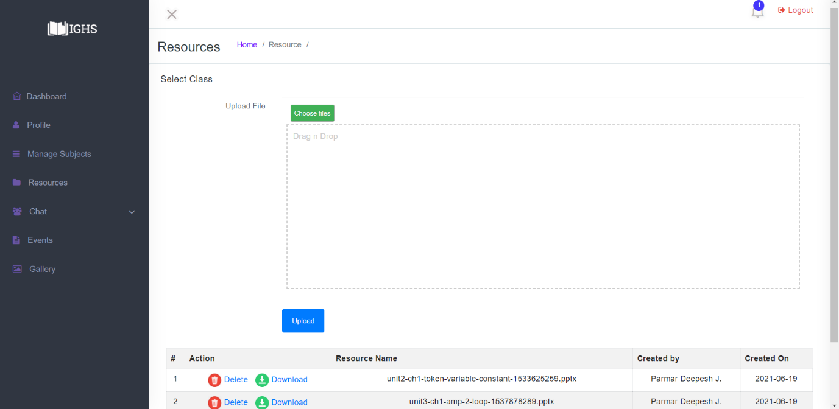

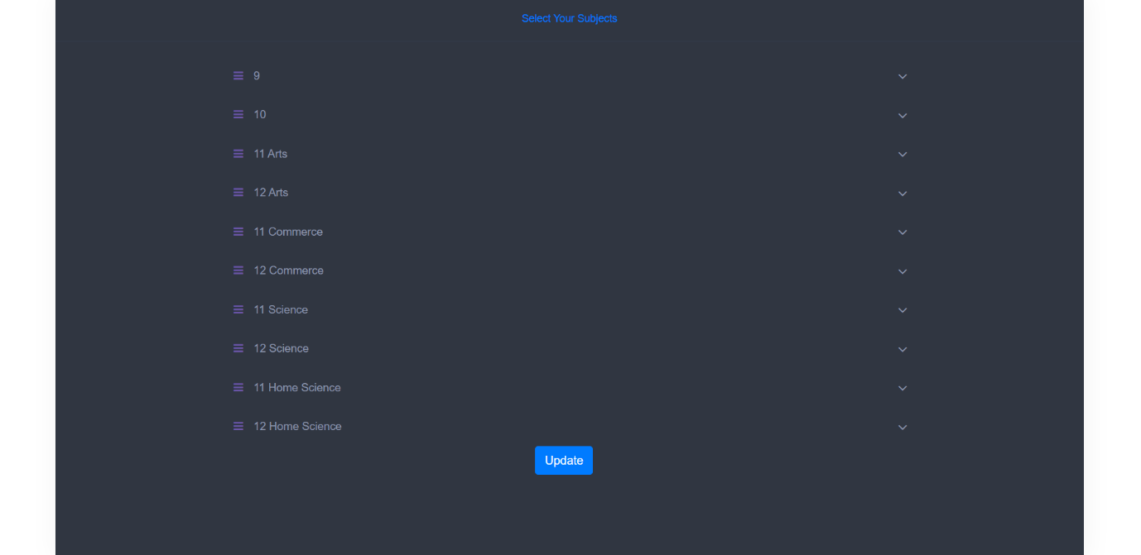

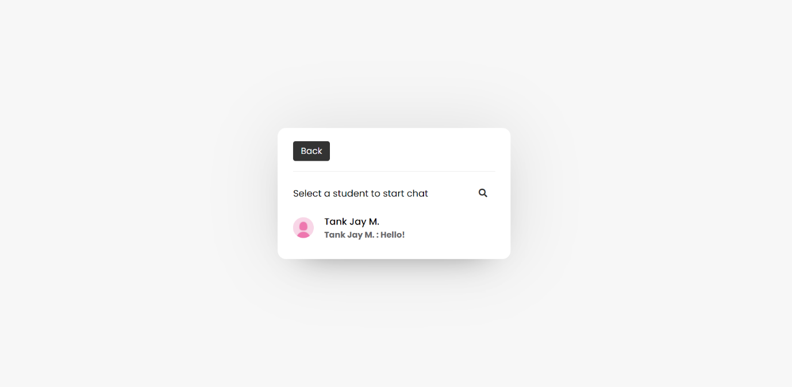

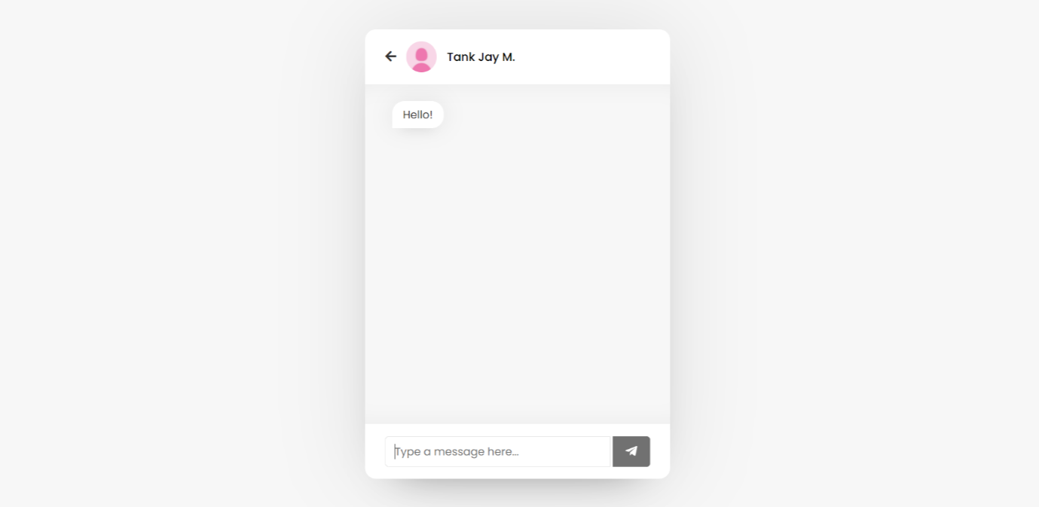

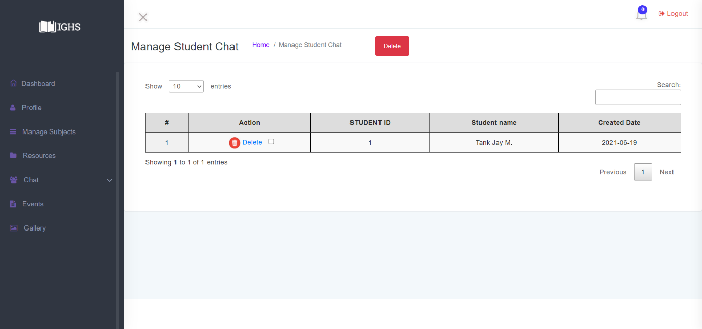

Student

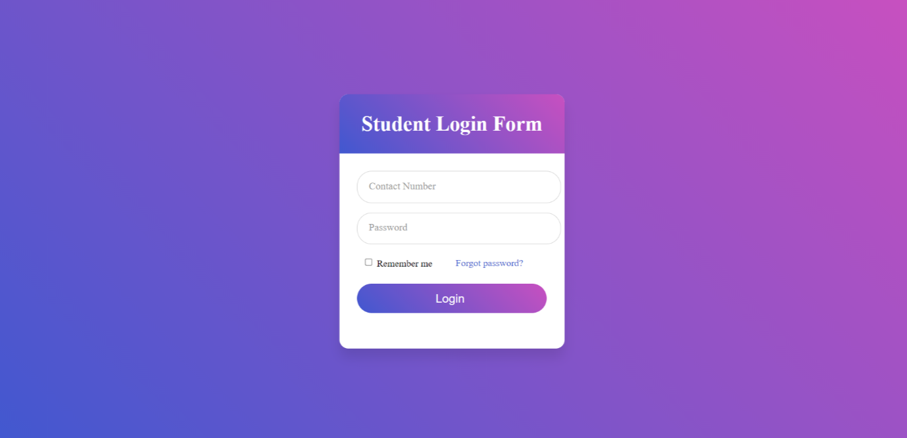

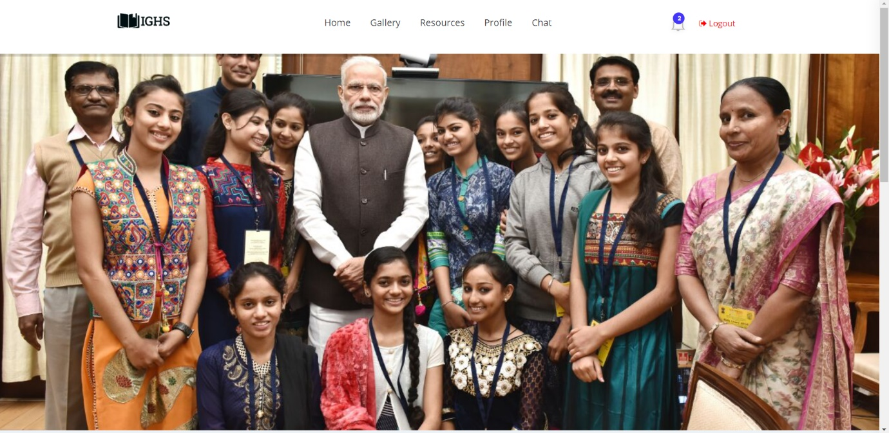

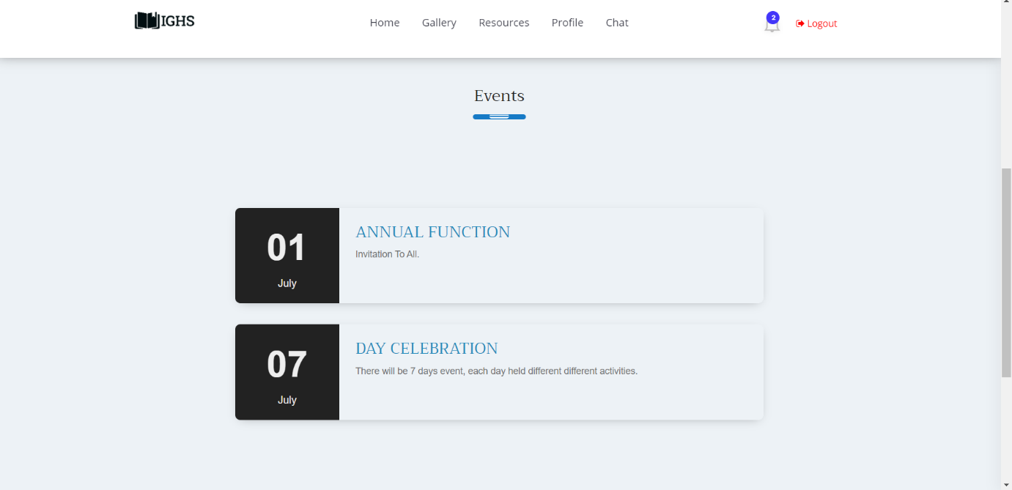

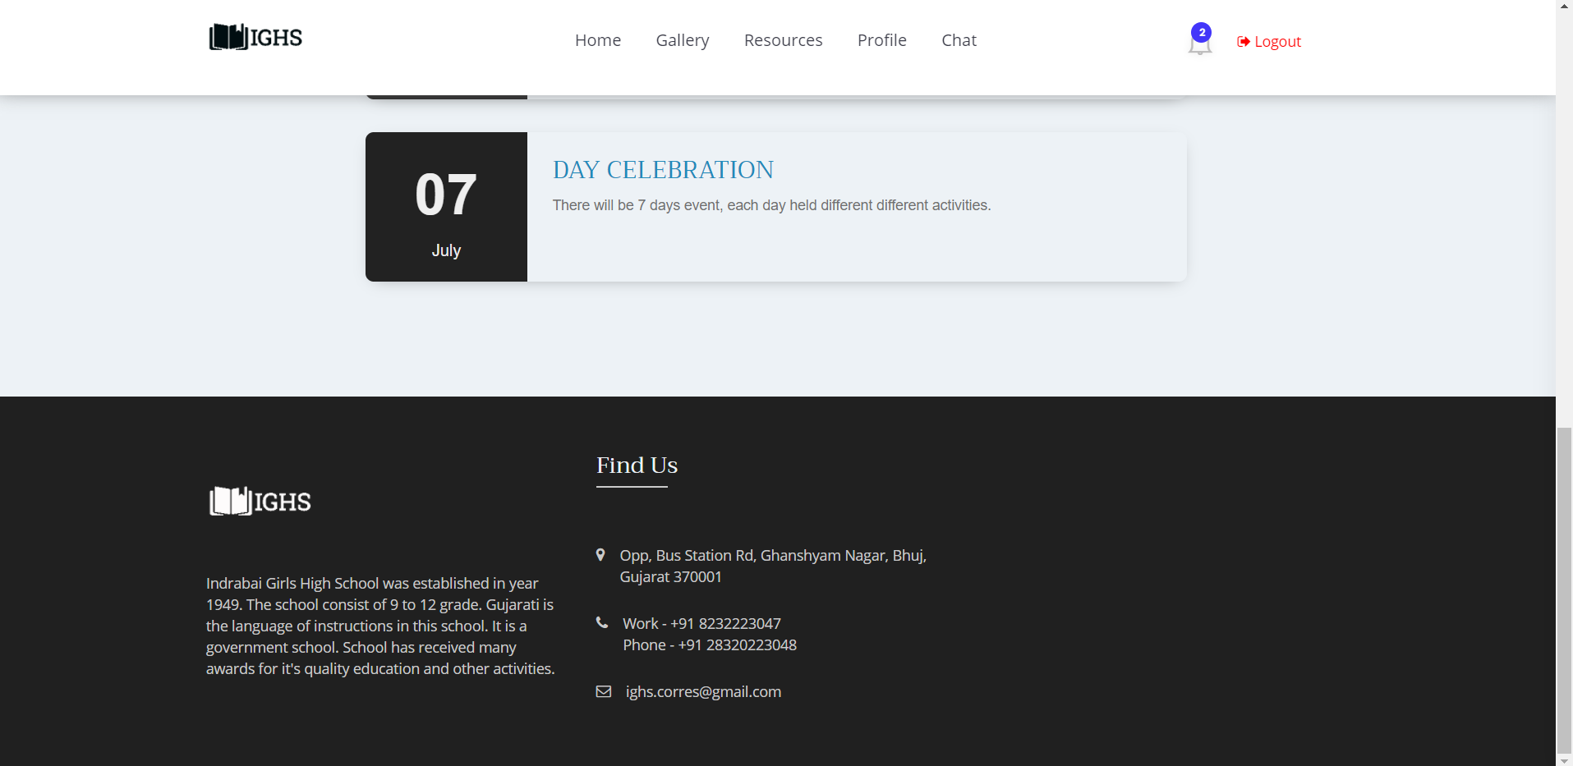

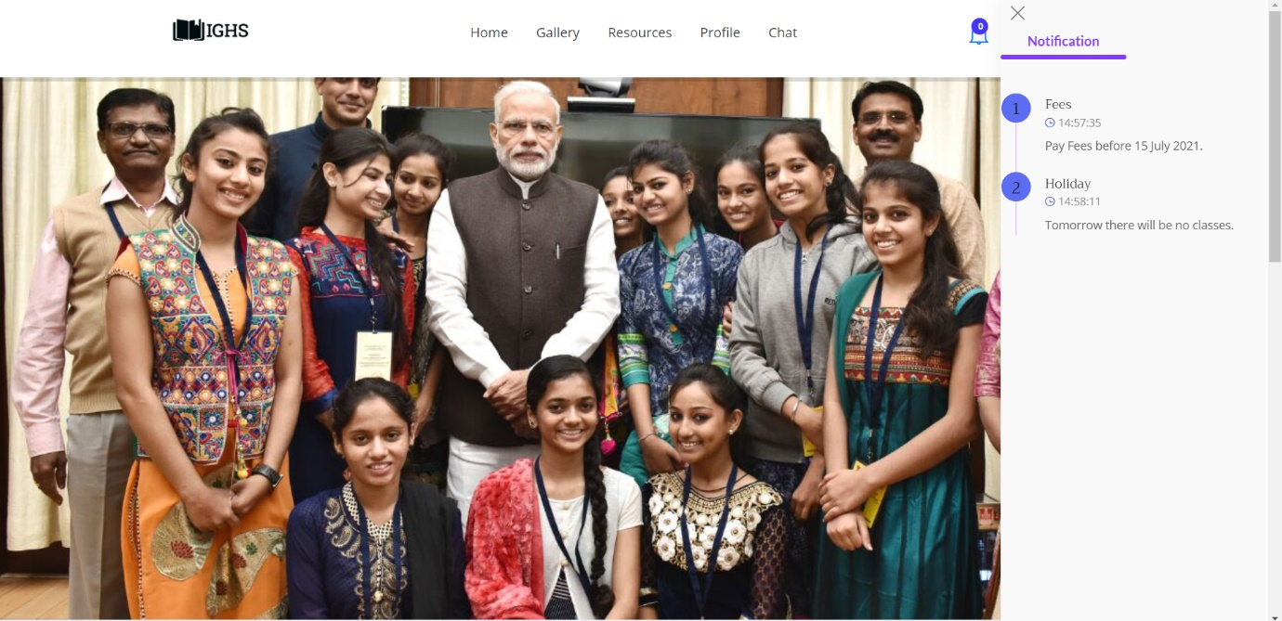

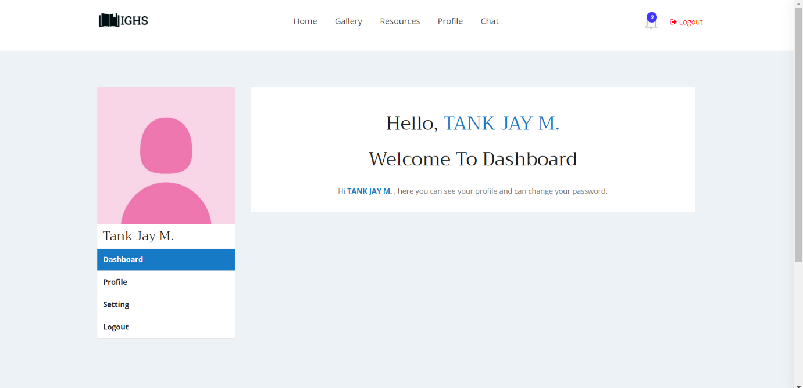

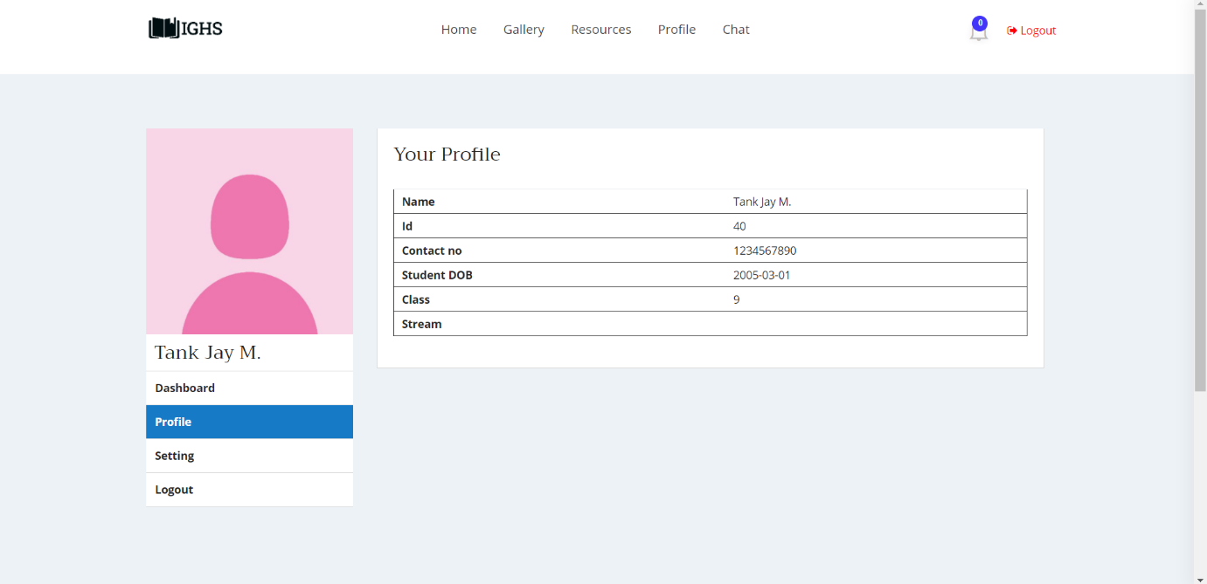

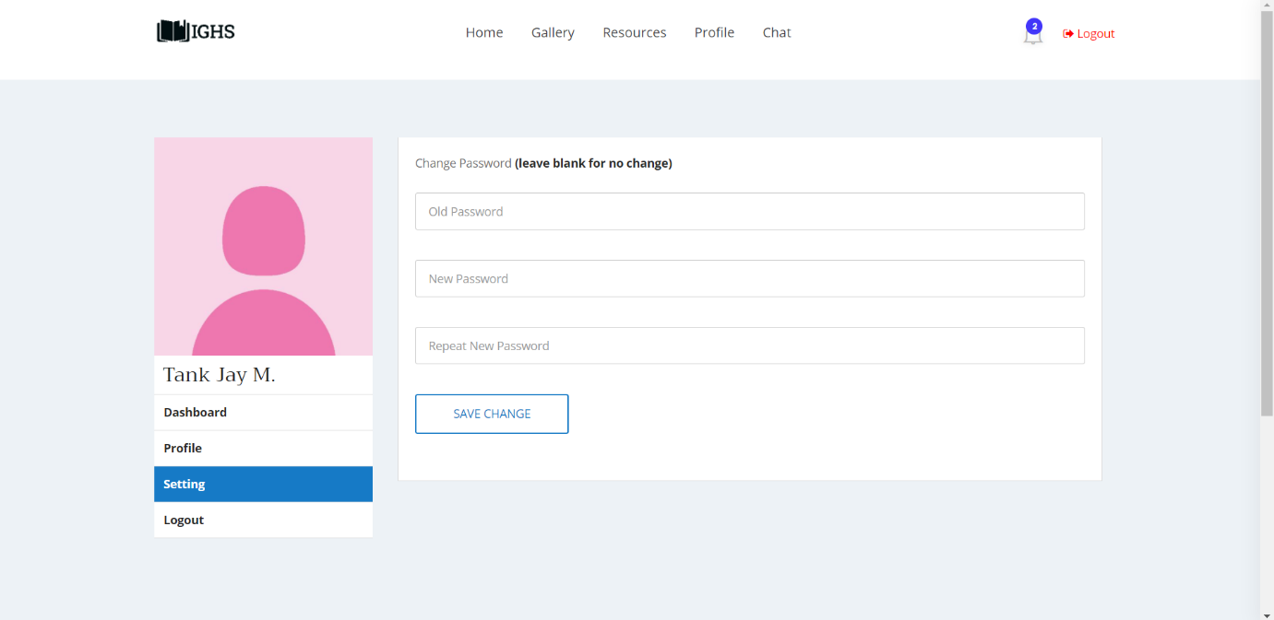

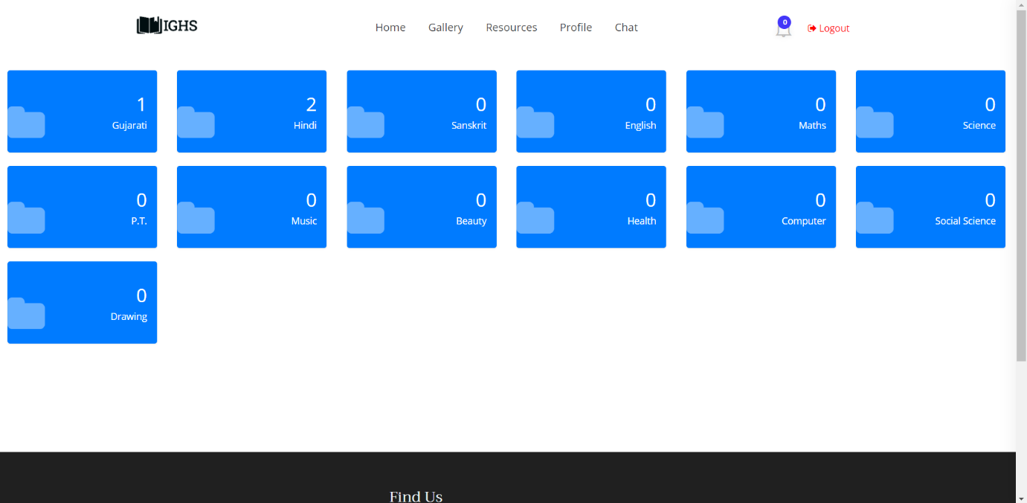

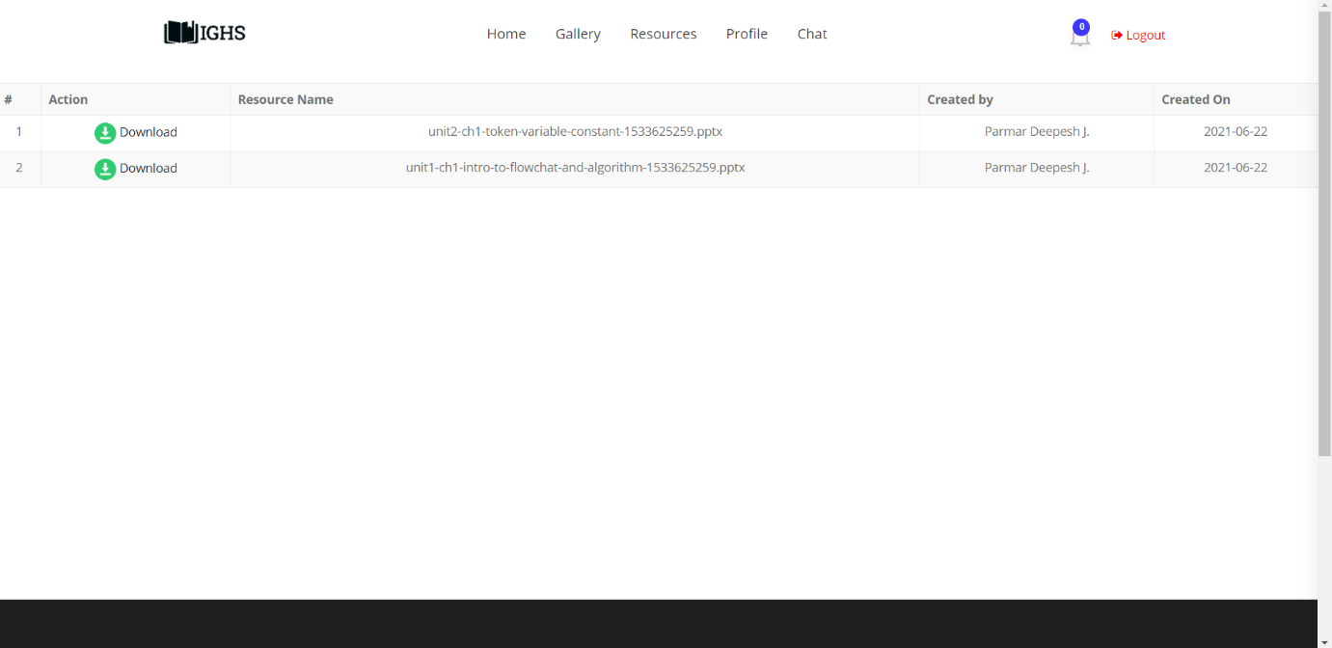

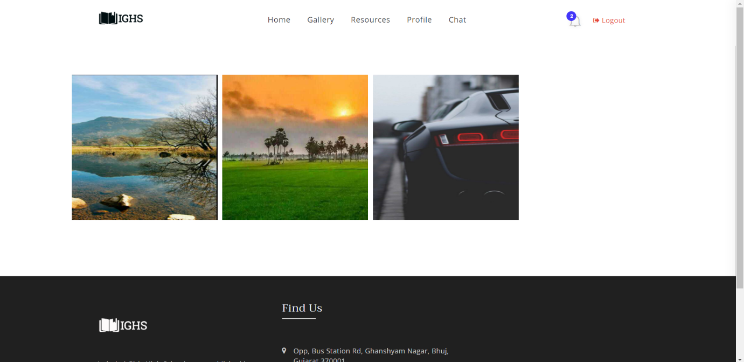

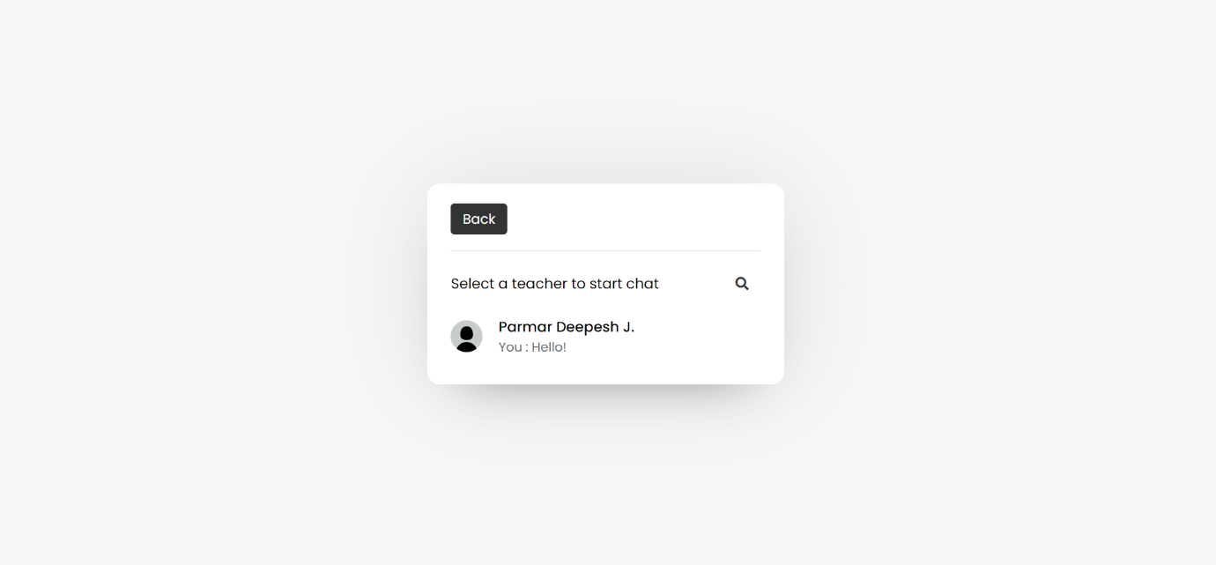

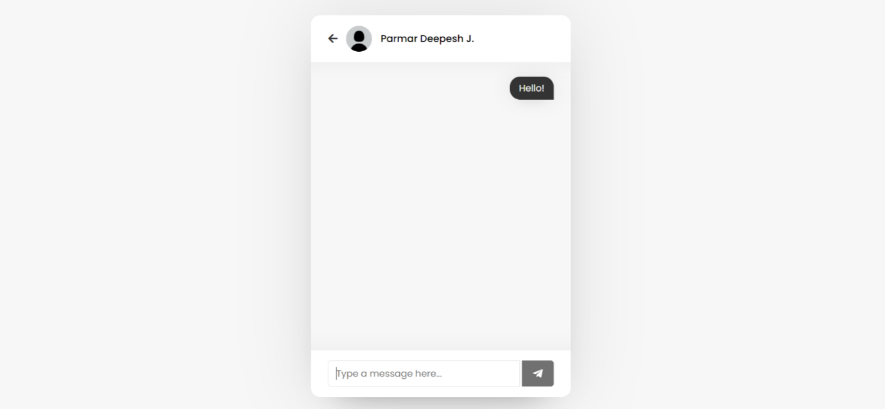

**admin**

|  |  |  |  |
| --- | --- | --- | --- |
| **Column** | **Type** | **Null** | **Default** |
| A_id *(Primary)* | bigint(20) | No |  |
| A_Photo | varchar(50) | Yes | *NULL* |
| A_name | varchar(60) | No |  |
| A_mobile | varchar(10) | No |  |
| A_address | varchar(255) | No |  |
| A_password | varchar(50) | No |  |
| is_deleted | tinyint(1) | No |  |
| A_dob | date | No |  |
| Created_on | date | No | curdate() |
| Created_by | bigint(20) | No |  |
| notification_count | int(20) | No |  |

**Class**

|  |  |  |
| --- | --- | --- |
| **Column** | **Type** | **Null** |
| Class_id *(Primary)* | bigint(20) | No |
| C_no | int(11) | No |
| Stream | varchar(40) | No |

**conversation**

|  |  |  |  |  |
| --- | --- | --- | --- | --- |
| **Column** | **Type** | **Null** | **Default** | **Links to** |
| chat_id | bigint(20) | No |  |  |
| chat_text | varchar(255) | No |  |  |
| Created_on | date | No | curdate() |  |
| S_srn | bigint(20) | No |  | students ->S_srn |
| T_srn | bigint(20) | No |  | teachers ->T_srn |
| is_c_deleted | tinyint(1) | No |  |  |
| sender_type | varchar(10) | No |  |  |

**event**

|  |  |  |  |  |
| --- | --- | --- | --- | --- |
| **Column** | **Type** | **Null** | **Default** | **Links to** |
| Sr_n *(Primary)* | bigint(20) | No |  |  |
| Event_topic | varchar(120) | No |  |  |
| Event_text | varchar(120) | No |  |  |
| is_deleted | tinyint(1) | No |  |  |
| disabled | tinyint(1) | No | 0 |  |
| Created_on | date | No | curdate() |  |
| event_date | date | No |  |  |
| created_by | bigint(20) | No |  | admin ->A_id |

**images**

|  |  |  |  |  |
| --- | --- | --- | --- | --- |
| **Column** | **Type** | **Null** | **Default** | **Links to** |
| Id *(Primary)* | bigint(20) | No |  |  |
| Image | varchar(255) | No |  |  |
| Uploaded_by | bigint(20) | No |  | admin ->A_id |
| Uploaded_on | date | No | curdate() |  |

**log**

|  |  |  |  |
| --- | --- | --- | --- |
| **Column** | **Type** | **Null** | **Default** |
| Sr_n *(Primary)* | bigint(20) | No |  |
| L_Date | date | No | curdate() |
| L_Time | time | No | current_timestamp() |
| Name | varchar(100) | No |  |
| Authority | varchar(10) | No |  |
| Contact | varchar(10) | No |  |
| Action | varchar(255) | No |  |
| Status | text | No |  |
| IP_address | varchar(35) | No |  |
| City | varchar(100) | No |  |
| Region | varchar(100) | No |  |
| Country | varchar(100) | No |  |

**notification**

|  |  |  |  |  |
| --- | --- | --- | --- | --- |
| **Column** | **Type** | **Null** | **Default** | **Links to** |
| Sr_n *(Primary)* | bigint(20) | No |  |  |
| Notification_topic | varchar(120) | No |  |  |
| Notification_text | varchar(120) | No |  |  |
| is_deleted | tinyint(1) | No |  |  |
| Created_on | date | No | curdate() |  |
| N_Time | time | No | current_timestamp() |  |
| created_by | bigint(20) | No |  | admin ->A_id |
| n_status | tinyint(1) | No |  |  |

**resources**

|  |  |  |  |  |
| --- | --- | --- | --- | --- |
| **Column** | **Type** | **Null** | **Default** | **Links to** |
| R_id *(Primary)* | bigint(20) | No |  |  |
| R_path | varchar(250) | No |  |  |
| Created_on | date | No | curdate() |  |
| Created_by | bigint(20) | No |  | teachers ->T_srn |
| Sub_id | bigint(20) | No |  | subjects ->Sub_id |
| is_deleted | tinyint(1) | No | 0 |  |

**students**

|  |  |  |  |
| --- | --- | --- | --- |
| **Column** | **Type** | **Null** | **Default** |
| S_srn *(Primary)* | bigint(20) | No |  |
| S_photo | varchar(50) | Yes | *NULL* |
| S_grn | int(5) | No |  |
| S_uidn | varchar(18) | No |  |
| S_name | varchar(50) | No |  |
| S_caste | varchar(50) | No |  |
| S_category | varchar(50) | No |  |
| S_dob | date | No |  |
| S_contact | varchar(10) | No |  |
| S_ad_date | date | No |  |
| Class_id | bigint(20) | No |  |
| S_adharn | varchar(12) | No |  |
| S_hostel | varchar(80) | No |  |
| S_home | varchar(80) | No |  |
| S_handicapped | varchar(5) | No |  |
| S_describe | varchar(80) | No |  |
| S_password | varchar(50) | No |  |
| S_remarks | varchar(50) | No |  |
| Academic_year | varchar(15) | No |  |
| is_deleted | tinyint(1) | No |  |
| Created_on | date | No | curdate() |
| s_status | varchar(20) | No |  |
| updated | int(2) | No |  |
| notification_count | int(20) | No |  |

**subjects**

|  |  |  |  |
| --- | --- | --- | --- |
| **Column** | **Type** | **Null** | **Links to** |
| Sub_id *(Primary)* | bigint(20) | No |  |
| Sub_name | varchar(40) | No |  |
| Class_id | bigint(20) | No | class ->Class_id |

**teachers**

|  |  |  |  |
| --- | --- | --- | --- |
| **Column** | **Type** | **Null** | **Default** |
| T_srn *(Primary)* | bigint(20) | No |  |
| login_count | int(11) | No |  |
| T_photo | varchar(50) | Yes | *NULL* |
| T_name | varchar(50) | No |  |
| DOB | date | No |  |
| Degree | varchar(50) | No |  |
| A_date | date | No |  |
| Joining_date | date | No |  |
| Retire_date | date | No |  |
| Contact | varchar(10) | No |  |
| Password | varchar(50) | No |  |
| is_deleted | tinyint(1) | No |  |
| Created_on | date | No | curdate() |
| t_status | varchar(20) | No |  |
| notification_count | int(20) | No |  |

**teacherstd**

|  |  |  |
| --- | --- | --- |
| **Column** | **Type** | **Null** |
| ts_id *(Primary)* | bigint(20) | No |
| id_sub | int(11) | No |
| id_teacher | int(11) | No |
| is_deleted | tinyint(1) | No |