**Exp. 13.** Design a system for home security systems, such that whenever someone approaches the gate, the LED starts blinking once every 100 ms.

* **Circuit Diagram:**

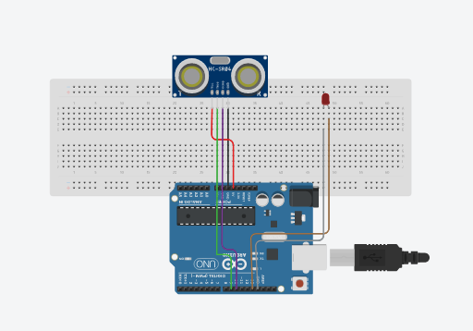

* **Theory :**
* Concept Used :

We have used the concept of Ultrasonic Sensor in which it generate the pulse and catch it back , if some thing is present in front of sonsor then led is start blinking. We have also used Switch, Arduino Uno R3, and LEDs to create the system.

* Learning & Observations :

In this we learnt , how we make gate alarm using Arduino. In this we use Ultrasonic Sensor which create pulse and send , if some one is come in front of it then the pulse is return and catched by Ultrasonic Sensor and the led will start blinking once in 100 ms. So , by that we can use it as gate alarm.

* Code :

void setup()

{

Serial.begin(9600);

pinMode(9,OUTPUT);

pinMode(10,INPUT);

pinMode(13,OUTPUT);

}

void loop()

{

digitalWrite(9,LOW);

delayMicroseconds(2);

digitalWrite(9,HIGH);

delayMicroseconds(10);

digitalWrite(9,LOW);

long time = pulseIn(10,HIGH);

float distance = 0.017*time;

Serial.println(distance);

if(distance>100)

{

digitalWrite(13,LOW);

}

else

{

digitalWrite(13,HIGH);

delay(100);

digitalWrite(13,LOW);

delay(100);

}

}

* Troubleshooting :

During the designing of this system we encountered some problem in using Ultrasonic Sensor because some time if distance is less than 100 cm still it donot start blinking.

* Precautions :

Make sure that all the connections are proper and tight. Check whether a bread board is working or not. Make sure that LED is working .

* Learning Outcomes :

We learnt how we can use UltrasonicSensor and Arduino to make a system which tell , some one is standing in front of gate or not. And we also learnt to make circuit on tindercad.