Activity Instructions
Kon Banega Nisthavan
Summer Shibir 2026 · Afternoon Karykram
8 group activities · with materials, setup, and step-by-step instructions
Contents
1. Chair Position Challenge — Hardships / Sahan Shakti / Shurvirtā
2. Apple Bobbing Challenge — Purushārth & Mandirs
3. Limbu Chamchi Challenge — Dhirāj
4. Limbo Challenge — Dāsbhāv
5. Blindfold Trust Walk — Āgnā
6. Balance Box Challenge — Niyam Dharma
7. Hula Hoop Circle — Samp
8. Gun Darshan Ball Pass — Mahimā

ACTIVITY 1 · HARDSHIPS / SAHAN SHAKTI / SHURVIRTĀ
Chair Position Challenge
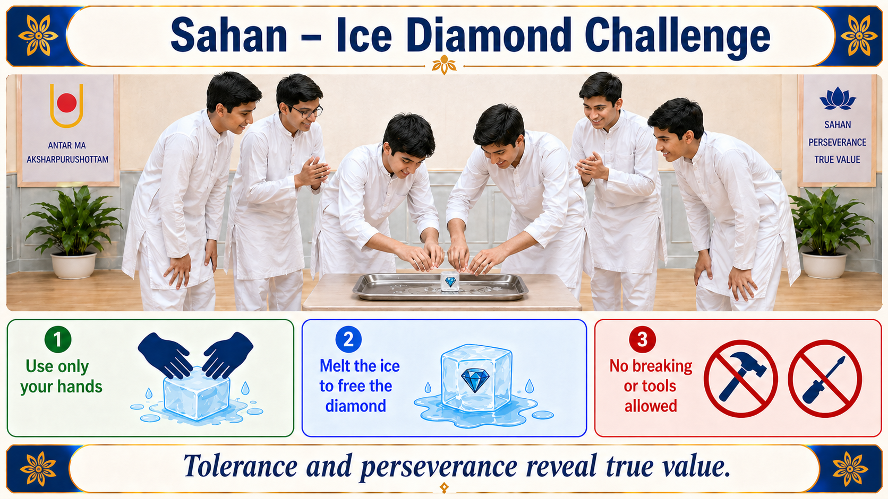
Objective
Hold a sitting position in mid-air, with no real chair, for as long as you can.
Materials Needed
- Open space
- Timer
Instructions
- Find your spot. Stand with your back against a wall, or pick a place in the open space.
- When we start, slowly bend your knees and lower yourself down as if you're sitting on an invisible chair.
- Keep your knees bent and your back straight the whole time.
- No support allowed — your hands can't touch the ground, the wall, your knees, or anything else.
- The moment you stand up, fall, or grab onto something, you're out.
- Stay strong and hold the position. Whoever lasts the longest wins!
Safety Note
Do not force anyone to continue if they feel pain or discomfort. This game should test endurance, not cause injury.

ACTIVITY 2 · PURUSHĀRTH & MANDIRS
Apple Bobbing Challenge
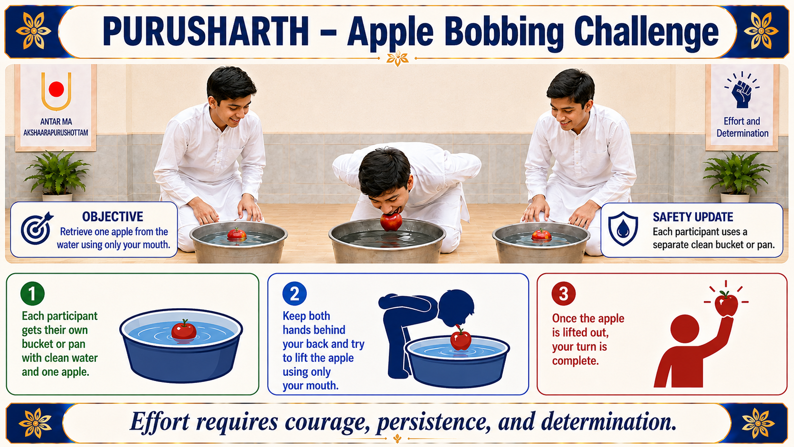
Objective
Retrieve one apple from the water using only your mouth.
Materials Needed
- Large tub or bucket (one per participant where possible)
- Clean water
- Apples
- Towels
Instructions
- Each participant will get their own clean bucket or pan with fresh water and apples.
- Keep both hands behind your back.
- When the game starts, try to pick up one apple using only your mouth.
- Do not use your hands to touch the bucket, water, or apple.
- Once you lift the apple out of the water, your turn is complete.
Safety Note
Use clean water and fresh apples. Replace the water when needed. Make sure participants do not push their face too deep into the water.

ACTIVITY 3 · DHIRĀJ
Limbu Chamchi Challenge
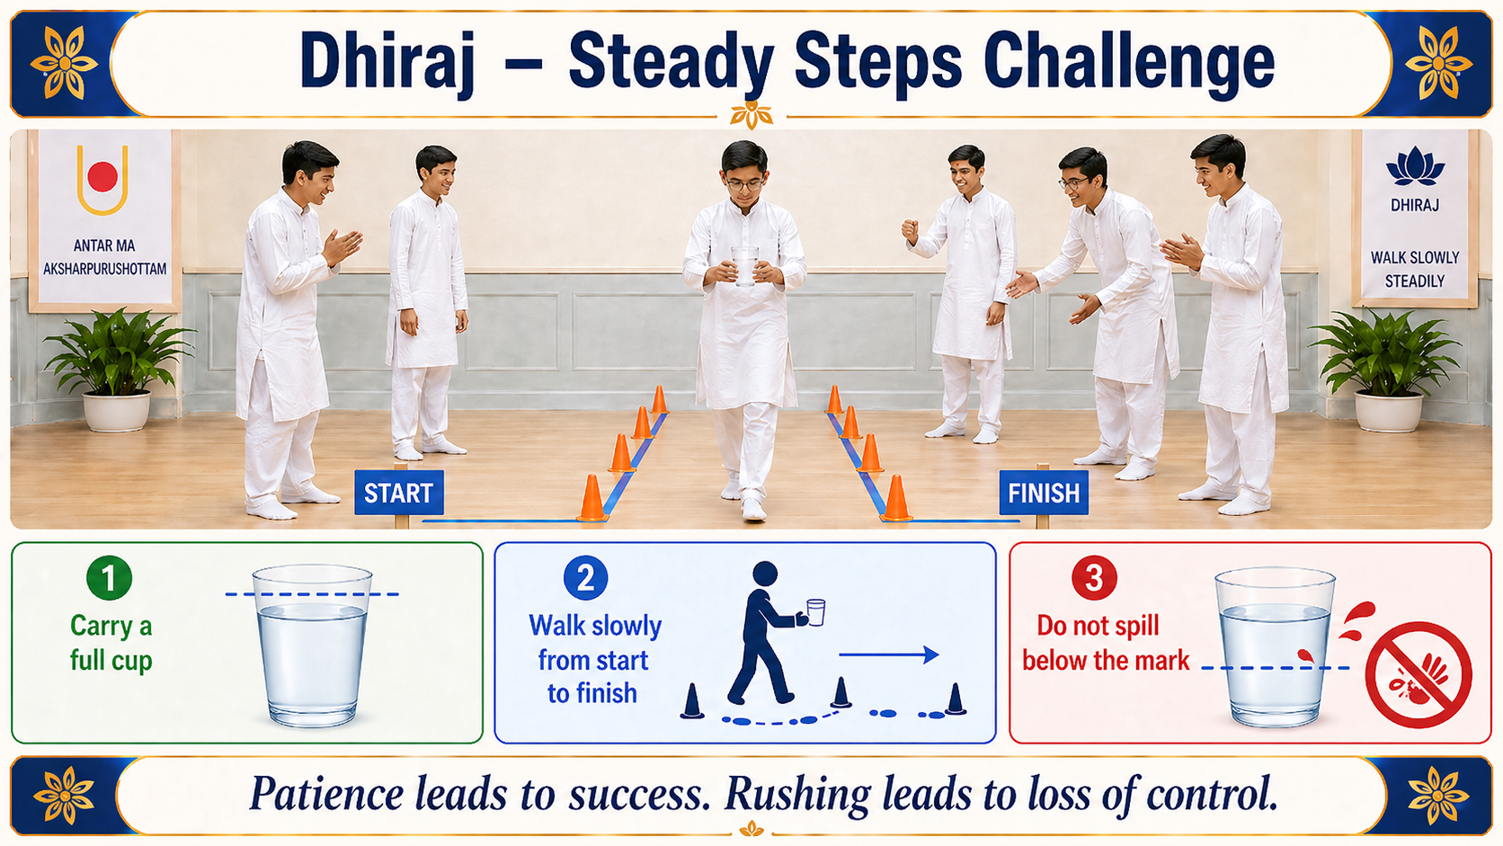
Objective
Balance the lemon on the spoon and cross the finish line without dropping it. The goal is not to finish first, but to stay steady, calm, and focused.
Materials Needed
- Lemons
- Spoons
- Tape or markers for start and finish lines
- Open space
Instructions
- Mark a clear start line and finish line.
- Five to six participants stand at the start line.
- Give each participant one spoon and one lemon.
- Each participant places the spoon handle in their mouth and balances the lemon on the spoon.
- When the game starts, participants walk carefully toward the finish line.
- Do not use your hands to hold the spoon or lemon during the challenge.
- If the lemon falls, the participant must return to the start line and begin again.
- The challenge is complete when you cross the finish line with the lemon still balanced on the spoon.
Rules
- Do not run or push others.
- Hands cannot touch the spoon or lemon during the challenge.
- Participants must stay in their own lane or path.
- If the lemon falls, the participant must restart from the start line.
- Focus on balance, patience, and steadiness.
Reflection
In life, speed is not always the most important thing. Sometimes, patience, balance, and focus help us reach the goal safely and successfully.

ACTIVITY 4 · DĀSBHĀV
Limbo Challenge
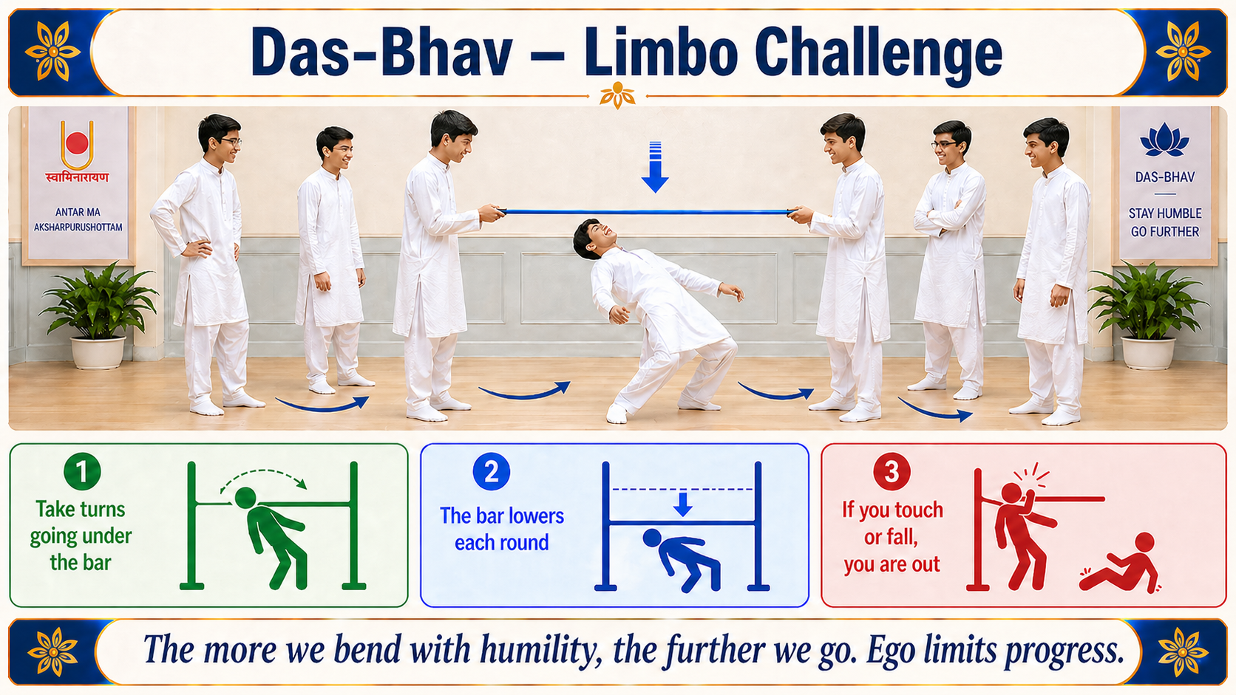
Objective
Pass under the limbo bar as it gets lower each round.
Materials Needed
- Limbo stick, rope, pool noodle, or any safe bar
- Open space
Instructions
- Two volunteers hold the limbo bar.
- One participant goes at a time.
- Each participant must pass under the bar by leaning backward.
- Hands should not touch the ground.
- If a participant touches the bar, falls, or uses hands for support, they are out for that round.
- After every round, lower the bar slightly.
- Continue until the final participant remains, or until the team completes the challenge.
Reflection Before Turn
Before going under the bar, each participant may share one way they can practice humility (dāsbhāv) in daily life.

ACTIVITY 5 · ĀGNĀ
Blindfold Trust Walk
Objective
Reach the finish line safely by following verbal instructions from one teammate (or audio guidance).
Materials Needed
- Blindfold
- Speaker / audio of Guruhari Mahant Swami Maharaj
- Cones or simple safe obstacles
- Open space
Instructions
- Selected participants will be blindfolded.
- Everyone will listen carefully to the Guruhari Mahant Swami Maharaj audio.
- The blindfolded participants must follow the instructions given in the audio.
- Participants should move carefully and complete each step as guided.
- No one may touch or physically guide the blindfolded participants.
- If a participant is confused, they should pause and listen carefully before continuing.
- If a participant touches an obstacle, they must pause and continue from that spot.
- The challenge is complete when the participant safely reaches the final point by following the audio guidance.

ACTIVITY 6 · NIYAM DHARMA
Balance Box Challenge
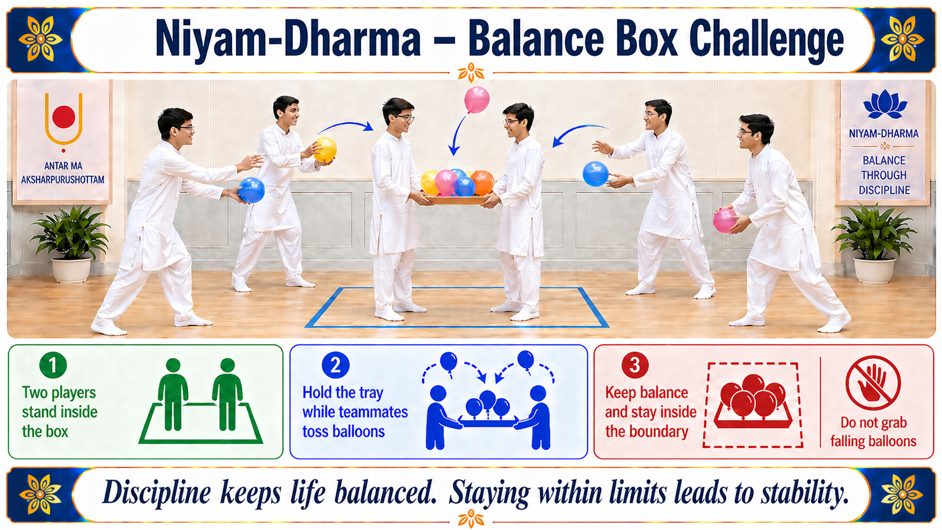
Objective
Keep as many balloons as possible in the air, above shoulder level, while staying inside the marked box.
Materials Needed
- Tape to mark a square boundary on the floor
- Balloons (multiple)
- Timer
Instructions
- Mark a square boundary on the floor using tape.
- Two players stand inside the box.
- One helper stands outside the box with extra balloons.
- Start with one balloon in the air.
- The two players must keep the balloon(s) in the air using only their hands.
- Balloons must stay above shoulder level as much as possible.
- The helper adds one new balloon every 10 seconds.
- Players must remain inside the box at all times.
- If a balloon touches the floor, that balloon is out.
- The round ends when all balloons fall or when the set time is complete.
Rules
- Players must stay inside the marked boundary at all times.
- Balloons should stay above shoulder level.
- Only hands may be used to keep balloons in the air.
- If a balloon touches the floor, it cannot be picked up again.

ACTIVITY 7 · SAMP
Hula Hoop Circle
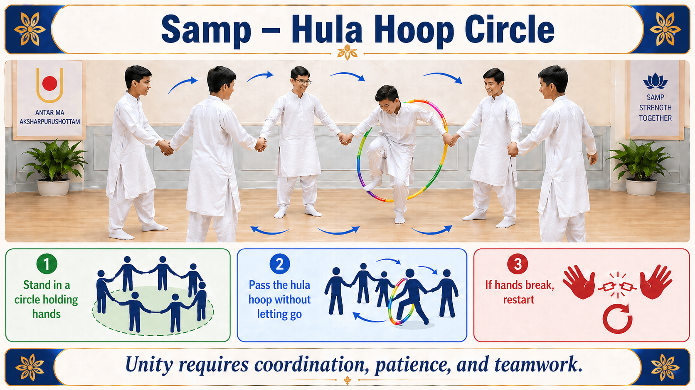
Objective
Pass the hula hoop around the entire circle without letting go of each other's hands.
Materials Needed
- 1 hula hoop
- Open space
Instructions
- All team members stand in a circle.
- Everyone holds hands.
- Place the hula hoop between two people before they join hands.
- The team must move the hula hoop around the full circle.
- Players may use their arms, shoulders, head, legs, and body movement.
- Hands must stay connected at all times.
- If anyone lets go, the team must restart.

ACTIVITY 8 · MAHIMĀ
Gun Darshan Ball Pass
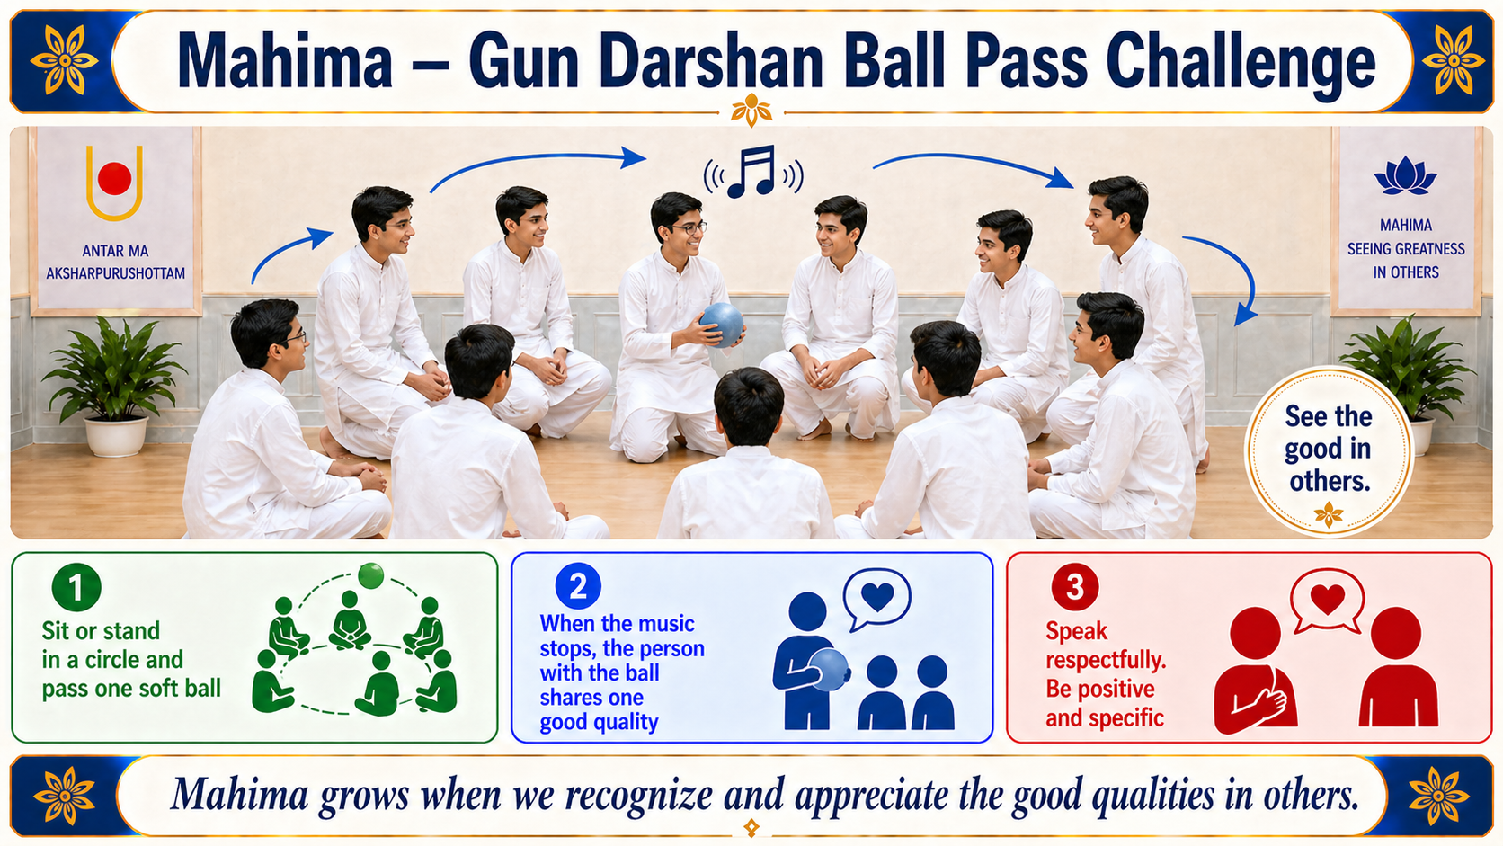
Objective
Recognize and share one good quality (gun) of someone in the group.
Materials Needed
- 1 soft ball
- Speaker
- Kirtan or music
- Open space
Setup
- Make one group of 8 to 10 participants.
- Ask everyone to sit or stand in a circle.
- Give one soft ball to the group.
- Start playing kirtan or music.
Instructions
- When the music starts, participants pass the ball around the group.
- Everyone must keep passing the ball until the music stops.
- When the music stops, the person holding the ball stays in their place.
- That person chooses anyone in the group and says one good quality about them.
- After they share, start the music again.
- Continue for multiple rounds so different people get a chance.
Rules
- The quality must be respectful and positive.
- Do not repeat the same quality too many times.
- Try to be specific.
- No teasing or comments that may hurt someone.
- If someone cannot think of a quality, the group can help them.

