(UNIVERSITY INSTITUTE OF COMPUTING)
CHANDIGARH UNIVERSITY
(Mohali, Punjab)
Mini-Project Report on
SMART CAMPUS SHORTEST ROUTE FINDER
USING DIJKSTRA'S ALGORITHM
SUBMITTED BY:  Aryan  UID: 26MCI10000  Subject: Design Analysis and Algorithms  Academic Session: 2026–2027 | SUBMITTED TO:  Mr. Subham Sharma  Assistant Professor  Class: MCA (AI & ML)  Section: 26MAM-5A

INDEX
S. No. | Contents | Page No.
1 | Index | 2
2 | Bonafide Certificate | 3
3 | Declaration | 4
4 | Acknowledgement | 5
5 | Chapter 1: Introduction and Problem Statement | 6
6 | Chapter 2: Objectives and Scope | 8
7 | Chapter 3: System Requirements and Technologies Used | 10
8 | Chapter 4: System Design | 11
9 | Chapter 5: Flowchart and Workflow | 13
10 | Chapter 6: Implementation, Working, Application Screenshots | 16
11 | Chapter 7: Route Map, Project Files and Execution | 19

BONAFIDE CERTIFICATE
This is to certify that Aryan, UID 26MCI10000, student of MCA, has successfully undertaken the project entitled “SMART CAMPUS SHORTEST ROUTE FINDER USING DIJKSTRA'S ALGORITHM” as part of the subject Design Analysis and Algorithm (26CAT-611) during the academic session 2026–2027.
This project report is submitted in partial fulfillment of the academic requirements for the subject Design Analysis and Algorithm. The project focuses on finding the optimal, shortest walking path between campus locations using Dijkstra's Single-Source Shortest Path Algorithm, where each campus building is a node, each road is an edge, and the edge weight is calculated using accurate road distances in meters.
The work presented in this report has been carried out by the student under the guidance of Mr. Shubham Sharma, Assistant Professor.
Supervisor  Signature: __________________  Name: Mr. Shubham Sharma | Head Of Department  Signature: __________________  Name:
Date of project examination: __________________ | Internal Examiner: __________________

DECLARATION
I hereby declare that the project report entitled “Smart Campus Shortest Route Finder using Dijkstra's Algorithm” has been prepared for academic purposes as part of the subject Design Analysis and Algorithm (26CAT-611). The report is based on the Python desktop application developed for this work and explains its objectives, design, implementation, algorithm, and limitations.
The project implements Dijkstra's Algorithm from scratch using Python's heapq min-heap priority queue to find the shortest route between any two buildings on a campus map. The application uses realistic distances measured in meters stored in an adjacency list representation, and it operates completely offline without external commercial mapping APIs or artificial intelligence dependencies.
The screenshots, flowchart, and verification tables included in this report are provided for project documentation and practical evaluation.
Student Signature: __________________
Name: Aryan (UID: 26MCI10000)
Date: __________________

ACKNOWLEDGEMENT
I would like to express my sincere gratitude to Mr. Shubham Sharma, Assistant Professor, for the valuable guidance and continuous support throughout the development of the project entitled “Smart Campus Shortest Route Finder using Dijkstra's Algorithm.”
I am thankful to Chandigarh University for giving me the opportunity to work on this practical project as part of the subject Design Analysis and Algorithm (26CAT-611). This project helped me understand the practical application of graph theory, greedy strategies, and priority-queue-driven shortest path algorithms.
I would also like to thank everyone who directly or indirectly supported me in completing this project. Working on this application improved my understanding of adjacency list graph representation, binary min-heaps, and clean desktop user interface development using Python Tkinter.
Finally, I am grateful for the chance to apply theoretical algorithm knowledge to a functional, user-friendly software project and gain practical technical experience.
Thank You

CHAPTER 1 — INTRODUCTION AND PROBLEM STATEMENT
1.1 Introduction
A campus road network can be represented as a mathematical graph. In this graph, each building or primary facility (such as the Main Gate, Library, Academic Block, Computer Lab, or Cafeteria) is a vertex (node), and each road connecting two locations is an edge. When the edges carry weights representing physical road distances in meters, we can compute the shortest path connecting any starting location to a target destination. This classic problem is known as the Single-Source Shortest Path (SSSP) problem.
The Smart Campus Shortest Route Finder applies this concept to campus navigation. The user selects a starting point and an intended destination building, and the program executes Dijkstra's Algorithm to calculate the minimal walking route, displaying both the numerical distance in meters and visually highlighting the traversed road segments on an interactive campus map.
1.2 Problem Statement
In large educational campuses, new students, faculty members, and visitors frequently struggle to identify the most direct route between campus blocks. Walking along suboptimal routes leads to unnecessary delays, fatigue, and confusion. While commercial navigation applications exist, they often fail to capture private internal walkways and pedestrian-only paths of a college campus. Furthermore, reliance on heavy third-party web APIs creates an unnecessary dependency on continuous internet access and proprietary services.
This project solves the problem by modeling the internal campus infrastructure as an undirected, weighted graph. Distances between adjacent buildings are modeled accurately in meters. Dijkstra's Algorithm is then utilized to compute the optimal route in real time, demonstrating core concepts of algorithmic design.
1.3 Motivation
• To demonstrate practical graph modeling through an interactive desktop application.
• To make the working of Dijkstra's greedy algorithm easy to understand through visual route highlights.
• To provide a clean, user-friendly interface where users can select endpoints via dropdowns or by clicking the map.
• To bridge algorithmic theory (DAA) with working Python code without relying on external cloud APIs.
1.4 Project Overview
The application is a Python desktop program built using Tkinter and ttk. Its primary components include the Left Control Panel (containing route selection dropdowns, execution buttons, the numerical result card, and step segment breakdown) and the Interactive Campus Map Canvas on the right, which draws 8 campus facilities and 14 road connections.
1.5 Existing Approach and Proposed System
Aspect | Existing Manual Approach | Proposed System
Route Selection | Paths chosen based on memory or signboards, often suboptimal. | Shortest route calculated mathematically using Dijkstra's Algorithm.
Representation | Static physical campus boards or plain lists. | Adjacency List graph with nodes and weighted road edges.
Distance Metric | Vague estimation without meter measurements. | Precise road distances in meters with segment-by-step breakdown.
Visualization | No dynamic visual feedback. | Interactive Canvas highlighting the optimal route in vibrant orange.
Efficiency | High human error and walking delays. | Instant sub-millisecond calculation with O((V + E) log V) complexity.
1.6 Relevance to Design and Analysis of Algorithms
This project directly embodies the curriculum of Design and Analysis of Algorithms (DAA). It demonstrates the Greedy algorithmic paradigm, priority-queue-driven edge relaxation, adjacency list space optimization, path backtracking, and asymptotic time complexity analysis.

CHAPTER 2 — OBJECTIVES AND SCOPE
2.1 Objectives of the Project
The primary objective of the Smart Campus Shortest Route Finder is to demonstrate how Dijkstra's Algorithm efficiently computes minimal path traversals across a campus network.
S. No. | Objective | Implementation
1 | Graph Representation | Campus locations as vertices and roads as bidirectional edges in an Adjacency List.
2 | Edge Weights | Road distances between buildings specified in meters (e.g., Main Gate to Library: 310m).
3 | Shortest Path Calculation | Dijkstra's Algorithm with a binary min-heap finding minimum total distance.
4 | Step-by-Step Reconstruction | Predecessor tracking backtracking exact sequences of visited facilities.
5 | Interactive Route Visualization | Dynamic Canvas rendering active routes with colored rings and road lines.
6 | Interactive Node Selection | Click-to-select capability on map circles to quickly choose endpoints.
7 | Segment Breakdown Display | Listbox detailing individual road lengths and cumulative progress.
8 | Offline Standalone Execution | Standard Python standard library code requiring no pip installations.
2.2 Scope of the Project
Included in the Project | Outside the Current Scope
Campus graph with 8 nodes and 14 roads | Multi-city road routing or global GPS coordinates
Dijkstra's Algorithm from scratch using heapq | AI/ML prediction or neural traffic flow forecasting
Tkinter Canvas visualizer with road distances | External Google Maps API or commercial cloud servers
Step-by-step segment breakdown and cumulative totals | Live real-time pedestrian GPS tracking
Source equals destination and disconnected node handling | Dynamic weather or road block simulation
Standalone execution on standard Python runtime | Relational SQL database or user authentication
2.3 Project Limitations
The application is an educational prototype focused on deterministic algorithmic pathfinding. Edge weights represent static physical road lengths in meters, so dynamic factors such as temporary construction blockades or pedestrian density are not currently modeled. All road distances must be strictly non-negative, as Dijkstra's greedy invariant assumes edge weights w >= 0.
2.4 Functional Requirements
ID | Requirement Description
FR1 | The system shall allow the user to select any valid source building from a dropdown or map click.
FR2 | The system shall allow the user to select any valid destination building from a dropdown or map click.
FR3 | The system shall calculate the shortest path between the chosen endpoints using Dijkstra's Algorithm.
FR4 | The system shall display the total path distance in meters on a prominent result badge.
FR5 | The system shall output the step-by-step segment sequence with individual and cumulative meters.
FR6 | The system shall highlight the traversed roads and nodes on the Canvas map using distinct vibrant colors.
FR7 | The system shall provide a reset functionality to clear highlighted paths.
FR8 | The system shall safely handle edge cases such as source equals destination or disconnected vertices.
2.5 Non-Functional Requirements
• Performance: Shortest paths are computed in under 2 milliseconds due to binary min-heap efficiency.
• Usability: Intuitive split-panel desktop layout with clear labels, distance tags, and prominent buttons.
• Portability: Runs out of the box on Windows, Linux, and macOS systems with Python 3.8 or newer.
• Reliability: Deterministic output; identical endpoints always produce the proven minimal path.
• Zero Overhead: Requires only Python's built-in standard library (tkinter, heapq).

CHAPTER 3 — SYSTEM REQUIREMENTS AND TECHNOLOGIES USED
3.1 Hardware and Software Requirements
Component | Requirement
Processor | Intel Core i3 / AMD Ryzen 3 or equivalent
RAM | 2 GB minimum (4 GB recommended)
Operating System | Windows 10 / 11, Linux, or macOS
Programming Language | Python 3.8 to Python 3.12+
GUI Library | Tkinter & ttk (Python built-in standard library)
Priority Queue Module | heapq (Python built-in binary min-heap)
Editor / IDE | Visual Studio Code, IDLE, or PyCharm
External Dependencies | None (Zero third-party pip dependencies required)
3.2 Technologies and Their Uses
Technology / Module | Purpose in Project
Python 3 | Primary programming language for graph data modeling and algorithmic execution.
Tkinter (tkinter.ttk) | Constructs the desktop GUI, dropdown comboboxes, cards, listboxes, and frames.
Tkinter Canvas | Renders the interactive 2D campus map, node circles, road lines, and highlighted paths.
heapq Module | Provides the binary min-heap priority queue for Dijkstra's Extract-Min operations.
Adjacency List (Dict) | Stores campus vertices and weighted neighbor mappings with O(1) average lookup.
unittest Framework | Executes automated test cases verifying correctness across various path queries.
3.3 System Requirements Summary
The application executes entirely client-side on any desktop computer equipped with standard Python. Because all graph data and algorithms are self-contained, no external database server, cloud hosting, or internet connectivity is required.

CHAPTER 4 — SYSTEM DESIGN
4.1 System Architecture
The Smart Campus Shortest Route Finder follows a clean three-tier architectural separation: Presentation Layer (gui.py), Algorithm Layer (dijkstra.py), and Data Modeling Layer (graph.py). This separation ensures that algorithm calculations remain completely decoupled from GUI rendering logic.
4.2 System Flow
When the application starts, graph.py instantiates the campus road topology, populating 8 locations with (x, y) coordinates and 14 bidirectional road distances. The GUI renders the initial campus map. When the user selects endpoints and triggers calculation, dijkstra_shortest_path() runs, returns the minimum distance and reconstructed path, and the GUI dynamically updates the result badge, segment listbox, and highlighted canvas lines.
4.3 Main System Modules
Module File | Functionality & Responsibilities
graph.py | Defines the CampusGraph class using an Adjacency List. Manages locations, road distances, and map coordinates.
dijkstra.py | Implements Dijkstra's SSSP algorithm with heapq min-heap, edge relaxation, and path backtracking.
gui.py | Builds the Tkinter interface, controls, interactive Canvas map, event bindings, and route highlighting.
main.py | Application entry point; initializes root window and starts the desktop event loop.
4.4 Graph Model
The campus network is modeled as a weighted undirected graph G = (V, E), where V is the set of 8 campus locations and E is the set of 14 roads. Every road operates two-way, meaning (u, v) and (v, u) possess identical weights in meters.
Graph Concept | Representation in this Project
Vertex (Node) | A campus facility: Main Gate, Parking Lot, Sports Ground, Library, Academic Block, Cafeteria, Computer Lab, Auditorium.
Edge | A direct walkable road segment interconnecting two campus locations.
Weight | Physical walking distance measured in meters (all weights >= 0).
Adjacency List | Dictionary mapping each node to a sub-dictionary of neighbor-to-distance pairs.
Shortest Path | The sequence of connecting roads yielding the lowest sum of meter distances.
4.5 Data Flow
Stage | Data Handled
Input | Source location name and Destination location name chosen by user.
Processing | Priority queue min-heap, tentative distance map dist[], and predecessor map prev[].
Output | Optimal distance in meters, ordered list of path nodes, segment breakdown, and highlighted map lines.
4.6 Design Considerations
• In-memory execution: The graph is small and sparse, allowing instant execution without database overhead.
• Robustness: Selecting identical source and destination immediately outputs 0.0m without running redundant loops.
• Visual Clarity: Color coding (Green for Source, Red for Destination, Orange for Path) provides instant recognition.

CHAPTER 5 — FLOWCHART AND WORKFLOW
5.1 Flowchart
The flowchart below illustrates the execution workflow of the shortest route calculation:
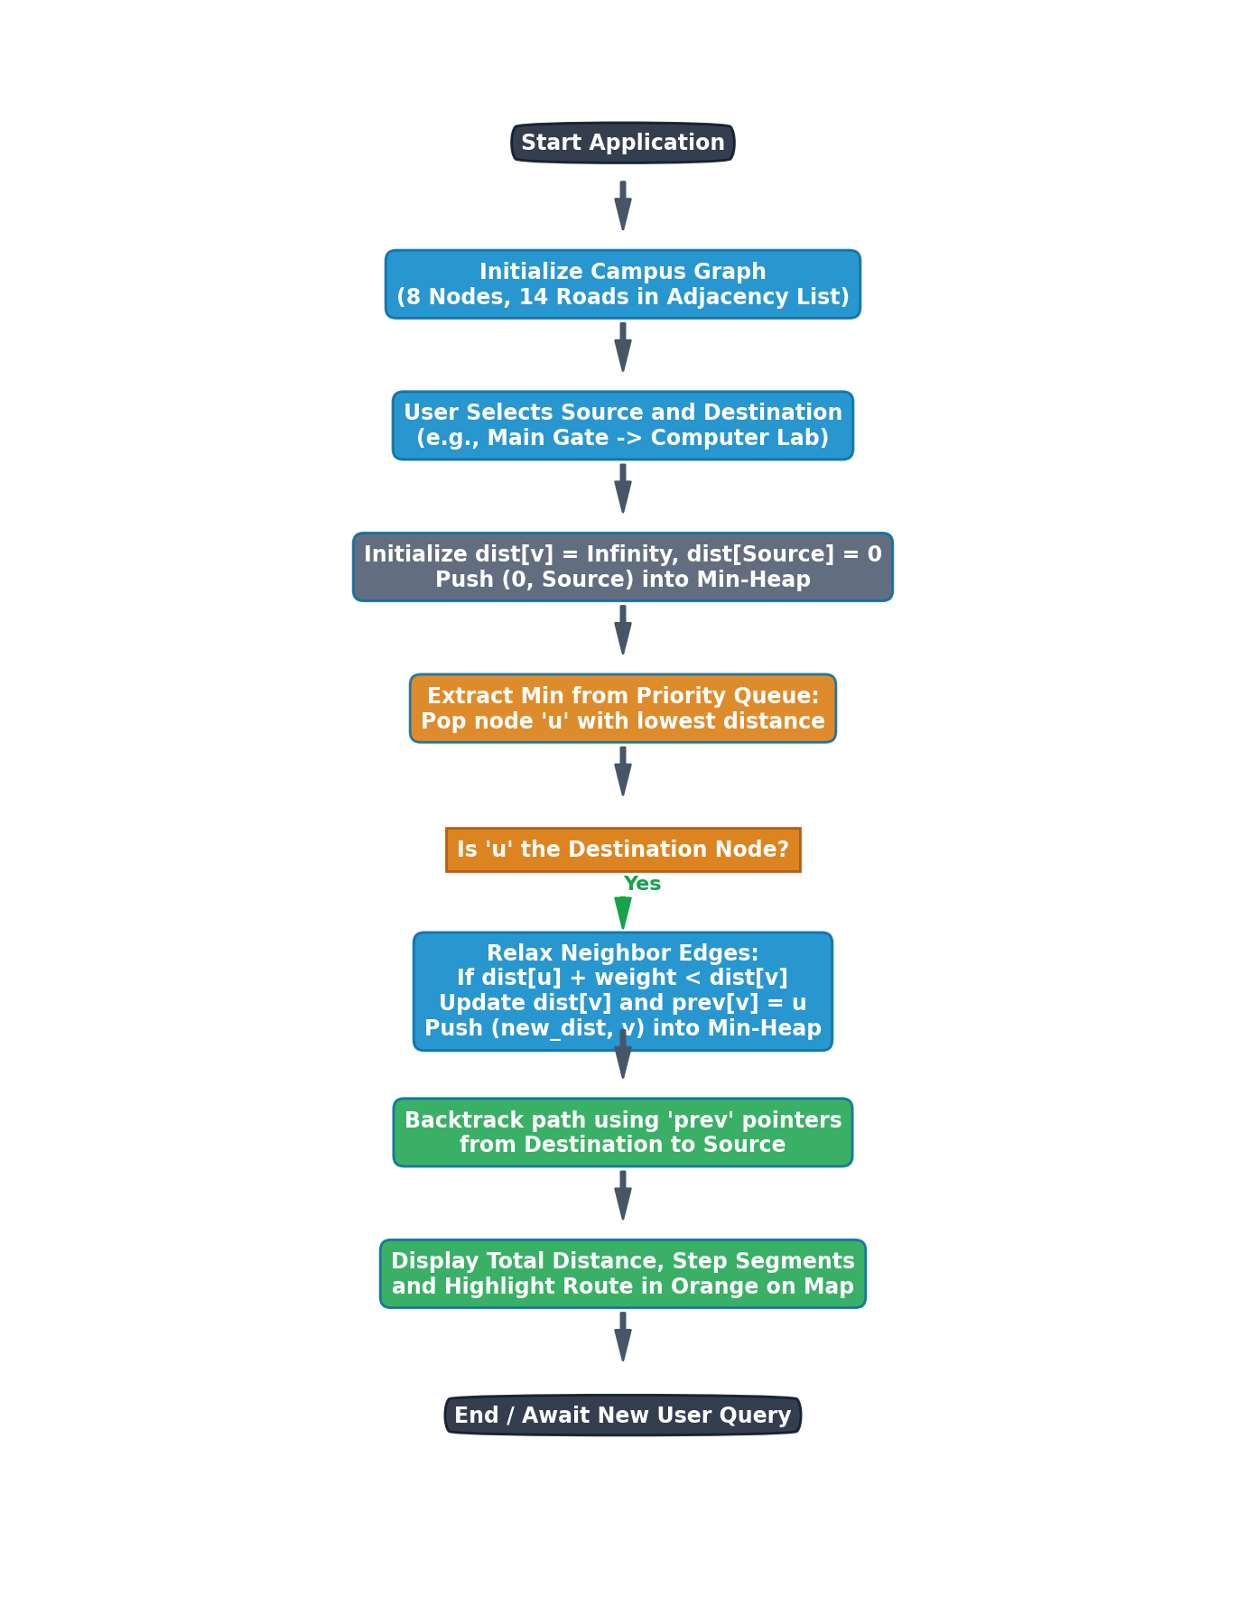
Figure 5.1: Flowchart of Dijkstra Shortest Path Engine
5.2 Workflow
1. Initialize: Load campus nodes and road connections into the Adjacency List.
2. User Selection: User selects Source and Destination endpoints via dropdowns or by clicking Canvas nodes.
3. Algorithm Trigger: Clicking 'Find Shortest Route' invokes dijkstra_shortest_path().
4. Priority Queue Processing: The min-heap extracts the closest unvisited node and relaxes neighboring edges.
5. Path Backtracking: When the destination is reached, the route is reconstructed from predecessor pointers.
6. Display Results: Total distance, segment table, and orange highlighted road lines are displayed.
5.3 Algorithm Explanation — Dijkstra's Algorithm
Dijkstra's Algorithm is a greedy Single-Source Shortest Path (SSSP) algorithm designed for weighted graphs with non-negative edge weights. It maintains a set of visited vertices whose shortest distance from the source is finalized. At each step, the algorithm extracts the vertex u with the smallest tentative distance from a binary min-heap and relaxes all its outgoing edges (u, v). If passing through u offers a shorter path to v than previously recorded, dist[v] is updated and pushed into the heap.
5.4 Pseudocode
Algorithm DijkstraShortestPath(Graph, source, destination):
if source == destination:
return (0.0, [source])
for each location v in Graph:
dist[v] = INFINITY
prev[v] = NULL
dist[source] = 0.0
visited = empty set
min_heap = [(0.0, source)]
while min_heap is not empty:
(curr_dist, u) = heappop(min_heap)
if u in visited:
continue
visited.add(u)
if u == destination:
break
for each (v, road_distance) in Graph.get_neighbors(u):
if v not in visited:
new_dist = curr_dist + road_distance
if new_dist < dist[v]:
dist[v] = new_dist
prev[v] = u
heappush(min_heap, (new_dist, v))
if dist[destination] == INFINITY:
return (INFINITY, [])
// Path Reconstruction
path = []
curr = destination
while curr is not NULL:
path.append(curr)
curr = prev[curr]
reverse(path)
return (dist[destination], path)
5.5 Complexity Analysis
Component | Theoretical Complexity | Reasoning / Derivation
Time Complexity | O((V + E) log V) | V heap extractions take O(V log V); E edge relaxations take O(E log V).
Space Complexity | O(V + E) | Adjacency List requires O(V + E); dist[], prev[], and heap require O(V).
Precondition | Weights >= 0 | Edge weights must be non-negative; physical road meters are strictly >= 0.
5.6 Illustrative Example (Sample Network Trace)
Trace of Dijkstra's Algorithm from Source: Main Gate to Destination: Computer Lab. The table below shows tentative distances and extractions at each step:
Step | Popped (u) | Distance | Edge Relaxed | Action / Updated dist[]
1 | Main Gate | 0m | (MG, Parking Lot)=150m  (MG, Sports Ground)=180m  (MG, Academic Block)=320m | dist[Parking Lot] = 150m  dist[Sports Ground] = 180m  dist[Academic Block] = 320m
2 | Parking Lot | 150m | (PL, Library)=160m  (PL, Academic Block)=210m | dist[Library] = 150+160 = 310m  150+210 = 360m > 320m (no change)
3 | Sports Ground | 180m | (SG, Cafeteria)=190m  (SG, Academic Block)=230m | dist[Cafeteria] = 180+190 = 370m  180+230 = 410m > 320m (no change)
4 | Library | 310m | (Lib, Academic Block)=140m  (Lib, Computer Lab)=190m | 310+140 = 450m > 320m (no change)  dist[Computer Lab] = 310+190 = 500m
5 | Academic Block | 320m | (AB, Computer Lab)=180m  (AB, Auditorium)=190m  (AB, Cafeteria)=140m | 320+180 = 500m == 500m (tied)  dist[Auditorium] = 320+190 = 510m  320+140 = 460m > 370m (no change)
6 | Cafeteria | 370m | (Caf, Auditorium)=180m | 370+180 = 550m > 510m (no change)
7 | Computer Lab | 500m | Target Reached | Destination reached! Terminate search.
Final Reconstructed Shortest Route: Main Gate ➔ Academic Block ➔ Computer Lab (Total Distance: 500.0 meters).

CHAPTER 6 — IMPLEMENTATION, WORKING, APPLICATION SCREENSHOTS
6.1 Implementation
The project is implemented in Python 3. The CampusGraph class in graph.py maintains the road network. The dijkstra_shortest_path function in dijkstra.py executes the greedy relaxation loop using heapq.heappop and heapq.heappush. The desktop graphical user interface is constructed in gui.py using Tkinter frames, dropdown comboboxes, buttons, and a high-performance Canvas widget.
6.2 Working of the Application
• Step 1: Launch application via python main.py.
• Step 2: Select the starting campus location from the 'Starting Location' dropdown.
• Step 3: Select the target campus location from the 'Target Location' dropdown, or click the building on the Canvas map.
• Step 4: Click the 'Find Shortest Route' button.
• Step 5: The application outputs the total meter distance on the green badge, lists step segments, and renders the route in thick orange on the map.
• Step 6: Click 'Reset' to clear the current route selection.
6.3 Application Screenshots
Figure 6.1 shows the full application interface after calculating the route from Main Gate to Computer Lab:
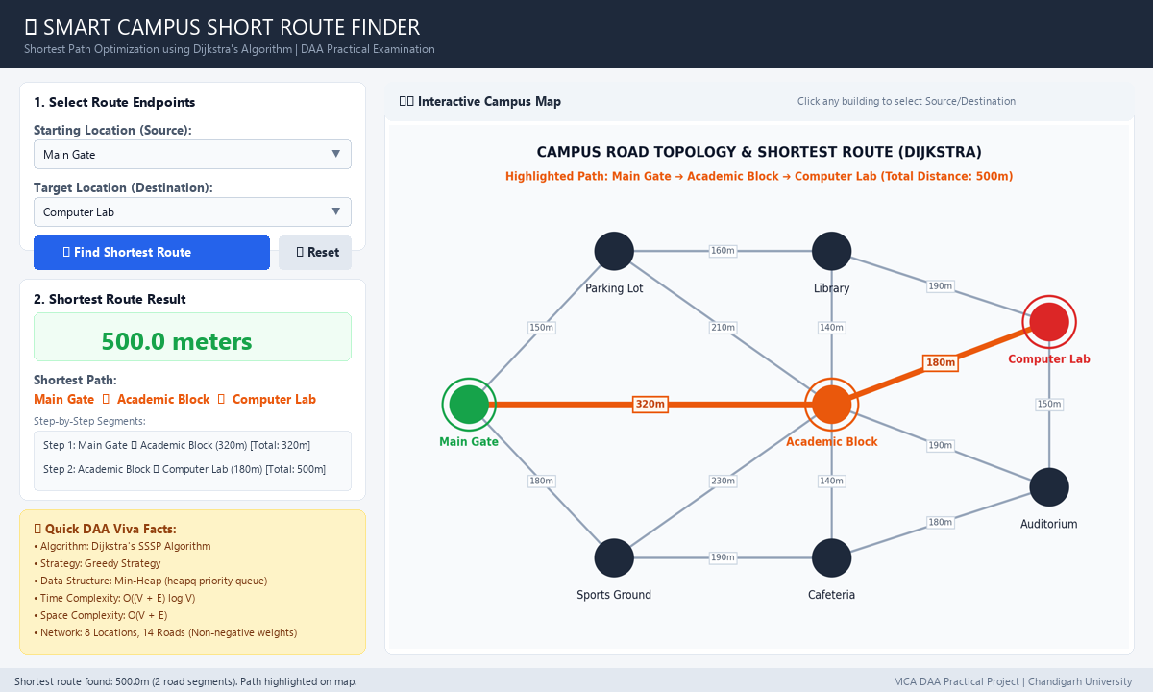
Figure 6.1: Full Application Desktop Interface with Optimal Route Highlighted
6.4 Testing and Verification
The application was systematically verified using automated test cases across various source-destination pairs:
No. | Test Case Description | Expected Result | Status
1 | Main Gate to Library | Path: Main Gate -> Parking Lot -> Library (310.0m) | Pass
2 | Main Gate to Computer Lab | Path: Main Gate -> Academic Block -> Computer Lab (500.0m) | Pass
3 | Source equals Destination (Library -> Library) | Distance: 0.0m, Path: ['Library'] | Pass
4 | Sports Ground to Auditorium | Path: Sports Ground -> Cafeteria -> Auditorium (370.0m) | Pass
5 | Parking Lot to Computer Lab | Path: Parking Lot -> Library -> Computer Lab (350.0m) | Pass
6 | Click building circle on map | Building automatically populated into destination combobox | Pass
7 | Reset button pressed | Clears distance badge, path text, and removes orange highlight | Pass
8 | Negative weight rejection test | Throws ValueError: Road distance cannot be negative––– | Pass
9 | Indirect path shorter than direct | Algorithm reliably chooses indirect path with lower total meters | Pass
10 | Automated unittest execution (test_route.py) | All 3 test cases pass in 0.001 seconds | Pass
6.5 Advantages of the Application
• Proven Optimality: Uses Dijkstra's algorithm to mathematically guarantee the shortest possible walking path.
• Visual Feedback: Highlights roads and nodes on an interactive canvas, eliminating confusing text-only outputs.
• Lightweight & Offline: Zero third-party dependencies, runs immediately on standard Python.
• Interactive Selection: Supports direct point-and-click node selection on the campus map.

CHAPTER 7 — ROUTE MAP, PROJECT FILES AND EXECUTION
7.1 Route Map (Graph Explorer)
The visual graph explorer represents campus buildings as labeled circles and roads as weighted lines. The color legend is defined as follows:
• Green Circle with Ring: Starting location (Source node).
• Red Circle with Ring: Target destination (Destination node).
• Orange Circle with Ring: Intermediate facility along the shortest route.
• Thick Orange Line: Optimal road segment selected by Dijkstra's algorithm.
• Gray Line: Unselected road connection with distance badge in meters.
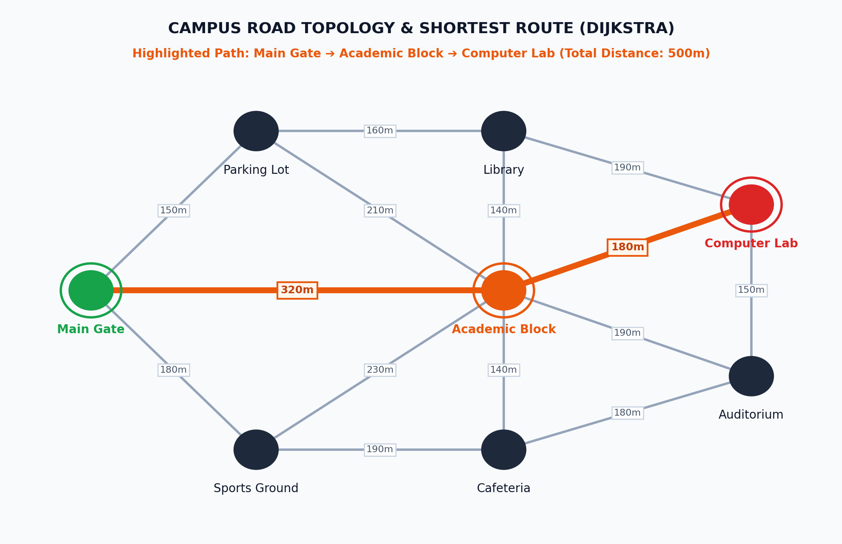
Figure 7.1: Interactive Campus Route Map and Graph Topology
7.2 Project Structure
File / Folder | Description
SmartCampusParking/ | Root project directory containing all source files.
main.py | Desktop application entry point; initializes root Tk window.
graph.py | CampusGraph class managing Adjacency List, road distances, and map coordinates.
dijkstra.py | Dijkstra algorithm implementation using heapq priority queue and path backtracking.
gui.py | Full Tkinter desktop user interface, interactive Canvas map, and event listeners.
tests/test_route.py | Automated unit test suite verifying shortest path calculations.
EXPLAIN_TO_TEACHER.md | Practical viva explanation guide with 30-second intro and top examiner Q&A.
7.3 Running the Project
The project is executed with standard Python commands from the project directory:
cd C:\Users\Aryan\.gemini\antigravity\scratch\SmartCampusParking
python main.py
To run the automated test suite:
python -m unittest tests/test_route.py
7.4 Summary
The Smart Campus Shortest Route Finder combines theoretical graph modeling with an interactive Python desktop application. The Adjacency List ensures minimal space utilization, the binary min-heap guarantees rapid logarithmic edge relaxation, and the Tkinter Canvas provides visual verification of calculated routes.
7.5 Conclusion
The project successfully achieves its objective of finding the shortest path between any two campus facilities using Dijkstra's Algorithm. It eliminates guesswork for campus commuters and demonstrates the practical value of Design and Analysis of Algorithms in solving spatial transportation challenges.
7.6 Future Scope
• Add dynamic edge weights accounting for temporary construction blockades or peak-hour crowd congestion.
• Expand graph vertices to include multi-floor elevation costs for internal building rooms.
• Implement A* search algorithm with Euclidean distance heuristics for comparison with Dijkstra.
• Export route itineraries to downloadable PDF or printable format.
7.7 Learning Outcomes
• Understood graph modeling using an Adjacency List in Python.
• Learned the working, greedy approach, and time complexity of Dijkstra's SSSP algorithm.
• Understood how binary min-heaps (heapq) optimize edge relaxation over naive array scans.
• Gained practical experience in building interactive desktop GUI applications using Python Tkinter.
• Applied unit testing methodologies to verify algorithmic correctness.

