AI WEATHERWISE
Phase 5. Project Development

Team Details
Team Head
Name | Email ID
DINESH KUMAR.T | dinesh45at@gmail.com
Team Members
Name | Email ID
DEEPAK.K | deepakarts2006@gmail.com
DEVASAGAYAM.V | devasagayamv307@gmail.com
ESWAR.V | mr.vishal0990@gmail.com

5. Project Development

Complete Source Code
The source describes the main implementation structure: index.js as entry point; routing, controllers, middleware, models and utility modules; REST APIs; MongoDB connection; authentication; weather and AI integrations.
C:\Users\ganap\Downloads\Backend-20260924T120333Z-1-001.zip

Database Files
The source documents MongoDB/Mongoose configuration, User and Location schemas, and database connection.

Configuration Files
The project creates index.js, .env, package.json and .gitignore. Environment variables include PORT=5000, MONGO_URI, JWT_SECRET and GEMINI_API_KEY.

Screenshots
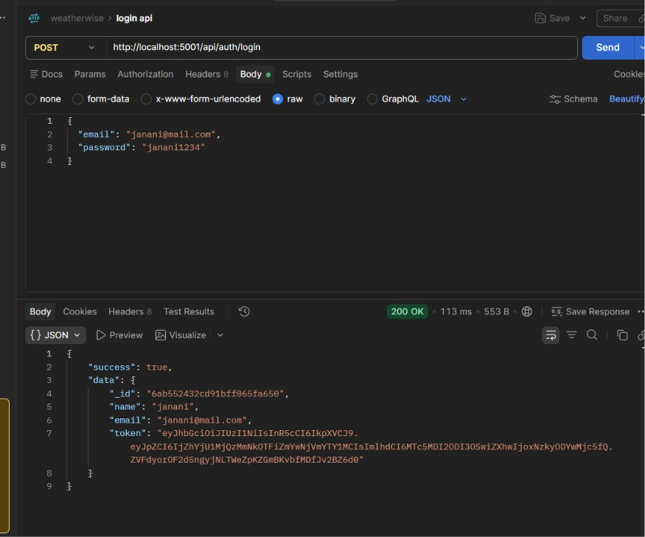
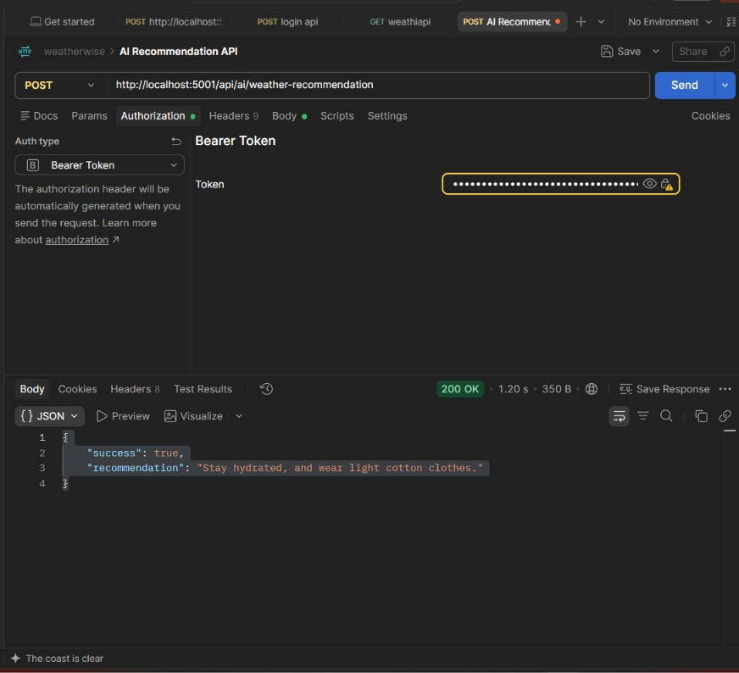

Project Files Link
C:\Users\ganap\Downloads\Backend-20260924T120333Z-1-001.zip

