AI WEATHERWISE
Phase 7. Project Documentation

Team Details
Project Title : AI Weather Wise API
Team Head
Name | Email ID
DINESH KUMAR.T | dinesh45at@gmail.com
Team Members
Name | Email ID
DEEPAK.K | deepakarts2006@gmail.com
DEVASAGAYAM.V | devasagayamv307@gmail.com
ESWAR.V | mr.vishal0990@gmail.com

7. Project Documentation

Final Project Report

- INTRODUCTION
AI WeatherWise is a RESTful backend platform developed using Node.js and Express.js. It uses MongoDB and Mongoose for data persistence and integrates Google Gemini AI to provide intelligent weather summaries and personalized recommendations based on live environmental conditions.
- SOFTWARE & HARDWARE REQUIREMENTS
- Operating System: Windows 10/11.
- Node.js v16 or above and npm v8 or above.
- MongoDB with Mongoose ODM.
- Gemini AI SDK for AI-based insights.
- Postman for API testing.
- Open Weather App API.
- Visual Studio Code.
- Minimum 8 GB RAM and approximately 1 GB available storage.
- SYSTEM ARCHITECTURE
The application follows the MVC pattern. The Controller layer manages request execution, the Model layer manages User and Location data through Mongoose, and the API routing layer acts as the interface in this headless backend service.
- Express Server Gateway – handles HTTP methods, JSON payloads and routes.
- Authentication Middleware – validates JWT tokens and authorization.
- Database Interface – communicates with MongoDB through Mongoose.
- AI Service Integration – generates weather summaries and recommendations using Gemini AI.
- DATABASE DESIGN
User Entity:
- _id – Primary key / ObjectId.
- name – Required string.
- email – Required and unique.
- password – Required hashed password.
- role – Default value: reader.
Location Entity:
- _id – Primary key / ObjectId.
- user – Reference to User collection.
- city and country – Required fields.
- createdAt – Date field.
Relationship: One User can have multiple favorite Locations.
- USER ROLES & USER FLOW
Admin: Manages user accounts, monitors API health and system/database integrity.
Registered User: Manages favorite locations, requests weather data, receives Gemini AI recommendations, and manages authentication details.
User Flow:
- 1. User registers or logs in.
- 2. User saves a favorite city.
- 3. User fetches current weather.
- 4. User requests AI-driven insights.
- 5. System validates JWT and returns the requested information.
- BACKEND DEVELOPMENT
The backend is developed using Node.js, Express.js and MongoDB with a modular architecture. Routing, controllers, middleware, models and utility modules are separated to improve maintainability and scalability. The index.js file initializes the Express server, loads environment variables, connects to MongoDB, registers API routes and starts the server.
Project setup commands:
npm init -y npm install express mongoose bcryptjs jsonwebtoken cors dotenv multer
@google/genai npm install --save-dev nodemon
- API TESTING & PROJECT EXECUTION
The APIs can be tested using Postman or Thunder Client. The project includes testing for Register API, Login API, Weather API and Recommendation API.
Execution:
- Ensure MongoDB is running.
- Configure required environment variables.
- Run npm install.
- Start the server using npm start.
- After successful execution, the server connects to MongoDB and listens for API requests.
The project also includes JWT authentication, bcrypt password hashing, request sanitization, centralized error handling and a fallback mode for API functionality.
The final report should consolidate the project statement, requirements, architecture, development, testing and outcomes documented across the project.

Screenshots
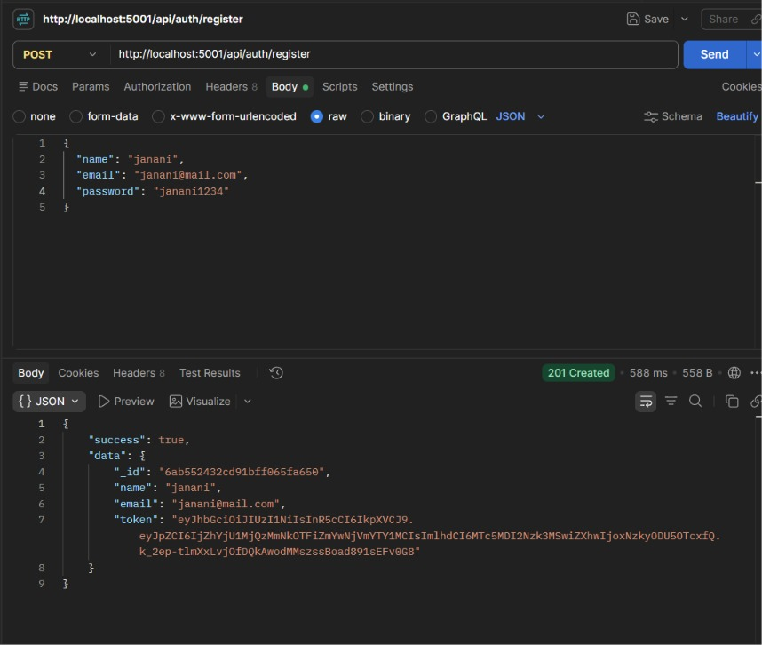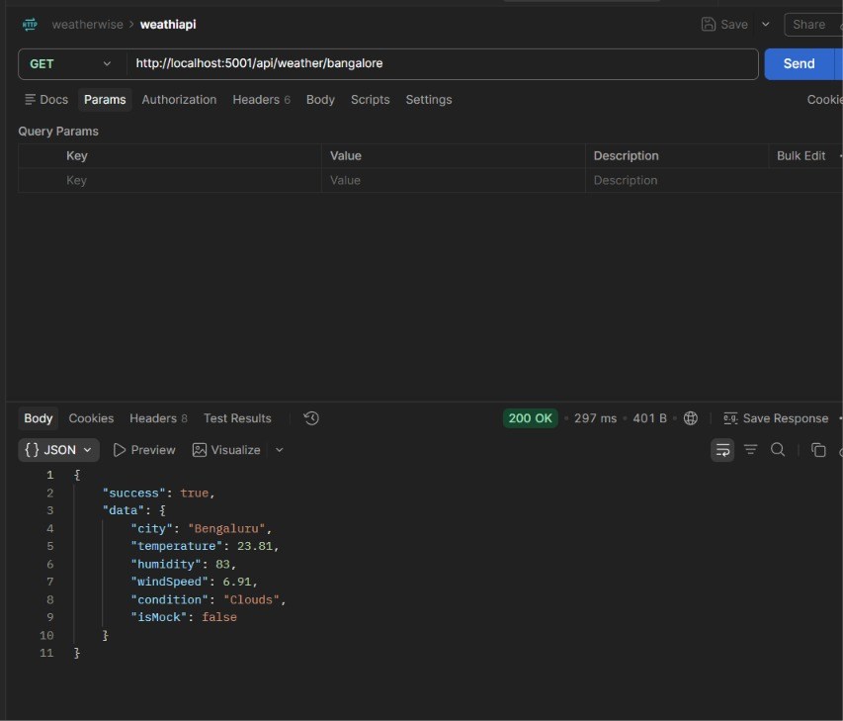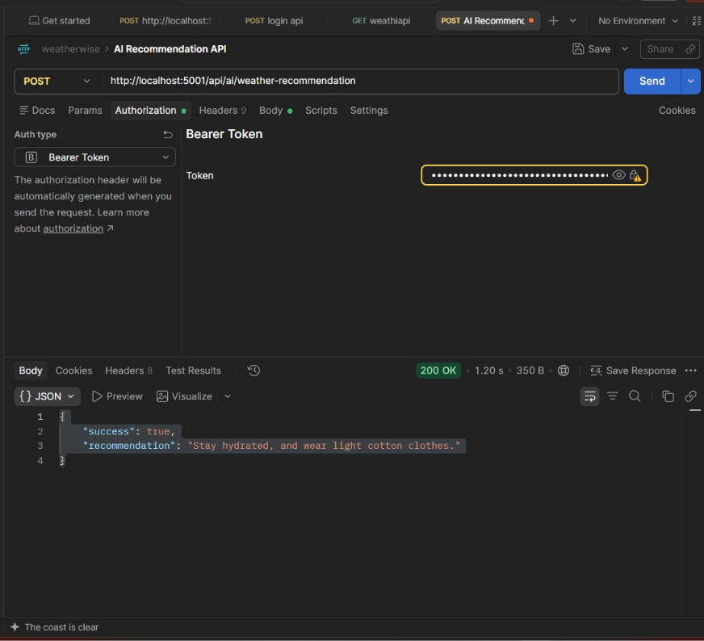

References
OpenWeatherMap is used for weather data retrieval; Google Gemini is used for AI-generated summaries and personalized recommendations; MongoDB/Mongoose are used for persistence; Postman is used for API verification.

