|  |
| --- |
| David School |
| Python Project File |
| Github : devasheeshG |
| Email : swastik.mishra.c322.smart@gmail.com |

|  |
| --- |
| Devasheesh Mishra  2-28-2021 |

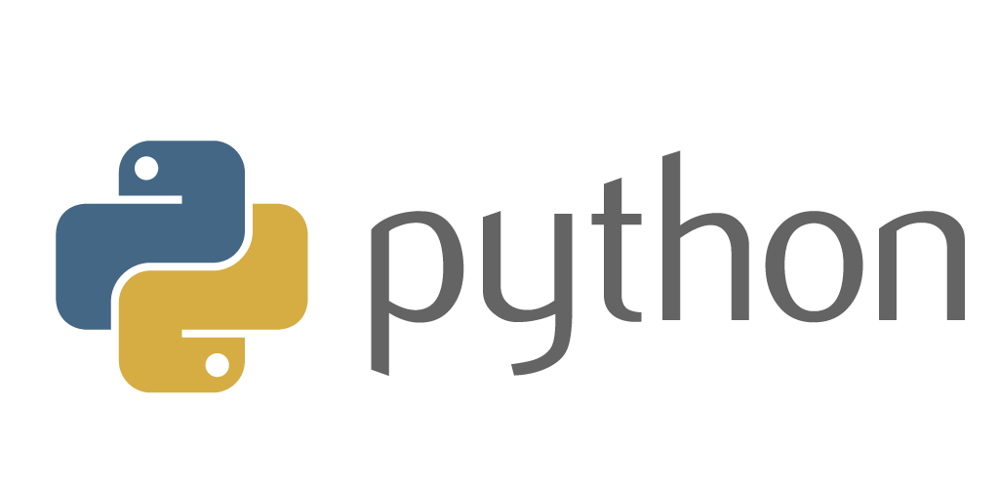

Q1- Write a program that takes a number and checks whether the given number is even or odd.

n=int(input("Enter a number : "))

if(n%2==0):

    print(n, "is an odd number")

else:

    print(n, "is an even number")

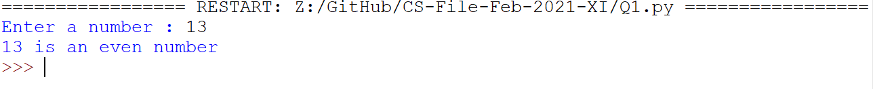

Q2-Write a program to accept three integers and print the largest of the three.

num1 = float(input("Enter first number: "))

num2 = float(input("Enter second number: "))

num3 = float(input("Enter third number: "))

if(num1>num2):

    print(num1, "is the largest integer")

elif(num2>num3):

    print(num2, "is the largest integer")

else:

    print(num3, "is the largest integer")

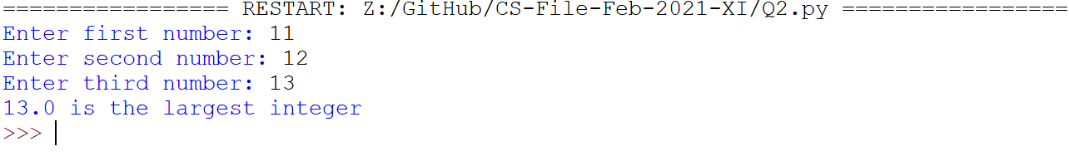

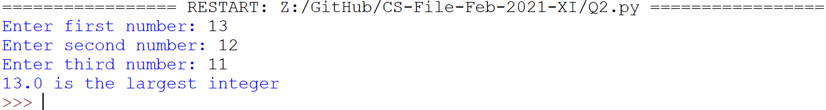

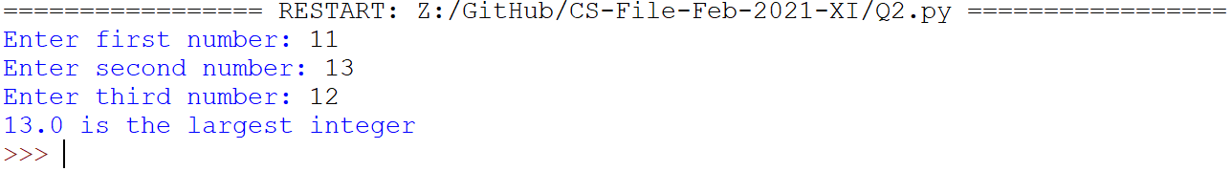

Q3. Write a program to print table of a given number by user.