REPORT
ON
DIGITAL MODULATION TECHNIQUES
(in High-Speed Wireless Communication Systems)

Submission Date: 08th April 2024

Submitted By:
BATCH- EC2

Submitted To:
Prof. Rajendra Prasad Yadav Professor-HAG



DEPARTMENT OF
ELECTRONICS AND COMMUNICATION ENGINEERING

MALAVIYA NATIONAL INSTITUTE OF TECHNOLOGY JAIPUR

CONTENTS
- Introduction:
- Digital Modulation:
  - Amplitude Shift keying
  - Frequency Shift Keying
  - Phase Shift Keying
- Development of Wireless Communication Networks: From 1G to 5G
  - Introduction
  - Features of 1G
  - Features of 2G
  - Features of 3G
  - Features of 4G
  - Features of 5G
- Requirement of Digital Modulation Techniques in 4G & 5G
  - Digital Modulation Schemes
  - Quadrature Phase Shift Keying
  - 16-Quadrature Amplitude Modulation
  - Orthogonal Frequency Division Multiplexing
  - Multiple Input Multiple Output
  - Incorporation of Modulation methods in 4G
  - Integration of Modulating Methods in 4G
  - Why 5G is Better?
  - How fast is 5G?
- Improvement in Modulation Methods
- Disadvantages of Digital Modulation Methods
- Disadvantages & Drawbacks in 5G
- Scope of Improvement in 5G
- Conclusion
- References
Abstract:
Wireless communications has become an emerging and fastly growing field in our modern life and creates enormous impact on nearly every feature of our daily life. A tremendous technological transformation during the previous two decades has provided a potential growth in the field of digital communication and lot of latest applications and technologies are coming up every day due to these valid reasons. Digital modulation schemes contribute to the evolution of mobile communications by increasing the capacity, speed as well as the quality of the wireless network. In communication, the concept of modulation is a prime factor because without an appropriate modulation scheme, it would be impossible to achieve an expected throughput. Available bandwidth, permissible power and inherent noise level of the system are the constraints which should be considered while developing the communication systems. Due to error-free capability in digital modulation, it is preferred over the analogue modulation techniques. The Worldwide interoperability for Microwave Access (Wi-max) uses combinations of different modulation schemes which are BPSK, QPSK , 4-QAM AND 16-QAM and it is a promising technology which offers high speed voice, video and data services.

Introduction:
Communicating effectively over a huge distance has always been the challenge for engineers and scientists and with the transition of modulating systems from Analog to Digital has further complicated the situations. The transition from analog to digital modulation provides more information capacity, compatibility with digital data services, advanced data security, faster system availability and better quality communications. Digital Modulation schemes provide more data security and RF spectrum sharing to accommodate more services.
Reasons to prefer Digital Modulation Schemes over Analog Modulation:
- The digital modulation schemes are preferred over analog modulation schemes because they provide larger immunity to noise at the cost of large bandwidth requirements.
- Advanced Data Security
- More Information Capacity
- Compatibility with Digital Data Services
- Advanced Data Security
- Its distinct transmission stated can more easily be detected at a receiver in the presence of noise.

Figure 1: Basic Digital Communication System
Digital Modulation:
In digital modulation techniques, an analog carrier signal is modulated by a binary code. The digital modulator device acts an interface between the transmitter and the channel. The digital modulation schemes can be categorized basically either on the basis of their detection characteristics or in terms of their bandwidth compaction characteristics. The basic criteria for best modulation scheme depends on Bit Error Rate (BER), Signal to Noise Ratio (SNR), Available Bandwidth, Power efficiency, better Quality of Service, cost effectiveness. The performance of each modulation scheme is measured by estimating its probability of error with an assumption that system are operating with Additive White Gaussian Noise. Modulation methods which are capable of transmitting more bits per symbol are more immune to error caused by noise and interference induced in the channel. The delay distortion can be an important measure while deciding modulation scheme for digital radio.
Modulation Schemes | Applications
BPSK | Cable modems, Deep space telemetry
FSK, GFSK | Paging, Land mobile, public safety
MSK, GMSK | Global System for Mobile
QPSK, $\frac{π}{4}$ QPSK | Satellites, CDMA, cable modems, TFTS
OQPSK | CDMA, Satellites
8-PSK | Satellites, Aircraft, Telemetry pilots for monitoring broadband video systems
16-QAM | Modems, microwave digital radio
32-QAM | Terrestrial Microwave
64-QAM | Broadband set top boxes, Modems, MMDS
256-QAM | Modems, Digital Video(US)
Table 1. Typical applications of different modulation schemes

ASK- In amplitude shift keying, once the instant amplitude of the carrier signal is changed in quantity toward m(t) message signal. For instance, if we have the modulated carrier (m(t)coswct) then the carrier signal will be coswct. Because the data is an ON/OFF signal, and the output is also an ON/OFF signal wherever the carrier is there when data is 1, as well as the carrier, is not present when data is 0. Therefore this modulation scheme is called as OOK or on/off keying (OOK) otherwise amplitude shift keying or ASK. The applications of ASK mainly include IR remote controls and fiber optic transmitter & receiver.
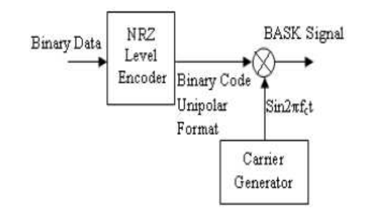

Figure 2. Basic Block Diagram of Binary Amplitude Shift Keying

The following figure represents the waveform of BASK:
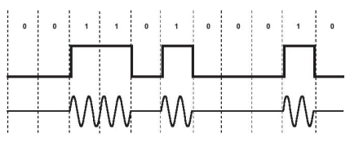

Figure 3. BASK signal waveforms

FSK-In frequency shift keying, when the immediate frequency of the carrier signal is changed then the information will be transmitted. In this type of modulation, carrier signal has two pre-defined frequencies namely wc1, and wc2. Whenever the data bit is ‘1’ then the carrier signal by wc1 is transmitted that is coswc1. Similarly, when the data bit is ‘0’ then the carrier signal by wc0 will be transmitted that is coswc0. The applications of frequency shift keying mainly include several modems in telemetry systems and phase shift keying.

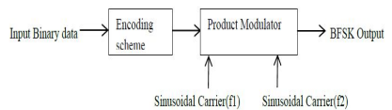

Figure 4. Basic Block Diagram of Binary Frequency Shift Keying

The following figure represents the waveforms of BFSK:
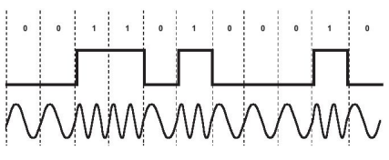

Figure 5. BFSK signal waveforms

PSK-In phase shift keying, the instant phase of the carrier signal is moved for this modulation. If the m(t) baseband signal is =1 then the carrier signal within phase will be transmitted. Similarly, If the baseband signal m(t)=0 then the carrier signal by out of phase is transmitted that is cos(wct+π). If phase shift can be done in four dissimilar quadrants then 2-bit of data will be transmitted at once. This method is an individual case of phase shift keying modulation which is known as Quadrature Phase Shift Keying or QPSK. The applications of phase shift keying include a broadband modem (ADSL), satellite communications, mobile phones, etc.

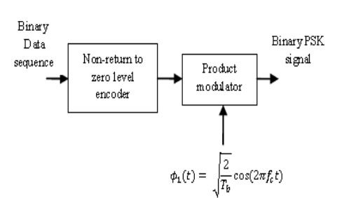

Figure 6. Basic Block Diagram of Binary Phase Shift Keying
The following figure represents the waveforms of BPSK:
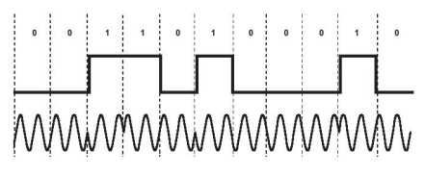

Figure 7. BPSK signal waveforms

Development of Wireless Communication Networks: From 1G to 5G
Introduction:
Mobile communications and wireless networks are developing at an astounding speed, with evidences of significant growth in the areas of mobile subscribers and terminals, mobile and wireless access networks, and mobile services and applications. The fourth generation, 4G, of mobile networks that will supersede the 3G and 2G families of standards, is already upon us. A new mobile generation has appeared every 10th year since the first 1G system was first introduced in 1981, followed by the 2G system that started to roll out in 1992, and 3G, which appeared in 2001. 5G technology has changed the means to use cell phones within very high bandwidth 5G systems.
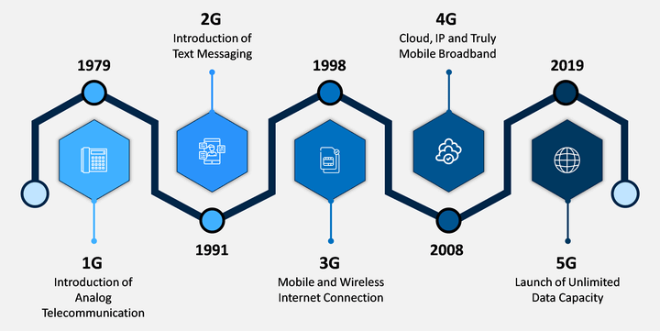
The evolution from 4G to 5G communication systems marks a significant technological advancement, addressing the limitations of 4G and setting new benchmarks in connectivity.
5G outpaces 4G with data speeds up to 10 Gbps, essential for high-definition content, VR/AR, and gaming. It slashes latency to under 1 millisecond, vital for real-time applications like autonomous driving and remote surgery.
5G’s enhanced capacity and spectrum efficiency cater to the burgeoning IoT ecosystem, supporting billions of connected devices. It’s engineered for massive IoT deployments, offering low-power, wide-area coverage, and numerous simultaneous connections, benefiting smart cities, healthcare, and more.
Network slicing in 5G allows for customized virtual networks, providing tailored solutions for diverse requirements. This future-proof technology fosters innovation, enabling new services and applications.
Differing from 4G’s narrower frequency bands and up to 20 MHz channel bandwidths, 5G exploits sub-6 GHz and mmWave bands, with channel bandwidths extending to 400 MHz. This grants 5G higher data rates and capacity, leveraging mmWave spectrum for unparalleled connectivity.
In essence, 5G’s superior bandwidth and efficiency promise a transformative impact on digital communication, heralding a new era of ultra-fast, reliable, and expansive wireless networking.
Features of 1G: 1G is the first generation cellular network that existed in 1980s.
- 1G network were conceived and designed purely for voice calls with almost no consideration of data services (with the possible exception of built-in modems in some headsets).
- It has limitation because there is no encryption, the sound quality is poor and the speed of transfer is only at 9.6kbps.
- It has FDMA in multiplexing possess circuit switching and uses PSTN as core network.
- It has Poor carrier aggregation, no MIMO technology, very large cells may range from 2- 20 km and its time consuming too.
Features of 2G: 2G networks first commercially began on the Global System for Mobile Communications, or GSM/CDMA, standard. 2G on GSM standards was first used in commercial practice in 1991. Being digital, they overcame some of the limitations of 1G, such as it omits the radio power from handsets making life healthier, and it has enhanced privacy has better coverage, capacity, offering improved sound quality.
- GSM supports circuitswitched data (CSD), allowing users to place dial-up data calls digitally, so that the network's switching station receives actual ones and zeroes rather than the screech of an analog modem.
- It uses TDMA, CDMA in multiplexing possess circuit and packet switching and uses PSTN as core network.
- All the standards belonging to this generation were commercial centric and they were digital in form.
- Its Peak speed may be up to 14.4 kbps and carrier bit rate is 270.8 kbps & speech coding bit rate is 13kbps also its channel bandwidth is 200 k Hz in GSM.
Features of 3G: 3G supersedes 2G technology and precedes 4G technology. Current 3G systems have been established through ITU’s project on International Mobile Telecommunications 2000.
- It was the first mobile broadband based on high capacity broadband data.
- Its network architecture is cell based but has frequency band dependent on country or continent (1800-2400 MHz) uses bandwidth of 5-20MHz.
- It uses switching scheme of packet and circuit. They are based on two parallel backbone-infrastructures, one consisting of circuit switched nodes, and one of packet oriented nodes.
- It has more features like the data throughput is up to 3.1Mbps
- It has a peak upload rate of 5 Mbps.
- It uses turbo codes for error correction.
- It provides digital navigation but costly in implementation.

Features of 4G: A 4G system is expected to provide a comprehensive and secure all-IP based mobile broadband solution to laptop computer wireless modems, smartphones, and other mobile devices. Facilities such as ultra-broadband Internet access, IP telephony, gaming services, and streamed multimedia may be provided to users.
4G LTE (Long Term Evolution) Advanced has following features:
- UMTS Long Term Evolution (LTE) was introduced in 3GPP Release 8 which supports data rates of up to 300 Mbps (4x4 MIMO) and up to 150 Mbps (2x2 MIMO) in the downlink and up to 75 Mbps in the uplink.
- Uses 64-QAM modulation.
- Uses MIMO and beam forming with up to 4 antennas.
- Uses OFDMA for downlink & Uses Single Carrier Frequency Division Multiple Access (SC-FDMA) for uplink.
Features of 5G: 5G denotes the next major phase of mobile telecommunications standards beyond the 4G/IMT-Advanced standards.
- The advanced billing interfaces of 5G technology makes it more attractive and effective with the following future perspectives.
- 5G is a packet switched wireless system with wide area coverage and high throughput.
- 5G networks will comprise LTE access based on Orthogonal Frequency Division Multiplexing (OFDM) along with new radio interfaces using possibly new techniques, e.g., Filter Bank Multicarrier Transmission technique (FBMC).
Parameters | Key Values for 5G
Peak data rate: maximum accomplishable data rate under ideal conditions per user/device (in Gbit/s) | 10–20 Gbit/s
User experienced data rate: accomplishable data rate that is available ubiquitously in the coverage area to a mobile user/device (in Mbit/s or Gbit/s) | 100 Mbit/s (for wide area coverage, e.g., in urban and sub-urban areas) and 1 Gbit/s (in hotspot cases, e.g., indoor)
Latency: the time contribution of the radio network from when the source sends a packet to when the destination receives it (in ms) | 1 ms
Mobility: maximum speed at which a defined quality of service (QoS) and seamless transfer between radio nodes which may belong to different layers and/or radio access technologies can be accomplished (in km/h) | 500 km/h (e.g. for high speed trains)
Connection density: total number of connected and/or accessible devices per area unit (per km²) | 10⁶ devices/km²
Spectrum efficiency: average data throughput per spectrum unit resource and per cell (bit/s/Hz) | 3x greater than IMT-Advanced
Area traffic capacity: total traffic throughput served per geographic area (in Mbit/s/m² ) | 10 Mbit/s/m²

Table 2. Parameters of 5G wireless communication systems

REQUIREMENT OF DIGITAL MODULATION TECHNIQUES IN
4G & 5G
As electronics engineers, understanding the importance of digital modulation schemes in the evolution of telecommunications is crucial. This section explores the significance of digital modulation schemes in the context of 4G and 5G technologies, emphasizing their role in enabling efficient data transmission and reception in wireless communication systems
4G technology, such as Long-Term Evolution (LTE), uses digital modulation techniques like Orthogonal Frequency Division Multiplexing (OFDM) to play a pivotal role. OFDM divides the available spectrum into multiple orthogonal subcarriers, allowing simultaneous transmission of data symbols across these subcarriers. This technique effectively combats multipath fading and enables high data rates, making it well-suited for 4G communication systems.
5G technologies build upon the foundation laid by 4G and introduce even more advanced digital modulation techniques to meet the increasing demands for higher data rates, ultra-low latency, and massive connectivity. One of the key advancements in 5G is the utilization of higher-order modulation schemes, such as 256-QAM (Quadrature Amplitude Modulation) and beyond.
Moreover, 5G standards incorporate sophisticated modulation and coding schemes, including adaptive modulation and coding (AMC), which dynamically adjust modulation order and coding rate based on channel conditions. It also introduces new waveform technologies like Filtered-OFDM (f-OFDM) and Universal Filtered Multi-Carrier (UFMC), which offer enhanced spectral efficiency and improved interference mitigation capabilities compared to traditional OFDM.
These waveform technologies leverage advanced digital signal processing techniques to shape the transmitted signals and optimize spectral utilization, thereby supporting the diverse requirements of 5G applications, including enhanced mobile broadband, massive machine-type communication, and ultra-reliable low-latency communication.

DIGITAL MODULATION SCHEMES
This section provides an overview of essential digital modulation schemes in wireless communication systems. It examines Quadrature Phase Shift Keying (QPSK), 16-Quadrature Amplitude Modulation (16QAM), Orthogonal Frequency Division Multiplexing (OFDM), and Multiple Input Multiple Output (MIMO) technologies.
- Quadrature Phase Shift Keying (QPSK)
  - QPSK conveys data by modulating the phase of a carrier wave with four possible phase shifts, each representing two bits of data per symbol.
  - Compared to Binary Phase Shift Keying (BPSK), QPSK doubles the data rate .
- 16-Quadrature Amplitude Modulation (16QAM)
  - 16QAM encodes data as variations in both amplitude and phase of a carrier wave, with each symbol representing four bits of data.
  - It offers higher data rates than QPSK but is more susceptible to noise and interference.

- Orthogonal Frequency Division Multiplexing (OFDM)
  - OFDM divides the spectrum into orthogonal subcarriers, each carrying low-rate data streams.
  - It enables efficient spectrum utilization and mitigates multipath interference, making it effective in high-data-rate applications.
- Multiple Input Multiple Output (MIMO)
  - MIMO technology enhances communication performance by using multiple antennas at both transmitter and receiver ends.
  - It increases data throughput, improves link reliability, and achieves spectral efficiency through techniques like spatial multiplexing and beamforming .

Digital modulation schemes such as QPSK, 16QAM, OFDM, and MIMO are integral to modern wireless communication systems. Each technology offers unique advantages, catering to the increasing demand for higher data rates, spectral efficiency, and reliable connectivity in wireless networks.

INCORPORATION OF MODULATION METHODS IN 4G TECHNOLOGY
This section examines the integration of modulation methods in 4G technology, focusing on Binary Phase Shift Keying (BPSK), Orthogonal Frequency Division Multiplexing (OFDM), 16-Quadrature Amplitude Modulation (16-QAM), and Multiple-Input Multiple-Output (MIMO) technologies.
- Binary Phase Shift Keying (BPSK)
  - BPSK varies the phase of the carrier signal to represent binary
data (0 or 1).
  - In 4G, BPSK is preferred for its simplicity and robustness in transmitting data over wireless channels, especially in low signal-to-noise ratio (SNR) scenarios.
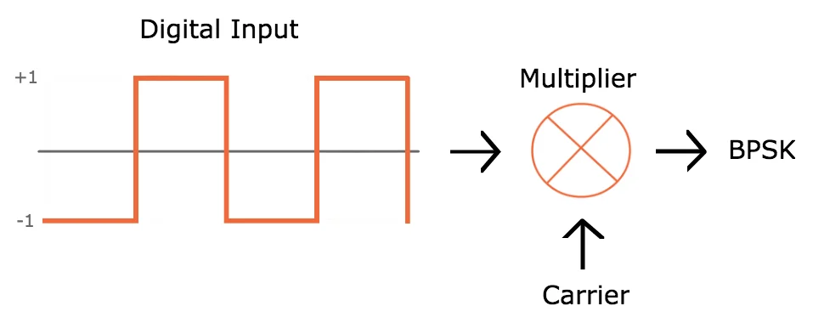
- Orthogonal Frequency Division Multiplexing (OFDM)
  - OFDM divides the spectrum into orthogonal subcarriers, enabling parallel transmission of data.
  - It is fundamental in 4G for downlink transmission, facilitating high data rates and efficient spectrum utilization while mitigating multipath propagation and frequency-selective fading.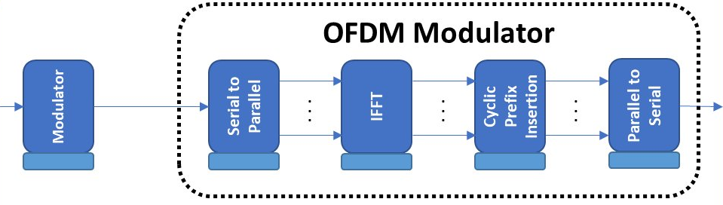

- 16-Quadrature Amplitude Modulation (16-QAM)
  - 16-QAM varies both amplitude and phase of the carrier signal to represent multiple bits per symbol.
  - It is used in conjunction with OFDM in 4G for higher data rates, particularly in data-bearing channels requiring higher spectral efficiency.

- Multiple-Input Multiple-Output (MIMO)
  - MIMO technology improves communication performance by exploiting spatial diversity and multipath propagation.
  - Widely deployed in 4G, MIMO enhances data rates, link reliability, and network capacity through techniques like spatial multiplexing and beamforming.

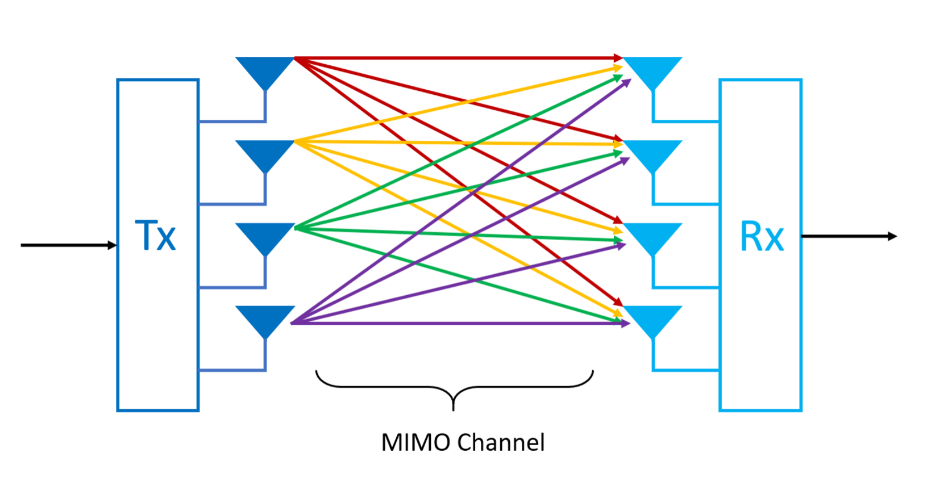

INTEGRATION OF MODULATION METHODS IN 4G
  - 4G networks combine these modulation methods to optimize performance for various services and applications.
  - For example, BPSK may be used for control signaling, while OFDM with 16-QAM or higher-order schemes is employed for high-speed data transmission.
  - MIMO technology further enhances spectral efficiency and overall quality of service in 4G networks.

The integration of modulation methods like BPSK, OFDM, 16-QAM, and MIMO is essential for achieving the high data rates, spectral efficiency, and reliability required by 4G technology. Leveraging these advanced modulation techniques allows 4G networks to deliver enhanced performance, support diverse services, and meet the evolving needs of mobile communication users.

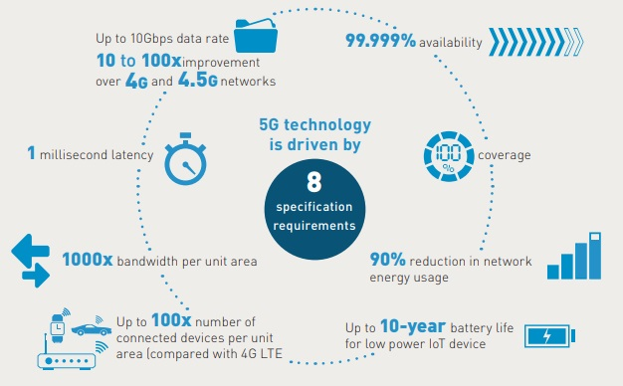
WHY IS 5G BETTER?

Elevated Data Speeds: 5G technology surpasses 4G LTE, offering peak data speeds up to 20 Gbps. This acceleration enables more rapid data retrieval and transfer, enhancing the user experience in streaming ultra-high-definition media and engaging with bandwidth-heavy applications like AR and VR.
Reduced Latency: 5G dramatically cuts down the data transmission time between devices to as little as 1 millisecond. This improvement is crucial for instantaneous communication, pivotal in scenarios such as competitive online gaming, self-driving cars, telesurgery, and automated industrial processes.
Amplified Device Capacity: The 5G framework is capable of supporting a substantially larger number of devices within a given area, surpassing previous generations. This capability is vital for managing the increasing quantity of IoT devices and supporting densely populated urban locales.
Spectral Efficiency Advancements: Leveraging cutting-edge technologies like massive MIMO and beamforming, 5G enhances the spectral efficiency. This advancement allows for a more effective transmission of data, optimizing the use of available spectrum and elevating network performance.
Advanced Network Slicing: 5G introduces network slicing, enabling the creation of distinct virtual networks, each customized for specific applications or user demographics. This feature allows providers to deliver bespoke services with diverse specifications for latency, bandwidth, and reliability, accommodating a wide array of use cases from personal broadband to critical operations.
Diverse Use Case Support: 5G is engineered to facilitate a broad spectrum of applications across different sectors, extending beyond conventional mobile broadband. It supports ultra-reliable low-latency communication (URLLC) for essential services like industrial automation, massive machine-type communication (mMTC) for IoT, and enhanced mobile broadband (eMBB) for swift mobile connectivity. This versatility positions 5G as a cornerstone for the digital overhaul of industries and the advent of novel applications and services.
HOW FAST IS 5G?
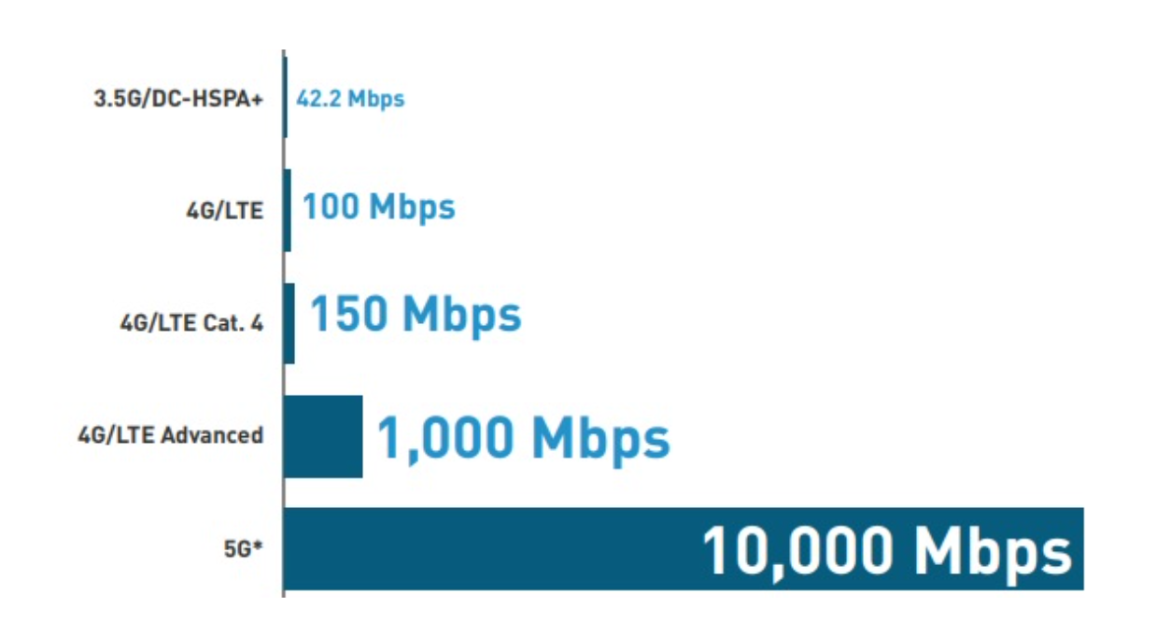

IMPROVEMENT IN MODULATION METHODS
The advent of 5G technology heralds a new era in telecommunications, offering substantial improvements over 4G LTE. With peak data speeds reaching 20 Gbps, 5G facilitates swift data exchange, enriching experiences in ultra-high-definition media streaming and interactive applications like AR and VR.
A standout feature of 5G is its minimal latency, with data transmission times reduced to as low as 1 millisecond. This is a game-changer for real-time communication, essential for applications demanding immediate response, such as online gaming, autonomous vehicles, and remote medical procedures.
5G’s expanded device support is another leap forward, accommodating a significantly larger number of devices per area. This is particularly important for the growing IoT landscape and urban areas with high device density.
Through technologies like massive MIMO and beamforming, 5G achieves remarkable spectral efficiency, optimizing data transmission and network performance. Additionally, network slicing allows for the creation of customized virtual networks, catering to specific needs with varying latency, bandwidth, and reliability requirements.
Finally, 5G’s versatility supports a wide range of applications, from ultra-reliable low-latency communication for critical services to enhanced mobile broadband for fast connectivity. This positions 5G as a foundational technology for industry digitalization and the development of innovative applications and services. The transition to 5G is not just an upgrade; it’s a transformation that will redefine wireless communication.

DISADVANTAGES OF DIGITAL MODULATION METHODS
Despite offering advantages such as efficient bandwidth utilization and compatibility with digital signal processing, digital modulation methods face significant challenges in rapid data transmission scenarios.
By analyzing these disadvantages, including sensitivity to channel variability, complexity in implementation, elevated power consumption, susceptibility to interference and noise, nonlinear effects, limited spectral efficiency, and degradation in error performance, this highlights the nuanced challenges of deploying digital modulation schemes in high-speed wireless communication environments.
Digital modulation methods play a crucial role in high-speed wireless communication systems due to their inherent advantages. However, they also pose several disadvantages, particularly in the context of rapid data transmission. This section explores these disadvantages and their implications for high-speed wireless communication systems.
Sensitivity to Channel Variability: Digital modulation schemes are sensitive to variations in the wireless channel, leading to increased errors and reduced reliability, especially in high-mobility environments.
Complexity and Implementation Challenges: As data rates increase, implementing digital modulation schemes becomes more complex, requiring advanced signal processing techniques and high-performance hardware.
High Power Consumption: High-speed digital modulation schemes often require complex signal processing algorithms and high transmit power, resulting in increased power consumption, particularly problematic for battery-powered devices.
Interference and Noise: In high-speed communication systems, interference and noise can degrade the performance of digital modulation schemes, reducing overall throughput.
Nonlinear Effects: Nonlinear effects in RF components can distort the transmitted signal, leading to performance degradation and requiring careful system design to mitigate.
Limited Spectral Efficiency: Despite being more spectrally efficient than analog modulation, digital modulation schemes may still suffer from limited spectral efficiency, especially at very high data rates, leading to congestion in the frequency spectrum].
Error Performance Degradation: Increasing data rates make digital modulation schemes more susceptible to errors, necessitating sophisticated error correction techniques.
Digital modulation methods, while offering advantages in high-speed wireless communication, also pose significant challenges. Understanding these disadvantages is crucial for the development of more robust and efficient communication systems tailored for high-speed applications.

DISADVANTAGES AND DRAWBACKS IN 5G

While 5G technology offers a multitude of benefits and advancements over its predecessors, it also presents certain challenges and disadvantages that warrant consideration:
Infrastructure Requirements: Implementing 5G networks necessitates significant investment in infrastructure, including the deployment of small cells and extensive fiber-optic networks. This infrastructure upgrade can be time-consuming and costly, particularly in rural or remote areas where coverage may be limited.
Coverage Limitations: Despite its promise of high-speed connectivity, 5G coverage may initially be limited to urban and densely populated areas. The deployment of mmWave frequencies, which offer high data rates but have limited propagation characteristics, presents challenges in achieving widespread coverage, especially in suburban and rural regions.
Interference and Signal Penetration: 5G signals, particularly those in the mmWave spectrum, are susceptible to interference from obstacles such as buildings, foliage, and inclement weather. Additionally, mmWave signals have poor penetration capabilities, making indoor coverage and connectivity in dense urban environments challenging.
Device Compatibility and Cost: The adoption of 5G technology requires compatible devices equipped with 5G-capable modems and antennas. However, the initial cost of 5G-enabled devices may be prohibitive for some users, limiting widespread adoption until prices become more affordable.
Energy Consumption: The deployment of 5G infrastructure, including small cells and massive MIMO antennas, requires considerable energy consumption. This may raise concerns about the environmental impact and sustainability of 5G networks, particularly in light of efforts to reduce carbon emissions and energy consumption in the telecommunications industry.

SCOPE OF IMPROVEMENT IN 5G
While 5G offers significant advancements over 4G, there's still room for improvement. Here are some key areas:
Coverage: Extending 5G reach to rural and remote areas remains a challenge. Infrastructure development and innovative solutions are needed for wider accessibility.
Energy Efficiency: 5G networks require more power. Optimizing network architecture and developing energy-efficient equipment can lower the environmental impact.
Cost: Deploying and maintaining 5G infrastructure is expensive. More cost-effective solutions for deployment and user access are crucial for wider adoption.
Device Compatibility: Not all devices are currently compatible with 5G. Ensuring broader compatibility with existing and future devices is essential.
Security: New vulnerabilities may emerge with 5G advancements. Continuous development of robust security protocols is necessary to protect data and network integrity.
Standardization: Multiple standards exist within 5G, which can lead to compatibility issues between networks. Further standardization efforts can improve interoperability.
Latency: While significantly reduced compared to 4G, 5G latency can still be an issue for real-time applications like remote surgery or autonomous vehicles. Further advancements are needed to achieve ultra-low latency.
Network Slicing: Network slicing, which allows for virtual networks tailored to specific needs, is a promising 5G technology. Optimizing this technology and developing use cases is crucial for its full potential.
Millimeter Wave (mmWave) Challenges: mmWave frequencies offer high capacity but have limited range and are susceptible to signal blockage. Developing solutions to overcome these limitations will expand mmWave applications.
By addressing these areas, 5G can reach its full potential and unlock further innovation across various sectors.

CONCLUSION

In conclusion, the evolution of telecommunications from 4G to 5G has been marked by significant advancements in digital modulation schemes, playing a pivotal role in shaping the capabilities and performance of wireless communication systems. Digital modulation techniques such as Orthogonal Frequency Division Multiplexing (OFDM), Quadrature Phase Shift Keying (QPSK), 16-Quadrature Amplitude Modulation (16QAM), and Multiple Input Multiple Output (MIMO) have been instrumental in enhancing data rates, spectral efficiency, and reliability in both 4G and 5G technologies.
While 4G laid the groundwork with techniques like OFDM and MIMO, 5G has further refined these methods and introduced new modulation and coding schemes such as adaptive modulation and coding (AMC), Filtered-OFDM (f-OFDM), and Universal Filtered Multi-Carrier (UFMC). These advancements address the increasing demands for higher data rates, ultra-low latency, and massive connectivity in the era of 5G.
However, despite the significant advantages offered by digital modulation methods, they also pose challenges, particularly in rapid data transmission scenarios. Issues such as sensitivity to channel variability, complexity in implementation, elevated power consumption, susceptibility to interference and noise, limited spectral efficiency, and degradation in error performance need to be carefully addressed to ensure the robustness and efficiency of high-speed wireless communication systems.
Looking ahead, the scope of improvement in 5G remains vast. With its unparalleled data speeds, reduced latency, expanded device capacity, and enhanced spectral efficiency, 5G promises to revolutionize various industries and pave the way for innovative applications and services. The transition to 5G represents not just an upgrade but a transformative shift that will redefine the landscape of wireless communication, shaping the future of connectivity and digitalization across the globe.

REFERENCES

Scholar Google (2023). IEEE Paper: Digital Modulation Methods (16 QAM, MIMO, QPSK, OFDM) [Online]. Available from: https://scholar.google.com/
Tutorialspoint (n.d.). Principles of Communication: Digital Modulation Techniques [Online]. Available from: https://www.tutorialspoint.com/digital_communication/digital_communication_digital_modulation_techniques.htm
Telecom Regulatory Authority of India (TRAI) (2018). Technology Digest May 2018 [PDF]. Available from: https://www.trai.gov.in/
Google (n.d.). Incorporation of Modulation Methods in 4G Technology [Online]. Available from: https://tome.app/vishal-sodhani/incorporation-of-modulation-methods-in-4g-technology-clumn9xbn0lg9o762enzn4grv
Lumenci (n.d.). 4G to 5G [Online]. Available from: https://www.lumenci.com/post/4g-to-5g
National Institutes of Health (NIH) (2021). Author: Mao Sui et al. Title: Channel Estimation for Uplink Massive MIMO With Imperfect CSIT: A Deep Learning Approach [Online]. Available from: https://www.ncbi.nlm.nih.gov/pmc/articles/PMC8747744/
PREETI JAIN, “4G Technology” in “engineers garage” http://www.engineersgarage.com/articles/4Gtechnology.
International Journal of Wired and Wireless Communications Vol.2, Issue 2, April, 2014
R. R.Bhambare, R.D. Raut., A Survey on Digital Modulation Techniques for Software Defined Radio Applications, IRACST, ISSN: 2250-3501 Vol.3, No.3, June 2013.
R. Mongre, M. Kapoor, Compative Analysis of Digital modulation Techniques on the Basis of Their Bit Error Rate in VHDL, IJETR, ISSN : 2277-5668, Volume-2, Issue-6 2013
K. Hamid, I. Khider, A. Babiker, Performance Evaluation of Digital Modulation Techniques on DS-WCDMA, IJCA (0975-8887),Vol. 74, No. 8, July 2013.
D.K.Sharma, A.Mishra and R.Saxena, Analog and Digital Modulation Techniques : An Overview, TECHNIA-IJCSCT, ISSN 0974-3375,VOL. 3, NO. 1, July 2010

BATCH – EC2
Sr. No. | Student Id | Name
1 | 2022UEC1487 | DEVASHISH TUSHAR
2 | 2022UEC1497 | SIDDHANT MOHANTY
3 | 2022UEC1517 | ADITYA KULSHRESHTHA
4 | 2022UEC1523 | KUSHAL JAIN
5 | 2022UEC1530 | MUKUL GUPTA
6 | 2022UEC1536 | TRISHA KEDIA
7 | 2022UEC1542 | KANAN AGARWAL
8 | 2022UEC1550 | SHREYA H. GHIYAD
9 | 2022UEC1558 | BHOOMI
10 | 2022UEC1564 | DIYA TAHLIYANI
11 | 2022UEC1568 | SURUCHI LAKHOTIA
12 | 2022UEC1571 | VISHAL GUPTA
13 | 2022UEC1576 | MOHAN SHYAM PANDEY
14 | 2022UEC1578 | NITIN MEENA
15 | 2022UEC1579 | HARSHIT G BIHANI
16 | 2022UEC1582 | DHANAVATH CHARASMI
17 | 2022UEC1591 | ADITYA MEENA
18 | 2022UEC1596 | RAGHAV ARORA
19 | 2022UEC1602 | NISHANT KHANDELWAL
20 | 2022UEC1608 | VISHAL SODHANI
21 | 2022UEC1614 | OJASVI AGGARWAL
22 | 2022UEC1616 | TANMAY MAHESHWARI
23 | 2022UEC1620 | RUPESH KUMAR SHARMA
24 | 2022UEC1629 | AAYUSH CHOMAL

