TASK 2: Simple Jenkins CI/CD Pipeline Project

# Objective

The objective of this project is to set up a basic Jenkins pipeline to automate the process of building and deploying a simple Node.js application using Docker.

# Tools Used

1. Jenkins  
2. Docker  
3. GitHub  
4. Node.js

# Steps Performed

1. Installed Jenkins, Docker, and Node.js on Windows.  
2. Created a sample Node.js application (`app.js`, `package.json`).  
3. Wrote a Dockerfile to containerize the Node.js app.  
4. Created a Jenkinsfile to define the CI/CD pipeline.  
5. Pushed the project files to a GitHub repository.  
6. Configured Jenkins to pull code from GitHub and run the pipeline.  
7. Pipeline stages executed:  
 - Checkout code from GitHub  
 - Build Docker image  
 - Run container (deploy app)

# Results

The Jenkins pipeline executed successfully, building and deploying the application in a Docker container. The application was accessible via http://localhost:3000 after deployment.

# Screenshots

Below are the evidences of successful execution:

1. Jenkins Console Output (Successful Build):

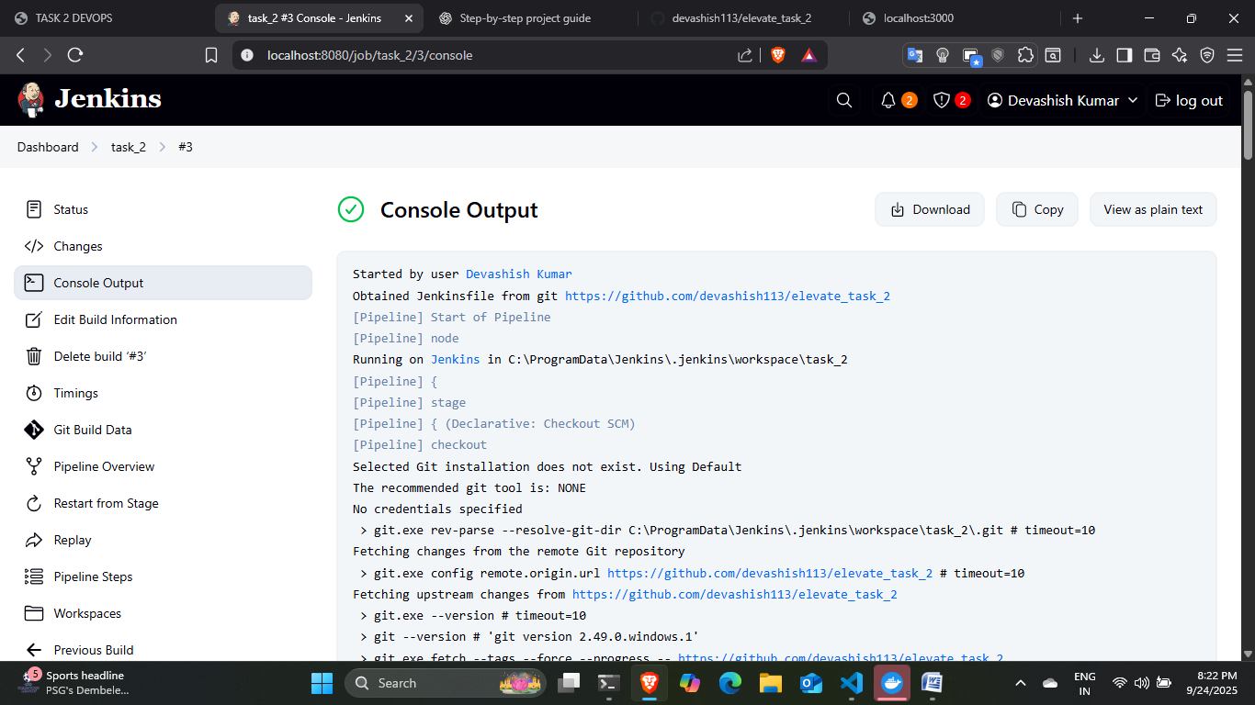

2. Docker ps output (Container Running):

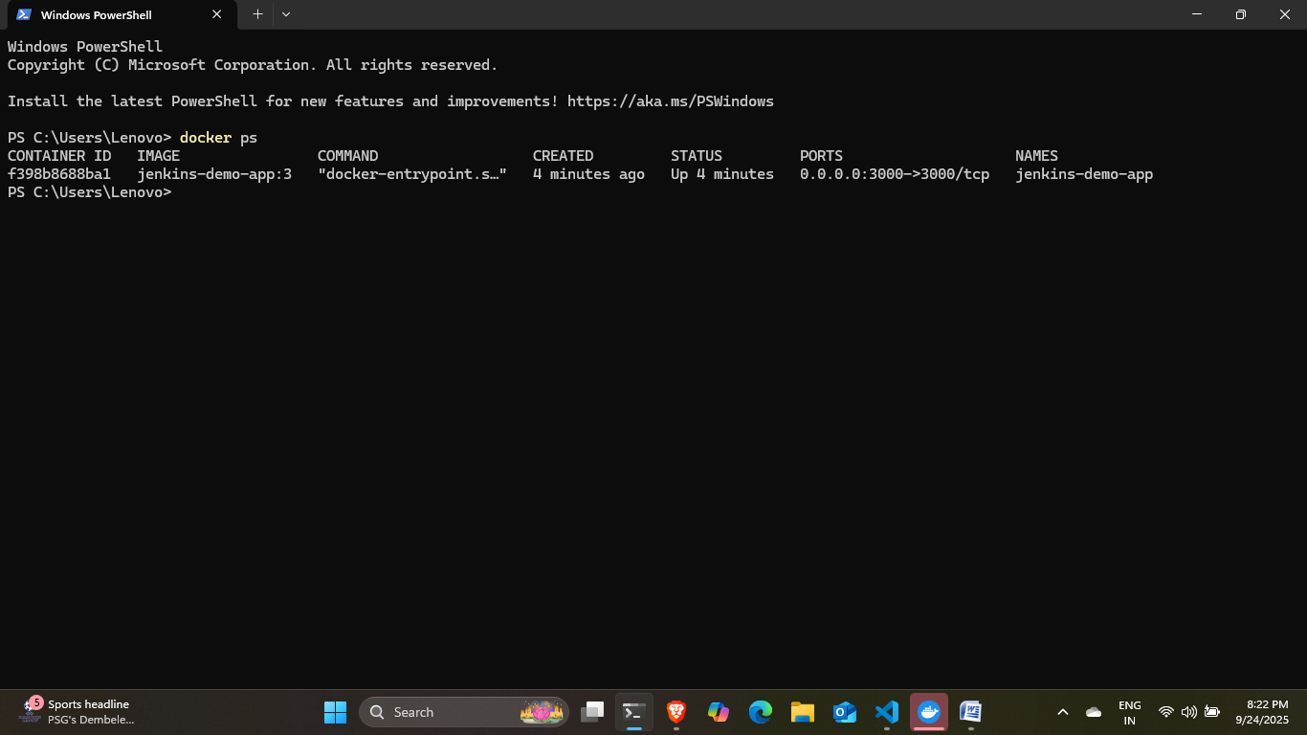

3. Application Running on localhost:3000:

# 

# Conclusion

This project demonstrated how to set up a simple CI/CD pipeline using Jenkins and Docker on Windows. The pipeline automated code fetching, image building, and container deployment, ensuring a smooth and repeatable workflow.