<https://rpaexercise.aisingapore.org/login>

wait 5

type 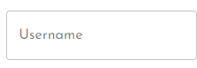 as jane007

wait 1

type 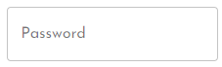 as TheBestHR123

click 